# Step by step process to build food ordering website using HTML, CSS and

## JAVASCRIPT:-

Creating a food ordering website using HTML, CSS, and JavaScript involves several steps. Below is a high-level overview of the process, followed by a more detailed step-by-step guide.

## High-Level Overview:

• **Setup Project Structure**

• **Create HTML Structure**

• **Style with CSS**

• **Add Interactivity with JavaScript**

• **Test and Deploy**

# Detailed Step-by-Step Guide

## Step 1: Setup Project Structure

Create a directory for your project and inside it, create the following files and folders:

•Celebration.html

•Celebration.css

•Celebration.js

🡨!-------food-ordering-website------🡪

//-- celebration.html

//-- celebration.css

//-- celebration.js

//-- / celebration images

## Step 2: Create HTML Structure

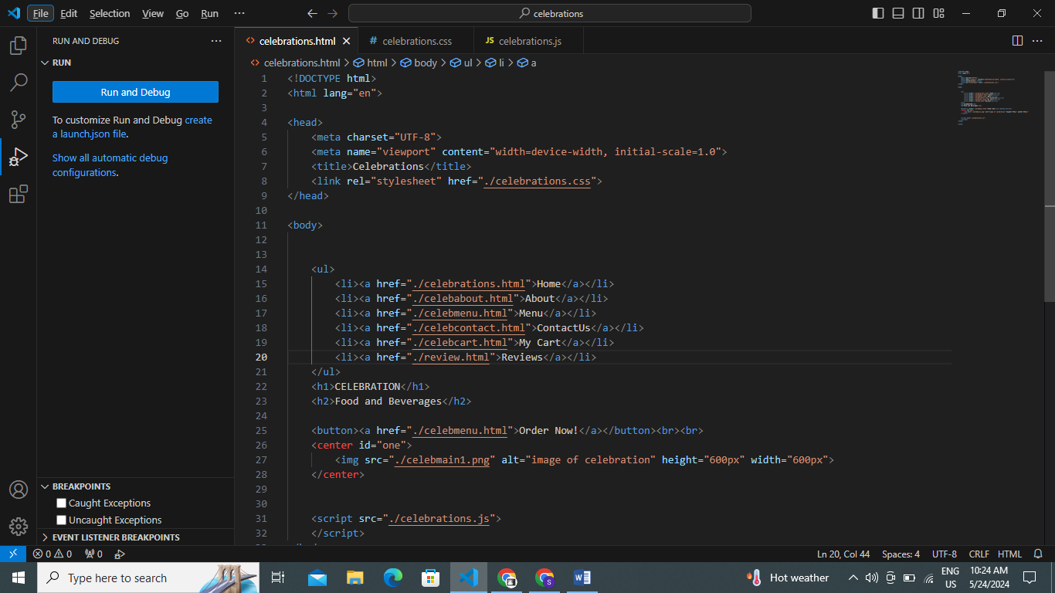

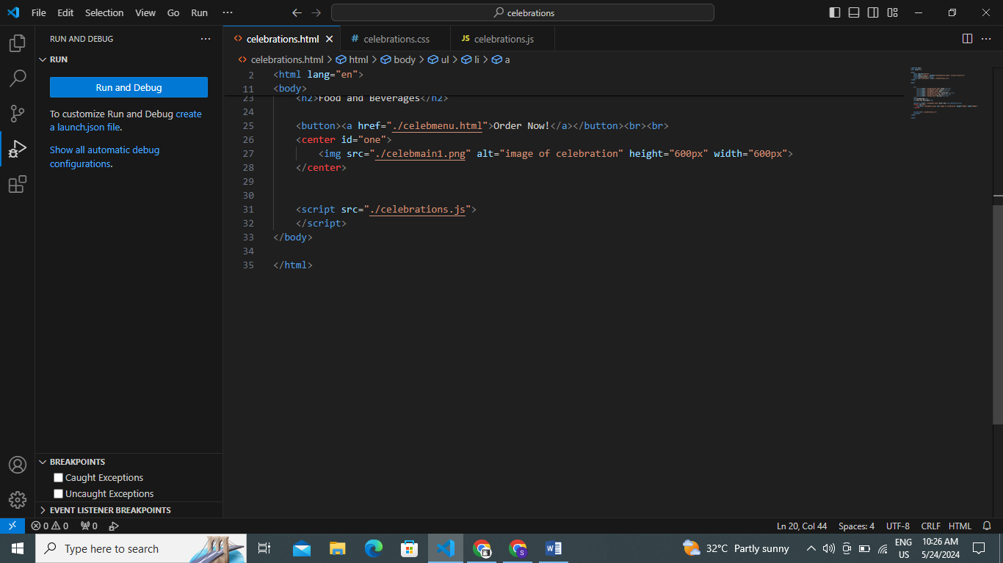

## Step 3: Style with CSS

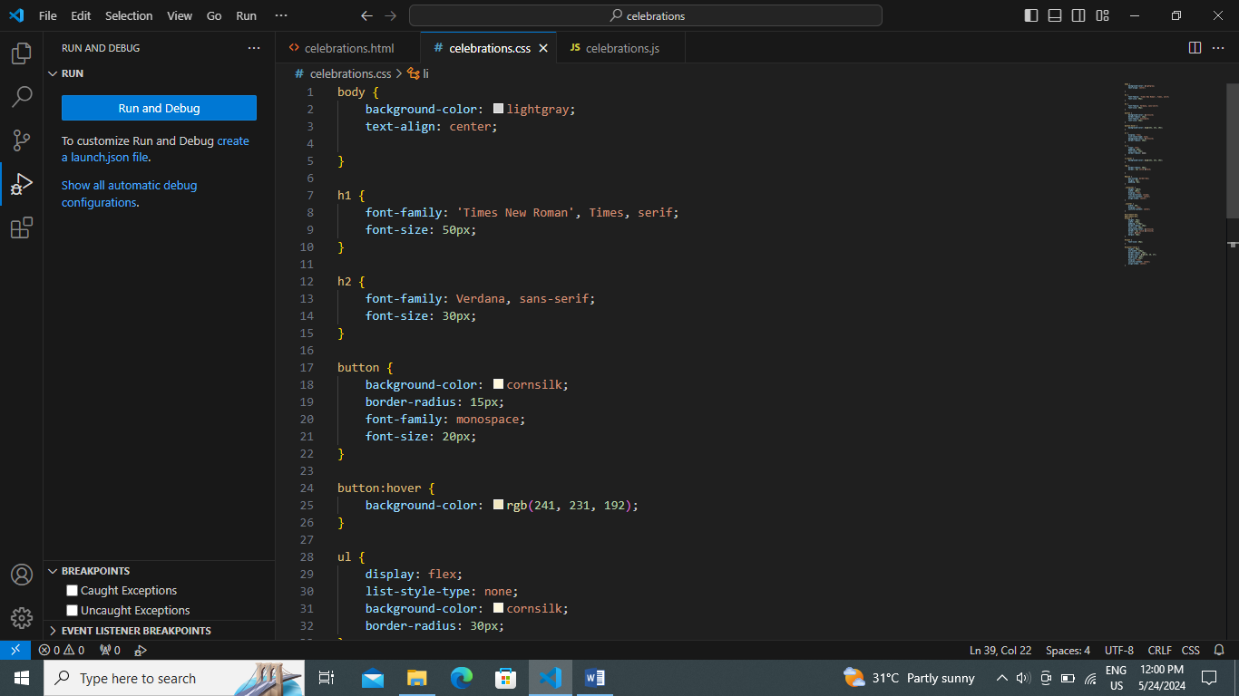

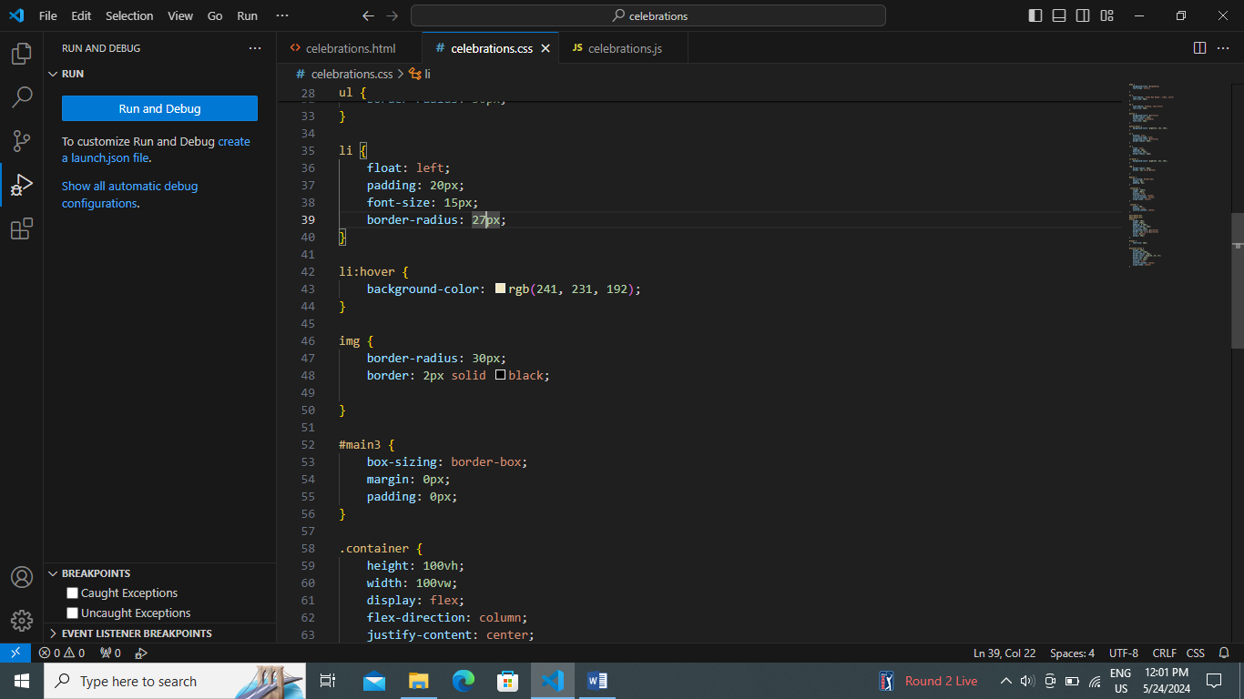

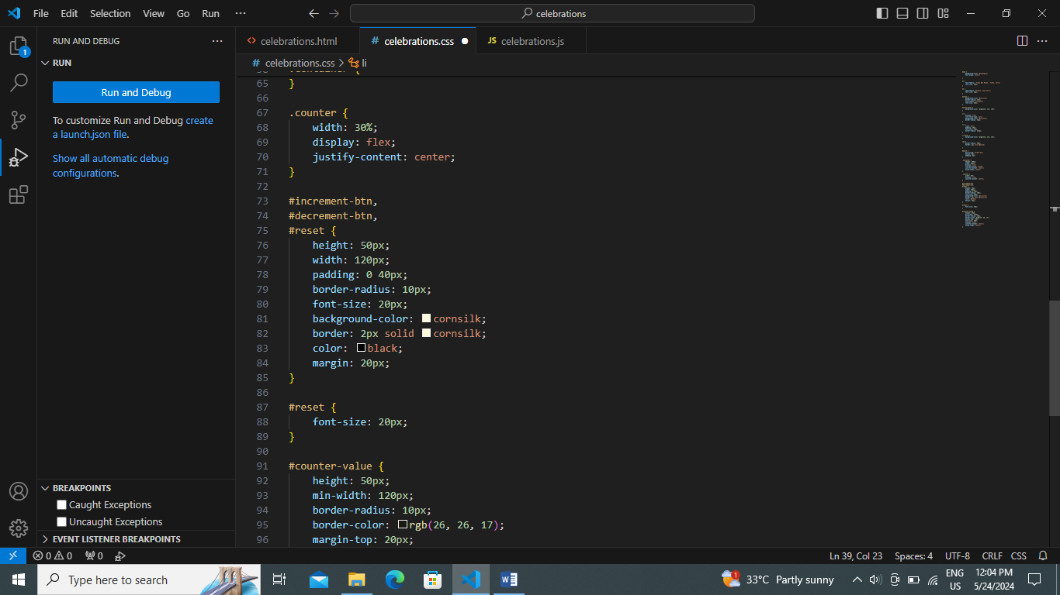

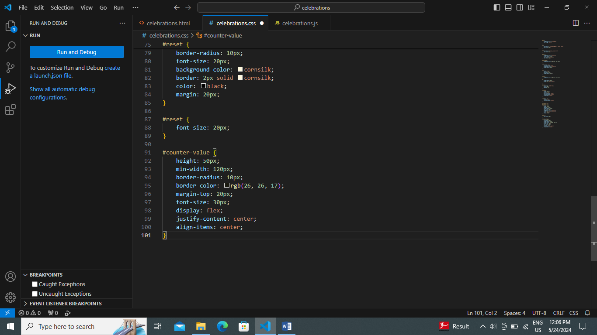

## Step 4: Add Interactivity with JavaScript

