Capstone Pre-Submission Document
Group 15 · Domain 15: Hospitality & Tourism (HorizonStay Hotels – Project StayWise)
Team: Shafi Shaik, Kavita Rawat, Savithabharathi D, Bhagyashree Patil · Oct 21, 2026

1. Business Problem Understanding and Objectives
Context. HorizonStay Hotels runs six hotels in India (two business, two leisure, two mixed; 22 rooms each) and sells through Direct, OTA, Corporate and Travel Agent channels. Bookings are growing, but occupancy and revenue swing from hotel to hotel. We examined 17,661 reservations (2024–2025) from 6,216 guests, plus 13,158 daily room-inventory records.
What the data shows (preliminary, unadjusted):
- Unreliable reservations: 27.1% of bookings never complete (23.7% cancelled, 3.4% no-show); a third of cancellations come within 7 days of arrival, leaving little time to resell the room.
- Concentrated risk: non-completion is 35% for OTA vs 20–22% for other channels, 44% for lead times over 60 days vs about 20% within 14 days, and 33% without a deposit vs 14% for non-refundable bookings.
- Revenue leakage: ₹305M was booked but only ₹218.7M realized (₹9.6M recovered through fees); occupancy is about 40%. OTA brings 45% of bookings at 18% commission: ₹9.8k net per booking vs ₹13.8k for Direct.
- Promotions and retention: cancellations stay near 24% at every discount level; 62.5% of guests book more than once; satisfaction varies by hotel (7.7 at H04 vs 8.3 at H03), but only 65% of completed stays leave a score.
Business objective. Make reservations more reliable and revenue more predictable by cutting cancellation and no-show losses and favouring channels and policies with higher net revenue, without harming guest engagement.
Analytical objectives
- Primary: using only information known at booking time, predict whether a reservation will complete, cancel or be a no-show, and identify the main risk drivers.
- Secondary: compare booked, realized and net revenue by channel, hotel, room category and segment, and estimate the expected net value of a booking given its risk.
- Stretch: find factors associated with repeat booking and guest satisfaction.

2. Challenges and Constraints
Challenges
- Bookings are not revenue: discounts, commissions, cancellations and acquisition costs cut what the hotel keeps; OTA bookings cancel most and earn least per booking.
- Uneven hotels and unclear retention: revenue and satisfaction differ across the six properties, and it is unclear which guests return and why.
- No defined problem: no target variable or method is given, so we must first choose the problem and approach.
Constraints
- Messy data: membership is 67% blank, text has stray spaces, and some columns are duplicated (Lead_Time_Days = Advance_Booking_Days), constant (Country, Currency) or legacy codes.
- Data leakage: 12 columns are known only after a stay ends (e.g. actual nights, realized revenue, satisfaction), so predictions use booking-time fields only, checked with a time-based split.
- Incomplete feedback: about 35% of completed stays have no satisfaction score, and feedback sits apart from booking history.
- Missing cost information: net revenue is not profit, no marketing spend is available, and 4,154 bookings show negative net revenue that must be explained.
- Limited scope: six hotels over two years, and repeat behaviour is cut off at the 1 Jan 2026 snapshot. Findings are associations, not causes, and we state our assumptions.

3. Background Study / Literature Review
Hotels have long studied cancellations because an empty room is lost revenue. These are the papers we can read in full and how each shapes our plan.
- Predicting cancellations: Antonio, Almeida & Nunes (2017) used machine learning on hotel reservation records to predict cancellations, our primary objective, using only information known at booking time. Their 2019 paper released two real hotel datasets (Portugal, 100,000+ bookings); we will compare our variables with theirs, not copy them.
- Modelling: Chen & Guestrin (2016) introduced XGBoost, a fast method for tabular data like ours; we start with logistic regression, then try boosted trees.
- Explaining results: Lundberg & Lee (2017) proposed SHAP, which shows what pushed each prediction up or down, so revenue managers can see which features raise cancellation risk.
- Evaluating fairly: Saito & Rehmsmeier (2015) showed that precision–recall plots are more honest than ROC curves when the cases we care about are rare (our no-shows are 3.4%).
References
- Antonio, N., Almeida, A. & Nunes, L. (2017). Predicting hotel booking cancellations to decrease uncertainty and increase revenue. Tourism & Management Studies, 13(2). https://doi.org/10.18089/tms.2017.13203
- Antonio, N., Almeida, A. & Nunes, L. (2019). Hotel booking demand datasets. Data in Brief, 22. https://doi.org/10.1016/j.dib.2018.11.126
- Chen, T. & Guestrin, C. (2016). XGBoost: A scalable tree boosting system. KDD. https://arxiv.org/abs/1603.02754
- Lundberg, S. & Lee, S.-I. (2017). A unified approach to interpreting model predictions. NeurIPS. https://arxiv.org/abs/1705.07874
- Saito, T. & Rehmsmeier, M. (2015). The precision-recall plot is more informative than the ROC plot when evaluating binary classifiers on imbalanced datasets. PLoS ONE, 10(3). https://doi.org/10.1371/journal.pone.0118432

4. Proposed Methodology / Solution Approach
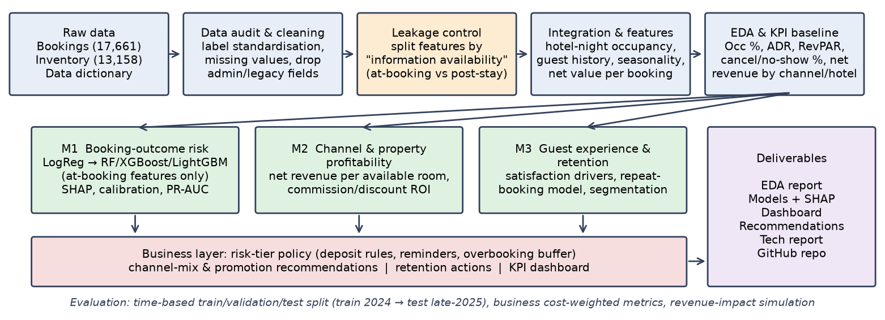
Figure 1: Project StayWise solution workflow
- Data preparation: Standardise text labels, fill Membership blanks as "None", flag survey non-response instead of filling it, and drop redundant and administrative columns. Check consistency, e.g. Booked = Listed × (1 − Discount).
- Integration & feature engineering: Join completed stays to Available_Rooms (hotel × room type × night) to compute occupancy, ADR and RevPAR. Features: lead-time bands, season and day-of-week flags, party size, guest history and net margin per booking.
- Modelling: (M1) Outcome models: logistic regression baseline → Random Forest/XGBoost/LightGBM, time-based split, PR-AUC/recall, calibration, SHAP and cost-sensitive thresholds for a risk-tier policy. (M2) Net revenue per booking and per available room by channel, discount band and hotel, with what-if analysis. (M3) Satisfaction drivers, repeat-booking classifier and RFM/K-Means segmentation.
- How it solves the problem: High-risk bookings get deposit or reminder actions and feed an overbooking buffer; weak channel/discount combinations are re-priced; back-testing on 2025 data estimates the recovered revenue (₹).

5. Estimated Costs and Resources
No paid resources are needed; the main cost is team time. The effort and hourly figures below are planning assumptions.
Item | Resource and assumption | Estimated cost
Team effort | 192 h (4 members × 6 h/week × 8 weeks) + 10% buffer ≈ 211 h | ₹0 cash; about ₹84,000 if valued at an assumed ₹400/hour
Tools, compute, data | Python, Jupyter, scikit-learn, XGBoost, SHAP, Git/GitHub (open source); laptops or Google Colab free tier; provided data (17,661 × 54), so no GPU or paid cloud | ₹0
AI assistant | Optional (e.g. GitHub Copilot), used only where we can explain the output | ₹0 on a free or student plan
For scale: about ₹86M of booked value went unrealized over two years; recovering even 5% (₹4.3M, an illustration, not a forecast) far exceeds the project’s cash cost.

6. Proposed Timeline
Activity | W1 | W2 | W3 | W4 | W5 | W6 | W7 | W8
Business understanding, literature review, pre-submission | ■
Data understanding & quality audit | ■ | ■
Cleaning, integration, leakage control |  | ■ | ■
EDA, KPI baseline (occupancy, RevPAR, channel economics) |  |  | ■ | ■
Feature engineering |  |  |  | ■
Model development M1–M3 & tuning |  |  |  | ■ | ■ | ■
Evaluation, SHAP interpretation, revenue simulation |  |  |  |  |  | ■ | ■
Dashboard & business recommendations |  |  |  |  |  |  | ■
Technical report, README/GitHub, presentation |  |  |  |  |  |  | ■ | ■

7. Expected Deliverables / Outputs
- Data analysis report: data-quality and leakage audit, EDA and problem discovery.
- Booking-outcome model(s) with evaluation and SHAP driver analysis; revenue and channel analysis with a dashboard by hotel, channel and segment.
- Business recommendations (deposit and lead-time policy, channel mix, overbooking), final report and presentation, and code with a README in each member’s GitHub repository.

