Experiment No :-
Name: Bhagyashree Rajgonda Patil Roll No: 27
Class: MCA SY Semester: 3rd
Subject: Mobile Application Development Batch: M2

Q) Implementation of DatePicker and TimePicker in Android for Capturing user input.

- Time Picker

- Activity_main.xml

<?xml version="1.0" encoding="utf-8"?>
<RelativeLayout xmlns:android="http://schemas.android.com/apk/res/android" android:layout_width="match_parent" android:layout_height="match_parent">
<EditText android:id="@+id/editText1" android:layout_width="wrap_content" android:layout_height="wrap_content" android:layout_marginLeft="100dp" android:layout_marginTop="160dp" android:ems="10"
android:hint="Enter Time" />
<Button
android:id="@+id/button1" android:layout_width="wrap_content" android:layout_height="wrap_content" android:layout_below="@+id/editText1" android:layout_marginLeft="100dp" android:text="Get Date" />
<TextView android:id="@+id/textView1" android:layout_width="wrap_content" android:layout_height="wrap_content" android:layout_below="@+id/button1" android:layout_marginLeft="100dp" android:layout_marginTop="10dp" android:textStyle="bold" android:textSize="18dp"/>
</RelativeLayout>

- MainActivity.java

package com.examples.timepicker;
import android.app.TimePickerDialog;
import android.os.Bundle;
import android.text.InputType;
import android.view.View;
import android.widget.Button;
import android.widget.EditText;
import android.widget.TextView;
import android.widget.TimePicker;
importandroidx.appcompat.app.AppCompatActivity;
import java.util.Calendar;
public class MainActivity extends AppCompatActivity {
TimePickerDialog picker;
EditText eText;
Button btnGet;
TextView tvw; @Override protected void onCreate(Bundle savedInstanceState) { super.onCreate(savedInstanceState); setContentView(R.layout.activity_main); tvw=(TextView)findViewById(R.id.textView1); eText=(EditText) findViewById(R.id.editText1); eText.setInputType(InputType.TYPE_NULL); eText.setOnClickListener(new View.OnClickListener() {
@Override public void onClick(View v) { final Calendar cldr = Calendar.getInstance(); int hour = cldr.get(Calendar.HOUR_OF_DAY); int minutes = cldr.get(Calendar.MINUTE);
// time picker dialog picker = new TimePickerDialog(MainActivity.this, new TimePickerDialog.OnTimeSetListener() {
@Override
public void onTimeSet(TimePicker tp, int sHour, int sMinute) { eText.setText(sHour + ":" + sMinute);
}
}, hour, minutes, true);
picker.show();
}
});
btnGet=(Button)findViewById(R.id.button1); btnGet.setOnClickListener(new View.OnClickListener() {
@Override public void onClick(View v) { tvw.setText("Selected Time: "+ eText.getText());
}
});
}
}

Output:-
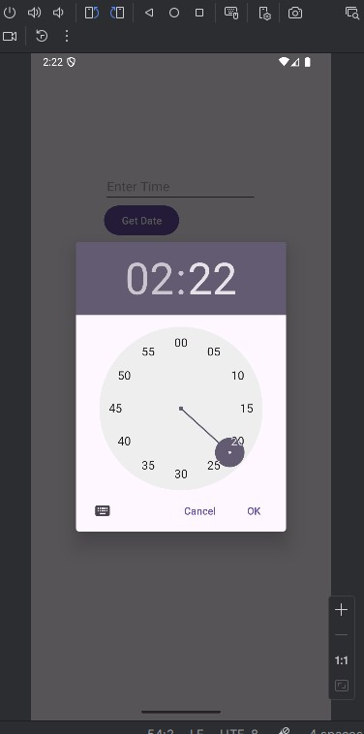

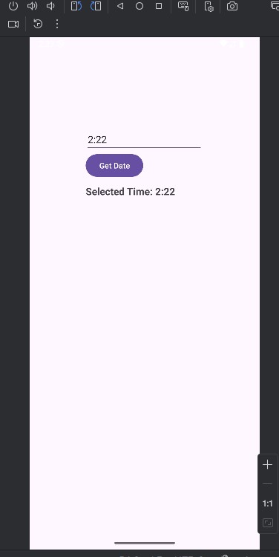

- DatePicker

- Activity_main.xml

<?xml version="1.0" encoding="utf-8"?>
<RelativeLayout xmlns:android="http://schemas.android.com/apk/res/android" android:layout_width="match_parent" android:layout_height="match_parent">
<EditText android:id="@+id/editText1" android:layout_width="wrap_content" android:layout_height="wrap_content" android:layout_marginLeft="100dp" android:layout_marginTop="160dp"
android:ems="10"
android:hint="Enter Time" />
<Button android:id="@+id/button1" android:layout_width="wrap_content" android:layout_height="wrap_content" android:layout_below="@+id/editText1" android:layout_marginLeft="100dp"
android:text="Get Date" />
<TextView
android:id="@+id/textView1" android:layout_width="wrap_content" android:layout_height="wrap_content" android:layout_below="@+id/button1" android:layout_marginLeft="100dp" android:layout_marginTop="10dp"
android:textStyle="bold"
android:textSize="18dp"/>
</RelativeLayout>

- MainActivity.java

package com.examples.datepicker;
import android.app.DatePickerDialog;
import android.os.Bundle;
import android.text.InputType;
import android.view.View;
import android.widget.Button;
import android.widget.DatePicker;
import android.widget.EditText;
import android.widget.TextView;
import androidx.appcompat.app.AppCompatActivity;
import java.util.Calendar;

public class MainActivity extends AppCompatActivity {
DatePickerDialog picker;
EditText eText;
Button btnGet;
TextView tvw;
@Override
void onCreate(Bundle savedInstanceState) { super.onCreate(savedInstanceState); setContentView(R.layout.activity_main); tvw=(TextView)findViewById(R.id.textView1); eText=(EditText) findViewById(R.id.editText1); eText.setInputType(InputType.TYPE_NULL); eText.setOnClickListener(new View.OnClickListener() {
@Override public void onClick(View v) {
final Calendar cldr = Calendar.getInstance();
int day = cldr.get(Calendar.DAY_OF_MONTH);
int month = cldr.get(Calendar.MONTH);
int year = cldr.get(Calendar.YEAR);
// date picker dialog picker = new DatePickerDialog(MainActivity.this,
new DatePickerDialog.OnDateSetListener() {
@Override
public void onDateSet(DatePicker view, int year, int monthOfYear, int dayOfMonth) {
eText.setText(dayOfMonth + "/" + (monthOfYear + 1) + "/" + year);
}
}, year, month, day); picker.show();
}
});
btnGet=(Button)findViewById(R.id.button1);
btnGet.setOnClickListener(new View.OnClickListener() {
@Override public void onClick(View v) { tvw.setText("Selected Date: "+ eText.getText());
}
});
}
}

Output:-

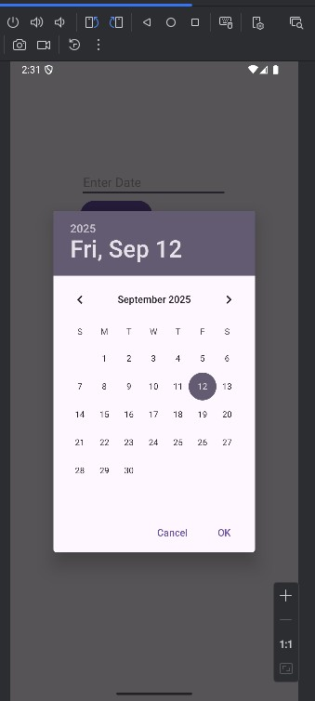

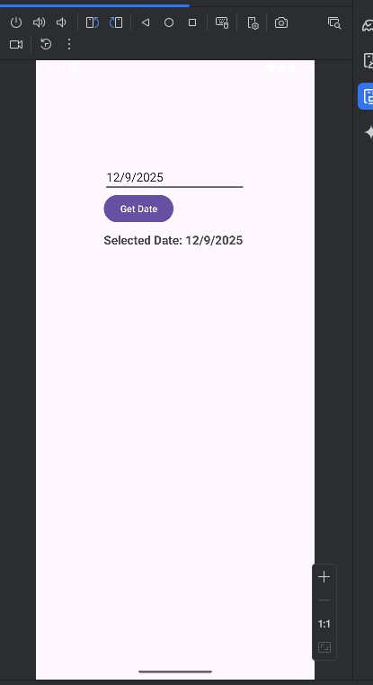

Cognitive  (04) | Psychomotor  Skill (04) | Affective Domain (02) | Total (10) | Sign

