
INVESTOR PRODUCT & TECHNOLOGY DILIGENCE REPORT

UNREAL BS
  - Bangladesh's bilingual business operating system
What the product is, what is live, how it can earn, and what remains to prove
Prepared for: Prospective investors and strategic partners
Snapshot date: 4 August 2026 (Asia/Dhaka)
Evidence base: Current local repository, production HTTP probes, prior release records, and local media inspection
Assessment stage: Working production product with early-commercialization modules; not yet a complete investor data room
Evidence-backed discussion draft. Product claims are separated from concepts, unverified integrations, and management assumptions.

Executive summary
Bottom line UNREAL BS is no longer only a concept deck. It is a production-deployed Next.js application that combines a bilingual business dashboard, GoHighLevel CRM operations, a Supabase-backed money layer, metered multi-provider AI, virtual-card fulfillment, and a managed Meta advertising workflow. However, the repository does not contain verified traction, revenue, customer concentration, legal entity, cap-table, or financial data. It should be presented as an early commercialization opportunity—not as a scaled SaaS business.
The strongest investment case is the integrated operating model: a Bangladeshi business owner can manage customer records, messages, workflow automation, wallet activity, informal credit, AI usage, advertising requests, and—within the local release candidate—digital products from one English/Bangla application. The product is deliberately honest about unavailable modules and degrades to explicit not-connected or coming-soon states instead of presenting fabricated activity.
The principal diligence issue is the difference between three states: (1) production at the committed head, (2) verified local code that is not yet deployed, and (3) product concepts. The new digital-products marketplace is the largest current monetization expansion, but it remains uncommitted and undeployed. Direct Meta publishing, several GHL write capabilities, automatic payments, social publishing, opportunity matching, and business credit are not proven live.
Investor question | Repository-backed answer
What is it? | A bilingual business operating system for Bangladesh, built around CRM, money, AI, ads, and owner workflows.
Is anything live? | Yes. The production domain, authentication boundary, public campaign/application/signup routes, and committed dashboard are live. Several data flows are implemented against GHL and Supabase.
How can it earn? | Founding activation/membership pricing, prepaid AI packages, managed-ad service fees, service-lead conversion, virtual-card fulfillment, and a 10% digital-product commission candidate.
What is not proven? | Traction and revenue, authenticated production journeys in this audit, direct Meta publishing, new commerce migrations, automatic payments, GHL write scopes, and all coming-soon modules.
What should investors fund? | Release evidence, customer onboarding, payment automation, operational controls, security remediation, measurable sales, and a focused Bangladesh go-to-market motion.

Report map
- Company and market thesis
- Product system and user journeys
- Module-by-module current state
- Revenue model and unit economics encoded in the product
- Architecture, security, production evidence, and risks
- Claude design video assessment
- Investor-readiness gaps, roadmap, and decision framing

1. Company and opportunity thesis
UNREAL BS (Business Systems) is positioned as a business operating system for Bangladeshi entrepreneurs and small businesses. The draft investor material identifies the venture under Lifting Up Bangladesh Enterprises (LUBE) and presents BhaiSazzaD as founder. The repository itself does not contain corporate formation documents, ownership records, audited financials, or a specified seed amount; those facts remain management-supplied and require a formal data room.
The product thesis is locally specific: many target businesses operate through WhatsApp, spreadsheets, mobile-wallet transactions, and memory, while mainstream CRMs are English-first and fragmented across sales, finance, automation, and AI. UNREAL BS attempts to compress that stack into one bilingual control surface connected to GoHighLevel and Supabase.

Target users
- Bangladeshi small-business owners who need a mobile-friendly operational dashboard rather than a generic global CRM.
- Service providers and agencies using GoHighLevel sub-accounts for contacts, conversations, funnels, workflows, and agents.
- Sellers who may monetize courses, downloads, consultations, or fixed-price services through mobile-wallet payments.
- Operators administering deposits, virtual cards, advertising campaigns, AI rates, product orders, and payouts.
- Prospective buyers or applicants entering through public landing, application, signup, and storefront flows.

What is differentiated
Differentiator | Why it matters | Evidence level
English/Bangla product shell | The locale is persistent and designed for the operator's working language rather than a translated marketing page. | Verified
GHL plus local money layer | CRM automation is combined with wallet, deposits, Udhar Khata, AI charges, and virtual-card workflows. | Verified
Honest capability states | Disconnected, unavailable, and coming-soon modules are explicitly labeled; fabricated metrics were removed. | Verified
Multi-provider AI economics | Provider costs, markup, prepaid bundles, daily caps, and free allowance are encoded in deterministic logic. | Verified
Bangladesh payment reality | The commerce candidate tells buyers when human TrxID confirmation is required instead of simulating an automatic gateway. | Implemented locally

Market-data boundary No independently validated market size, customer count, MRR, GMV, retention, CAC, LTV, or conversion funnel is present in the repository. Those numbers should not be invented from screenshots or the draft deck.

2. Product system
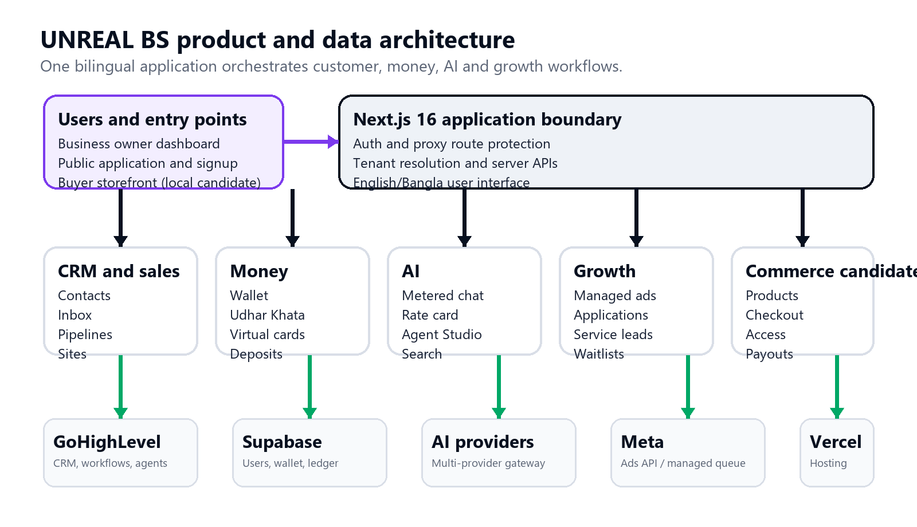
Figure 1. UNREAL BS product and data architecture at the current local snapshot.
The platform is organized around one authenticated owner workspace plus selected public acquisition and buyer routes. Next.js server routes enforce authentication and tenant selection, then call server-only clients for GoHighLevel, Supabase, AI providers, Meta, and supporting tools. This gives the product a coherent owner experience while preserving integration boundaries.

Core product pillars
Pillar | Current product scope
Customer operating system | Control Room, customers, inbox, sales pipeline, sites/funnels, brand board, workflows, and GHL Agent Studio.
Money and trust | Wallet, deposit requests, ledger, Udhar Khata, encrypted virtual-card credentials, AI charges, refund controls, and operator queues.
AI utility | Multi-provider metered chat, search-assisted responses, model rate cards, prepaid packages, free allowance, spend caps, and GHL agent operations.
Growth services | Public application capture, managed Meta advertising workflow, service packs, waitlists, and operator-led onboarding.
Seller commerce candidate | Courses, downloads, services, consultations, storefronts, manual mobile-wallet checkout, payout accounting, and GHL buyer synchronization.

3. End-to-end user journeys
Journey | Connected flow
Owner onboarding | Public signup -> password hashing -> Supabase user -> login -> tenant resolution -> personal wallet/money data -> assigned GHL workspace or explicit not-connected state.
Founding pilot | Public campaign -> eligibility application -> Zod validation -> server-side GHL contact upsert -> additive applicant tags -> manual onboarding.
AI usage | Select model -> estimate worst-case cost -> wallet or free-allowance decision -> provider request -> actual usage charge -> ledger and usage record.
Managed advertising | Create campaign brief -> enforce minimum ad spend -> charge platform service fee from wallet -> queue for operator or direct Meta path when approved -> refund service fee if rejected/fails before fulfillment.
Digital product sale (local candidate) | Seller publishes -> buyer opens public page -> buyer submits mobile-wallet TrxID -> operator confirms -> commission retained -> seller wallet credited -> access token unlocks lesson/download -> buyer optionally synced to seller's GHL location.

Operational reality The platform currently blends software automation with operator-controlled fulfillment. That is commercially acceptable at pilot stage, but investors should model the labor cost, fraud exposure, reconciliation workload, and service-level requirements before extrapolating SaaS margins.

4. Module portfolio and maturity
The status matrix below separates production-connected features from locally implemented release-candidate work and product concepts. 'Verified' means repository implementation plus a relevant local or public check in this review. It does not imply end-to-end financial acceptance testing with real accounts.
Module | State | Evidence and boundary
Control Room | Verified | Live GHL counts when connected; Supabase wallet and Udhar snapshot; explicit null state on failures.
Customers / Inbox / Pipeline / Sites | Partially verified | Typed GHL wrappers and per-tenant location boundary. Authenticated live data was not re-tested in this audit.
Agent Studio | Partially verified | Prior production read/analytics returned one Voice AI agent; write scopes were historically unavailable.
Wallet / deposits / ledger | Verified | Supabase-backed balance and request paths with atomic database guards; local tests/build passed.
Udhar Khata | Verified | Persisted informal-credit entries and attributed payments, scoped by user.
AI subscriptions | Verified | Multi-provider adapters, rate card, packages, daily cap, free allowance, usage billing, and admin controls.
Virtual cards | Partially verified | Inventory/order/admin flow and encrypted credential handling exist; real fulfillment was not exercised.
Managed Meta ads | Partially verified | Campaign and fee logic exist; direct publishing remains gated by platform approval and was not exercised.
Founding application | Partially verified | Public route is live and invalid payload validation is historically verified; this audit did not create a real CRM contact.
Digital products / courses | Implemented locally | Full local feature set, 3 new test files, two migrations, build success; uncommitted, unmigrated, and not deployed.
400 Services | Limited | Static lead-generation catalog currently contains 10 starter service packs that link into the application flow.
Integrations | Limited | Curated links into GHL integration settings; no in-app OAuth or stored connection status.
Social Market | Coming soon | All platforms disconnected, publishing disabled, and post history empty by design.
Agentic HQ / Skills / Clan | Coming soon | Honest waitlist screens replaced fabricated activity, installations, and membership revenue.
Opportunities / Credit Center / MeetAlly | Coming soon | Waitlist/partner positioning only; no live opportunity marketplace, underwriting, or in-product marketplace.

Local release candidate versus production
Snapshot | Size | Meaning
Committed head / origin main | 39 page files, 35 API route files, 12 migrations | This is the repository state aligned to commit 5a937e3 and the current production behavior.
Current local worktree | 49 page files, 50 API route files, 14 migrations | Includes the uncommitted digital-products, storefront, orders, payouts, and wallet-sign-guard candidate.
Pre-report Git state | 5 modified files and 24 untracked implementation paths | The commerce expansion is not a releasable artifact until reviewed, committed, migrated, and deployed.

5. Revenue model and encoded economics
The repository contains several monetization mechanisms. Some are live software logic, some are current management pricing, and some are prospective. Revenue claims should be tied to actual ledger and bank evidence before investor use.
Revenue stream | Commercial rule | Evidence / caveat | State
Founding activation | BDT 4,999 one-time | Displayed on the public campaign page; no transaction evidence reviewed. | Management pricing
Founding membership | BDT 6,999 monthly | Displayed on the public campaign page; automated subscription collection is not evidenced. | Management pricing
AI Starter | Pay 699 -> 720 wallet credit | Uniform 1.45x model markup; encoded maximum provider-cost cap approximately BDT 496.55. | Implemented
AI Growth | Pay 999 -> 1,150 credit | Encoded cost cap approximately BDT 793.10. | Implemented
AI Pro | Pay 1,999 -> 2,600 credit | Encoded cost cap approximately BDT 1,793.10. | Implemented
Managed ads | 15% of ad spend | Fee floor BDT 199, cap BDT 2,999, and minimum managed spend BDT 1,000. Ad spend itself goes to Meta. | Implemented
Digital products | 10% commission | Candidate floor BDT 10, cap BDT 2,000; paid price minimum BDT 50; free products allowed; minimum payout BDT 500. | Implemented locally
Service projects | Starting prices BDT 7,500-25,000 | Ten starter packs route to an application; no booking, contracting, or recognized-revenue ledger reviewed. | Lead-generation concept
Virtual cards | Operator-set inventory economics | Fulfillment workflow exists, but no investor-grade margin schedule or transaction sample was reviewed. | Partially verified

Unit-economics strengths
- AI bundle exposure is bounded by a uniform provider-cost markup and a pessimistic pre-flight cost estimate.
- Managed-ad fees are separated from media spend, with a minimum viable spend and automatic service-fee refund path.
- Digital-product commission and seller payout are computed from one shared function and constrained so the split equals the sale price.
- The commerce candidate collects buyer funds at the platform before seller wallet credit, making commission collection structural rather than optional.

Unit-economics unknowns
- No actual revenue, gross margin, support cost, refund rate, fraud rate, payment failure rate, or provider invoice was provided.
- Manual mobile-wallet confirmation adds labor and reconciliation cost that is not included in the software margin formulas.
- FX basis and provider pricing can change; the AI rate card needs ongoing administrative review and invoice reconciliation.
- Service-project prices and the draft marketplace narrative are not evidence of booked or recurring revenue.

6. Technology architecture
Layer | Implementation
Application | Next.js 16.2.11 App Router, React 19.2.4, TypeScript 5, Tailwind CSS 4
Authentication | NextAuth v5 credentials with JWT sessions; bcrypt for registered users; environment-configured operator fallback
Primary data systems | GoHighLevel for CRM/automation; Supabase/Postgres for users, wallet, ledger, Udhar, AI, cards, ads, waitlists, and commerce candidate
AI layer | OpenAI, Anthropic, Google, Moonshot, OpenRouter, Cohere, Cerebras, Cloudflare, Hugging Face, plus Tavily search and client-side Puter surfaces
Hosting | Vercel production deployment; canonical host www.unreal-bs.shop
Front-end systems | Custom UI primitives, Framer Motion, Recharts, React Query, Zustand, bilingual dictionaries and persistent locale
Local release scope | Manual payment-provider abstraction, private Supabase storage, signed downloads, product/course engine, seller stores, orders, payouts

Architectural strengths
- GHL tokens and location IDs are used server-side; the generic proxy is authenticated and allowlisted.
- Tenant resolution prevents a registered user from silently inheriting the operator's shared GHL location.
- Money-critical logic is extracted into deterministic functions and database constraints rather than duplicated in UI components.
- Public storefront access is designed around published-product checks and per-order UUID access tokens; paid downloads receive 60-second signed URLs.
- External integrations are designed to fail without pretending success: GHL buyer sync is non-blocking after a sale, and unavailable features show explicit states.

7. Security, reliability, and compliance posture
Area | Current control | State
Route access | Auth proxy redirects protected requests; public routes are explicit; live headers include HSTS, X-Frame-Options DENY, no-sniff, and restricted camera/microphone/geolocation. | Verified
Tenant isolation | Per-user GHL location lookup; money tables scoped to the resolved user; no default workspace for non-admin users. | Verified
Input validation | Zod schemas and allowlisted upstream paths are used on public and integration endpoints. | Verified
Secret handling | Server-only environment variables; card credentials use a dedicated encryption key; no secret values were included in this report. | Partially verified
Database controls | Fourteen local migrations include RLS, uniqueness/check constraints, and money guards; two commerce migrations are not deployed. | Partially verified
Abuse controls | Login rate limiting fails closed; AI daily spend cap and free limits reduce runaway cost. | Verified
Dependency posture | Current production dependency audit reports five vulnerabilities: three high, one moderate, and one low; remediation requires compatibility review. | Risk
Observability | DB-backed error logging exists, but no externally verified incident monitoring, alerting, SLO, or uptime history was reviewed. | Limited

Security priority Do not run an automatic force-upgrade to clear the audit report without a controlled Next.js 16 compatibility review. The correct investor-readiness milestone is a tested dependency remediation, refreshed build, route smoke test, and documented residual-risk decision.

8. Verification evidence
Check | Result | Exact scope
Type checking | PASS | npm run typecheck; TypeScript completed with exit code 0.
Lint | PASS with warnings | 0 errors; warnings for a raw avatar <img> and one unused Meta client parameter.
Unit tests | PASS | 105 tests across 6 files; includes pricing, ad-fee, campaign, digital-product, publish-rule, and video-URL logic.
Production build | PASS | Next.js 16.2.11 optimized build completed; current worktree produced 31 static pages and all dynamic routes.
Dependency audit | FAIL threshold | Five production dependency vulnerabilities reported, including three high-severity advisories.
Browser / responsive | Not run | No authenticated visual walkthrough, keyboard audit, or multi-width browser acceptance was completed in this review.
Live integrations | Limited | Public HTTP behavior was checked; authenticated GHL, Supabase money, Meta publishing, and payment operations were not executed.

Live production probes on 4 August 2026
Route | HTTP | Interpretation
unreal-bs.shop | 308 | Redirected permanently to the www canonical host.
www.unreal-bs.shop/ | 307 | Redirected unauthenticated request to /login?callbackUrl=/ with security headers.
/login, /unreal-bs, /apply, /signup | 200 | Public authentication, campaign, application, and signup pages are reachable.
/opportunities and /products | 307 | Protected routes redirect to login as expected.
/p/not-a-real-product | 307 | Production still protects the storefront route, confirming that the local commerce proxy changes are not deployed.

Important limitation A green build and public redirects do not prove authenticated dashboards, real money movement, CRM writes, Meta publication, seller payouts, or database migrations. Those require approved test accounts and controlled end-to-end evidence.

9. Claude design video asset
The local workstation contains a branded UNREAL BS video named 'Coming Soon - Unreal BS.mp4'. A verified copy is included beside this report as UNREAL-BS-Claude-Design-Teaser.mp4.
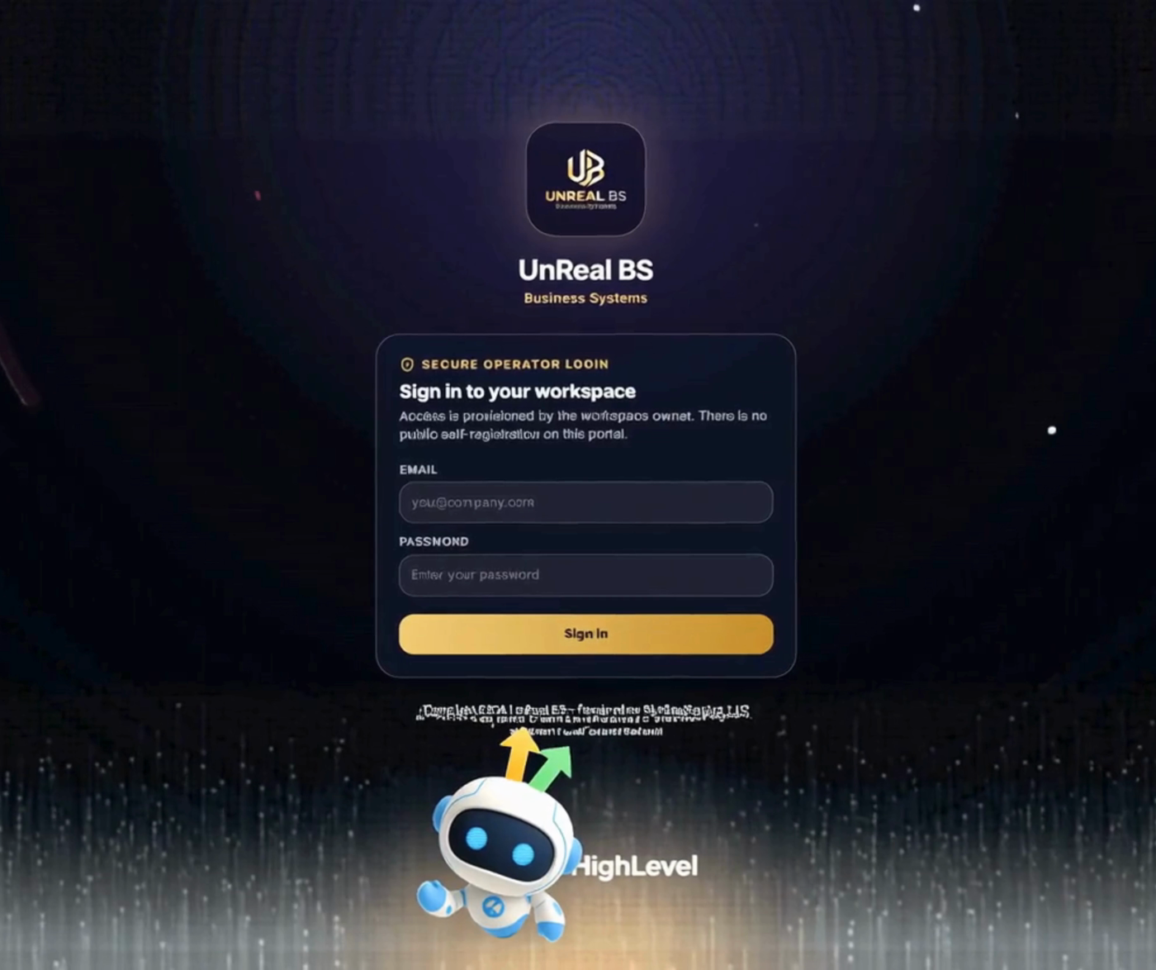
Figure 2. Still from the locally found Claude design teaser. It presents the secure operator-login screen, UNREAL BS branding, and HighLevel attribution.
Attribute | Finding
Source found | C:\Users\user\Downloads\Coming Soon - Unreal BS.mp4
Duration | 6.653 seconds
Video | H.264 High profile, 3144 x 2636, 30 fps, BT.709
Audio | AAC-LC, mono, 48 kHz
File size | 11,216,027 bytes (about 10.7 MiB)
Content assessment | Short branded motion teaser focused on the login screen; not a feature walkthrough or investor film.
Best use | Coming-soon/social teaser, title bumper, or visual reference for a longer investor video.

Video recommendation
For investor use, extend the asset into a 60-90 second product story with only verified flows: the founder problem statement, bilingual Control Room, real customer/CRM records with permission, wallet and AI metering, managed-ads request, and the local commerce journey after deployment. End with traction, round size, and milestone use of funds. Do not use old dashboard numbers or the current draft deck's placeholder raise amount as evidence.

10. Investor-readiness gaps
Diligence area | Gap | Priority
Traction | No verified active users, paying customers, MRR, ARR, GMV, retention, conversion, pipeline, or customer references. | Critical
Fundraise | Seed amount is a placeholder; valuation, instrument, runway, and use-of-funds budget are absent. | Critical
Corporate | No entity documents, cap table, IP assignments, employment/contractor agreements, or board approvals reviewed. | Critical
Financial | No bank statements, management accounts, provider invoices, reconciliation samples, forecasts, or tax treatment. | Critical
Product release | Commerce candidate is uncommitted, migrations are undeployed, and production storefront remains protected. | High
Security | Five dependency vulnerabilities; no pen test, backup/restore evidence, incident runbook, or production access review in this audit. | High
Integration authority | GHL write scopes, Meta approval/direct publishing, payment gateway, and real provider configurations are not fully evidenced. | High
Operations | Manual payment confirmation, card fulfillment, ad operations, refunds, and payouts need owner, SLA, fraud, and reconciliation procedures. | High
Documentation | README and designer handoff contain stale statements about single-admin/no-database/no-tests and older feature status. | Medium
Investor collateral | The local HTML deck references missing runtime assets, contains a seed-amount placeholder, and includes claims/metrics without a diligence appendix. | Medium

Required investor data room
- Corporate: incorporation, cap table, founder/contractor IP assignments, material contracts, and current liabilities.
- Commercial: customer list, signed contracts, invoices, bank receipts, monthly cohort retention, pipeline stages, and customer references.
- Financial: historical P&L/cash flow, 24-month forecast, provider costs, support/operations costs, tax/VAT treatment, and runway model.
- Product: production architecture, environment inventory without secret values, release history, integration scopes, backups, incident response, and dependency remediation.
- Compliance: privacy policy implementation, data-processing map, payment and advertising terms, user-consent evidence, and local legal review.
- Fundraise: instrument, target amount, valuation/cap, allocation by milestone, hiring plan, and measurable 12-18 month outcomes.

11. Recommended 180-day roadmap
Horizon | Objective | Exit evidence
0-30 days | Release and evidence | Review/commit commerce, stage migrations, fix dependency risks, deploy, run full buyer/seller/admin acceptance, reconcile one controlled transaction, and update all documentation.
31-60 days | Commercial proof | Onboard a narrow founder-led cohort, instrument activation and retention, collect payment evidence, calculate true support cost, and secure customer references.
61-90 days | Operational leverage | Automate payment verification where legally/contractually possible, define refund/payout SLAs, strengthen monitoring, and validate GHL/Meta scopes.
91-180 days | Repeatable growth | Prove one repeatable acquisition channel, demonstrate recurring AI/membership revenue, expand only the modules with measured adoption, and prepare an investor data room.

Use-of-funds logic
Because the round size is not specified, the correct presentation is milestone-based rather than percentage theater. Priority order should be: (1) release/security and production evidence, (2) customer success and operator capacity, (3) payment and reconciliation automation, (4) focused sales acquisition, and (5) only then broader ecosystem modules. Funding Agentic HQ, Clan, Skills, Credit Center, and social publishing simultaneously would dilute proof before the core revenue engine is measured.

12. Investment framing

Why the opportunity is credible
- The product is operational software, not only a pitch: the production domain, application shell, integration boundaries, money primitives, and AI billing logic exist.
- Localization goes deeper than translated copy: tenant behavior, Bangla UI, mobile-wallet workflows, Dhaka-day spend limits, and operator-led fulfillment reflect the target market.
- The codebase shows repeated correction of fabricated states, cross-tenant leakage risks, money leaks, and silent failures—evidence of maturing product discipline.
- There are multiple monetization levers inside one customer relationship, allowing expansion from software to usage, managed services, and transaction revenue.

Why an investor may wait
- No verified commercial traction or historical financial performance was provided.
- Several high-value flows depend on manual operators, external approvals, or scopes that were not proven in this review.
- The largest new commerce feature is still a local candidate, and current production behavior proves it has not launched.
- Security dependencies, documentation drift, lack of end-to-end acceptance evidence, and missing data-room materials add diligence friction.
Recommended round narrative Present UNREAL BS as a product-complete, early-commercialization platform seeking capital to turn integrated software into repeatable revenue and audited operations. Do not present it as a mature all-in-one ecosystem or use coming-soon modules to inflate current scope.

Pre-investment milestone gate
- Deploy and verify the digital-products release with one controlled paid transaction and full reconciliation.
- Provide three to five referenceable paying customers and a monthly cohort table.
- Close or formally accept the production dependency risks and publish a security/release evidence pack.
- Document gross margin by revenue stream, including operator labor and provider costs.
- Specify the legal entity, cap table, round instrument, amount, runway, and use-of-funds milestones.

Appendix A. Evidence ledger
ID | Source | Used for
E1 | package.json; local typecheck/lint/test/build output | Stack, scripts, 105-test result, build status
E2 | auth.ts; proxy.ts; lib/tenant.ts | Authentication, public routes, tenant isolation
E3 | lib/ghl/*; app/api/agent-studio/route.ts | GHL server integration and Agent Studio boundary
E4 | supabase/migrations/0001-0014 | Users, wallet, AI, cards, waitlists, ads, commerce, RLS and constraints
E5 | lib/pricing.ts; lib/meta/service-fee.ts; lib/commerce/pricing.ts | AI, ads and commerce economics
E6 | Git HEAD/status and origin-main comparison | Production-aligned commit versus dirty local release candidate
E7 | Direct HTTPS probes on 4 August 2026 | Canonical domain, public route availability and auth redirects
E8 | Local ffprobe metadata and inspected video frames | Claude design teaser identity, duration, format and content
E9 | public/investor-deck/index.html | Draft founder/problem/revenue narrative; placeholder raise amount and incomplete runtime
E10 | Prior release verification record dated 24 July 2026 | Historical Agent Studio production read/analytics and unavailable write scopes

Appendix B. Environment and integration inventory
Area | Variable names / group | Purpose
Identity | ADMIN_EMAIL, ADMIN_PASSWORD, AUTH_SECRET | Operator fallback and session signing
GoHighLevel | GHL_PRIVATE_TOKEN, GHL_LOCATION_ID | CRM, workflows, sites, contacts, agents
Supabase | SUPABASE_URL, SUPABASE_SERVICE_ROLE_KEY | Application data and server-side admin access
AI providers | OpenAI, Anthropic, Google, Moonshot, OpenRouter, Cohere, Cerebras, Cloudflare, Hugging Face | Provider-specific runtime access
Search | TAVILY_API_KEY | Search-assisted AI responses
Sensitive credentials | CARD_CREDENTIAL_ENC_KEY | Virtual-card credential encryption
Meta | META_APP_ID, META_APP_SECRET, META_API_VERSION, META_ADS_MANAGEMENT_APPROVED | Campaign integration and approval gate
Commerce candidate | PLATFORM_BKASH_NUMBER, PLATFORM_NAGAD_NUMBER, PLATFORM_ROCKET_NUMBER, PAYMENT_GATEWAY_ENABLED | Buyer payment instructions and gateway state

Secret-handling note This report lists variable names only. No token, password, encryption key, location ID, account number, or service-role value was copied into the document.

Appendix C. Final diligence interpretation
This report is a product and technology assessment, not a legal opinion, valuation, market-sizing study, financial audit, penetration test, or confirmation of customer revenue. Its claims are limited to the inspected local repository, direct public HTTP responses, the available prior release record, and the verified local media asset as of the snapshot date.
The most decision-useful next step is a management session that fills the missing commercial and corporate evidence while engineering completes the release and security gate. Once those two tracks converge, the current draft HTML pitch can be replaced with a shorter, metric-backed investor deck derived from this report.

