

Concepts and Technologies of AI-5CS037

“Statistical Interpretation and Exploratory Data Analysis on HDI Dataset”

Uni ID: 2462305
Submitted by: Aashutosh Bakhrel
Lecturer: Ms. Sunita Parajuli
Tutor: Ms. Sunita Parajuli
Submitted on: 01/10/2026

Table of Contents
- Introduction
2. Problem 1A – Single Year HDI Exploration
3. Problem 1B – HDI Trend Analysis (2020–2022)
4. Problem 2 – Advanced HDI Exploration
5. Problem 3 – Comparative Regional Analysis
6. Conclusion
7. References
8. Appendix

Table of Figures
Figure 1 : HDI of Nepal, India, China, United States and Germany, 2020-2022 10
Figure 2 : Average HDI by Region, 2020-2022 11
Figure 3 : Human Development Index Distribution, 2020-2022 12
Figure 4 : HDI and the GNI per Capita (2020-2022) Relationship 13
Figure 5 : 5 South Asian Countries with the highest Composite Development Score (2022) 16
Figure 6 : HDI vs GNI per Capita: Outlier Detection, South Asia, 2022 17
Figure 7 : Relationship Life Expectancy and HDI 18
Figure 8 : GDI Index vs HDI 19
Figure 9 : The 3 Top Positive and Negative GNI-HDI Gaps in South Asia 20
Figure 10 : South Asia vs Middle East (Average HDI, 2020-2022): Top and Bottom HDI Performers. 23
Figure 11 : Development Metrics: South Asia vs Middle East (2020-2022 Averages) Comparison 24
Figure 12 : HDI vs Gender Development in South Asia 25
Figure 13 : HDI vs Life Expectancy in South Asia Region 25
Figure 14: HDI vs Gender Development in Middle East 26
Figure 15 : HDI vs Life Expectancy in Middle East 26
Figure 16 : HDI vs GNI per capita outlier detection. This scatter diagram was applied to check the outliers. No outliers were detected in South Asia. 27
Figure 17 : HDI vs. GNI per Capita Outlier Detection This scatter diagram is applied to detect an anomaly in which the economic output of a country (gross national income per capita) is not consistent with human development. The figure shows certain outliers especially in the Middle East where some countries show extreme income levels which may not be fully reflected on the education or health scores. 28

Introduction
The measure that is used to compare the levels of development of different countries, is commonly known as HDI (Human Development Index). It not only focus on income of citizens and overall country but also on health and education sectors. HDI helps people and bureaucrats understand how well people are living and their happiness to some extent, in different countries.
The goal of this report is to analyze and study the HDI data provided by UNDP (United Nations Development Program) and find patterns and differences between different countries and regions around the earth. The analysis here mainly focuses on years 2020 to 2022. This timeline was chosen because many countries were affected by the COVID-19 pandemic.
We have covered four main problems. Studying HDI of one single year, analyzing HDI trends over the period of years, exploring HDI in south Asian countries, and comparing the data of South Asia with middle east. The Jupiter notebook contains all codes and calculations, and this report discusses the results and findings.

Problem 1A – Single Year HDI Exploration
Methods / Approach
The dataset on Human Development Index (HDI) was employed to analyze the level of development in one year. The first step was to load and check the data to get acquainted with its structure and available variables. A year was selected on which I would have a dedicated analysis.
Attention was paid to the most important variables such as country name, HDI value, life expectancy, and gross national income per capita. In order to clean the data, I ensured that I verified the missing values and dropped incomplete records.
The data was ranked according to the HDI values to indicate the low and the high scoring countries.
Simple summary statistics was used to determine minimum, maximum, and average HDI to have a general idea about the distribution of development that year.
Key Results
The analysis revealed that there was a significant disparity in the values of the HDI as it was observed among countries. There were a few nations which had extremely high HDI scores and this implies high health, education and income performance. Conversely, some countries were significantly lower in terms of HDI values and this presents a challenge in basic development indicators.
The findings also indicated that general average of HDI was middle level though there was also a large disparity between the top most and the lowest countries with regard to HDI. This brings out the disparate state of human development in the world.
Visualizations and Tables
The best and the worst countries in terms of HDI values of the chosen year were presented in the form of tables. The high and the lowest countries in terms of human development could be identified well with the assistance of these tables.
Bar charts were developed to make a visual comparison of the HDI of countries. These charts enabled easier observation of the differences in the development levels, as well as to notice how drastically HDI decreases between the countries with a high level of performance and to those with low performance.
Discussion and Interpretation
Higher HDI usually results in the countries being of good health care, more life expectancy, greater access to education, and increased income. Combined together, these factors help to develop living conditions and human development in general.
Low HDI countries are usually associated with issues of poverty, the lack of access to education, the moribund healthcare systems, and lower earnings. Such problems decrease the quality of life in general and decelerate the progress.
On the whole, the findings of this one-year study indicate that not all countries are equipped with human development. There are still considerable gaps, which makes it evident that special developmental policies and international assistance to countries where the performance is lower are required.

Problem 1B - HDI Trend Analysis (2020-2022)
Methods / Approach
In this issue, HPI was narrowed down to cover the years 2020, 2021 and 2022. Other columns like country, year, and HDI were observed and cleaned where there was an absence of values. The rows with duplicated data were deleted to make a proper analysis.
Given that the dataset lacked a column of region, the regions were formed manually through mapping nations with their regions. The purged data was stored and it was to be used throughout the analysis in this problem. The aggregation and grouping were done based on country, region, and year to analyse the trends in the HDI with time.
Key Results
This analysis revealed that in the course of the three years the HDI values of most countries were comparably stable with minor increases or decreases. It was found that in some countries, HDI improved by 2022 but in other countries, it decreased during the pandemic years.
On a regional basis, it was revealed that developed regions like Europe and North America had always had high average HDI value and those regions such as Sub-Saharan and South Asia had lower average HDI values.
Visualizations and Tables
HDI trends of countries of choice between 2020 and 2022 were presented using line charts. Bar graphs have been drawn to compare average values of HDI by region in each of the years. The distribution of HDI values in every year was depicted by use of box plots. The relationship between GNI per capita and HDI was studied by a scatter plot.
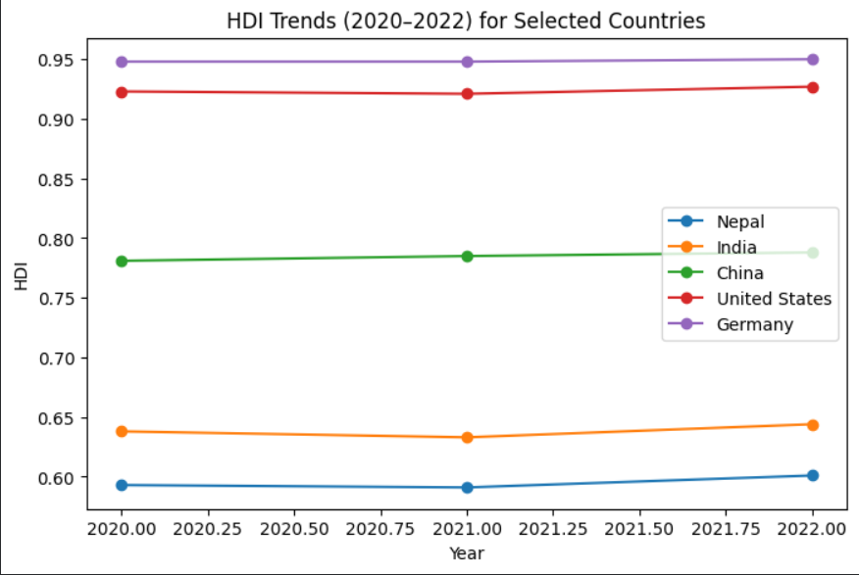
Figure 1 : HDI of Nepal, India, China, United States and Germany, 2020-2022
Figure 1 shows the trends of HDI of selected countries in three years. The HDI rating is not changing significantly, and slight gains have been realized in most nations by 2022. The value of HDI is always high in developed countries like Germany and the United States than in developing countries like Nepal and India.

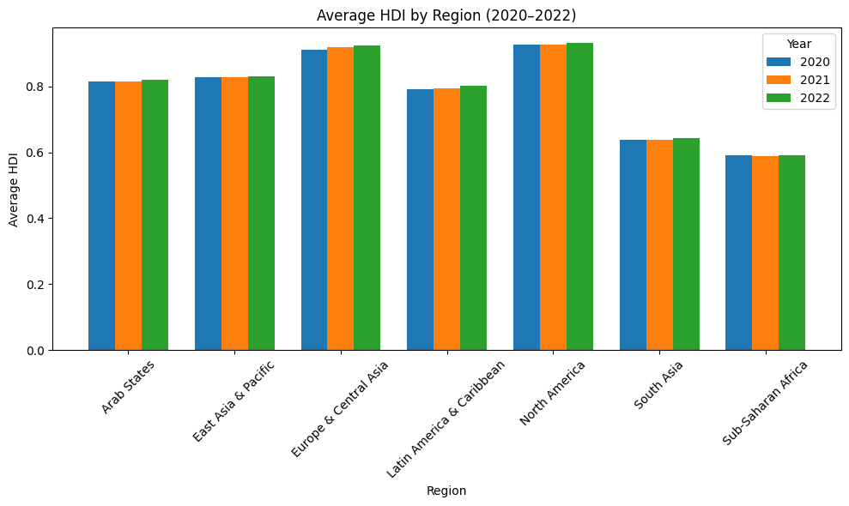
Figure 2 : Average HDI by Region, 2020-2022
Figure 2 provides a comparison between the average HDI values across regions in three years. North America and Europe & Central Asia always have the mean HDI at the highest whereas Sub-Saharan Africa has the lowest. The HDI is slightly yet consistently improving in most regions between 2020 and 2022.
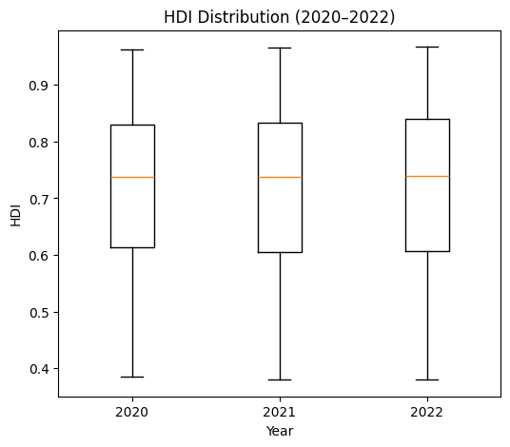
Figure 3 : Human Development Index Distribution, 2020-2022
The distribution of values of HDI in the year 2020, 2021 and 2022 is depicted in figure 3. The median HDI is gradually improving, and this shows that the world is slowly becoming much better in human development. The HDI values continue to spread in the same way in the three years, and this implies that during the three years inequality between countries did not alter considerably.

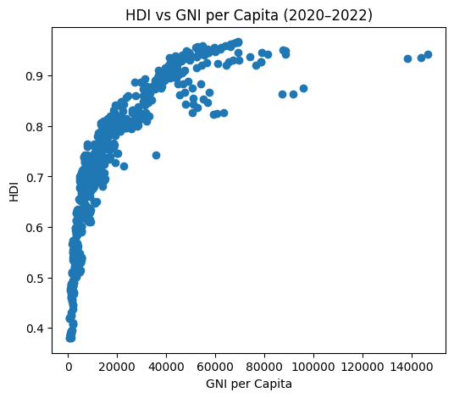
Figure 4 : HDI and the GNI per Capita (2020-2022) Relationship
Figure 4 shows that the positive relationship between GNI per capita and HDI is strong. The more a country is income earners; the higher the HDI of that country is. Nevertheless, certain nations seem like outliers, which demonstrates that high income does not necessarily imply similar high human development results
Discussion and Interpretation
According to the findings, the COVID-19 pandemic negatively affected the development of humans in most countries and particularly in the year 2020 and 2021. Problems with health, school shutdowns, and economic difficulties helped to decrease or reduce the growth of HDI. The fact that it improved in 2022 shows that there was some recovery given that countries adjusted, and economies were opened.

Problem 2 - Advanced HDI Exploration
Methods / Approach
In this issue, the discussion was done in reference to South Asian nations. A sample of the data was made up of a list of South Asian countries and saved by a predefined name as a different CSV file. A composite development score was developed by taking the normalized life expectancy and gross national income per capita.
Calculation of outliers was carried out on the basis of 1.5 x IQR of HDI and GNI per capita. The relationship between the HDI and the various indicators including life expectancy and gender development had been studied using Pearson correlation. The gap calculated between GNI-HDI was also taken to compare the economic performance and human development.
Key Results
The ranking of the composite development score was different as compared to the HDI ranking of certain countries. Even when the HDI of countries was low, there was also better ranking on the composite score especially in countries with higher income. There were no significant outliers between countries of South Asia.
Life expectancy was revealed to be positively correlated with HDI and gender development was a weaker correlation. The GNI-HDI gap analysis demonstrated that inability of certain countries to live on higher income than expected came at a lower HDI than anticipated.
Visualizations and Tables
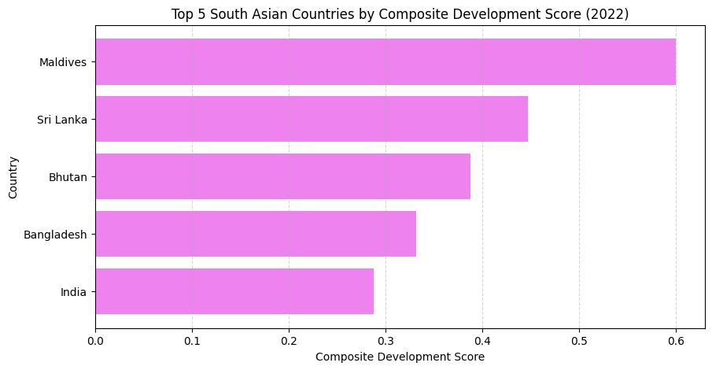
Figure 5 : 5 South Asian Countries with the highest Composite Development Score (2022)
The top five South Asian countries with respect to a composite score of development which is based on normalizing life expectancy and GNI per capita appear in Figure 5. Maldives is the top performing country despite Sri Lanka and Bhutan coming in second and third respectively. The ranking is contrary to regular HDI rankings, which means that other composite measures may give supplementary information about the development performance. This underscores the need to have numerous indicators in place of just looking at HDI in the assessment of human development.
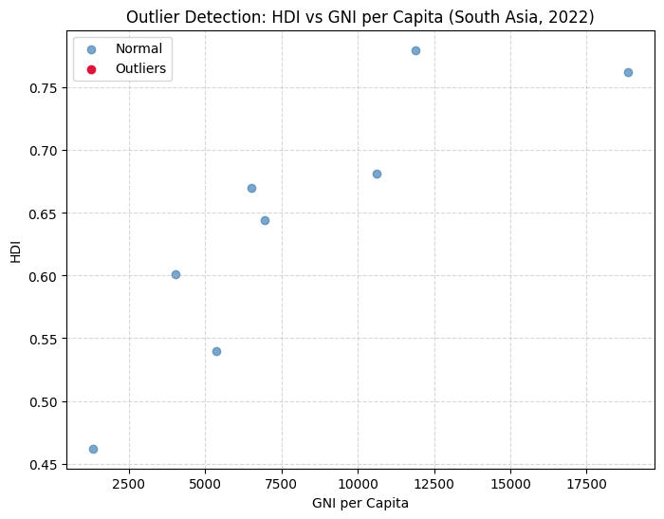
Figure 6 : HDI vs GNI per Capita: Outlier Detection, South Asia, 2022
Figure 6 shows how much the South Asian countries related to Gross National Income (GNI) per capita and Human Development Index (HDI) were in 2022, and the outliers were determined by applying the Interquartile Range (IQR) method. Most of the countries have a positive correlation, meaning that the more the income level is increased the higher the level of HDI is. There are no extreme outliers that are observed in this area and this means that the level of income and human development is relatively steady in South Asia and no abnormal deviations. This implies that in South Asian, HDI disparity is mostly consistent with discrepancies in incomes, but cannot be associated with outstanding economic or developmental exceptions.
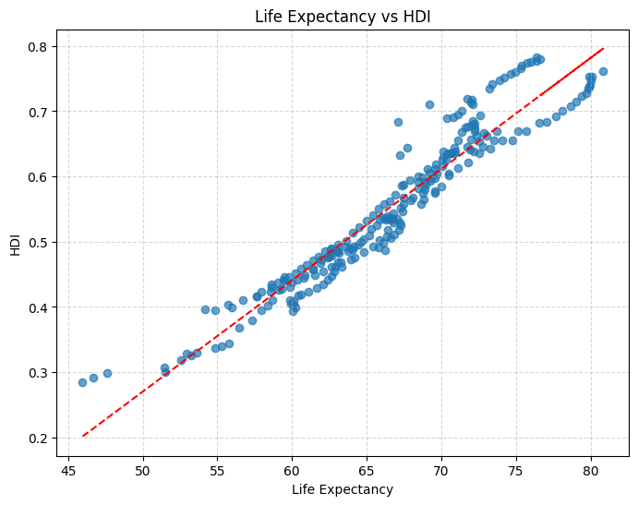
Figure 7 : Relationship Life Expectancy and HDI
Figure 7 indicates that Life expectancy and HDI have a strong positive relationship among countries. With the increase in life expectancy, the values of HDI also grow steadily, which proves the fact that the human development depends on the health outcomes to a large scale. This close correlation is supported by the fitted trend line, which shows that those countries which have higher average lifespan are more likely to experience higher levels of overall development. This finding supports the value of healthcare access and life expectancy in enhancing human development outcomes especially in developing countries like South Asia.
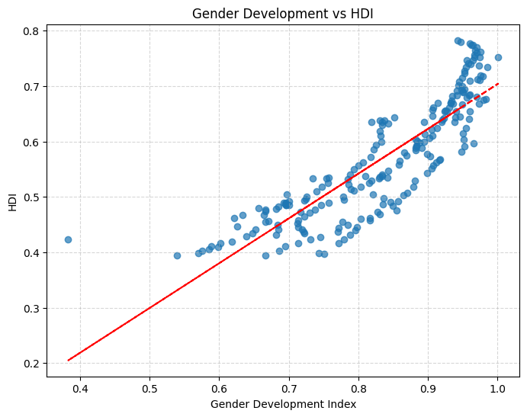
Figure 8 : GDI Index vs HDI
Figure 8 shows the correlation between the index of Gender development (GDI) and HDI. The positive trend suggests that the more gender equality the country has the higher the value of the HDI is. Nevertheless, the points are dispersed around the trend line, which indicates that the correlation is not as strong as that which was observed between life expectancy and HDI. This means that the role of gender development in human development is also achieved but its effects are moderated by other social and economic factors.
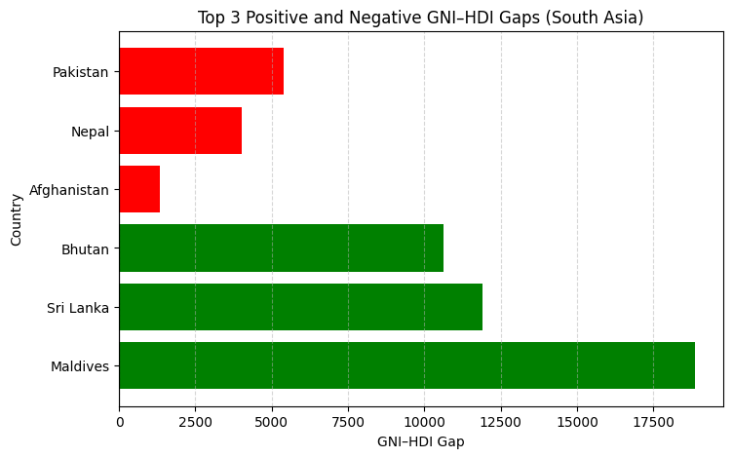
Figure 9 : The 3 Top Positive and Negative GNI-HDI Gaps in South Asia
The three highest positive and negative GNI-HDI gaps of the South Asian countries have been compared in Figure 8. Positive gaps (the green ones) are those in which countries have a higher performance in HDI than it would be given their income levels, e.g. Maldives and Sri Lanka, which means that social development is efficient in spite of income limitations. Negative gaps (in red), which are witnessed in countries including Pakistan and Afghanistan, indicate where there is failure of economic output in translating into human development adequately. This discussion shows that income is not a sufficient condition to have a high level of human development.

The bar charts were horizontal to present the top countries with the highest composite score. Correlations between HDI and other indicators were presented in scatter plots with trendlines. Positive and negative GNI-HDI gaps were also demonstrated by the use of bar charts.
Discussion and Interpretation
This is due to the fact that the HDI has education whereas the composite score does not. The results of the correlation indicate that health is a significant factor in the human development in South Asia. The GNI-HDI gap shows that the growth in the economy is not the only indicator that can show the rise in general human well-being.

Problem 3 Comparative Regional Analysis South Asia vs Middle East
Methods / Approach
The HDI data on South Asia and the Middle East were compared in 2020 and 2022 to identify the issue. Data in each region was extracted into separate datasets based on a preexisting country list. The descriptive statistics like mean, standard deviation, range, and coefficient of variation were calculated.
Gender development, life expectancy and GNI per capita between regions were also compared in the analysis. Both regions were analyzed with correlation analysis and the outlier by using the IQR method.
Key Results
In all the three years, the Middle East was above South Asia in terms of average HDI. It also had higher divergence in the HDI values. Middle East was doing better concerning income, whereas health and gender development disparities were minor.
The analysis of the correlation revealed that HDI and life expectancy were strongly related in both regions with a positive correlation. The outlier was used to detect the countries having extreme income or level of development and particularly in the Middle East.
Visualizations and Tables
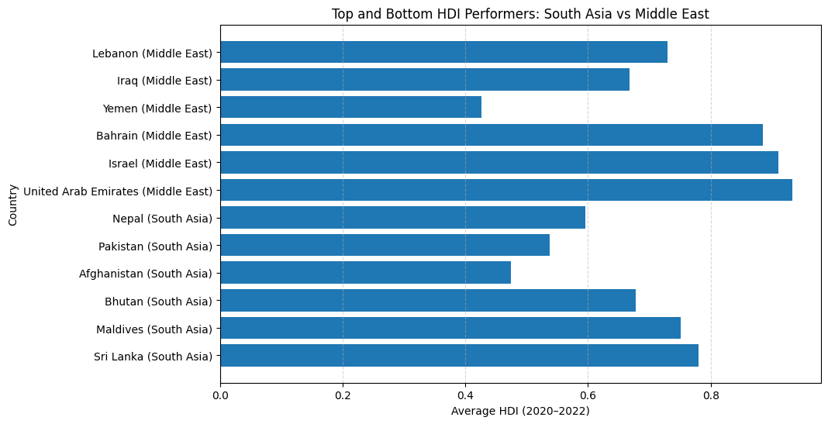
Figure 10 : South Asia vs Middle East (Average HDI, 2020-2022): Top and Bottom HDI Performers.

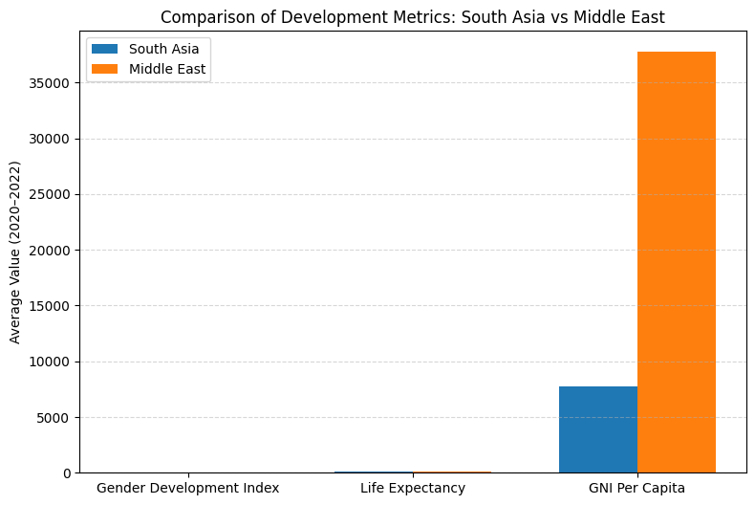
Figure 11 : Development Metrics: South Asia vs Middle East (2020-2022 Averages) Comparison
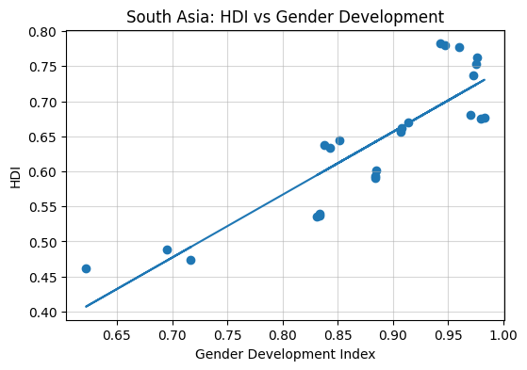
Figure 12 : HDI vs Gender Development in South Asia
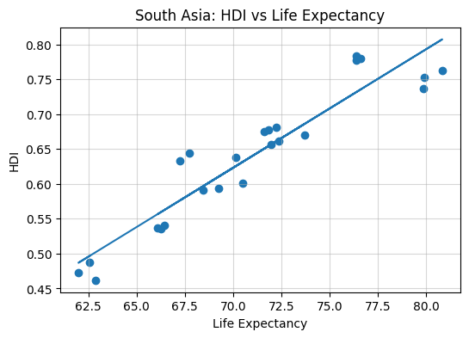
Figure 13 : HDI vs Life Expectancy in South Asia Region
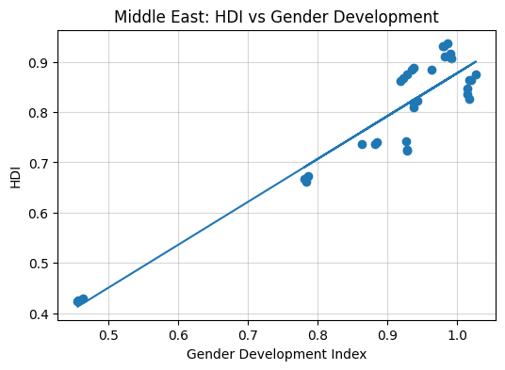
Figure 14: HDI vs Gender Development in Middle East
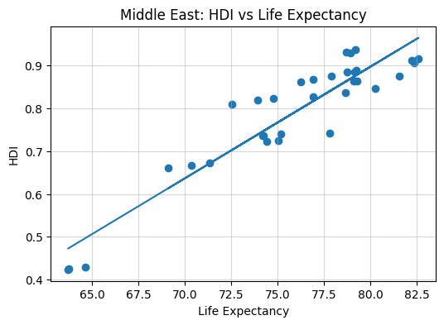
Figure 15 : HDI vs Life Expectancy in Middle East
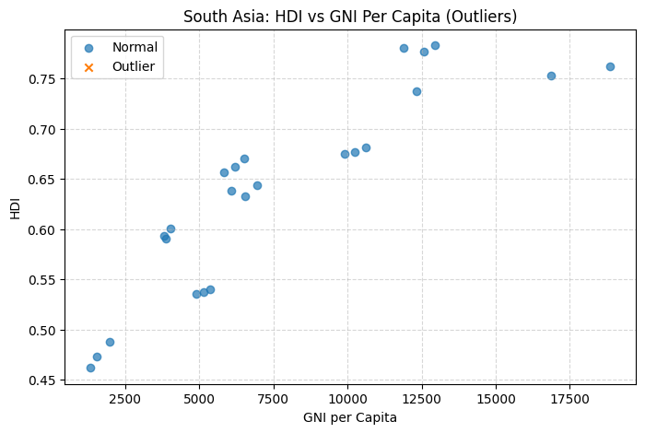
Figure 16 : HDI vs GNI per capita outlier detection. This scatter diagram was applied to check the outliers. No outliers were detected in South Asia.
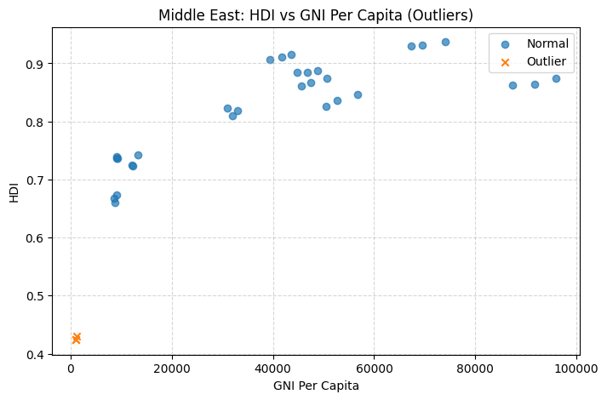
Figure 17 : HDI vs. GNI per Capita Outlier Detection This scatter diagram is applied to detect an anomaly in which the economic output of a country (gross national income per capita) is not consistent with human development. The figure shows certain outliers especially in the Middle East where some countries show extreme income levels which may not be fully reflected on the education or health scores.

The development indicators of regions were compared using grouped bar charts. Scatter plots with a trendline were generated to demonstrate how HDI is correlated with other indicators. More scatter plots were utilized to point out the anomalies in HDI and GNI per capita.
Discussion and Interpretation
The findings indicate obvious development disparities between the Middle East and South Asia. The level of income in the Middle East increases the HDI values. South Asia is less but more evenly developed. These results identify the issues of inequality in the regions and balanced development in the terms of health, education, and income.
Conclusion
In this report, the data on Human Development Index (HDI) was examined to comprehend the level of development and trends of development across countries and regions. The findings indicated that there is a wide variation in HDI within countries and regions. The highest values of HDI were always made in developed regions whereas low level of human development was made at developing regions.
It was found that the trend in the years 2020 and 2022 revealed that a significant number of nations grew at a slow pace or had minor decreases in HDI in the COVID-19 pandemic. There are signs of improvements in 2022 which indicate that certain countries are beginning to recover. The regional analysis revealed a high difference in the results of income, health, and general development.
The paper also revealed that increased income does not necessarily translate into increased human development. Education, health, and gender development are some of the factors that are of importance. This comes to emphasize the fact that there is need to have balanced development policies which are not only aimed at pursuing economic growth, but also based on the need to improve the quality of life.
A short time span of analysis is one of the limitations in this analysis. Manual region classification, as well as the presence of some indicators, also limit the study. The future research may involve a longer span of years and other development indicators.
Altogether, the results indicate that the government and policy makers need to work more on enhancing the health, education and social equality to promote long term human development.
References
United Nations Development Programme. (2023). Human Development Reports. https://hdr.undp.org
University of Wolverhampton. (2024). HDI dataset provided for course 5CS037.
University of Wolverhampton. (2024). Lecture slides and assignment instructions for 5CS037. Unpublished course materials.

Appendix
