Proposal: mandatory evaluation gates for LLM releases
  - Why we should block releases that fail automated evaluation, and how to roll it out by Q1
AI Engineering · October 2026
Recommendation
Make automated evaluation a required release gate for every LLM feature from January. The judge now agrees with expert raters (κ = 0.82) and would have caught all three Q3 regressions.

86%  Traffic scored daily  +61 pts since Q1 | 0.82  Judge–expert agreement  +0.09 vs. Q2 | -71%  Cost vs. manual QA  $0.004 per conversation

Background
Until this year, LLM quality was measured by sampling about 2% of conversations for manual review. Findings arrived two weeks after a release, which meant regressions were discovered by customers first. Since April we have run an LLM-as-judge pipeline that scores most production conversations daily against a shared rubric.
The judge is now accurate enough to act on. Agreement with expert human raters has reached 0.82 Cohen's κ across six channels, above the 0.75 bar we set for decision use.

What the data shows

Quality varies most in billing
Billing resolution quality trails every other channel by at least 13 points. Root-cause review traced most failures to stale policy documents in the retrieval corpus rather than to the model itself.
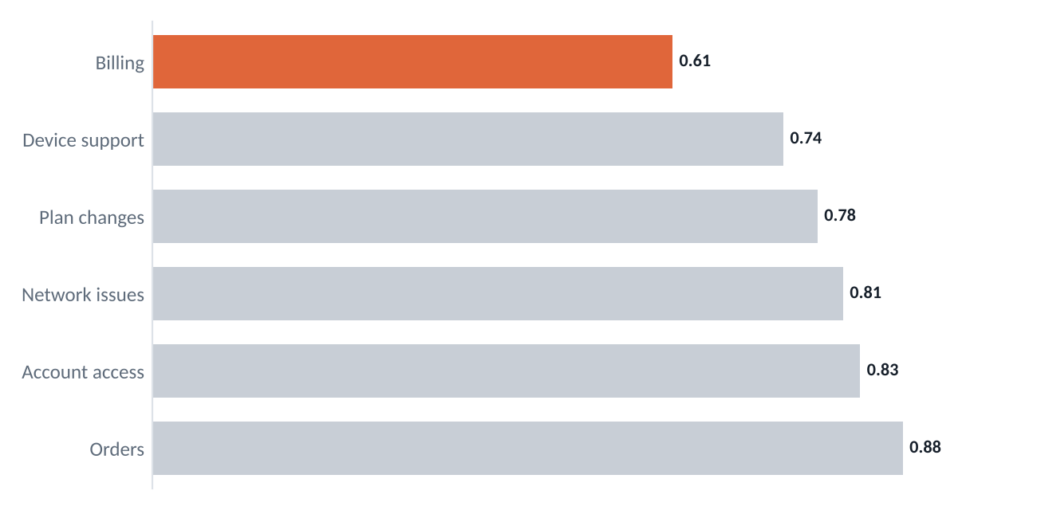
Figure 1. Mean judge resolution score by channel, Jul–Sep 2026 (illustrative).

Fixes are working
Retrieval and prompt changes shipped since April cut unsupported claims by two-thirds. Every Q3 regression that reached customers would have failed a gate on at least two metrics when replayed.
Channel | Coverage | κ | Resolution | Status
Billing | 91% | 0.79 | 0.61 | Rubric revision
Device support | 88% | 0.77 | 0.74 | Rubric revision
Plan changes | 85% | 0.84 | 0.78 | Gating live
Network issues | 83% | 0.85 | 0.81 | Gating live
Account access | 80% | 0.86 | 0.83 | Gating live
Orders | 79% | 0.88 | 0.88 | Gating live
Table 1. Evaluation readiness by channel (illustrative).

Proposal
- Fix billing retrieval first. Refresh the policy corpus weekly and require citations in answers.
- Calibrate scores per channel so a threshold means the same thing everywhere.
- Platt scaling against a held-out expert-labelled set
- Thresholds signed off by each channel owner
- Make the gate mandatory for all LLM releases from January, with a documented override path.
Risk
A miscalibrated gate could block good releases. The override path and monthly threshold review are there to contain that, and we will report false-block rates alongside the gate results.

Decisions requested
- Approve two engineers for Q1 calibration and retrieval work
- Endorse mandatory release gating from January
- Nominate one owner per channel for rubric sign-off
For the first time we found out about a quality problem before our customers did.
— Channel owner, Device Support

