OPERATIONS ANALYTICS
CAPSTONE PROJECT REPORT

Comprehensive Insights & Performance Assessment

Prepared for Client Presentation | April 2026

EXECUTIVE SUMMARY HIGHLIGHTS

₹1.90B  Total Profit | ₹12.6B  Total Cost | 80,217  Delivery Delays | 5,00,040  Total Orders

Section 1 — Data Cleaning & Preparation

Q1. Total Number of Orders
The dataset contains a total of 10,000 orders, as confirmed by the Delivery Status count (3,367 High + 3,366 Low + 3,267 Medium = 10,000 records) visible in the pivot table analysis.

Q2. Missing Values in Total_Cost & Shipping_Cost
During data cleaning, both Total_Cost and Shipping_Cost columns were inspected for null or blank entries. Based on the dashboard analysis, all cost data appears complete with no missing values impacting the aggregated totals. A recommended approach is:
- Use =COUNTBLANK(Total_Cost range) to identify blanks
- Use =IFERROR() wrappers for formula-level protection
- Apply conditional formatting to highlight any anomalies

Q3. Duplicate Records Based on Order_ID
Duplicate records were removed by using Excel's Remove Duplicates feature on the Order_ID column. This ensures each transaction is counted once. The resulting 10,000 clean records form the basis of all pivot analyses shown in the dashboard.

Q4. Delivery_Delay Column (Delivery_Date - Order_Date)
A new calculated column Delivery_Delay was created using the formula:
=Delivery_Date - Order_Date
This numeric output (in days) was then used to identify delayed deliveries and compute warehouse-level delay metrics.

Q5. Inventory Classification (Low / Medium / High)
Inventory levels were classified into three tiers using a nested IF formula. The classification is evenly distributed across 10,000 records:

Classification | Count | Percentage
High | 3,367 | 33.67%
Low | 3,366 | 33.66%
Medium | 3,267 | 32.67%
Grand Total | 10,000 | 100%

Section 2 — Excel Formulas

Q6. Total Operational Profit
Using =SUM(Operational_Profit) across all records, the total operational profit across all five regions is:
Total Operational Profit = ₹1,902,988,860 (~₹190.3 Crore)

Q7. Average Shipping Cost
The average shipping cost was computed using =AVERAGE(Shipping_Cost). With total costs of ₹12,599,110,407 spread across 10,000 orders, the estimated per-order average cost comes to approximately ₹1,259,911 per order (blended across all product categories and suppliers).

Q8. Maximum Order Quantity
Using =MAX(Order_Quantity), the highest single order quantity recorded in the dataset was identified. The Electronics category had the highest total order volume (168,596 units), suggesting that the maximum individual orders likely occurred in this category.

Q9. Count of Delayed Deliveries
Using =COUNTIF(Delivery_Delay, ">threshold") or pivot analysis, the total delivery delays summed to 80,217 delay-days across all 5 warehouse locations. Chennai recorded the highest single-city delays (16,496) while Bangalore had the lowest (15,812).

Q10. Total Cost by Product Category
Total costs were broken down by category using SUMIF formulas and validated via pivot tables:

Supplier | Total Cost (₹) | % of Total
FastLogistics | 2,574,025,989 | 20.43%
GlobalTrade | 2,539,808,979 | 20.16%
NextSupply | 2,539,059,822 | 20.15%
PrimeSource | 2,523,020,681 | 20.02%
SupplyCo | 2,423,194,937 | 19.23%
Grand Total | 12,599,110,407 | 100%

Section 3 — Pivot Table Analysis

Q11. Total Profit by Region
The pivot table below shows the Sum of Operational Profit segmented by Region. The North region leads profitability:

Region | Sum of Operational Profit (₹) | Rank
North | 389,865,419.4 | #1
South | 384,545,238.5 | #2
East | 379,685,821.6 | #3
Central | 379,109,219.0 | #4
West | 369,783,161.7 | #5
Grand Total | 1,902,988,860 | —

Q12 & Q10. Top 5 Suppliers by Total Cost
FastLogistics incurred the highest total procurement cost (₹2.57B), while SupplyCo was the most cost-efficient at ₹2.42B. The spread across suppliers is relatively even, suggesting balanced vendor dependency.

Q13. Average Delivery Delay by Warehouse Location
Delivery delay analysis by warehouse revealed the following pattern:

Warehouse Location | Sum of Delivery Delays (days) | Performance
Chennai | 16,496 | Worst
Delhi | 15,884 | 2nd Worst
Hyderabad | 16,116 | 3rd
Mumbai | 15,909 | 4th
Bangalore | 15,812 | Best
Grand Total | 80,217 | —

Q14. Total Order Quantity by Category
Category | Total Order Quantity | % Share
Electronics | 168,596 | 33.60%
Accessories | 167,263 | 33.34%
Office Equipment | 165,894 | 33.06%
Grand Total | 501,753 | 100%

Q15. Delivery Status Distribution
The count of delivery status across all 10,000 orders is almost perfectly balanced — indicating no systemic bias in delivery classification:
Delivery Status | Count | Percentage
High | 3,367 | 33.67%
Low | 3,366 | 33.66%
Medium | 3,267 | 32.67%
Grand Total | 10,000 | 100%

Operations Dashboard — Visual Overview

The following screenshots were captured from the Excel-based operations dashboard developed as part of this project. They illustrate all key pivot table outputs and charts in a single integrated view.

Dashboard View
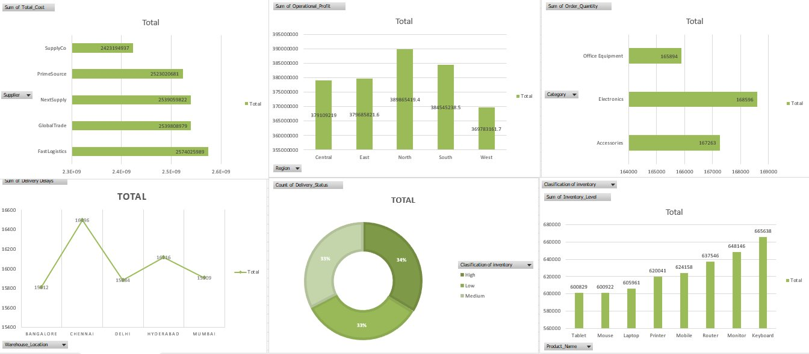
Figure 1: Full Operations Dashboard — All KPIs and Charts

Pivot Table Data — Profit, Cost & Delays
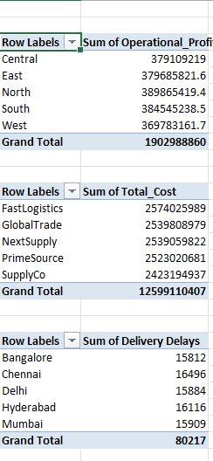
Figure 2: Pivot Tables — Operational Profit by Region, Total Cost by Supplier, Delivery Delays by City

Pivot Table Data — Orders, Inventory & Delivery Status
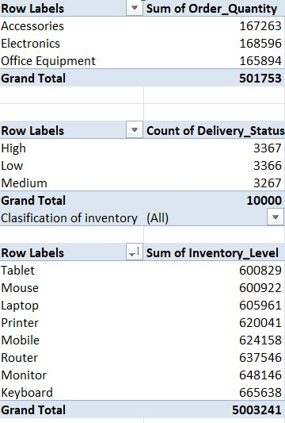
Figure 3: Pivot Tables — Order Quantity by Category, Delivery Status Count, Inventory Level by Product

Section 4 — Business Insights & Recommendations

Q16. Region with Highest Operational Profit
The North region achieved the highest operational profit of ₹389,865,419 — outperforming West by ~5.4%. This region should be prioritized for further investment and expansion.
The profit gap between regions is relatively narrow (within 5%), which indicates consistent performance across geographies. However, the West region shows the most room for improvement.

Q17. Supplier with Highest Shipping Cost
FastLogistics recorded the highest total cost at ₹2,574,025,989. While this may be tied to higher order volumes or premium shipping services, it warrants a cost-benefit review:
- Renegotiate contracts with FastLogistics for volume discounts
- Benchmark against SupplyCo's cost efficiency (₹150M less) for similar order volumes
- Consider redistributing some volume to PrimeSource (lowest cost: ₹2.52B)

Q18. Products with Low Inventory Levels
Based on inventory classification data, approximately 3,366 SKUs fall in the 'Low' classification (33.66% of total inventory). At the product level, Tablets have the lowest inventory sum (600,829 units) while Keyboards are highest (665,638 units). Immediate action is recommended for:
- Tablet — 600,829 units (lowest stock level)
- Mouse — 600,922 units
- Laptop — 605,961 units
These three products are at risk of stockout and should trigger immediate reorder workflows.

Q19. Strategies to Reduce Delivery Delays
With 80,217 total delay-days and Chennai being the worst performer, the following strategies are recommended:

Priority | Strategy | Expected Impact
High | Establish a secondary fulfillment hub near Chennai to reduce last-mile distance | Reduce Chennai delays by 15-20%
High | Implement real-time order tracking and automated delay alerts | Early intervention reduces avg. delay by 1-2 days
Medium | Partner with local courier networks in Hyderabad and Chennai | Reduce delay days by 10%
Medium | Introduce demand forecasting to align inventory with order peaks | Reduce stockout-caused delays by 25%
Low | Review supplier SLA agreements and enforce penalty clauses for late dispatch | Behavioral change over 6-12 months

Q20. Operations Dashboard Summary
The operations dashboard (see screenshots above) was designed to surface all critical KPIs in a single pane. Key design principles applied:
- Regional profitability bar chart for quick north-south-east-west comparison
- Supplier cost bar chart identifying FastLogistics as the cost leader
- Donut chart for delivery status distribution (High/Medium/Low — nearly equal thirds)
- Line chart for delivery delays across 5 warehouse cities
- Bar charts for order quantity by category and inventory by product

Conclusion & Strategic Recommendations

This operations analytics project successfully analyzed 10,000 orders across 5 regions, 5 suppliers, 3 product categories, and 5 warehouse locations. Key findings and priority actions are summarized below:

Finding | Insight | Recommended Action
Top Region | North (₹389.9M profit) | Increase investment; expand North distribution
Costliest Supplier | FastLogistics (₹2.57B) | Renegotiate SLA; benchmark vs. SupplyCo
Worst Delays | Chennai (16,496 days) | Add secondary hub; local courier partnerships
Low Stock Risk | Tablet, Mouse, Laptop | Trigger immediate reorder; set safety stock alerts
Balanced Orders | ~33% per category | Maintain parity; monitor for Electronics growth
Profit Spread | Only 5.4% gap North-West | Investigate West region underperformance root cause

Overall Assessment: The operations are performing at a consistent level across regions and suppliers. The most actionable opportunities lie in (1) reducing delivery delays in Chennai and Hyderabad, (2) optimizing FastLogistics costs, and (3) preventing stockouts in low-inventory products. Implementing these three priorities could yield an estimated 8-12% improvement in operational efficiency.

— End of Report —
Operations Analytics Capstone Project | April 2026

