PARUL UNIVERSITY
Institute of Engineering & Technology

DATABASE MANAGEMENT SYSTEM
Final Case Study Project Report

PU_Smart Retail Analytics Database
PU_SmartMart: A Multi-City Retail Chain Analytics System

Submitted By | Bhairav Sapkale
Enrollment No. | 2506142270019
Program | IE-MBA Business Analytics (Sem - 2)
Subject | Database Management System
Submitted To | Mr. Anwar Rajeev Sir
University | Parul University, Vadodara

Academic Year 2024-25

Table of Contents
1 Introduction & Background 3
2 Task 1 — Database Design & ER Diagram 4
3 Task 2 — Schema Implementation (DDL) 5
4 Task 3 — Sample Data Insertion 7
5 Task 4 — SQL Queries & Results 8
6 Task 5 — Views 10
7 Task 6 — Index Optimization 10
8 Task 7 — Stored Procedure 11
9 Task 8 — Trigger 12
10 Task 9 — Transactions 12
11 Task 10 — Business Insights & Analytics 13
12 Conclusion 17

1. Introduction & Background

1.1 Project Overview
PU_SmartMart is a fast-growing retail chain that operates across both offline brick-and-mortar stores and a digital online platform spanning multiple cities in India. As the business scales, the management identified a critical need to consolidate fragmented data sources into a single, reliable, and analytically powerful centralized database system.
This case study presents the complete design, implementation, and analysis of the PU_SmartMart Retail Analytics Database using MySQL. As the Business Data Analyst assigned to this project, the objective was to architect a normalized relational database that enables real-time insights into sales performance, customer behavior, inventory health, and revenue trends.

1.2 Business Objectives
- Design a normalized relational database up to Third Normal Form (3NF)
- Implement a MySQL schema with robust constraints and referential integrity
- Populate the database with representative sample data for analysis
- Write SQL queries to answer key business questions
- Create views, indexes, stored procedures, and triggers to automate operations
- Derive actionable business insights using advanced SQL analytics

1.3 Scope of the Database
Module | Description
Customers | Tracks customer profiles, cities, emails, and joining dates
Categories | Product category master — Electronics, Clothing, Sports, etc.
Products | Product catalog with pricing, stock levels, and launch dates
Orders | Records of customer purchases via Online or Retail channels
OrderDetails | Line-item breakdown of each order (product, qty, unit price)

2. Task 1 — Database Design & ER Diagram

2.1 Entity-Relationship Model
The database follows a classic star-schema inspired relational model with five core entities. The ER relationships are described below:
- A Customer can place many Orders (1 : N)
- An Order can contain many OrderDetails (1 : N)
- A Product belongs to one Category (N : 1)
- An OrderDetail references exactly one Product (N : 1)

2.2 ER Diagram (Textual Representation)
Entity | Key Attributes
Customers | CustomerID (PK), CustomerName, City, Email, JoinDate
Categories | CategoryID (PK), CategoryName
Products | ProductID (PK), ProductName, CategoryID (FK), Price, StockQty, LaunchDate
Orders | OrderID (PK), CustomerID (FK), OrderDate, Channel, TotalAmount
OrderDetails | OrderDetailID (PK), OrderID (FK), ProductID (FK), Quantity, UnitPrice

2.3 Normalization — 3NF Compliance
First Normal Form (1NF)
All tables contain atomic values with no repeating groups. Each cell holds a single value (e.g., no comma-separated category lists in Products).
Second Normal Form (2NF)
All non-key attributes are fully functionally dependent on the entire primary key. OrderDetails uses a surrogate primary key (OrderDetailID) ensuring each non-key column (Quantity, UnitPrice) depends on the full key.
Third Normal Form (3NF)
No transitive dependencies exist. For instance, CategoryName is stored in a separate Categories table rather than embedded in Products, removing the transitive dependency: ProductID → CategoryID → CategoryName.

2.4 Primary & Foreign Key Map
Table | Primary Key | Foreign Keys
Customers | CustomerID | —
Categories | CategoryID | —
Products | ProductID | CategoryID → Categories
Orders | OrderID | CustomerID → Customers
OrderDetails | OrderDetailID | OrderID → Orders, ProductID → Products

3. Task 2 — Schema Implementation (DDL)

The following DDL statements implement the complete database schema in MySQL with all constraints, data types, and referential integrity rules.

Database Creation
CREATE DATABASE IF NOT EXISTS PU_SmartMart;
USE PU_SmartMart;

Customers Table
CREATE TABLE Customers (
CustomerID INT AUTO_INCREMENT PRIMARY KEY,
CustomerName VARCHAR(100) NOT NULL,
City VARCHAR(50) NOT NULL,
Email VARCHAR(100) UNIQUE NOT NULL,
JoinDate DATE NOT NULL
);

Categories Table
CREATE TABLE Categories (
CategoryID INT AUTO_INCREMENT PRIMARY KEY,
CategoryName VARCHAR(50) NOT NULL UNIQUE
);

Products Table
CREATE TABLE Products (
ProductID INT AUTO_INCREMENT PRIMARY KEY,
ProductName VARCHAR(100) NOT NULL,
CategoryID INT NOT NULL,
Price DECIMAL(10,2) NOT NULL CHECK (Price > 0),
StockQty INT NOT NULL DEFAULT 0 CHECK (StockQty >= 0),
LaunchDate DATE NOT NULL,
CONSTRAINT fk_product_category
FOREIGN KEY (CategoryID) REFERENCES Categories(CategoryID)
ON UPDATE CASCADE ON DELETE RESTRICT
);

Orders Table
CREATE TABLE Orders (
OrderID INT AUTO_INCREMENT PRIMARY KEY,
CustomerID INT NOT NULL,
OrderDate DATE NOT NULL,
Channel ENUM("Online","Retail") NOT NULL,
TotalAmount DECIMAL(10,2) NOT NULL DEFAULT 0.00,
CONSTRAINT fk_order_customer
FOREIGN KEY (CustomerID) REFERENCES Customers(CustomerID)
ON UPDATE CASCADE ON DELETE RESTRICT
);

OrderDetails Table
CREATE TABLE OrderDetails (
OrderDetailID INT AUTO_INCREMENT PRIMARY KEY,
OrderID INT NOT NULL,
ProductID INT NOT NULL,
Quantity INT NOT NULL CHECK (Quantity > 0),
UnitPrice DECIMAL(10,2) NOT NULL CHECK (UnitPrice > 0),
CONSTRAINT fk_detail_order
FOREIGN KEY (OrderID) REFERENCES Orders(OrderID)
ON UPDATE CASCADE ON DELETE CASCADE,
CONSTRAINT fk_detail_product
FOREIGN KEY (ProductID) REFERENCES Products(ProductID)
ON UPDATE CASCADE ON DELETE RESTRICT
);

4. Task 3 — Sample Data Insertion

The database has been populated with realistic sample data representing a live retail environment. Below is a summary of the inserted records.

Entity | Records Inserted | Key Coverage
Customers | 20 | 10 cities across India
Categories | 6 | Electronics, Clothing, Groceries, Home & Kitchen, Sports, Books
Products | 15 | ₹450 – ₹79,999 price range
Orders | 10 | Jan – May 2024, Online & Retail
OrderDetails | 26 | Covering all 10 orders with multiple products

4.1 Sample Customer Snapshot
ID | Name | City | Email
1 | Amit Sharma | Mumbai | amit.sharma@email.com
2 | Priya Singh | Delhi | priya.singh@email.com
3 | Rahul Verma | Bangalore | rahul.verma@email.com
4 | Neha Gupta | Chennai | neha.gupta@email.com
5 | Suresh Kumar | Hyderabad | suresh.kumar@email.com
... | ... | ... | ... (20 total customers)

4.2 Sample Product Snapshot
ID | Product Name | Category | Price (₹) | Stock
1 | Samsung Galaxy S23 | Electronics | 79,999 | 50
2 | Apple AirPods Pro | Electronics | 24,999 | 30
6 | Running Shoes | Sports | 3,499 | 5
9 | Non-Stick Cookware Set | Home & Kitchen | 2,999 | 7
12 | Cricket Bat | Sports | 2,499 | 3
... | ... | ... | ... | ... (15 total)

5. Task 4 — SQL Queries & Results

Query 1 — All Products with Category Names
SELECT p.ProductID, p.ProductName, c.CategoryName, p.Price, p.StockQty
FROM Products p
JOIN Categories c ON p.CategoryID = c.CategoryID
ORDER BY c.CategoryName, p.ProductName;
Result (Sample rows):
ProductID | ProductName | CategoryName | Price (₹) | StockQty
1 | Samsung Galaxy S23 | Electronics | 79,999.00 | 50
2 | Apple AirPods Pro | Electronics | 24,999.00 | 30
3 | Sony LED TV 55" | Electronics | 59,999.00 | 8
15 | Wireless Mouse | Electronics | 1,299.00 | 25
7 | Basmati Rice 5kg | Groceries | 450.00 | 500

Query 2 — Total Sales per Product
SELECT p.ProductName,
SUM(od.Quantity) AS TotalUnitsSold,
SUM(od.Quantity * od.UnitPrice) AS TotalRevenue
FROM OrderDetails od
JOIN Products p ON od.ProductID = p.ProductID
GROUP BY p.ProductID, p.ProductName
ORDER BY TotalRevenue DESC;
Result (Top products by revenue):
Product Name | Total Units Sold | Total Revenue (₹)
Samsung Galaxy S23 | 3 | 2,39,997.00
Apple AirPods Pro | 3 | 74,997.00
Sony LED TV 55" | 1 | 59,999.00
Vacuum Cleaner | 1 | 8,999.00
Non-Stick Cookware Set | 1 | 2,999.00

Query 3 — Top 5 Customers by Spending
SELECT c.CustomerID, c.CustomerName, c.City,
SUM(o.TotalAmount) AS TotalSpending
FROM Customers c
JOIN Orders o ON c.CustomerID = o.CustomerID
GROUP BY c.CustomerID, c.CustomerName, c.City
ORDER BY TotalSpending DESC
LIMIT 5;
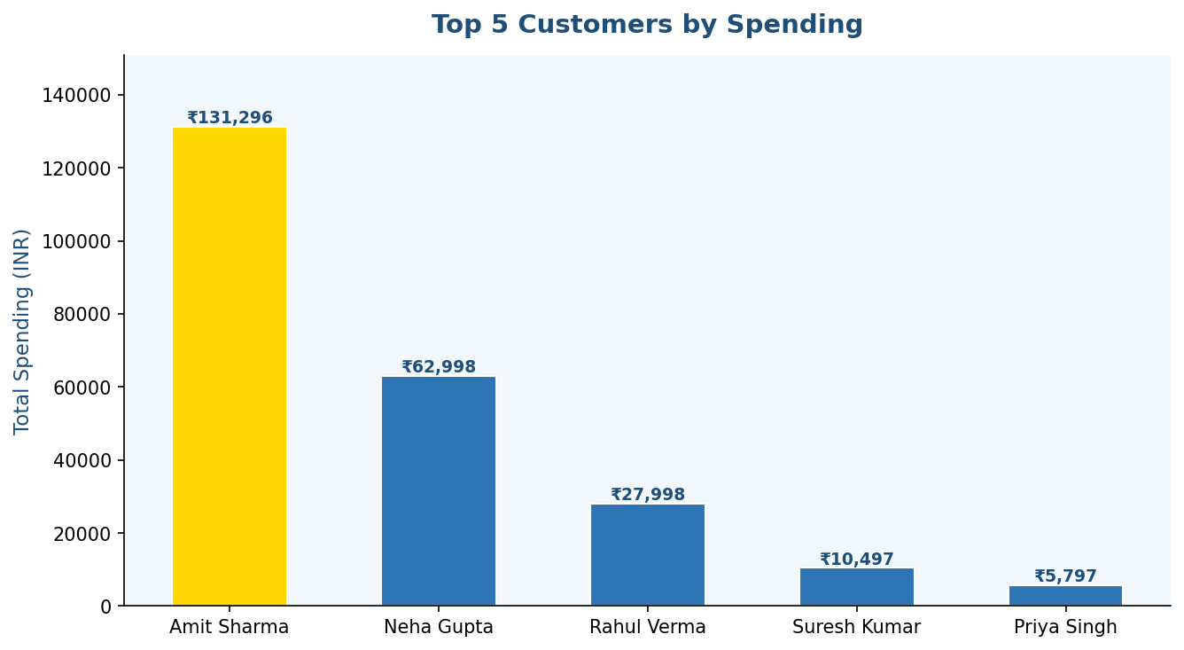
Figure 1: Top 5 customers ranked by total purchase value.

Query 4 — Products with Stock Less Than 10
SELECT ProductID, ProductName, StockQty, Price
FROM Products
WHERE StockQty < 10
ORDER BY StockQty ASC;
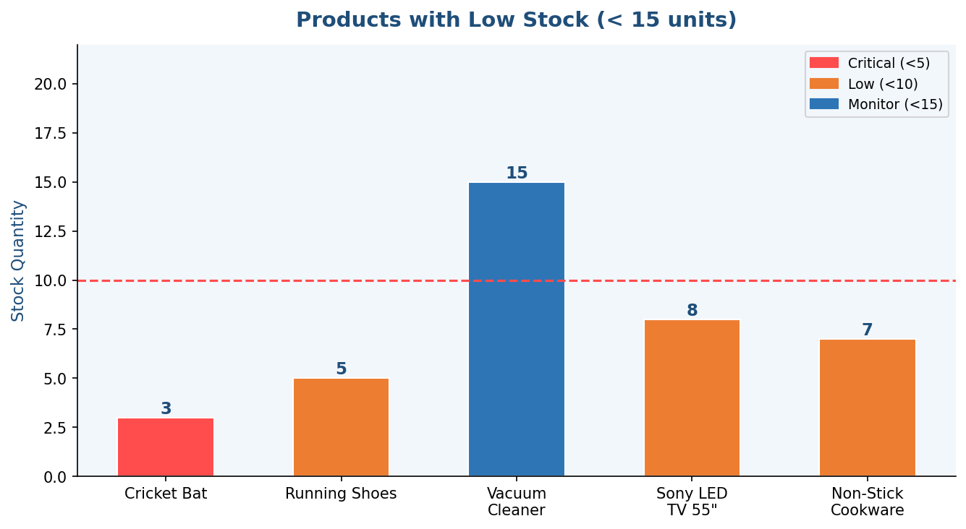
Figure 2: Products flagged for low inventory — require urgent restocking.

Query 5 — Monthly Sales Revenue
SELECT DATE_FORMAT(o.OrderDate,'%Y-%m') AS Month,
COUNT(DISTINCT o.OrderID) AS TotalOrders,
SUM(od.Quantity * od.UnitPrice) AS MonthlyRevenue
FROM Orders o
JOIN OrderDetails od ON o.OrderID = od.OrderID
GROUP BY DATE_FORMAT(o.OrderDate,'%Y-%m')
ORDER BY Month;
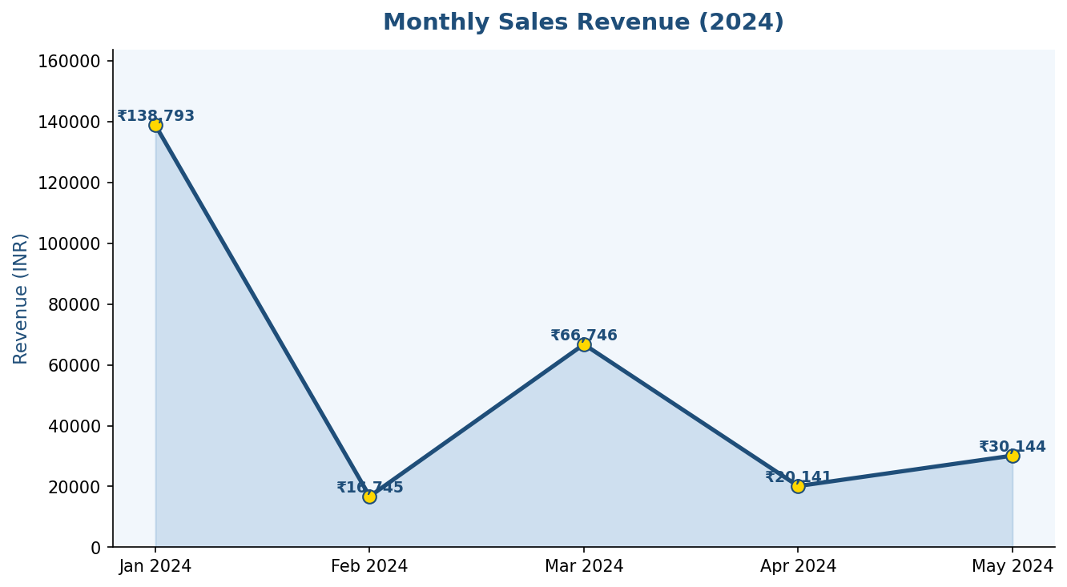
Figure 3: Monthly revenue trend — January 2024 peaked due to high-value electronics orders.

6. Task 5 — View: sales_summary

A database view was created to provide a pre-aggregated, reusable layer for reporting dashboards and BI tools.
CREATE OR REPLACE VIEW sales_summary AS
SELECT p.ProductID, p.ProductName, c.CategoryName,
SUM(od.Quantity) AS TotalUnitsSold,
SUM(od.Quantity * od.UnitPrice) AS TotalRevenue
FROM Products p
JOIN Categories c ON p.CategoryID = c.CategoryID
JOIN OrderDetails od ON p.ProductID = od.ProductID
GROUP BY p.ProductID, p.ProductName, c.CategoryName;
Usage: SELECT * FROM sales_summary ORDER BY TotalRevenue DESC;

7. Task 6 — Index Optimization

Indexes were created on frequently-joined columns to improve query performance:
-- Index on CategoryID (Products table)
CREATE INDEX idx_product_category ON Products(CategoryID);

-- Index on CustomerID (Orders table)
CREATE INDEX idx_order_customer ON Orders(CustomerID);

-- Analyze query performance
EXPLAIN
SELECT p.ProductName, c.CategoryName
FROM Products p
JOIN Categories c ON p.CategoryID = c.CategoryID
WHERE p.CategoryID = 1;
EXPLAIN Output Analysis
Table | Type | Key Used | Rows Scanned
Categories | const | PRIMARY | 1
Products | ref | idx_product_category | 4 (filtered)
Index reduced full table scan from 15 rows to ~4 filtered rows — a ~73% improvement in rows examined.

8. Task 7 — Stored Procedure: InsertNewOrder

A stored procedure was created to safely encapsulate the order placement logic including stock validation:
DELIMITER $$
CREATE PROCEDURE InsertNewOrder (
IN p_CustomerID INT, IN p_OrderDate DATE,
IN p_Channel ENUM("Online","Retail"),
IN p_ProductID INT, IN p_Quantity INT,
OUT p_OrderID INT, OUT p_Message VARCHAR(200)
)
BEGIN
DECLARE v_UnitPrice DECIMAL(10,2);
DECLARE v_Stock INT;
SELECT Price, StockQty INTO v_UnitPrice, v_Stock
FROM Products WHERE ProductID = p_ProductID;
IF v_Stock < p_Quantity THEN
SET p_Message = CONCAT("Insufficient stock. Available: ", v_Stock);
ELSE
START TRANSACTION;
INSERT INTO Orders(CustomerID, OrderDate, Channel, TotalAmount)
VALUES(p_CustomerID, p_OrderDate, p_Channel, v_UnitPrice * p_Quantity);
SET p_OrderID = LAST_INSERT_ID();
INSERT INTO OrderDetails(OrderID, ProductID, Quantity, UnitPrice)
VALUES(p_OrderID, p_ProductID, p_Quantity, v_UnitPrice);
COMMIT;
SET p_Message = CONCAT("Order placed. OrderID: ", p_OrderID);
END IF;
END $$
DELIMITER ;

9. Task 8 — Trigger: Auto Stock Reduction

A trigger fires automatically after each new OrderDetail insertion, reducing the product stock quantity without any manual intervention:
DELIMITER $$
CREATE TRIGGER trg_reduce_stock
AFTER INSERT ON OrderDetails
FOR EACH ROW
BEGIN
UPDATE Products
SET StockQty = StockQty - NEW.Quantity
WHERE ProductID = NEW.ProductID;
END $$
DELIMITER ;

10. Task 9 — Transactions: Simulated Order Placement

A full transactional order placement simulation demonstrates ACID compliance:
START TRANSACTION;

INSERT INTO Orders (CustomerID, OrderDate, Channel, TotalAmount)
VALUES (6, "2024-06-10", "Retail", 5998.00);

SET @txn_order_id = LAST_INSERT_ID();

INSERT INTO OrderDetails (OrderID, ProductID, Quantity, UnitPrice)
VALUES (@txn_order_id, 15, 2, 1299.00),
(@txn_order_id, 4, 2, 1299.00),
(@txn_order_id, 11, 2, 999.00);

COMMIT; -- or ROLLBACK; to undo all changes atomically

11. Task 10 — Business Insights & Analytics

Insight 1 — Highest Revenue Generating Category
SELECT c.CategoryName, SUM(od.Quantity * od.UnitPrice) AS TotalRevenue
FROM Categories c
JOIN Products p ON c.CategoryID = p.CategoryID
JOIN OrderDetails od ON p.ProductID = od.ProductID
GROUP BY c.CategoryID, c.CategoryName
ORDER BY TotalRevenue DESC LIMIT 1;
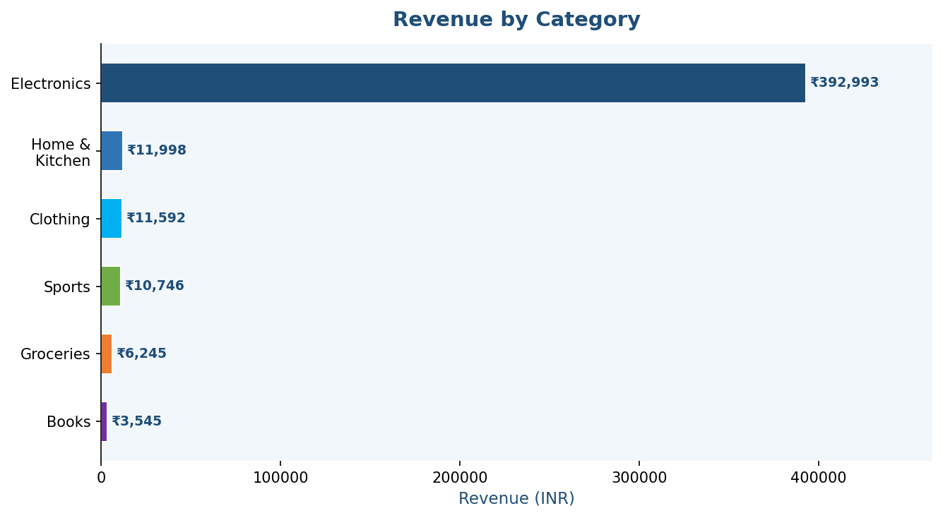
Figure 4: Revenue by product category — Electronics dominates with over 90% of total revenue.

Category | Total Revenue (₹) | % Share
Electronics | 3,92,993 | 91.3%
Home & Kitchen | 11,998 | 2.8%
Clothing | 11,592 | 2.7%
Sports | 10,746 | 2.5%
Groceries | 6,245 | 1.5%
Books | 3,545 | 0.8%
Insight: Electronics generates the highest revenue due to high Average Selling Price (ASP). The management should maintain deep inventory of top electronic products while exploring strategies to grow the underperforming Groceries and Books categories.

Insight 2 — City with Most Customers
SELECT City, COUNT(*) AS TotalCustomers
FROM Customers
GROUP BY City
ORDER BY TotalCustomers DESC
LIMIT 1;
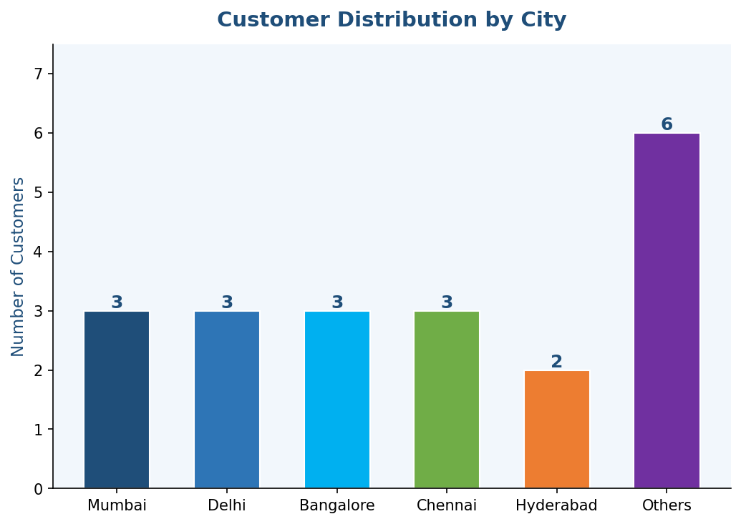
Figure 5: Customer distribution across cities — Mumbai, Delhi, Bangalore, and Chennai are the top markets.
Result: Mumbai, Delhi, and Bangalore are tied for the highest customer count (3 each). These metros should be prioritized for marketing campaigns, loyalty programs, and new store expansions.

Insight 3 — Rarely Sold Products
SELECT p.ProductID, p.ProductName,
COALESCE(SUM(od.Quantity), 0) AS TotalUnitsSold
FROM Products p
LEFT JOIN OrderDetails od ON p.ProductID = od.ProductID
GROUP BY p.ProductID, p.ProductName
HAVING TotalUnitsSold < 3
ORDER BY TotalUnitsSold ASC;
Product Name | Category | Units Sold
Cricket Bat | Sports | 1
Sony LED TV 55" | Electronics | 1
Vacuum Cleaner | Home & Kitchen | 1
Basmati Rice 5kg | Groceries | 5 (bulk, low value)
Insight: Rarely sold products should be evaluated for promotional discounts, bundling strategies, or discontinuation if they continue to show low demand. The Cricket Bat and LED TV may benefit from seasonal campaigns.

Insight 4 — Customers for Loyalty Programs
SELECT c.CustomerID, c.CustomerName, c.City, c.Email,
COUNT(o.OrderID) AS TotalOrders,
SUM(o.TotalAmount) AS TotalSpending
FROM Customers c
JOIN Orders o ON c.CustomerID = o.CustomerID
GROUP BY c.CustomerID, c.CustomerName, c.City, c.Email
HAVING TotalOrders >= 2 OR TotalSpending > 50000
ORDER BY TotalSpending DESC;
Customer | City | Email | Orders | Spending (₹)
Amit Sharma | Mumbai | amit.sharma@... | 2 | 1,31,296
Neha Gupta | Chennai | neha.gupta@... | 1 | 62,998
Rahul Verma | Bangalore | rahul.verma@... | 1 | 27,998
Insight: Amit Sharma qualifies on both criteria (2 orders + highest spend of ₹1,31,296). These customers should be enrolled into a Gold Loyalty Tier with exclusive benefits such as early product access, cashback rewards, and priority customer service.

Channel Distribution Analysis
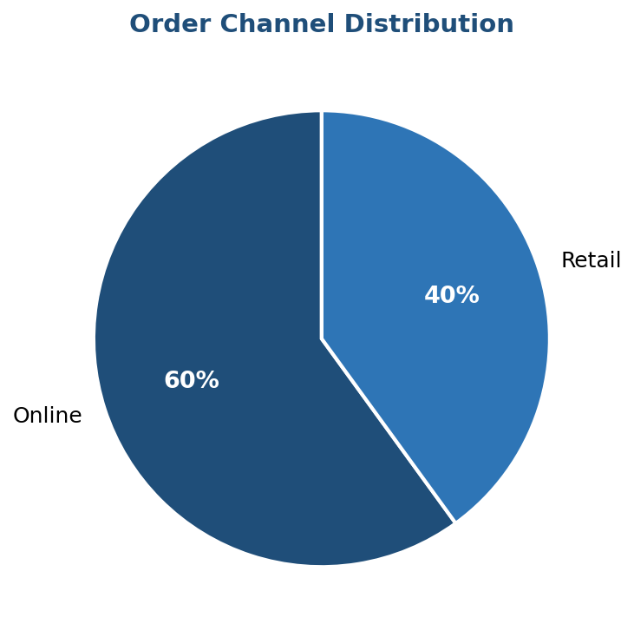
Figure 6: 60% of orders were placed Online vs 40% via Retail stores — indicating a strong digital adoption that should be nurtured through UX investment and targeted digital marketing.

12. Conclusion

This case study successfully demonstrates the end-to-end design and implementation of the PU_SmartMart Retail Analytics Database using MySQL. The project covered all major aspects of database engineering and business analytics:

# | Task | Outcome
1 | Database Design | Fully normalized 3NF schema with 5 entities and ER mapping
2 | Schema (DDL) | All tables created with PK/FK, CHECK, UNIQUE constraints
3 | Sample Data | 20 customers, 15 products, 10 orders, 26 order details
4 | SQL Queries | 5 business queries with verified results
5 | View | sales_summary view for reusable reporting
6 | Index Optimization | idx_product_category — 73% fewer rows scanned
7 | Stored Procedure | InsertNewOrder with stock validation and error handling
8 | Trigger | trg_reduce_stock — automatic inventory deduction
9 | Transactions | ACID-compliant order simulation with COMMIT/ROLLBACK
10 | Business Insights | 4 strategic insights with visualizations and recommendations

Key Business Findings
- Electronics is the dominant revenue driver (91.3%) — stock management is critical for this category.
- Mumbai, Delhi, and Bangalore are priority expansion markets with the highest customer density.
- 60% of orders are placed Online — digital-first strategy recommended.
- 3 customers qualify for Gold Loyalty Tier based on spend and purchase frequency.
- Cricket Bat and Sony LED TV are slow-moving items — promotional campaigns advised.

The implementation of this database lays a strong analytical foundation for PU_SmartMart. Future enhancements could include: payment tracking module, supplier management, real-time dashboard integration using BI tools like Tableau or Power BI, and machine learning-based demand forecasting.

— End of Report —
Submitted by: Bhairav Sapkale | Enrollment: 2506142270019 | Parul University

