1. Download Jenkins from location :
   1. <https://jenkins.io/download/>
   2. Install from exe

Once Installation is done below window will be opened

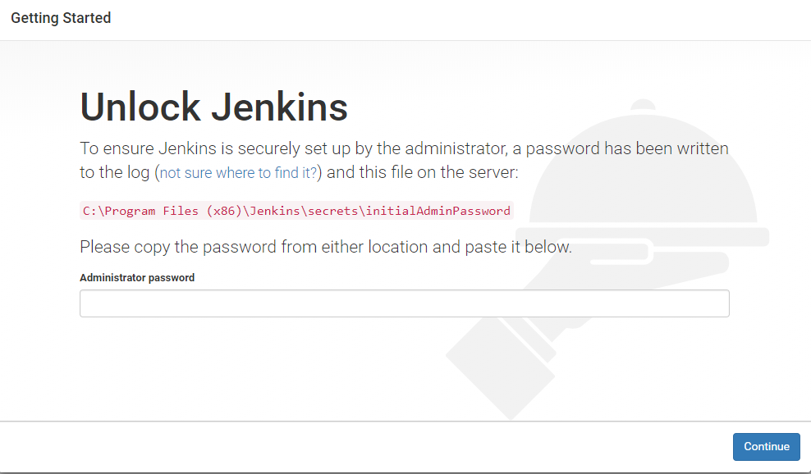

1. Open the Location mentioned in the above screenshot
2. Copy the Key from location and put it in the Administrator password field
3. Click on Continue
4. Click on Install Suggested Plugin . following window will appear
   1. 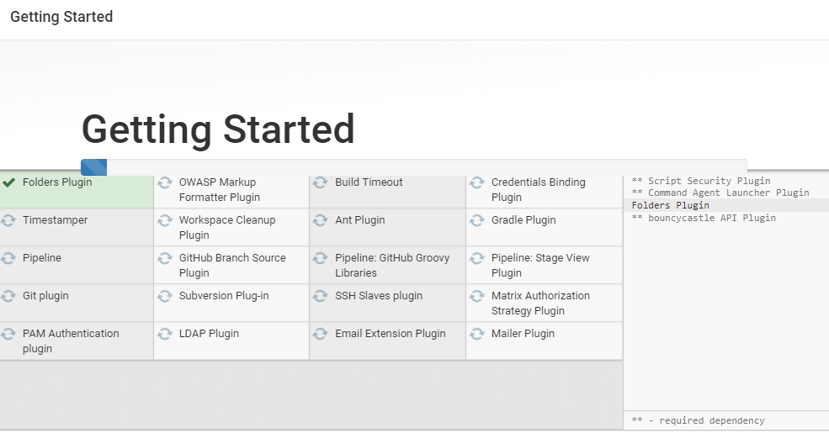
5. 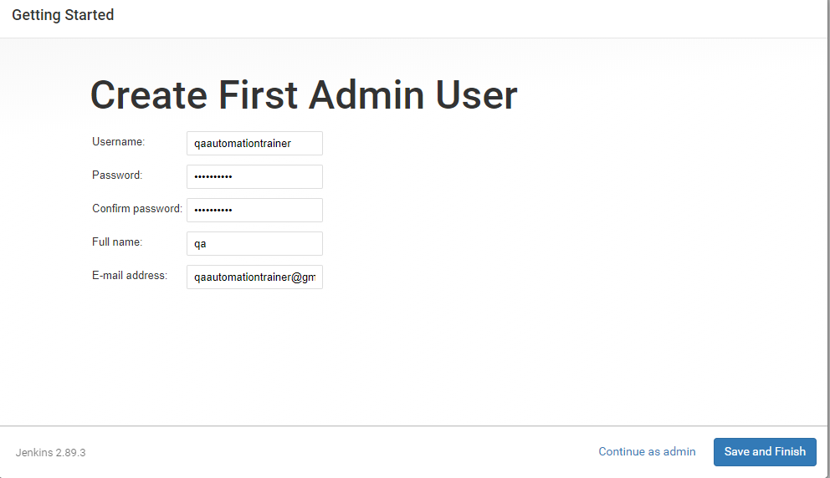

You've skipped creating an admin user. To log in, use the username: 'admin' and the administrator password you used to access the setup wizard.

User Credentials

Joshibha/Jenkins1980

1. Then Install Robot Framework Plugin
2. Create a New Job in the Jenkins

Configuration of new job

1. In Source code management provide the repository url of the subversion
2. Build Trigger Should be built periodically or Poll SCM
3. In Post Build Actions Publish Robot Framework test results

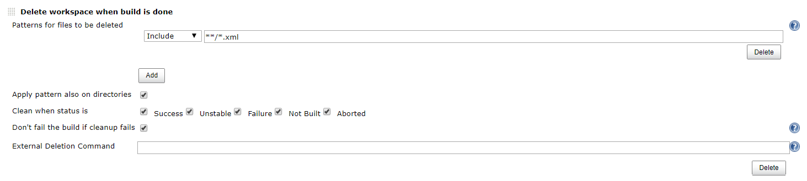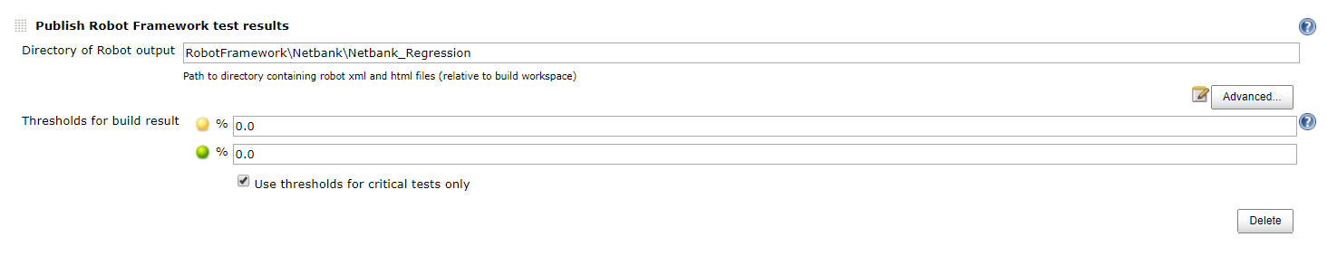

1. Pybot Command
   1. pybot --include FF --timestampoutputs -l NetBankLogs.html -r NetbankReport.html -d %WorkSpace%\RobotFramework\Netbank\Netbank_Regression %WorkSpace%\Netbank_Regression\NetBank_Web\
2. Jenkins Slave Creation – Manage Nodes
3. Jenkins Plugin installation
4. Jenkins Global Configuration
5. Configure Global Security