1. Components design of a framework

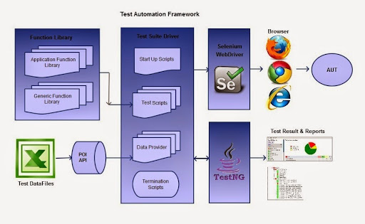

1. How to start creating frameworks
   1. Create Control flow logic
   2. Create Data Passing Mechanism
   3. Create Reporting Mechanism
   4. Create Business and functional Flows
2. Reading Test Data File using Fillo Libraries
3. Reporting Structure
   1. <https://www.techbeamers.com/generate-reports-selenium-webdriver/>
   2. <https://www.softwaretestinghelp.com/extent-reports-selenium-webdriver/>
   3. <http://allure.qatools.ru/>
   4. <https://www.seleniumeasy.com/testng-tutorials/allure-example>
   5. https://www.swtestacademy.com/allure-testng/