1. Installation of Git
   1. <https://desktop.github.com/>
2. Basic concept of Git
   1. 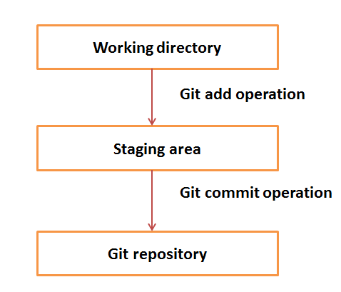
3. Basic git commands
   1. Git init
   2. Git Clone
   3. Git Commit
   4. Git Pull
   5. Git Push
   6. Git checkout
   7. Git log
   8. Git diff
   9. Git add
   10. Git status
   11. Git stash
4. Handling different Objects: Links, Tables, Lists
5. Action Class: Gestures in Selenium