1. Basics of automation framework
   1. Discussed already
2. Components design of a framework

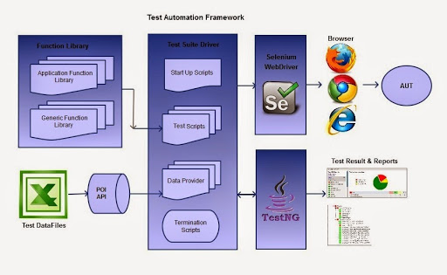

1. How to start creating frameworks
   1. Create Control flow logic
   2. Create Data Passing Mechanism
   3. Create Reporting Mechanism