Documentation of “CSS” Folder
Index
1) themeCss.php
2) ThemeCss2.php
3) autosuggest
4)winjs
5)bt
6) calendar-win2k-cold-1
7)css
8)examples
9)ext-all
10)menu
11)phpCalender
12)slider
13)sortable
14)tab
15)tab-view
16)teacherCss

themeCss.php

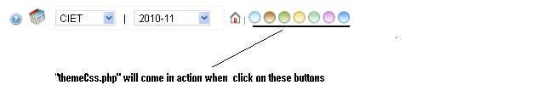
themeCss.php is in “ css” Folder and file is called on clicking the colored rings lying on the Top-Right corner of Dashboard. These Rings will provide different theme-colors to the physical outlook of ERP. themeCss.php is a theme specific file.
How this css works ?
Each colored Rings are assigned with certain “id” containing values. By clicking on the Rings, “id” value is passed onto the themeCss.php page and desired theme will get activated.
How themeCss.php works ?
Through $_GET['id'] id value is fetched and then Check whether this id is set or is empty or equals to 1. If condition meets the “default theme will get activated [blue color Theme].
Otherwise if
Id =2 brown color Id = 3 Green color Id = 4 orange color
Id = 5 Green-light color Id =6 violet color Id =7 Blue-light color , respective Themes will get activated.
There are some classes which are meant for “Internet Explorer” and some for Mozilla Firefox, although these classes Perform The same functionality.
$browser =$_SERVER['HTTP_USER_AGENT']
This function will tell whether one is using Internet Explorer or using Mozilla . This Function is used because there are some css property that will only work only in IE or in Mozilla . For eg.. for showing shadows .png images are used for Mozilla whereas .gif files are used for IE.

themeCss2.php

themeCss2.php is the other css file used in the ERP. This file contains the classes which are not Theme specific i.e which are common for all themes .
themeCss2.php is mainly used for –
- headings- Row headings ,action heading , Various fields heading ,linking, coloring the text ,padding[left ,right, bottom, top],HTML
- Header- headings,heading-font,heading image
- footer-footer text
- Logo ,icon

- Tables – table border , table font , table content , select fields, table Rows [row0 row1] ,row Selected , scroll ,listing tables 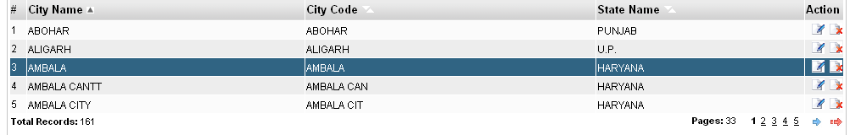

- Select class ,text class ,titles ,breadcrumbs,searchbox
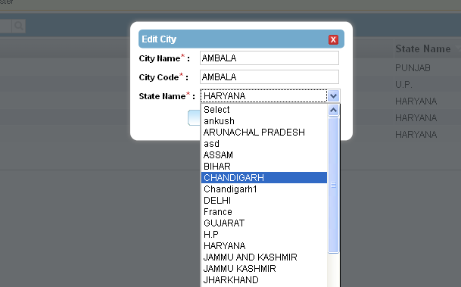
- Font -text , paging , caption ,inputBox ,small text etc

multiple css files are called by "require_once"
require_once('calendar-win2k-cold-1.css');
require_once('bt.css');
to make it single file and preventing multiple http requests

