Tribhuvan University

Faculty of Humanities and Social Sciences

eAuction
A PROJECT REPORT

Submitted to
Department of Computer Application
Kathmandu Business Campus
Bypass, Balaju-16, Kathmandu

In partial fulfilment of the requirements for the Bachelors in Computer Application

Submitted by
Lasata Maharjan  BCA 6th Semester  Reg. No: 6-2-1219-9-2022  Roll No.:10 | Om Krishna Shrestha  BCA 6th Semester  Reg. No: 6-2-1219-13-2022  Roll No.:14

Under the Supervision of
Rajan Bhandari

Faculty of Humanities and Social Sciences

Kathmandu Business Campus
Banasthali, Kathmandu
Bachelor in Computer Applications (BCA)

SUPERVISOR’S RECOMMENDATION

I hereby recommend that this project is prepared under my supervision by Lasata Maharjan and Om Krishna Shrestha entitled “eAuction” in the Partial Fulfillment of requirement for the degree of Bachelor in Computer Application is recommended for that final evaluation.

Rajan Bhandari
Project Supervisor
BCA Department
Kathmandu Business Campus

Faculty of Humanities and Social Sciences
Kathmandu Business Campus
Banasthali, Kathmandu
Bachelor in Computer Applications (BCA)

LETTER OF APPROVAL
This is certify that this project is prepared by Lasata Maharjan and Om Krishna Shrestha entitled “eAuction” in the Partial Fulfillment of requirement for the degree of Bachelor in Computer Application has been evaluated. In our opinion it is satisfactory in the scope and quality as a project for the required degree.

Rajan Bhandari  Supervisor  BCA Department  Kathmandu Business Campus |  | Nixon Maharjan  Program Coordinator  BCA Program  Kathmandu Business Campus
External Examiner |  | Internal Examiner

ABSTRACT
The eAuction system is a web-based online auction platform designed to provide a secure, efficient, and user-friendly environment for buyers and sellers. Traditional auction methods often face challenges such as manual bidding, geographical limitations, and delayed transaction processing. This project addresses these limitations by enabling real-time bidding, automated winner selection, and comprehensive fraud detection. The system is built using modern web technologies and follows Agile development practices, ensuring modular design, responsive interfaces, and effective database management.
Key features include dynamic auction management, weighted fraud risk scoring, bid velocity monitoring, and tie-breaking mechanisms to ensure fair competition. The project demonstrates practical application of software engineering principles and provides a foundation for future enhancements such as online payment integration, mobile support, and AI-driven fraud detection. Overall, eAuction offers a scalable and reliable platform that enhances the online auction experience while maintaining data security and fairness.

ACKNOWLEDGEMENT
First and foremost, we would like to thank our respected supervisor, Mr. Rajan Bhandari, for his continuous guidance, valuable suggestions, and encouragement throughout the development of this project. His support helped us stay focused and improve our work at every stage.
We are also thankful to the Department of Computer Application, Kathmandu Business Campus, for providing us with the opportunity and necessary resources to carry out this project.
We extend our heartfelt thanks to our friends and classmates for their support, cooperation, and constructive feedback during the project development.
Finally, we would like to express our gratitude to our family members for their constant motivation and encouragement.
Without the support of all these individuals, this project would not have been possible.

LIST OF ABBREVIATIONS
Abbreviation | Full Form
eAuction | Electronic Auction
DBMS | Database Management System
HTML | HyperText Markup Language
CSS | Cascading Style Sheets
JS / JavaScript | JavaScript
UI | User Interface
UX | User Experience
API | Application Programming Interface
COD | Cash on Delivery
OTP | One-Time Password
AI | Artificial Intelligence
IP | Internet Protocol
MVC | Model-View-Controller
SQL | Structured Query Language
ERD | Entity-Relationship Diagram
N/A | Not Applicable

Table of Contents
SUPERVISOR’S RECOMMENDATION ii
LETTER OF APPROVAL iii
ABSTRACT iv
ACKNOWLEDGEMENT v
LIST OF ABBREVIATIONS vi
Table of Contents vii
LIST OF FIGURES viii
LIST OF TABLES ix
CHAPTER: 1 1
INTRODUCTION 1
1.1 Introduction 1
1.2 Problem Statement 2
1.3 Objectives 2
1.4 Scope and Limitation 2
Chapter :2 3
Background Study and Literature Review 3
2.1 Background Study 3
2.2. Literature Review (Related work and theories) 4
CHAPTER: 3 6
SYSTEM ANALYSIS AND DESIGN 6
3.1 System Analysis 6
3.1.3 Data modeling 10
3.2 System Design 12
Chapter :4 17
Implementation and Testing 17
4.1 Implementation 17
4.2. Testing 19
CHAPTER: 5 CONCLUSION AND FUTURE RECOMMENDATIONS 20
5.2Conclusion 20
5.3 FutureRecommendations 20
References 20

LIST OF FIGURES
Figure 1. 1 Agile Methodology for eAuction 6
Figure 1. 2 Use Case Diagram of eAuction 8
Figure 1. 3 Gantt Chart of eAuction 10
Figure 1. 4 :Entity Relationship Diagram of eAuction 10
Figure 1. 5 Level 0 DFD of eAuction 11
Figure 1. 6 Level 1 DFD of eAuction 11
Figure 1. 7 Architectural design of eAuction 12
Figure 1. 8 Flow Chart of eAuction 13
Figure 1. 9 Admin Panel Interface 15
Figure 1. 10 Front-End Interface of eAuction 15
Figure 1. 11 Product Listing Interface 16

LIST OF TABLES
No table of figures entries found.

CHAPTER: 1

INTRODUCTION

1.1 Introduction
With the rapid growth of internet-based services, traditional auction systems are gradually being replaced by digital platforms that offer better accessibility, transparency, and efficiency. Conventional auctions require physical presence, manual bidding, and extensive paperwork, which limits participation and increases operational complexity.

The eAuction system is a web-based auction management platform designed to digitize the entire auction process. It enables sellers to list items online, define auction rules, and manage bidding schedules, while buyers can participate in auctions remotely by placing real-time bids. The system automates critical processes such as bid validation, auction closure, and winner determination, ensuring fairness and accuracy.

This project focuses on developing a secure, scalable, and user-friendly online auction platform suitable for the Nepalese market, where consumer-facing real-time auction systems are still limited.

1.2 Problem Statement
Traditional auction systems have limited reach, low transparency, and inefficient bid handling, as they require participants to be physically present, increasing cost and restricting access. Manual record-keeping also leads to errors, disputes, and delays in declaring winners. In Nepal, while some institutions use electronic bidding, there is still a lack of a user-friendly, centralized online auction platform that supports real-time bidding, highlighting the need for a more accessible, transparent, and efficient digital solution.

1.3 Objectives
The main objectives of the eAuction system are:
- To allow sellers to list auction items and manage auction schedules
- To enable buyers to browse items and place bids in real time
- To automate auction closure and winner selection

1.4 Scope and Limitation

1.4.1 Scope
The scope of the eAuction system includes user registration, product listing, real-time bidding, auction monitoring, automated winner determination, and administrative control through a dashboard.

1.4.2 Limitations
There are some limitations in the current version of the eAuction system, including:
- Online payment gateway and escrow services are not implemented
- The system does not support international shipping
- Advanced AI-based fraud prevention is limited to basic rule-based detection
- The platform is designed for small to medium-scale auctions

Chapter :2

Background Study and Literature Review

2.1 Background Study
The eAuction system is based on the concept of electronic commerce and online bidding systems. Online auctions function by allowing multiple users to place competitive bids within a specified time frame, with the highest valid bid winning at auction closure. Key concepts applied in this project include user authentication, role-based access control, real-time data handling, and automated decision-making.
In the context of Nepal, electronic procurement systems are primarily used for government and institutional purposes. However, consumer-oriented auction platforms with real-time interaction are still underdeveloped. This project adopts proven auction mechanisms and adapts them to a user-friendly web environment using modern web technologies.

2.2. Literature Review (Related work and theories)
A study published in the International Journal for Research in Applied Science & Engineering Technology (IJRASET) (2024) proposed a web-based e-auction system that enables buyers and sellers to participate efficiently in online auctions. The platform allows sellers to create detailed product listings, set reserve prices, and monitor bids in real time, while buyers can place secure bids. To ensure transaction safety, the system incorporates SSL encryption, user authentication, and audit trails for transparency and accountability. The study highlights that digitizing auctions improves accessibility, enhances security, and provides a user-friendly experience for both individuals and businesses. [1]
The research by R. T. Elias and A. H. Al-Wattar (2023) focused on designing and implementing an online auction system for the University of Mosul. It identified key limitations of traditional auctions, such as slow processes, complex procedures, and limited accessibility. The proposed system enables users to buy and sell items locally, display auction listings, and efficiently manage sales. System testing demonstrated flexibility, ease of use, and successful implementation, emphasizing improved efficiency, accuracy, and accessibility. [2]
A study by S. K. Singh and P. Kumar (2022) introduced an online auction platform aimed at enhancing bidding efficiency and user interaction. The system includes features such as automatic bid updates, time-based auction closing, and user notifications. It also supports multiple users through effective database management. The research concludes that automation reduces human error and significantly improves system performance. [3]
Research published by IEEE (2021) examined secure e-auction systems using advanced cryptographic techniques. The system ensures confidentiality, fairness, and integrity in the bidding process through encryption and secure authentication mechanisms. The findings suggest that strong security features are essential to build user trust and minimize fraud in online auction systems. [4]
The work of M. Sharma and R. Gupta (2020) focused on developing a real-time auction system using web technologies. The platform supports dynamic bidding, instant updates, and efficient data processing. The study demonstrates that real-time functionality enhances transparency and allows users to participate remotely, making auction systems more accessible and efficient. [5]
Another study in the International Journal of Computer Applications (2019) analyzed the usability of online auction platforms. It emphasizes the importance of user-friendly design, quick system response, and clear bidding processes. The study concludes that an intuitive interface significantly improves user satisfaction and increases participation in online auctions. [6]

CHAPTER: 3

SYSTEM ANALYSIS AND DESIGN

3.1 System Analysis
The development of the eAuction system follows a structured software engineering process, beginning with requirement analysis, where both functional and non-functional requirements are collected to ensure the system meets the needs of buyers, sellers, and administrators. In the design phase, the system’s architecture and user interface are carefully planned to provide a user-friendly and efficient experience. The development phase implements the core features, including real-time bidding, auction listing management, and secure transaction handling. After coding, the system undergoes rigorous integration and testing to verify functionality, security, and reliability. Upon successful testing, the system is deployed for live use, with maintenance conducted as needed to address any issues, ensuring a stable and effective online auction platform.

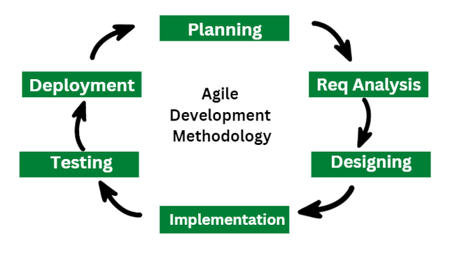

Figure 1. 1 Agile Methodology for eAuction

3.1.1 Requirement Analysis
The requirements for this e-commerce project are collected before starting the development life cycle. To design and develop the system, both functional and non-functional requirements have been considered.
i. Functional Requirements
For Administrators:
- The system should allow administrators to log in and log out securely.
- The system should enable administrators to add, delete, and update product listings and user information.
- The system should allow administrators to manage auctions, view reports, and monitor user activity.
For Buyers:
- The system should create and manage unique usernames and passwords for buyers.
- The system should enable buyers to browse auction items, place bids, and track ongoing auctions.
- The system should allow buyers to view and manage their order history, wishlist, and personal account details.
For Sellers:
- The system should create and manage usernames and passwords for sellers.
- The system should allow sellers to list products, set starting prices, and update stock.
- The system should display sales and bid data to sellers and provide order management functionality.

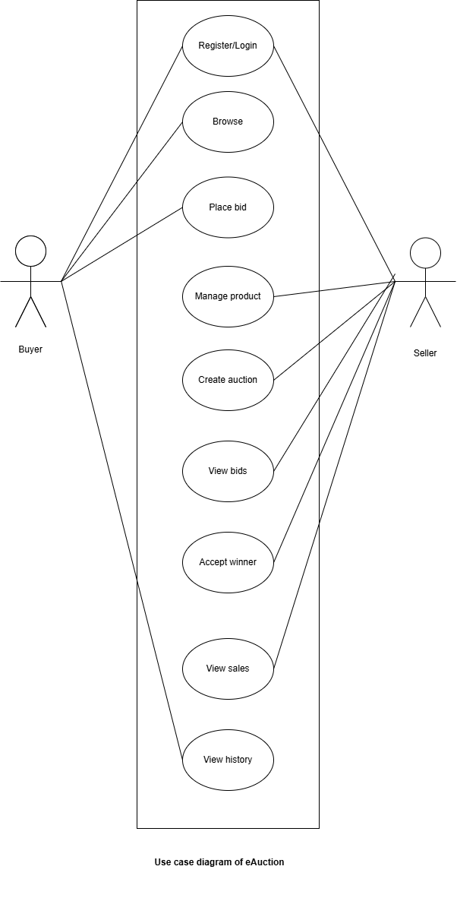
Figure 1. 2 Use Case Diagram of eAuction

i. Non Functional Requirement
Different non-functional requirement have been studied and identified and are listed as below:
- Usability:
Simple and responsive user interface
- Performance:
Efficient handling of concurrent bids
- Security:
Secure authentication and data protection
- Scalability:
Ability to support increasing users
- Reliability:
Accurate bid processing and data integrity

3.1.2 Feasibility Analysis
The feasibility study concludes that the eAuction system is achievable and can be successfully implemented due to careful planning and clear objectives.

i. Technical Feasibility Study

The system is technically feasible as it uses widely available technologies such as HTML, CSS, JavaScript, Django, and MySQL, which are well-supported and suitable for web-based applications.

ii. Operational Feasibility Study

The system simplifies auction operations by automating bidding and winner determination, reducing manual effort and improving efficiency for users and administrators.

iii. Economic Feasibility Study

The project is economically feasible as it utilizes open-source tools and is developed as part of an academic requirement, involving minimal financial cost.

iv. Schedule Feasibility Study
The project was completed within the allocated academic timeline using Agile methodology, allowing timely delivery through iterative development.

Gantt Chart
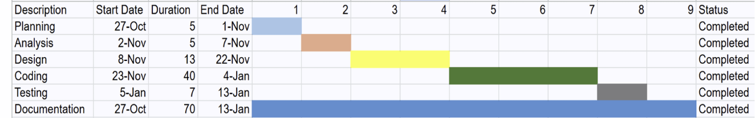
Figure 1. 3 Gantt Chart of eAuction

3.1.3 Data modeling

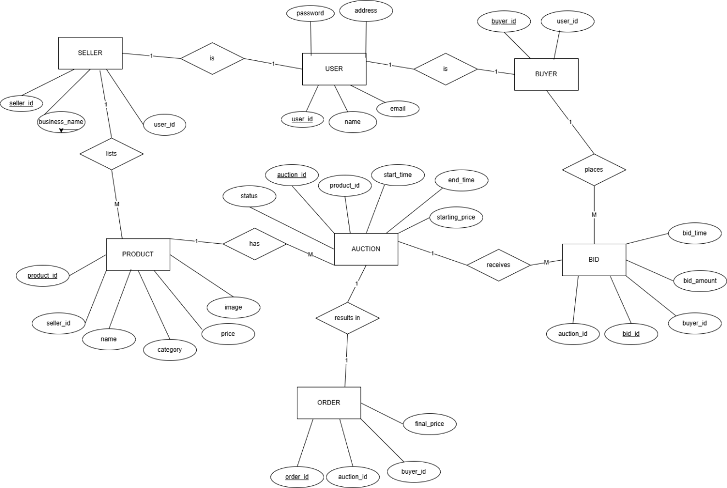

Figure 1. 4 :Entity Relationship Diagram of eAuction

3.1.4 DFD (Data Flow Diagram):

Figure 1. 5 Level 0 DFD of eAuction

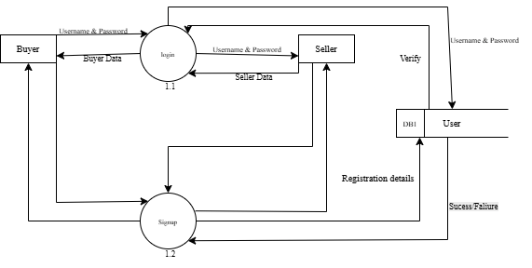
Figure 1. 6 Level 1 DFD of eAuction

3.2 System Design
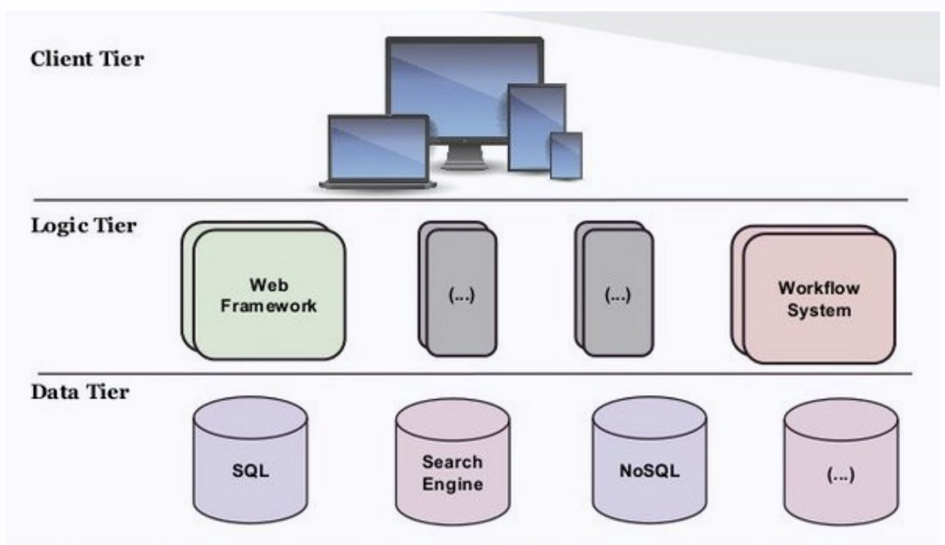
Figure 1. 7 Architectural design of eAuction
3.2.2 Flow Chart Diagram
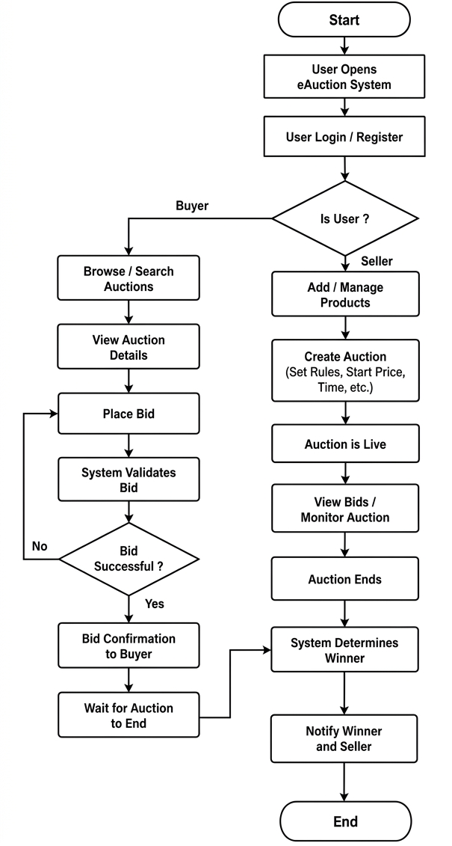
Figure 1. 8 Flow Chart of eAuction

3.2.3 Database Schema Design
The database schema of the e-auction system is designed to efficiently manage and organize data related to users, auction items, and bidding activities. It follows a relational structure with key tables such as Users, Products, Bids, and Orders, interconnected through primary and foreign keys. The Users table stores details of buyers and sellers, while the Products table contains item descriptions, starting prices, and auction duration. The Bids table records each bid, including bidder information, bid amount, and timestamp to support real-time tracking. The Orders table maintains records of completed auctions and delivery-related information. The schema is normalized to reduce data redundancy and ensure data integrity, enabling efficient data retrieval and smooth system operation.
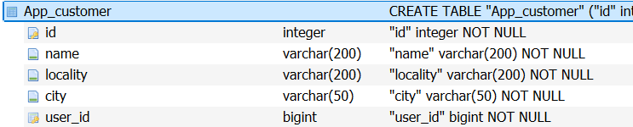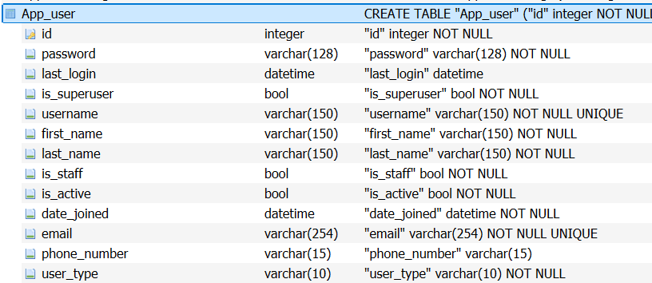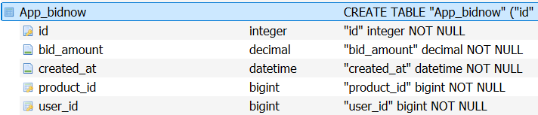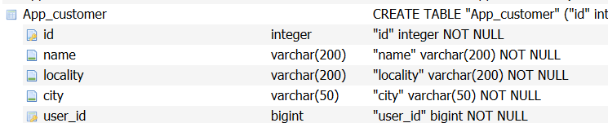

3.2.4 Interface Design (UI Interface)
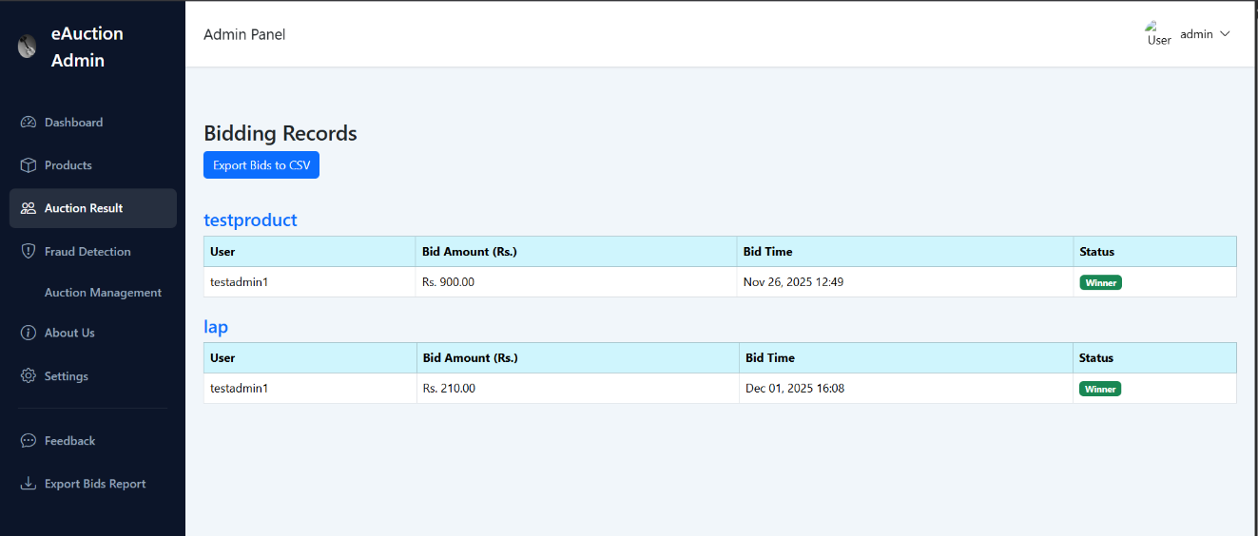
Figure 1. 9 Admin Panel Interface 
Figure 1. 10 Front-End Interface of eAuction

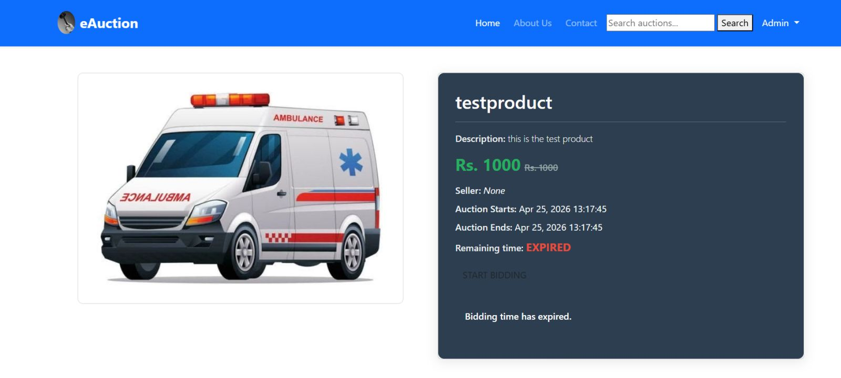
Figure 1. 11 Product Listing Interface

3.2.5 Algorithm
The Algorithms used in the system are mentioned below:
1. Auction Winner Selection Algorithm
This algorithm selects the winner by identifying the highest valid bid after the auction ends. It ignores invalid or late bids and compares all remaining bids to find the maximum value. If needed, tie-breaking rules like earliest bid time are used. It automates winner selection, making the process fast, fair, and error-free by removing manual judgment.
2. Weighted Fraud Risk Scoring Algorithm
This algorithm detects suspicious bidding behavior by assigning risk scores based on factors like unusual bidding patterns, rapid bids, and abnormal amounts. Each factor has a weight, and the total score determines whether a user is normal or suspicious. It helps improve security by identifying fraud and preventing unfair bidding.
3. Sliding Window Bid Velocity Algorithm
This algorithm monitors how frequently bids are placed within a short time window. It continuously checks bid activity in recent minutes to detect unusually fast bidding. If activity is too high, it flags it as suspicious. It helps prevent bot activity and ensures fair and stable bidding.

Chapter :4

Implementation and Testing

4.1 Implementation

4.1.1 Tools Used
CASE Tools: The eAuction project utilized CASE (Computer-Aided Software Engineering) tools to assist in designing, modeling, and visualizing the system:
- Draw.io: Used for creating diagrams such as ER diagrams, DFDs, and flowcharts.
- Figma: Used for designing user interfaces and visual layouts to ensure an intuitive and user-friendly experience.
Programming Languages/Front-End & Back-End:
- HTML/CSS: Used to structure and style the front-end, providing a visually appealing and responsive interface.
- JavaScript: Enhances interactivity on the client side, manages dynamic elements, and supports real-time updates (e.g., bid tracking).
- Python (Django): Used for back-end development to manage server-side logic, handle user requests, and connect with the database.
Database Platforms:
- MySQL: Selected for its reliability, scalability, and ability to store data related to users, auctions, bids, and product listings securely.

4.1.2 Implementation Details of Modules
Each module, including user authentication, product listing, bidding, and auction
management, was implemented as a separate functional unit to ensure modularity,
maintainability, and scalability.
- User Authentication Module:
- Provides secure user registration and login functionality.
- Passwords are encrypted to protect user data.
- Enables users to access personalized features such as bidding history, saved items, and account settings.
- Product Listing Module:
- Allows sellers to add, edit, and delete auction items.
- Uses MySQL queries to store product details such as descriptions, images, starting prices, and reserve prices.
- Retrieves and displays product listings dynamically for buyers to browse and place bids.
- Bidding Module:
- Enables buyers to place real-time bids on auction items.
- Ensures bid validation, prevents invalid or duplicate bids, and updates the highest bid in real time.
- Maintains a complete bid history for transparency and fairness.
- Auction Management Module:
- Automates auction closure and winner determination based on the highest valid bid at the end of the auction period.
- Notifies both sellers and buyers about auction results.
- Tracks auction status, allowing administrators to monitor ongoing and completed auctions.
- Admin Dashboard Module:
- Provides administrators with control over users, auctions, and system data.
- Displays reports on user activity, auction trends, and system performance.
- Enables administrators to manage disputes, approve or remove auctions, and ensure fair system operations.
- Security Module
- Manages user authentication and ensures only valid users can access the system.
- Monitors bidding activity to detect suspicious or fraudulent behavior.
- Maintains data security and ensures fairness and integrity in the auction process.

4.2. Testing
System testing is performed to ensure that all functionalities of the system work as intended and meet the requirements. Various test cases are designed to evaluate the performance, accuracy, and reliability of the system under different conditions. During the development phase, testing is conducted iteratively to identify and resolve issues. The series of tests conducted are as follows:

4.2.1. Test Cases for Unit Testing
In unit testing, each module is tested individually to ensure it functions correctly. The system is developed in a modular structure, and each module is validated for accurate outputs before integration. Input validation is thoroughly tested to prevent the acceptance of invalid data in forms and other fields, ensuring a robust and error-free system.
Table4. 1: Test Case For Registration Of User
S.N | Test Name |  | Input |  |  | Expected  Output |  | Actual  Output |  | Test  Result
1 | Open Application |  | http://127.0.0.1:8000/register/ |  |  | Signup Page |  | Signup Page |  | Pass
2 | Enter Invalid  Username, Email  ,Password |  | Email= omuser  Username = omuser  Password= omuser @123 |  |  | Invalid Email |  | Invalid Email |  | Pass
3 |  | Enter valid  Username, Email  ,Password |  | Email= omuser@gmail.com  Username = omuser  Password= omuser @123 | Registration  Successful |  | Registration  Successful |  | Pass

Table4. 2: Test Case For Login
S.  N | Test Name | Input | Expected  Outcome |  |  | Actual  Output | Test  Result
1 | Open Application | http://127.0.0.1:8000/login/ | Login Page |  |  | Login  Page | Pass
2 | Enter Invalid  Username, Email  ,Password | Email= omuser@gmai.com  Username = omuser  Password= omuser 123 | Incorrect  Password. Please try again. |  |  | Incorrect  Password. Please try again. | Pass
3 | Enter valid | Email=omuser@gmail.com |  | Login | Login
 | Username, Email  ,Password | Username = omuser  Password= omuser @123 |  | Successfu  l | Successful |  |  | Pass

Table4. 3: Test Case For Adding Auction in System
S.  N | Test Name | Input | Expected  Outcome | Actual  Output | Test  Result
1 | Open Application | http://127.0.0.1:8000/om/product/create/ | Product Add new product | Product Add new product | Pass

Invalid Test Product | Title= Abulance  Price = 3200  Discounted price =3000  Event: 2026-04-25 19:43:13  Event: 2026-04-25 19:43:13  Category= ambulance  Description = this is ambulance  Upload image = ambu.jpg  Is active = true | Enter the valid Date | Enter the valid Date | Pass
Valid Test Product | Title= Abulance  Price = 3200  Discounted price =3000  Event: 2026-04-25 19:43:13  Event: 2026-04-25 19:43:13  Category= ambulance  Description = this is ambulance  Upload image = ambu.jpg  Is active = true | Product added successfull  y | Product added successful  ly | Pass

4.1.4 Test Cases for System Testing
Table4. 4: Test case for User Action
Test Case | Expected Data | Test Result
On click of Home | View home page | Successful
On click of About Us | View all About Us | Successful
On click of Bid now | View product details for Bidding | Successful
On click of Contact us | View details of the web store | Successful

Table4. 5: Test case for Admin Action
Test Case | Expected Data | Test Result
On click of Dashnoard | View Admin panel dashboard / recent users | Successful
On click of Auction Result | View Product Recent Auction details | Successful
On click of Fraud Detection | View fraud detection dashboard | Successful
On click of Auction Management | View Auction management / Auction Details | Successful
On click of About us Management | View of About us Management | Successful

CHAPTER: 5
CONCLUSION AND FUTURE RECOMMENDATIONS

5.1 Lesson Learnt / Outcome
Every project teaches valuable lessons and enhances our knowledge in various areas. Through the DialDeal project, we have gained problem-solving skills, teamwork, effective use of guidelines, communication and writing skills, and time management.
- Teamwork
This project emphasized working collaboratively as a team, dividing tasks efficiently, and addressing errors together. It strengthened our ability to develop a system cooperatively.
- Problem-Solving Skills
We developed skills to identify and resolve system errors, fostering a structured approach to problem-solving.
- Writing Skills
The process of preparing documentation, proposals, and diagrams like use case, schema, and ER diagrams honed our technical writing skills.
- Time Management
Managing the project's timeline and prioritizing tasks based on their complexity was a crucial skill acquired.

5.2Conclusion
The DialDeal platform successfully met its objectives, offering a unique feature of video calls for real-time interaction between buyers and sellers. This feature bridges the gap between online and in-store shopping experiences. The platform also includes flexible delivery scheduling, enhancing user convenience. Designed with a user-friendly interface, it ensures accessibility for non-technical users. DialDeal effectively organizes and manages data, making it a secure and trustworthy platform for e-commerce.
5.3 FutureRecommendations
While DialDeal has achieved its initial goals, there are opportunities for future enhancements:
- Adding Payment Features:
Integrating secure payment systems for smooth transactions.
- OTP Authentication:
Adding One-Time Password (OTP) functionality for improved security.
- Improving Server Performance:
Enhancing page load speed and server response times.

References
[1] “Web-Based E-Auction System,” International Journal for Research in Applied Science & Engineering Technology (IJRASET), vol. XX, no. XX, pp. XX–XX, 2024.
[2] R. T. Elias and A. H. Al-Wattar, “Design and Implementation of an Online Auction System,” 2023.
[3] S. K. Singh and P. Kumar, “Online Auction Platform with Automated Bidding Features,” 2022.
[4] “Secure E-Auction System Using Cryptographic Techniques,” IEEE, 2021.
[5] M. Sharma and R. Gupta, “Real-Time Online Auction System Using Web Technologies,” 2020.
[6] “Usability Analysis of Online Auction Platforms,” International Journal of Computer Applications, 2019.

