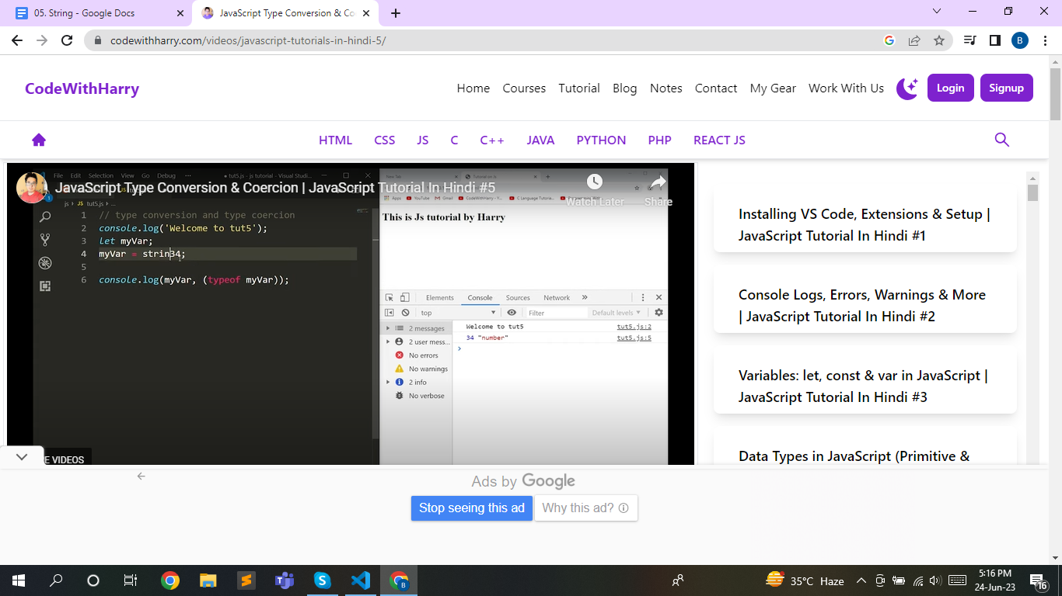

Dount in type of str with str (line 10)

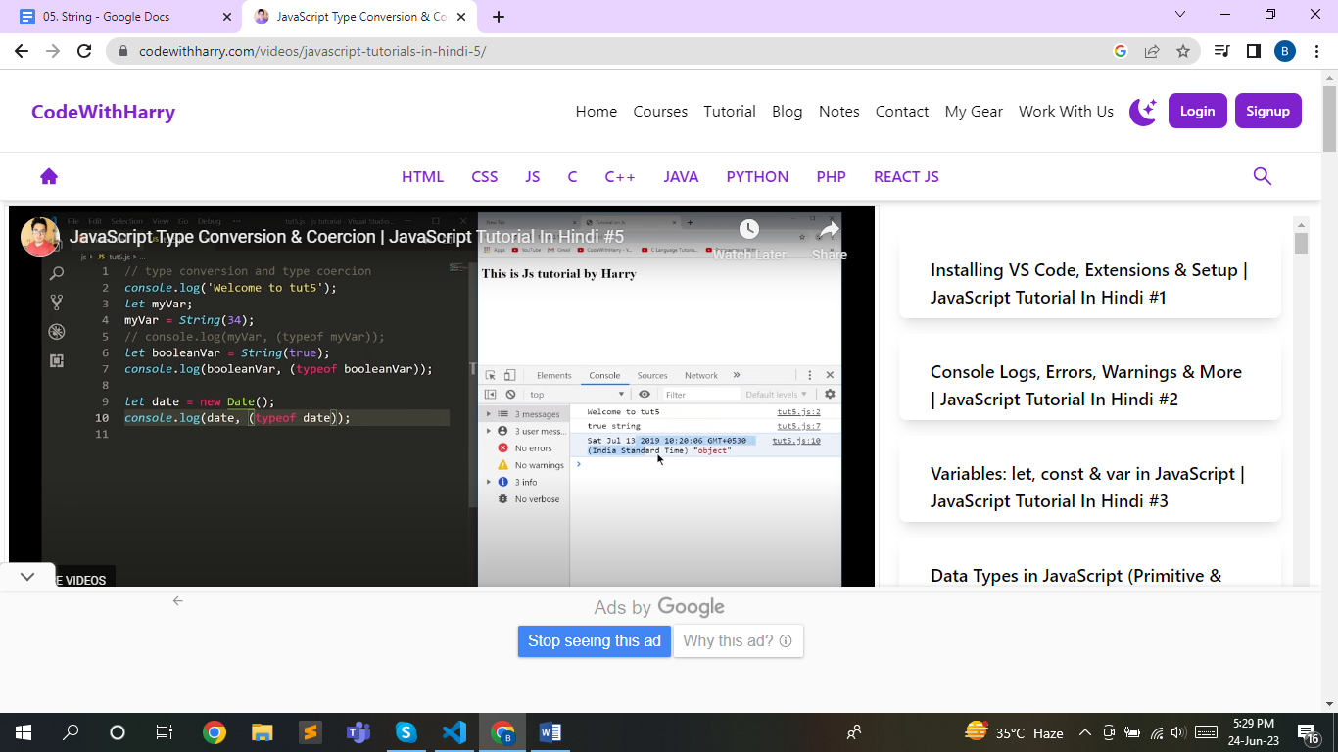

In this case in video object and practical function (line 21,22).

In (line 23,24) when we write string than op also function but in video op is srting.

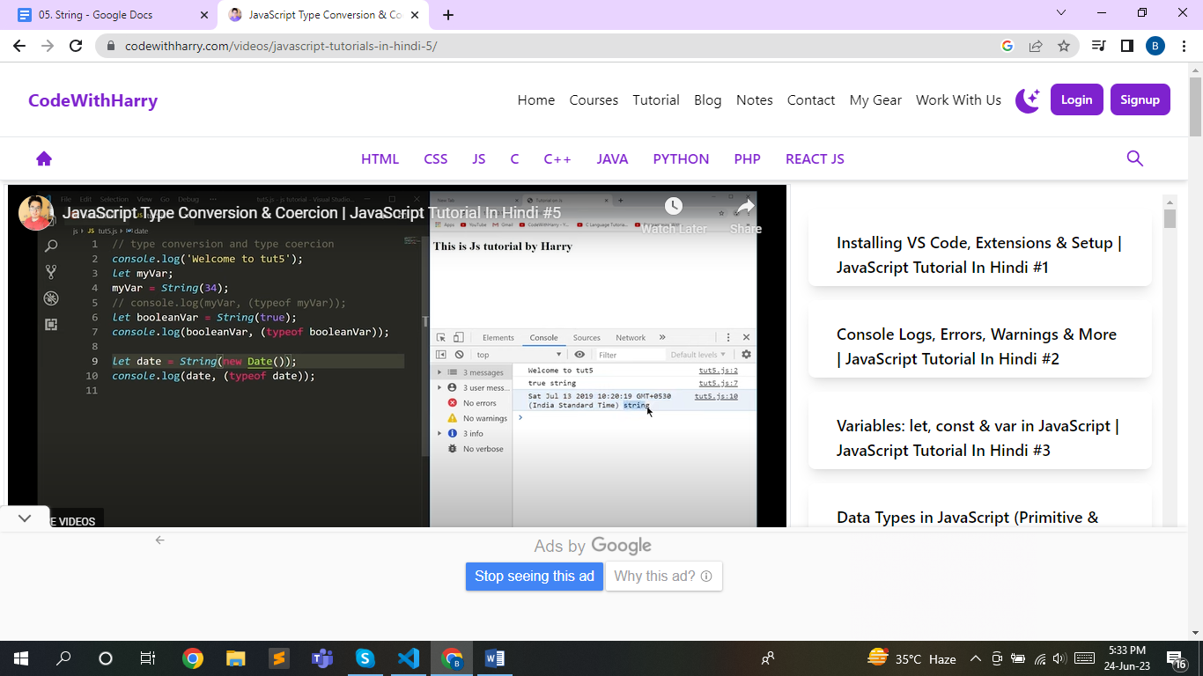

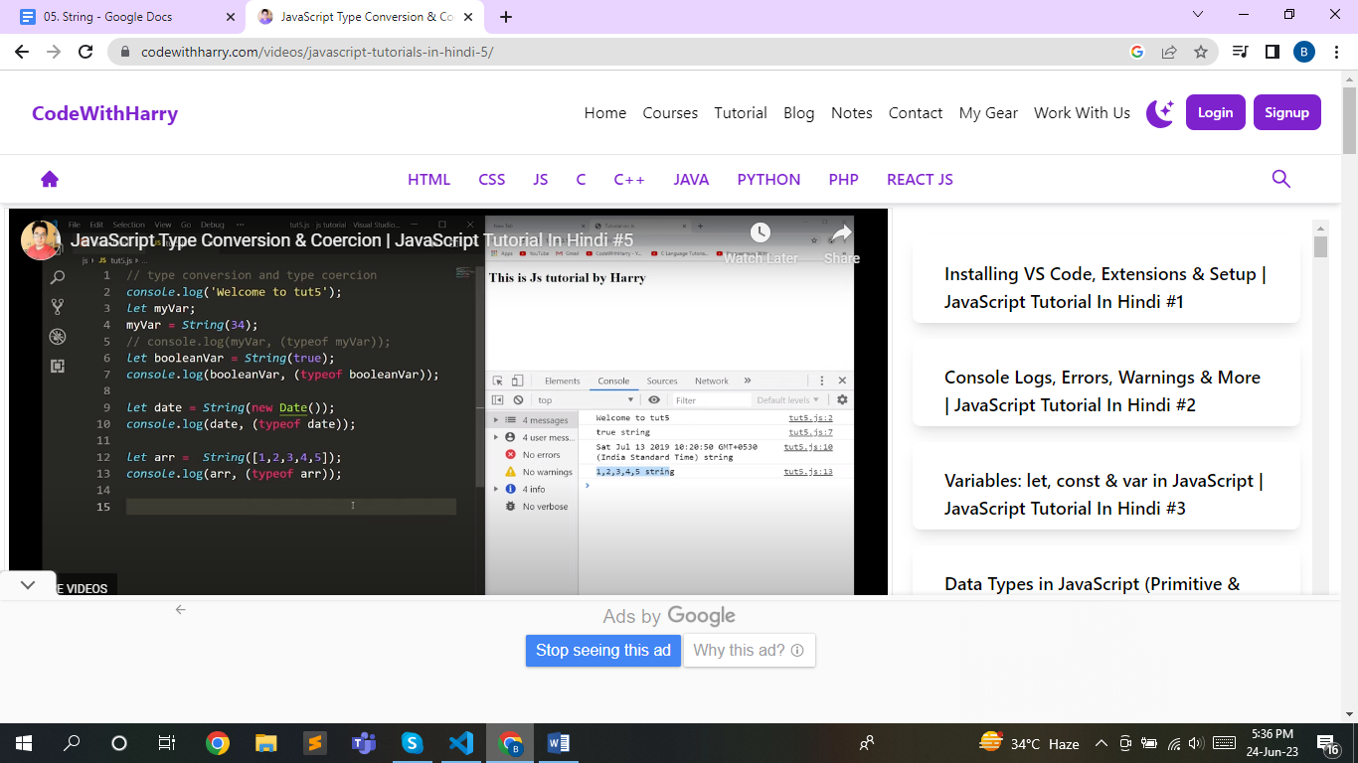

Array op show string also in video shaw string but in char and object not show in uppar case.

Line 137 why I not give his postion is ture. Even in place of 14 is I but it gives also false.

Line 159 in match what is group and why it gives undefined

Dount in mathAll not understand.

Line 192 respace method what is use of d and globale flag ‘g’ . in mamy video it should write.

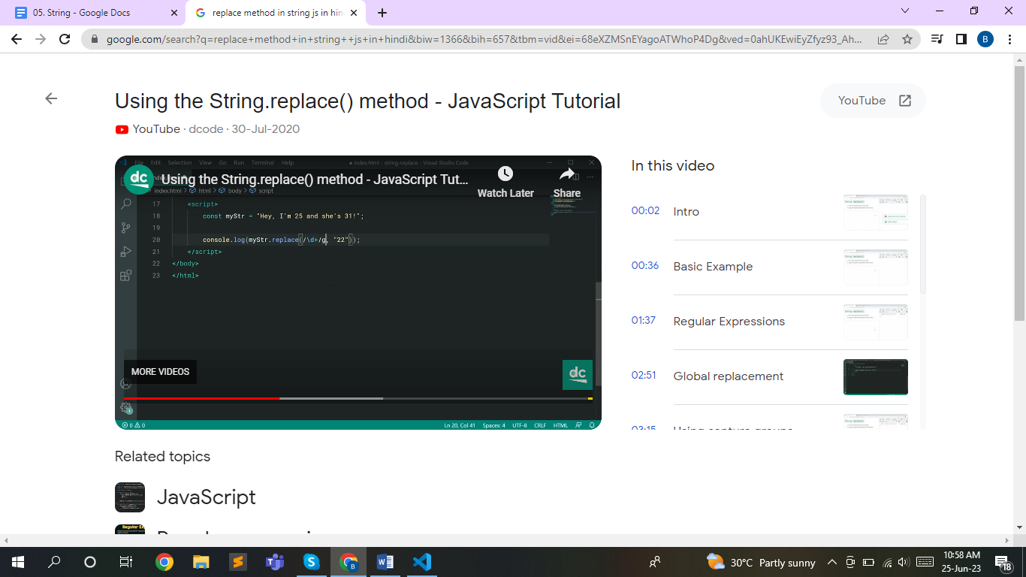

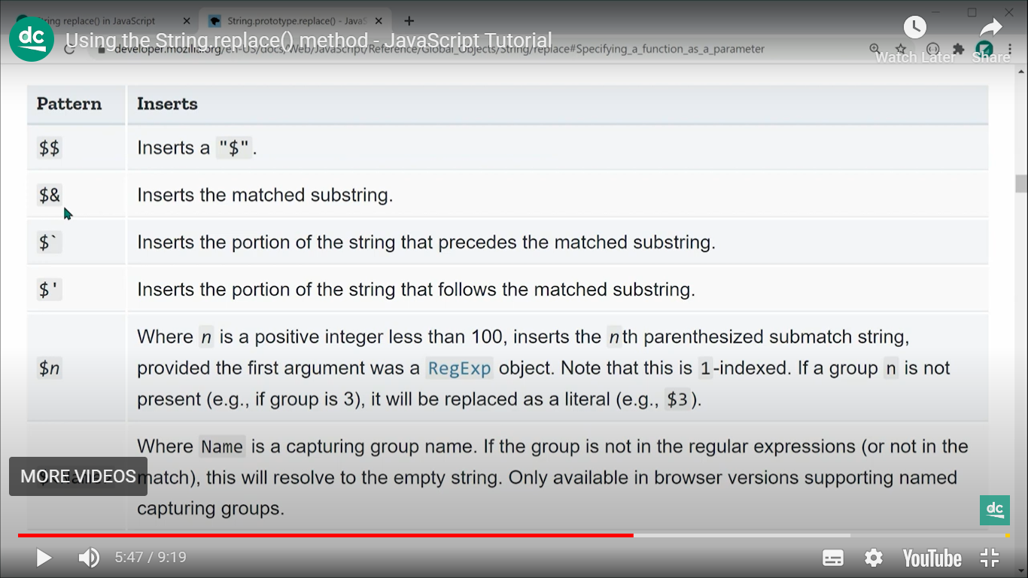

Use in respace key-word.