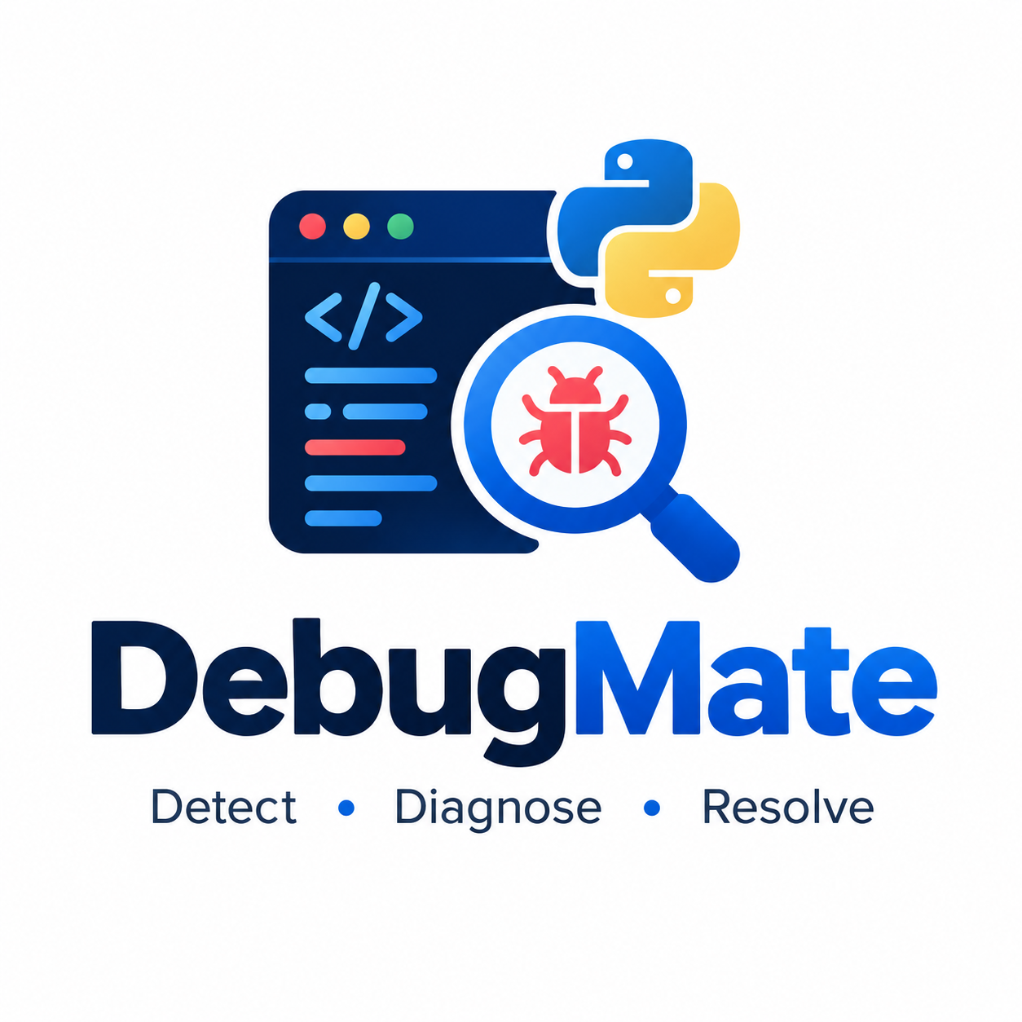

DEBUGMATE
Python Error Diagnosis and Learning Assistant
TECHNICAL PROJECT REPORT

Course: Python Programming
Name:Bhakti Sajjan Wagh
Roll No:58
Class : MCA(SEM I ) ‘B’

1. Abstract
DebugMate is a Python-based web application designed to help learners understand common Python errors. A user pastes an error message or traceback into the application, and the rule-based diagnosis engine identifies supported exception types and returns a beginner-friendly explanation, likely cause, and suggested next step. The application is built with Flask, HTML, CSS, and a MySQL database for storing and reviewing analysis history. Submitted code is treated as text and is not executed by the diagnosis engine. The interface includes an overview dashboard, an error-analysis page, and a history page.

2. Introduction
Python error messages can be difficult for beginners to interpret, especially when a traceback contains multiple lines. DebugMate provides a single web interface where users can paste the error output and receive a structured explanation. The project demonstrates intermediate Python programming concepts together with web development, database integration, input validation, exception handling, and automated testing.

3. Problem Statement
Learners may struggle to identify the meaning and likely cause of Python exceptions from raw terminal output. DebugMate addresses this learning problem by converting supported error messages into clear, organized diagnostic guidance and by allowing previous analyses to be reviewed through a history page.

4. Objectives
- Accept Python error messages and tracebacks through a browser-based form.
- Recognize supported exception types using rule-based text analysis.
- Display the error type, explanation, likely cause, and suggested fix when available.
- Handle empty, malformed, and unsupported inputs with clear status messages.
- Store completed analyses in MySQL and display saved records in the history page.
- Provide an overview dashboard using database-backed values where available.
- Use automated tests to verify diagnosis behavior and application routes.
- Avoid executing user-submitted Python code.

5. Scope

5.1 Included
- Browser-based user interface with Overview, Analyze Error, and History pages.
- Rule-based diagnosis of supported Python exceptions.
- Traceback text extraction and input validation.
- MySQL persistence and retrieval of analysis history.
- Search/filtering of the bounded history list, where implemented.
- Unit tests for diagnosis logic and tests for Flask routes/database behavior.

5.2 Not included
- Executing, compiling, or running submitted code as part of diagnosis.
- A guarantee that every possible Python exception will be diagnosed.
- An external AI/LLM diagnosis service; the current diagnosis approach is rule-based.
- User accounts, cloud deployment, or multi-user access control unless added separately.

6. Functional Requirements
ID | Requirement | Description
FR-01 | Submit error text | The user can paste an error message or traceback into a text area.
FR-02 | Diagnose input | The application analyzes the text using defined diagnosis rules.
FR-03 | Display result | The application displays the diagnosis status and available explanatory guidance.
FR-04 | Validate input | Empty, invalid, malformed, and unsupported inputs receive appropriate messages.
FR-05 | Save analysis | The application attempts to store analysis information in MySQL.
FR-06 | View history | The user can view recent saved analyses and inspect details where available.
FR-07 | Dashboard | The overview presents database-derived summary information when available.

7. Non-Functional Requirements
- Usability: pages should be understandable to beginner Python learners.
- Safety: submitted code must be treated as text and never executed.
- Security: SQL operations should use parameterized queries; submitted text should be rendered safely.
- Maintainability: diagnosis, database access, templates, and tests should remain separated.
- Reliability: expected input problems and database failures should be handled without exposing secrets.
- Responsiveness: the interface should adapt to desktop and smaller screens.

8. Technology Stack
Technology | Role in DebugMate
Python | Core programming language and diagnosis logic.
Flask | Web framework for handling browser requests and rendering pages.
HTML | Structure of the web pages and forms.
CSS / Bootstrap (as used in the project) | Page layout, styling, responsive UI components.
MySQL | Persistent storage for analysis history and dashboard data.
mysql-connector-python | Python-to-MySQL connectivity, as declared by the project setup.
unittest | Automated tests for diagnosis logic and application behavior.

9. System Architecture
DebugMate follows a simple web application architecture. The browser presents the user interface. A Flask route receives the submitted text and passes it to the diagnosis module. The diagnosis module inspects text and returns a structured result without executing the submitted code. The Flask layer renders the result and uses the database layer to save or retrieve history. The dashboard and history templates display values returned by database queries.
Layer | Responsibilities
Presentation layer | HTML templates, shared layout, CSS, navigation, forms, dashboard, and history views.
Application layer | Flask routes, request handling, validation, result rendering, and page flow.
Diagnosis layer | Rule-based traceback/error recognition and structured diagnostic messages.
Database layer | MySQL connection handling, parameterized INSERT/SELECT queries, and history retrieval.
Testing layer | Unit tests for diagnosis rules and tests for routes and database behavior.

9.1 Request flow
- The user opens the Analyze Error page in a browser.
- The user pastes an error message or traceback and submits the form.
- Flask validates the submitted value.
- The diagnosis engine extracts the exception information and applies supported rules.
- The result is returned to the page with a status and explanatory guidance.
- The application attempts to save the analysis to MySQL using parameterized SQL.
- The History page retrieves saved records; the Overview page displays available summary values.

10. Main Modules and Pages

10.1 Diagnosis engine
The diagnosis module analyzes text rather than executing Python. It recognizes configured exception names, extracts the final exception from a traceback when possible, and distinguishes supported, unknown, invalid, and malformed input outcomes. For supported errors, it supplies explanatory text and suggested next steps. Unsupported exceptions are reported as unknown instead of being presented as a confident diagnosis.

10.2 Analyze Error page
The Analyze Error page provides a large text area for a Python error message or traceback, an Analyze Error action, a Clear Input action, and an area for diagnosis results. The page also communicates that submitted content is treated as text and that the application does not run it.

10.3 Overview dashboard
The Overview page presents summary cards and recent activity based on database query results. Values should be derived from stored data rather than hardcoded demonstration figures. If the database is unavailable, the application should display a clear status instead of misleading statistics.

10.4 History page
The History page lists recent saved analyses, including the error type, status, submission time, and a details/inspect action where implemented. A search field helps users locate records in the displayed history list. An empty state is shown when no analyses have been saved.

10.5 Database module
The database module centralizes MySQL access. Connection details are supplied through environment variables: DB_HOST, DB_PORT, DB_NAME, DB_USER, and DB_PASSWORD. The project configuration discussed during development uses port 3300 on the user's local MySQL setup. Actual connection success depends on the local database service, credentials, schema, and installed connector.

11. Database Design
The application uses MySQL to persist diagnosis history. The exact table and column definitions should be taken from the project's schema.sql file. The application code uses parameterized SQL for database operations. This report does not invent a schema diagram or column list that has not been independently verified.

11.1 Database configuration
Environment variable | Purpose
DB_HOST | MySQL server host, commonly localhost for a local installation.
DB_PORT | MySQL server port; configured as 3300 in the current local setup.
DB_NAME | Database name defined by the project schema.
DB_USER | MySQL account used by the application.
DB_PASSWORD | Password for the configured MySQL account; keep private.

Credentials should not be committed to source control or included in screenshots and project documentation. The actual database name must match schema.sql. The project should be tested with the configured MySQL instance before submission.

12. Input Validation and Error Handling
- Empty or non-text input is treated as invalid.
- Incomplete or malformed traceback text is distinguished from a recognized exception when possible.
- Unsupported exception types receive an unknown status.
- Database failures are handled separately from diagnosis so the user can still receive a diagnosis when saving fails, where the route supports this behavior.
- Sensitive connection details and password values should not be shown in browser messages or logs.

13. Security and Safety Considerations
- Submitted code is analyzed as text; the application must not use exec(), eval(), or subprocess execution on user input.
- SQL statements should use placeholders and parameter values instead of string concatenation.
- HTML templates should escape user-controlled text to reduce cross-site scripting risk.
- Database credentials should be provided through environment variables and excluded from version control.
- Database error messages shown to users should be safe and should not reveal credentials or internal connection details.

14. Testing and Verification
The project includes Python unittest coverage for the diagnosis engine and tests for application routes/database behavior. During development, a reported test run completed with 23 tests discovered: 12 passed, 0 failed, and 11 skipped because Flask route tests were unavailable in that particular environment. This result is environment-specific and should not be presented as a complete live integration test.
A browser screenshot captured during local testing showed a saved NameError record in the History page, with status Supported and a submission timestamp. This is evidence that at least one analysis was saved and retrieved successfully in that local session. A live database integration test and a final local test-suite run should still be recorded separately if performed.
Test ID | Test scenario | Expected result
TC-01 | Submit a supported exception such as NameError. | A matching error type and guidance are displayed.
TC-02 | Submit an empty input. | A helpful validation message is displayed.
TC-03 | Submit an unsupported exception. | The result is reported as unknown without inventing a diagnosis.
TC-04 | Submit incomplete traceback text. | The malformed/incomplete status is handled appropriately.
TC-05 | Submit a valid analysis with MySQL configured. | The diagnosis is shown and the record is saved.
TC-06 | Open History after saving an analysis. | The saved record appears in the history list.
TC-07 | Open History with no records. | A clear empty-state message is displayed.
TC-08 | Open dashboard with saved records. | Summary values are based on database results.
TC-09 | Use search on the history list. | Matching visible records are filtered as intended.
TC-10 | Cause a database connection failure. | A safe, clear warning appears without exposing secrets.

15. Installation and Execution
The following commands assume Python is installed and PowerShell is opened in the DebugMate project folder.

15.1 Install dependencies
python -m pip install -r requirements.txt

15.2 Configure database environment
Set the values to match the actual schema and MySQL account. The password is a placeholder and must not be copied literally.
$env:DB_HOST = "localhost"
$env:DB_PORT = "3300"
$env:DB_NAME = "YOUR_DATABASE_NAME"
$env:DB_USER = "YOUR_MYSQL_USERNAME"
$env:DB_PASSWORD = "YOUR_MYSQL_PASSWORD"
Run schema.sql using a MySQL account with permission to create the required database/tables, following the actual schema file.

15.3 Start the application
python app.py
Open http://127.0.0.1:5000 in a browser. The application pages used during local verification include /, /dashboard, and /history.

15.4 Run tests
python -m unittest discover -s tests -v

16. Limitations
- Diagnosis depends on the configured rules and supported exception types.
- The application does not execute code or reproduce the user's runtime environment.
- It may not correctly diagnose custom exceptions or complex multi-error situations.
- History and dashboard features depend on a correctly configured MySQL service and schema.
- The test results vary by environment; skipped route tests must be rerun after dependencies are installed.

17. Future Enhancements
- Expand the diagnosis rule library and improve explanations for additional Python exceptions.
- Add more structured traceback parsing and highlight the final exception line.
- Provide safe, user-editable examples for common errors.
- Add export of analysis history to CSV or PDF.
- Add user accounts and per-user history if the project scope requires multi-user access.
- Improve automated test coverage for live Flask routes and MySQL integration.
- Add deployment configuration and production-grade logging after local validation.

Application Module Screenshots
This section documents the DebugMate web interface. The screenshots show the analysis form and history workflow. The dashboard visual is included as a design reference; it should not be presented as a live application screen unless that dashboard is implemented in the running build.

1. Overview Dashboard — Design Reference
A visual dashboard concept showing how summary cards, error breakdowns, recent analyses, and navigation could be presented. This is a design reference, not evidence of a live dashboard unless it matches the current application.
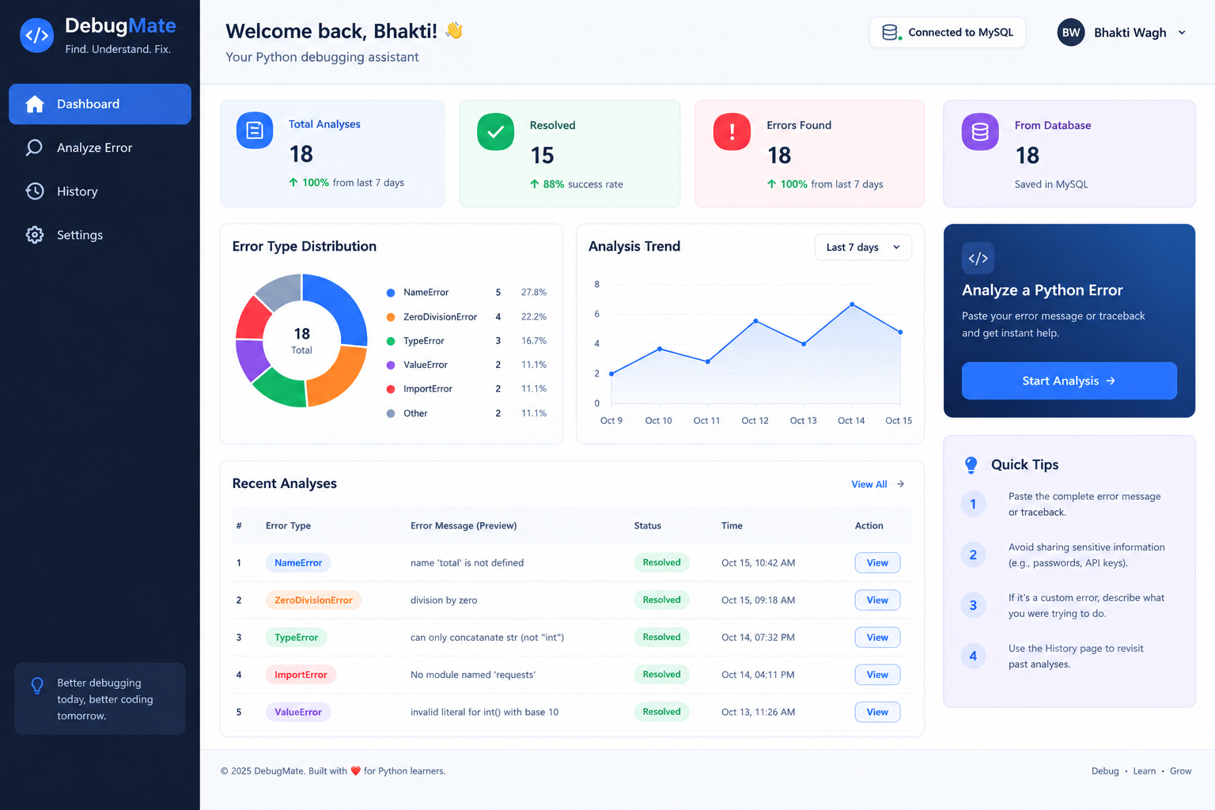

2. Analyze Error Module
The Analyze Error page allows a user to paste a Python error message or traceback. DebugMate processes the submitted text using its rule-based diagnosis engine and displays an explanation and suggested next step. Submitted code is treated as text and is not executed.
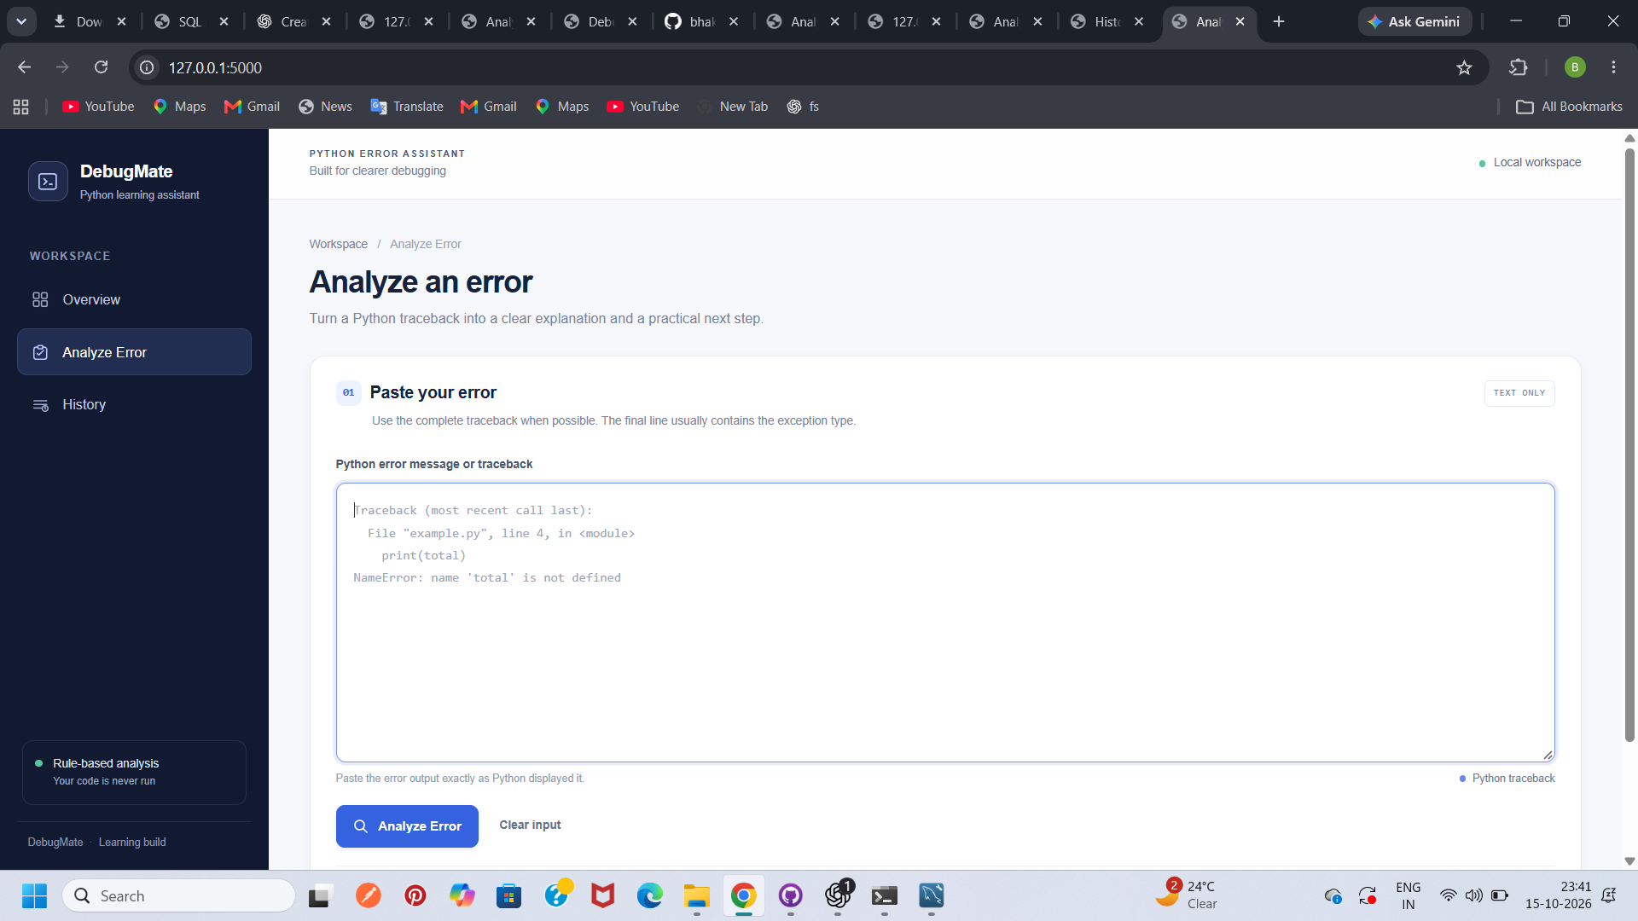

3. History Module — Empty State
The History page displays an empty-state message when there are no saved analyses available.
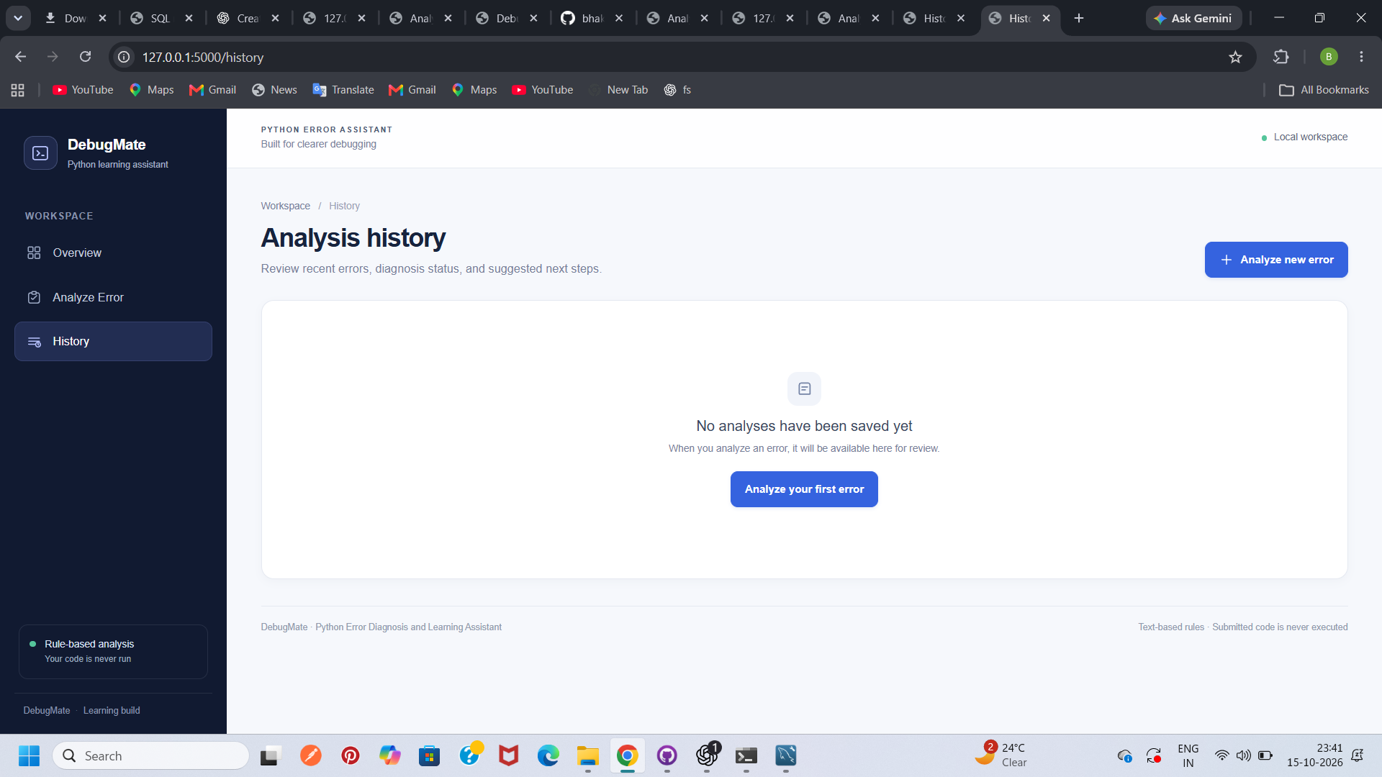

4. History Module — Saved Analysis
When an analysis has been saved, the History page lists the error type, status, submission time, and an option to inspect the record.
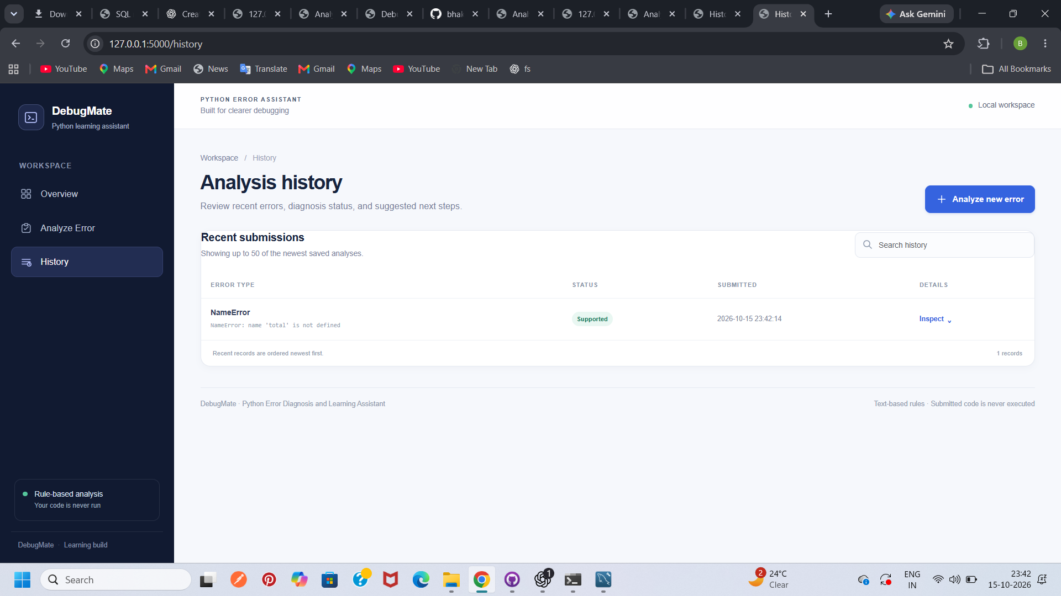
Screenshot note: The images document visible interface states only. Database connectivity and environment-variable configuration should be verified separately in the target environment.

Conclusion
DebugMate is a Python-based web application designed to help learners understand common Python errors. Users can submit an error message or traceback as text, and the rule-based diagnosis engine identifies supported exception types and provides an explanation, likely causes, and suggested fixes.
The application combines a web interface with Python diagnosis logic and a database layer intended to store analysis history. Its Analyze Error and History modules provide the main user workflow, while input validation and automated tests help improve reliability. Submitted code is treated as text and is not executed by the application.
This project demonstrates the practical use of intermediate Python programming concepts, web application development, modular design, database integration, and software testing. Future improvements may include expanding the diagnosis rules, adding more learning examples, and strengthening deployment and database verification.
Overall, DebugMate provides a foundation for a beginner-friendly debugging assistant and supports the goal of making Python errors easier to understand through clear explanations and practical next steps.

