Bhakti Gohil(1099) - HTML practicals

Practical 1

**Code:**

<html>

<head>

    <title>time table</title></head>

    <body>

<table border="1" cellspacing="0" style="text-align: center;">

    <tr>

<th colspan="6">

Time Table

</th>

</tr>

<tr>

    <th rowspan="6">Hours</th>

    <th> Monday </th>

    <th> Tuesday </th>

    <th> wednesday </th>

    <th> Thursday </th>

    <th> Friday </th>

</tr>

<tr>

<td>Math</td>

<td>Science</td>

<td>Math</td>

<td>Science</td>

<td>Arts</td>

</tr>

<tr>

    <td>Math</td>

    <td>Science</td>

    <td>Math</td>

    <td>Science</td>

    <td>Arts</td>

    </tr>

<tr>

        <th colspan="5">Lunch</th>

    </tr>

    <tr>

        <td>Math</td>

        <td>Science</td>

        <td>Math</td>

<td rowspan="2" colspan="2" style="text-align: center;">Project</td>

</tr>

          <tr>

            <td>Math</td>

            <td>Science</td>

            <td>Math</td>    </tr>

</tr>

</tr>

</table>

    </body>

</html>

Output:

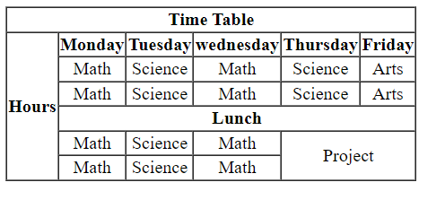

Practical 2:

Code:

<html>

<head>

    <title>time table</title></head>

    <body>

<table border="2" cellspacing="3" style="text-align: center;">

    <h2 style="text-align:left;">Time Table:</h2>

<tr>

    <th>Day/period </th>

    <th>I<br> 9:30-10:20</th>

    <th>II<br> 10:20-11:10</th>

    <th>III<br> 11:10-12:00</th>

    <th>12:00-<br>12:40</th>

    <th>IV<br> 12:40-1:30</th>

    <th>V<br> 1:30-2:20</th>

    <th>VI<br> 2:20-3:10</th>

    <th>VII<br> 3:10-4:00</th>

   <tr>

    <td>Monday</td>

    <td> Eng </td>

    <td> Math </td>

    <td> Che </td>

    <td rowspan="5"> LUNCH </td>

    <td colspan="3">LAB </td>

    <td>Phy</td>

    </tr>

<tr>

    <td>Tuesday</td>

    <td colspan="3" >LAB </td>

    <td> Eng </td>

    <td> Che </td>

    <td> math </td>

    <td>SPORTS</td>

</tr>

<tr>

    <td>Wednesday</td>

    <td> Math</td>

    <td> Phy </td>

    <td> Eng </td>

    <td>Che</td>

    <td colspan="3">LIBRARY </td>

</tr>

<tr>

    <td>Thursday</td>

    <td> Phy </td>

    <td> Eng </td>

    <td> Che </td>

    <td colspan="3">LAB </td>

    <td>Math</td>

</tr>

<tr>

    <td>Friday</td>

    <td> Phy </td>

    <td> Eng </td>

    <td> Che </td>

    <td colspan="3">LAB </td>

    <td>Math</td>

</tr>

</tr>

</table>

    </body>

</html>

Output:

