Bhakti Gohil(1099) - Assignment 2

**Q-1:**

**HTML file:**

<html>

<head>

    <meta charset="UTF-8">

    <meta name="viewport" content="width=device-width, initial-scale=1.0">

    <title>CSS Selectors Example</title>

    <link rel="stylesheet" href="styles.css">

</head>

<body>

    <h1>Welcome to My Website</h1>

    <p class="intro">This is a example of class selectors.</p>

    <p id="unique-element">this is paragraph about ID selector</p>

    <p>This paragraph has no special class.</p>

    <ul>

        <li>Item 1</li>

        <li>Item 2 </li>

        <li>Item 3</li>

    </ul>

    <a href="#">Click Here</a>

</body>

</html>

**Q-1: CSS Practical** Style.css

h1 {

    color: rgb(231, 20, 111);

    text-align: center;

    font-style: italic;

}

.intro {

    font-style: italic;

    color: green;

    font-size: larger;

}

#unique-element {

    font-weight: bold;

    background-color: yellow;

    padding: 10px;

    border: 2px solid black;

}

a:hover {

    color: red;

    text-decoration: underline;

}

**Output:**

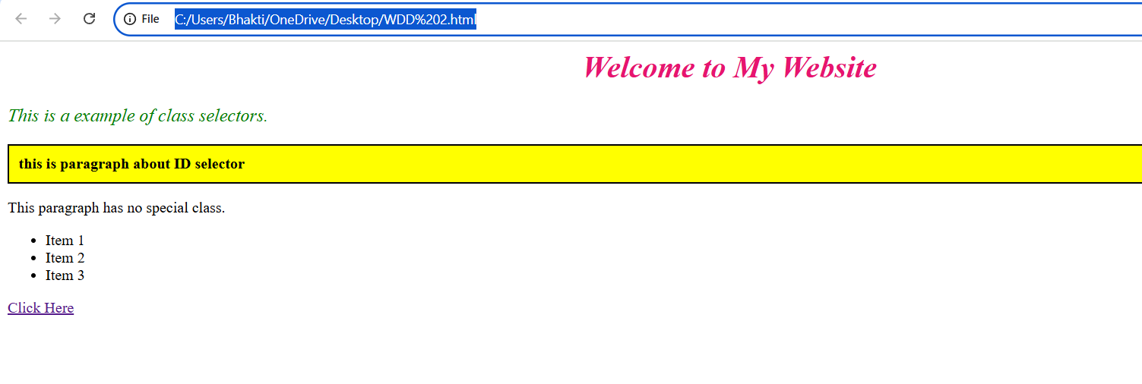

**Q-2:**

**HTML:**

<!DOCTYPE html>

<html lang="en">

<head>

    <meta charset="UTF-8">

    <meta name="viewport" content="width=device-width, initial-scale=1.0">

    <title>CSS Box Model Example</title>

    <link rel="stylesheet" href="styless.css">

</head>

<body>

    <h2>Box Model Example</h2>

        <p>This div demonstrates the CSS box model, including margin, border, padding, and content.</p>

    <div class="box">

        This is a example of box Model

    </div>

</body>

</html>

**CSS:**

.box {

    width: 50%;

    margin: 40px auto;

    padding: 20px;

    border: 3px solid rgb(209, 8, 8);

    background-color: rgb(122, 205, 118);

    text-align: center;

}

**Output:**

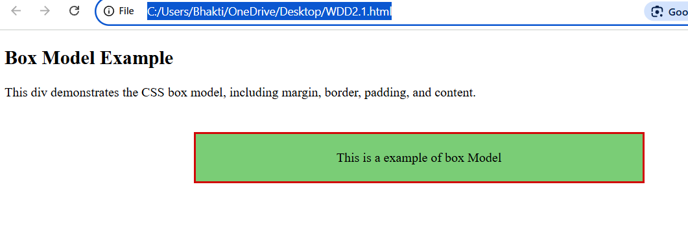

**Q-3:**

<html>

    <head>

        <title>

            Registration form

        </title>

    </head>

    <body>

        Enter Your Name<br>

        <input type="text"><br>

        Enter Your Email<br>

        <input type="email"><br>

        <input type="radio" name="gender" value="female">female

        <input type="radio" name="gender" value="male">male<br>

        <input type="checkbox" id="singing" name="interests" value="singing">singing

        <input type="checkbox" id="dancing" name="interests" value="dancing">dancing

        <input type="checkbox" id="art" name="interests" value="art">art

        <input type="checkbox" id="reading" name="interests" value="reading">reading<br>

        <br>Enter your Preferences for connecting you<br>

        <input type="radio" name="Preferred contact method" value="SMS">SMS

        <input type="radio" name="Preferred contact method" value="whatsapp">Whatsapp

        <input type="radio" name="Preferred contact method" value="call">Call<br>

        <button type="submit">submit</button><br>

        <br><button type="reset">reset</button><br>

    </body>

</html>

**Output:**

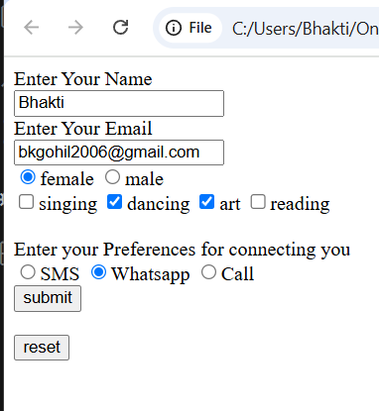

**Q-4:**

<!DOCTYPE html>

<html lang="en">

<head>

    <meta charset="UTF-8">

    <meta name="viewport" content="width=device-width, initial-scale=1.0">

    <title>Flexbox Box Model Example</title>

    <link rel="stylesheet" href="stylesss.css">

</head>

<body>

    <div class="container">

        <div class="box">Item 1</div>

        <div class="box">Item 2</div>

    </div>

</body>

</html>

**CSS:**

.container {

    width: 80%;

    height: 200px;

    margin: 50px auto;

    padding: 20px;

    border: 3px solid black;

    background-color: lightgray;

    display: flex;

    justify-content: space-between;

    align-items: center;

}

.box {

    width: 100px;

    height: 100px;

    background-color: skyblue;

    border: 2px solid darkblue;

    text-align: center;

    line-height: 100px;

    font-weight: bold;

}

**Output:**

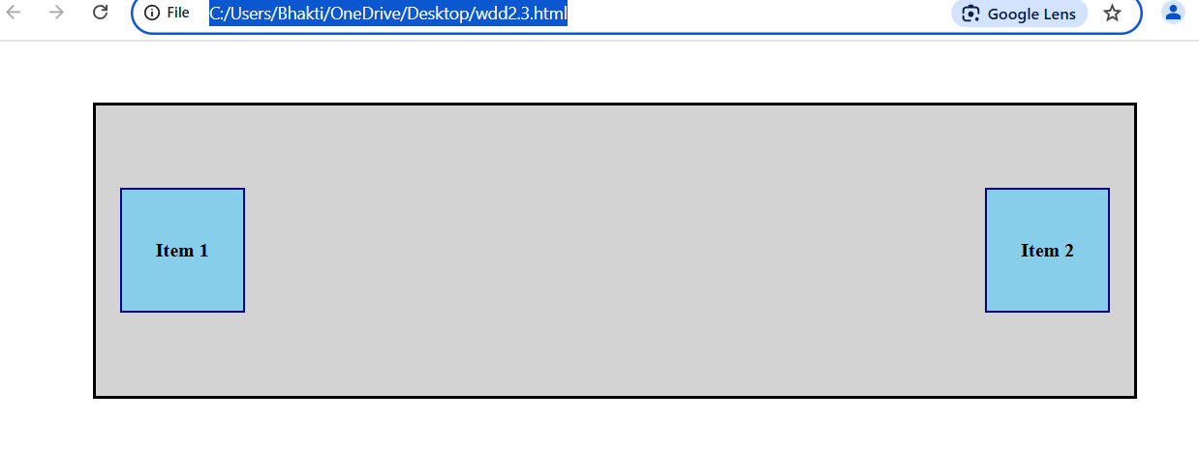

**Q-5:**

<!DOCTYPE html>

<html lang="en">

<head>

    <meta charset="UTF-8">

    <meta name="viewport" content="width=device-width, initial-scale=1.0">

    <title>Responsive Media Query Example</title>

    <link rel="stylesheet" href="stylessss.css">

</head>

<body>

    <div class="container">

        <h2>Responsive Design</h2>

        <p>Resize the window to see the background color and font size change.</p>

    </div>

</body>

</html>

**CSS:**

.container {

    width: 80%;

    margin: 50px auto;

    padding: 20px;

    border: 3px solid black;

    background-color: lightblue;

    text-align: center;

}

h2 {

    font-size: 32px;

}

p {

    font-size: 18px;

}

@media (max-width: 600px) {

    .container {

        background-color: lightcoral;

        text-align: center;

    }

    h2 {

        font-size: 24px;

    }

    p {

        font-size: 16px;

    }

}

@media (min-width: 601px) and (max-width: 900px) {

    .container {

        background-color: lightgreen;

    }

  h2 {

        font-size: 28px;

    }

    p {

        font-size: 17px;

    }

}

**Output:**

