**Assignment-3 WDD**

**Q-1:**

HTML:

<!DOCTYPE html>

<html lang="en">

<head>

    <meta charset="UTF-8">

    <meta name="viewport" content="width=device-width, initial-scale=1.0">

    <title>Grid</title>

<link rel="stylesheet" href="grid.css">

</head>

<body>

    <div class="container">

<div class="grid-item item1">1.</div>

<div class="grid-item item2">2.</div>

<div class="grid-item item3">3.</div>

<div class="grid-item item4">4.</div>

<div class="grid-item item5">5.</div>

<div class="grid-item item6">6.</div>

<div class="grid-item item7">7.</div>

<div class="grid-item item8">8.</div>

<div class="grid-item item9">9.</div>

    </div>

</body>

</html>

**CSS:**

*{

    padding:0;

    margin:0;

    box-sizing: border-box;

}

body{

    height:100vh;

    width:100vw;

}

.container{

    background-color: rgb(242,234,234);

    height:100%;

    width: 100%;

    display: grid;

    padding: 4rem;

gap:10px;

grid-template-columns: repeat(3,1fr);

grid-template-rows: repeat(3,1fr);

}

.grid-item{

    background-color: rgb(94,94,194);

    text-align: center;

    padding: 53px;

    color:white;

}

.item1{background-color: rgb(93,213,240);}

.item2{background-color: rgb(255,69,0);}

.item3{background-color: rgb(65,105,225);}

.item4{background-color: rgb(255,215,0);}

.item5{background-color: rgb(128,0,128);}

.item6{background-color: rgb(0,128,0);}

.item7{background-color: rgb(255,127,80);}

.item8{background-color: rgb(32,178,170);}

.item9{background-color: rgb(139,0,0);}

@media(max-width:658px){

    .grid-item{

        color:black;

    }

    .item1{background-color: rgb(255,153,153);}

    .item2{background-color: rgb(255,204,153);}

    .item3{background-color: rgb(255,255,153);}

    .item4{background-color: rgb(204,255,153);}

    .item5{background-color: rgb(153,255,204);}

    .item6{background-color: rgb(153,204,255);}

    .item7{background-color: rgb(204,153,255);}

    .item8{background-color: rgb(255,153,204);}

    .item9{background-color: rgb(211,211,211);}

}

**Output:**

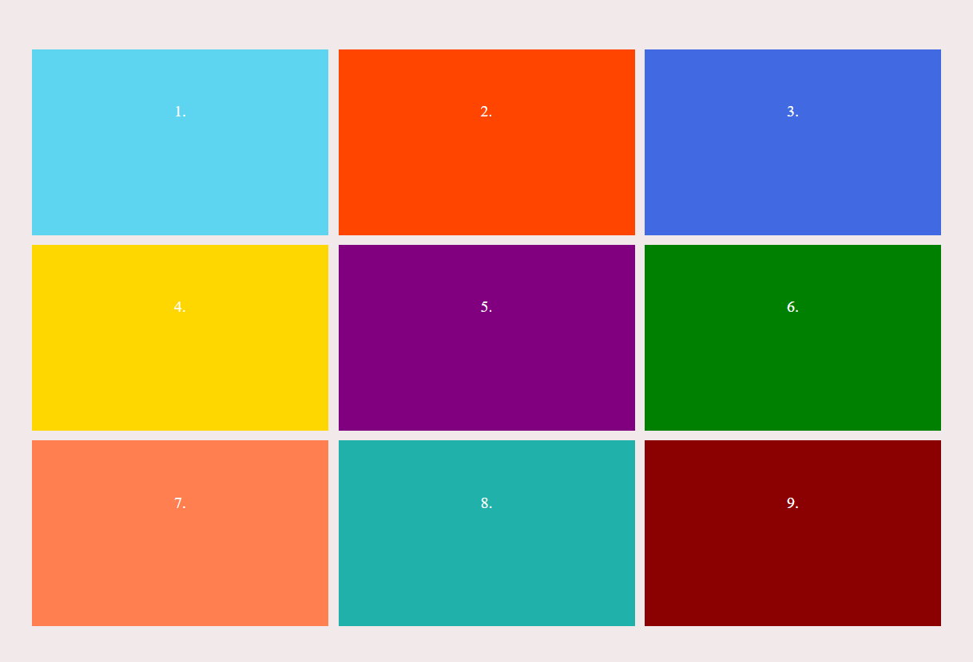

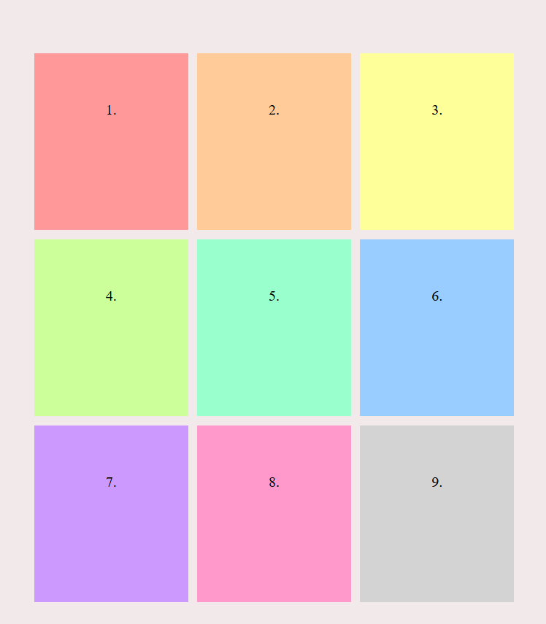

**Q-2:**

HTML:

<!DOCTYPE html>

<html lang="en">

<head>

    <meta charset="UTF-8">

    <meta name="viewport" content="width=device-width, initial-scale=1.0">

    <title>Time table</title>

<link rel="stylesheet" href="table2.css">

</head>

<body><h3>COLLEGE TIME TABLE</h3>

    <table border="2">

        <tr>

            <td></td>

            <td>8:30-9:30</td>

            <td>9:30-10:30</td>

            <td>10:30-11:30</td>

            <td>11:30-12:30</td>

            <td>12:30-2:00</td>

            <td>2:00-3:00</td>

            <td>3:00-4:00</td>

            <td>4:00-5:00</td>

        </tr>

        <tr>

            <td>MONDAY</td>

        <td>---</td>

        <td><div class="SUB1">SUB1</div></td>

        <td><div class="SUB2">SUB2</div></td>

        <td><div class="SUB3">SUB3</div></td>

        <td rowspan="6">L<br>U<br>N<br>C<br>H</td>

        <td><div class="SUB4">SUB4</div></td>

        <td><div class="SUB5">SUB5</div></td>

        <td><b>COUNSELLING CLASS</b></td></tr>

        <tr>

            <td>TUESDAY</td>

        <td><div class="SUB1">SUB1</div></td>

        <td><div class="SUB2">SUB2</div></td>

        <td><div class="SUB3">SUB3</div></td>

        <td>---</td>

        <td><div class="SUB2">SUB2</div></td>

        <td><div class="SUB2">SUB2</div></td>

    <td>LIBRARY</td></tr>

    <tr><TD>WEDNESDAY</TD>

    <TD><div class="SUB1">SUB1</div></TD>

    <TD><div class="SUB2">SUB2</div></TD>

    <TD><div class="SWA">SWA</div></TD>

    <TD>---</TD>

    <TD colspan="3">LAB</TD></tr>

    <tr><td>THURSDAY</td>

    <td><div class="SUB1">SUB1</div></td>

    <td><div class="SUB2">SUB2</div></td>

    <td><div class="SUB3">SUB3</div></td>

    <td>---</td>

    <td><div class="SUB2">SUB2</div></td>

    <td><div class="SUB2">SUB2</div></td>

    <td>LIBRARY</td></tr>

    <tr><TD>FRIDAY</TD>

    <TD><div class="SUB1">SUB1</div></TD>

    <TD><div class="SUB2">SUB2</div></TD>

    <TD><div class="SUB3">SUB3</div></TD>

    <TD>---</TD>

    <TD><div class="SUB4">SUB4</div></TD>

    <TD><div class="SUB5">SUB5</div></TD>

    <TD>LIBRARY</TD></tr>

    <tr><TD>SATURDAY</TD>

    <TD><div class="SUB1">SUB1</div></TD>

    <TD colspan="3"><b>SEMINAR</b></TD>

    <TD><div class="SUB4">SUB4</div></TD>

    <TD><div class="SUB5">SUB5</div></TD>

    <TD>LIBRARY</TD></tr>

    </table>

</body>

</html>

**CSS:**

body{

    text-align: center;

    align-items: center;

    font-family: Arial, Helvetica, sans-serif;

}

table{

    margin:0 auto;

    justify-content: center;

}

.SUB1{

    color:rgb(59, 59, 222);

    font-weight: bold;

    }

    .SUB2{

color:orange;

font-weight: bold;

    }

    .SUB3{

        color:purple;

        font-weight: bold;

    }

    .SUB4{

        color:green;

        font-weight: bold;

    }

    .SUB5{

        color:red;

        font-weight: bold;

    }

**OUTPUT:**

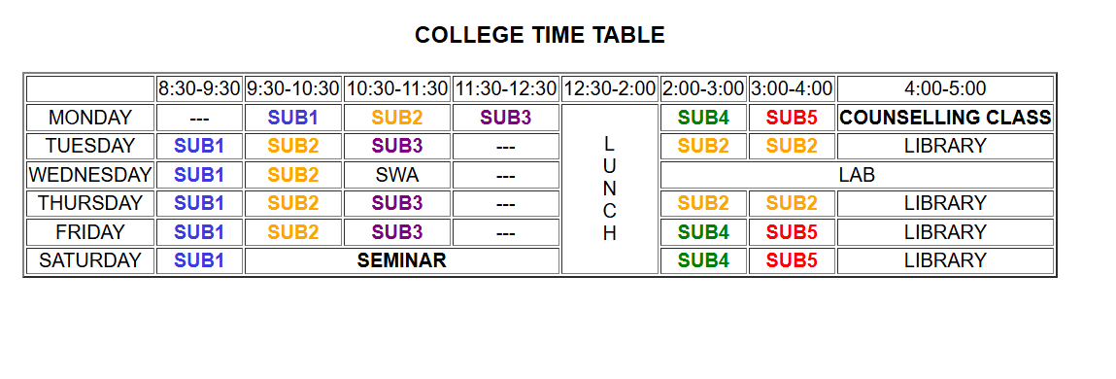

**Q-3:**

**HTML:**

<!DOCTYPE html>

<html lang="en">

<head>

    <meta charset="UTF-8">

    <meta name="viewport" content="width=device-width, initial-scale=1.0">

    <title>Table</title>

    <link rel="stylesheet" href="table1.css">

</head>

<body>

    <b>My Time Table</b>

    <table border="2">

        <tr>

            <th rowspan="2">Day</th>

            <th colspan="2">Session</th>

        </tr>

        <tr>

            <th>Schedule</th>

            <th>Course Name</th>

        </tr>

        <tr>

            <td>Sunday</td>

            <td>16:00-16:50</td>

            <td>Web Technology</td>

        </tr>

        <tr>

            <td>Sunday</td>

            <td>17:00-17:50</td>

            <td>Network Management</td>

        </tr>

        <tr>

            <td>Monday</td>

            <td>18:00-18:50</td>

            <td>IT Project Management</td>

        </tr>

        </table>

</body>

</html>

**CSS:**

body{

text-align: center;

}

table{

    justify-content: center;

margin: 0 auto;

}

**OUTPUT:**

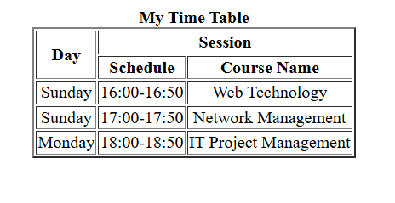

**Q-4:**

**HTML:**

<!DOCTYPE html>

<html lang="en">

<head>

    <meta charset="UTF-8">

    <meta name="viewport" content="width=device-width, initial-scale=1.0">

    <title>Centered Box</title>

<link rel="stylesheet" href="box.css">

</head>

<body>

    <div class="container">

<div class="box">

    Center Box

</div>

    </div>

</body>

</html>

**CSS:**

.container{

    display:flex;

    justify-content: center;

    align-items: center;

    height: 100vh;

    background-color: rgb(240,240,240);

}

.box{

    padding:40px 60px;

background-color: rgb(76,175,80);

color:white;

font-size:24px;

border-radius: 10px;

box-shadow: 0 4px 10px rgba(0,0,0,0.2);

}

**OUTPUT:**

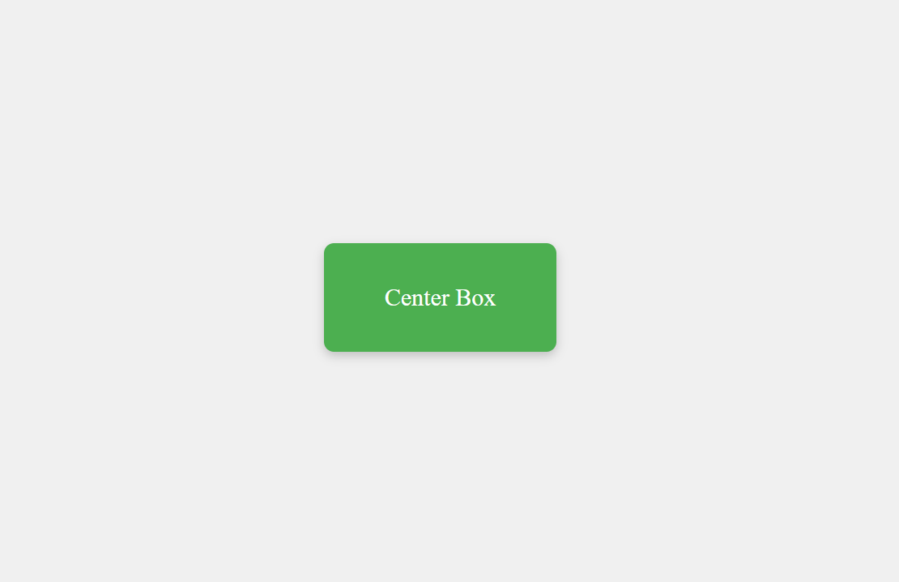

**Q-5:**

**HTML:**

<!DOCTYPE html>

<html lang="en">

<head>

  <meta charset="UTF-8">

  <meta name="viewport" content="width=device-width, initial-scale=1">

  <title>Responsive Navbar</title>

  <link rel="stylesheet" href="nav.css">

</head>

<body>

    <nav class="navbar">

        <ul class="nav-links">

          <li><a href="#">Home</a></li>

          <li><a href="#">About</a></li>

          <li><a href="#">Services</a></li>

          <li><a href="#">Contact</a></li>

        </ul>

      </nav>

    </ul>

  </nav>

</body>

</html>

**CSS:**

.navbar {

    display: flex;

    justify-content: center;

    background-color: #333;

    padding: 15px 0;

  }

  .nav-links {

    list-style: none;

    display: flex;

    gap: 40px;

  }

  .nav-links li a {

    text-decoration: none;

    color: white;

    font-size: 18px;

    transition: color 0.3s;

  }

  .nav-links li a:hover {

    color: #ff9800;

  }

  @media (max-width: 600px) {

    .nav-links {

      flex-direction: column;

      align-items: center;

      gap: 15px;

    }

  }

**OUTPUT:**



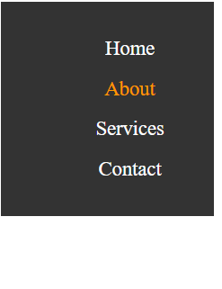

**Q-6:**

**HTML:**

<!DOCTYPE html>

<html lang="en">

<head>

  <meta charset="UTF-8" />

  <meta name="viewport" content="width=device-width, initial-scale=1.0"/>

  <title>Responsive Cards</title>

  <link rel="stylesheet" href="cards.css">

</head>

<body>

  <div class="card-container">

    <div class="card">

      <img src="C:\Users\Bhakti\OneDrive\Pictures\Screenshots\Screenshot 2025-04-06 234157.png">

      <div class="card-content">

        <h3>Nature</h3>

        <p>Explore the beauty of untouched landscapes and natural wonders.</p>

      </div>

    </div>

    <div class="card">

      <img src="C:\Users\Bhakti\OneDrive\Pictures\Screenshots\Screenshot 2025-04-06 234249.png">

      <div class="card-content">

        <h3>Technology</h3>

        <p>Discover the latest trends and innovations in the tech world.</p>

      </div>

    </div>

    <div class="card">

      <img src="C:\Users\Bhakti\OneDrive\Pictures\Screenshots\Screenshot 2025-04-06 234344.png">

      <div class="card-content">

        <h3>Travel</h3>

        <p>Get inspired to travel and experience new cultures and places.</p>

      </div>

    </div>

  </div>

</body>

</html>

**CSS:**

    .card-container {

    display: flex;

    flex-wrap: wrap;

    gap: 20px;

    justify-content: center;

  }

  .card {

    background-color: white;

    border-radius: 10px;

    box-shadow: 0 4px 8px rgba(0,0,0,0.1);

    overflow: hidden;

    flex-basis: 30%;

    max-width: 60%;

    transition: transform 0.3s ease;

  }

  .card:hover{

    background-color: #f1f1f1;

    transform: scale(1.03);

  }

img {

    width: 100%;

    height: 200px;

    display: block;

  }

  .card-content {

    padding: 15px;

  }

h3 {

    margin-top: 0;

  }

  @media (max-width: 900px) {

    .card {

        flex-direction: column;

    }

  }

  @media (max-width: 600px) {

    .card {

        flex-direction: column;

    }

  }

**OUTPUT:**

