**Assignment - 16**

1. What is a Macro? How is it useful in excel or in your daily work?

Ans: A macro is a scripting tool that can help you work more efficiently in programs such as Microsoft Excel. Macros are basic instructions that empower users to automate tasks so they can work on other projects or complex work. Although disabled by default in most programs to prevent attacks from macro viruses, you can enable macros from within the software. In this article, we discuss what a macro is and outline how to enable macros in Microsoft Excel for individual sessions and on a permanent basis, in addition to answering some frequently asked questions.

1. What is VBA? Write its full form and briefly explain why VBA is used in excel?

Ans: Visual Basic for Applications, is a programming language that empowers users to automate tasks and create personalized solutions within Microsoft Excel. It enables users to create macros, which are instructions that automatically perform repetitive tasks.

1. How do you record a macro? Write detailed steps to create a macro to automatically make the following table in bold and to create borders for it in excel?

Ans:On the Developer tab, click Record Macro. Optionally, enter a name for the macro in the Macro name box, enter a shortcut key in the Shortcut key box, and a description in the Description box, and then click OK to start recording.

1. Open the Developer tab. ...
2. Choose to record a macro. ...
3. Provide macro details. ...
4. Perform your chosen actions. ...
5. Complete your macro and stop recording. ...
6. Use your shortcut.

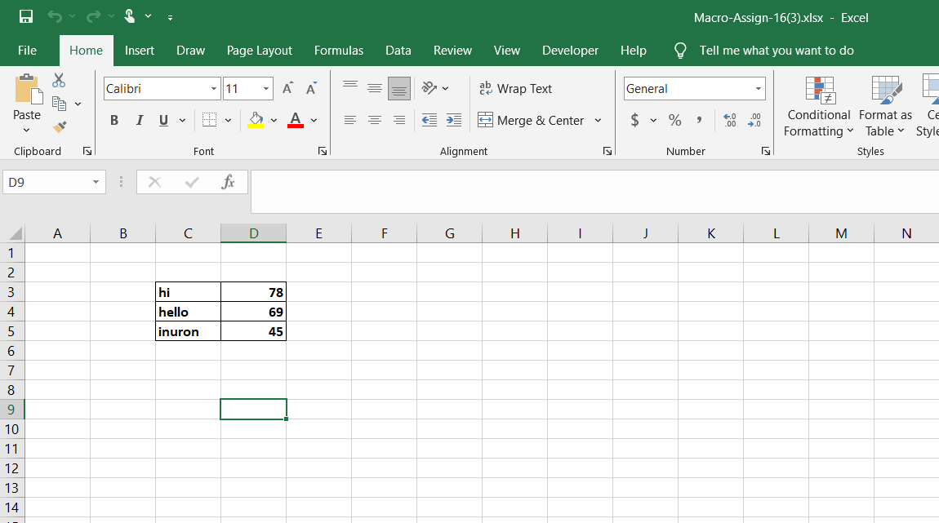

1. What do you mean when we say VBA Editor?

Ans: Microsoft Visual Basic for Applications (VBA) enables non-programmers to record, create, and edit macros that can automate tasks in Office applications.

1. Briefly describe the interface of a VBA editor? What is properties window? And what is watch window? How do you display these windows?

Ans: VBA is an interface for creating scripts. If you have done any programming in the integrated development environment(IDE), the VBA editor in Excel looks similar. It lets you create, manage, and run VBA code on your Excel Spreadsheet.

The [Properties window](https://learn.microsoft.com/en-us/office/vba/language/reference/user-interface-help/properties-window) lists the [design-time](https://learn.microsoft.com/en-us/office/vba/language/glossary/vbe-glossary#design-time) [properties](https://learn.microsoft.com/en-us/office/vba/language/glossary/vbe-glossary#property) for selected objects and their current settings. You can change these properties at design time. When you select multiple controls, the Properties window contains a list of the properties common to all the selected controls.

1. From the **View** menu of the Visual Basic Editor, choose Properties window (F4).
2. Select the object whose properties you want to display. You can either use the mouse to select the object or use the **Project Explorer** to choose from a list.
3. Click the **Alphabetic** tab to display properties in alphabetic order, or choose the **Categorized** tab to display object properties by category.
4. What is an immediate Window and what is it used for?

Ans: The Immediate window evaluates expressions by building and using the currently selected project.

To display the Immediate window, open a project for editing, and then choose Debug > Windows > Immediate or press Ctrl+Alt+I. You can also enter Debug.