1. What are the different margins options and do we adjust the margins of the excel worksheet?

Ans. On the Page Layout tab, in the Page Setup group, click Margins. Do one of the following: To use predefined margins, click Normal, Wide, or Narrow. Tip: If you previously used a custom margin setting, that setting is available as the Last Custom Setting option.

1. Set a background for your table created.

Ans.

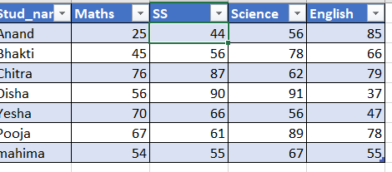

1. What is freeze panes and why do we use freeze panes? Give examples.

To keep an area of a worksheet visible while you scroll to another area of the worksheet, go to the View tab, where you can Freeze Panes to lock specific rows and columns in place, or you can Split panes to create separate windows of the same worksheet.

1. What are the different features available within the Freeze Panes command?

Ans. There is 3 type of Freeze Panes option available in the View menu tab under the Window section, Freeze Panes, Freeze Top Row, and Freeze First Column. Freeze Panes are used to freeze the worksheet from where we keep our cursor. This freezes both the row and column both.

1. Explain what the different sheet options present in excel are and what they do?

a). Open your workbook in Excel.

b) Click on the New Window button for every worksheet you want to view in that workbook.

c) In each new window, click on the tab of the worksheet you want to view.

d) In the following dialog, select your arrangement view.