

**Solution Design Document**

**E-Challan Payment**

**Maharashtra State**



**Revision History**

|  |  |  |  |  |
| --- | --- | --- | --- | --- |
| Version | Purpose | Author | Reviewer | Release Date |
| 1.0 | Initial Document | Bhakti Deshmukh  Ashwini Khandekar | Mr. Parimal Gujarathi | 24th Jan2023 |
|  |  |  |  |  |

**Table of Contents**

**1.** **Functional Requirements Overview** 5

**1.1** **Current Process** 5

**1.2** **Future Process** 5

**2.** **Proposed Solution** 6

**2.1** **BOTs Design** 6

**2.1.1** **BOT Scope** 6

**2.1.2** **BOT Goal and Objective** 6

**2.2** **Design Details** 7

**2.3** **BOTs Workflow** 8

**2.4** **BOTs Detailed Workflow** 11

**a.** **Configuration Details** 12

**b. Error/ Audit Log** 12

**3.** **Technical Design** 13

**3.1** **Technical Architecture** 13

**3.2** **Target System** 13

**4.** **Non-Functional Requirements** 15

**4.1** **Availability Requirements** 15

**4.2** **Volume and Performance Expectations** 15

**5.** **Key Assumptions & Dependencies** 16

**6.Error Handling** 17

**Introduction/Background**

Maharashtra government is to make sure that everyone while driving follows the traffic rules properly. Maharashtra E-Challan Payment is looking forward to automating some of the internal processes by using Automation Anywhere RPA tools.

The purpose of this document is to provide a high-level design describing the technical solution of the fetch and sort the e-challan disclosures automation process.

# **Functional Requirements Overview**

## **Current Process**

Currently, client have to put the vehicle number and Chassis/Engine number manually on the website and then they get the details of challan. For every vehicle owner, client have to fetch details manually and write the challan details in the excel worksheet arrange them in the ascending order on the basis of amount. After that send the output excel worksheet through email to the client.

Client wants to automate this process through a bot using automation anywhere 360 RPA tool. In addition to this, they want to achieve efficiency more than 95% and cost-saving by automating this process.

## **Future Process**

1. Launching the browser and opening https://mahatrafficechallan.gov.in/ website using Browser: Open action in A360.
2. Open the input excel file and read the vehicle details.
3. If vehicle number and chassis/engine number present then click on vehicle number and if challan number present, then click on challan number.
4. Enter the details on the website then handle the captcha and click on submit.
5. Capturing all available challan details.
6. Extracting the amount, towing amount and gst18%, challan number, challan date, driver name, vehicle number, license number, payment status data.
7. Sort the e-challan amount as per the ascending order which are present in the output excel file.
8. Sending the final output excel file to the client.

# **Proposed Solution**

## **BOTs Design**

## **BOT Scope**

In this process, there are two scenarios while getting the details of e-challan details. In the first scenario the vehicle number and chassis/engine number have to be entered in the input text box and in the second scenario the specific challan number has to be mentioned. If for the one vehicle the vehicle number, chassis/engine number and challan number details are present then in this case, go with vehicle number and extract the details to the output excel file.

While handling the captcha sometimes we get the popup if the popup exists then the window shows the message as invalid details.

 The high-level steps to perform the Maharashtra traffic E-challan process:

* Launch the Mahatrafficechallan Website on Google Chrome.
* Check if the Vehicle number and chassis/engine number present in input excel file then Select vehicle number.
* Enter the Vehicle number and chassis/engine number on login page and submit.
* Capture the E-challan details using the Recorder: Capture package in A360.
* Fill the details in the output excel sheet.
* Sort the details in ascending order on the basis of challan amount.
* Send the excel file to the client.

The high-level steps to perform the Maharashtra traffic E-challan process:

* Launch the Mahatrafficechallan Website on Google Chrome.
* Check if challan number present in input excel file, then Select challan number.
* Enter the Vehicle number and chassis/engine number on login page and submit.
* Capture the E-challan details using the Recorder: Capture package in A360.
* Fill the details in the output excel sheet.
* Sort the details in ascending order on the basis of challan amount.
* Send the excel file to the client.

## **BOT Goal and Objective**

The existing process involves a lot of human efforts and hundreds of vehicle details to process every business day. Now, this process is not just time taking but sometimes also involves the risk of the missing details to process the e-challan.

The client wants to automate the process for finding the details of e-challan through Bot developed using Automation Anywhere-A360 RPA tools.

The client wants to achieve more than 95% efficiency, improve accuracy & cost savings by automating this process. Automating this process eliminates the manual process. Automation makes this process faster, scalable, and less error-prone.

## **Design Details**

**TaskBot Used:**

**00_Master Bot:** Master BOT that needs to be pointed to the BOT runner (Scheduler).

* Firstly, bot read configuration settings from the config file. Extraction bot and email bot are run through Master Bot.

**01_Extraction Bot:** This bot contains the procedure of capturing the mahatrafficechallan website and selecting vehicle numbers and chassis/engine number. The bot will extract the challan details, sort the extracted data as per the amount in ascending order and write them to the excel file.

**02_Email_Bot:** Sending output excel file to the client.

## **BOTs Workflow**

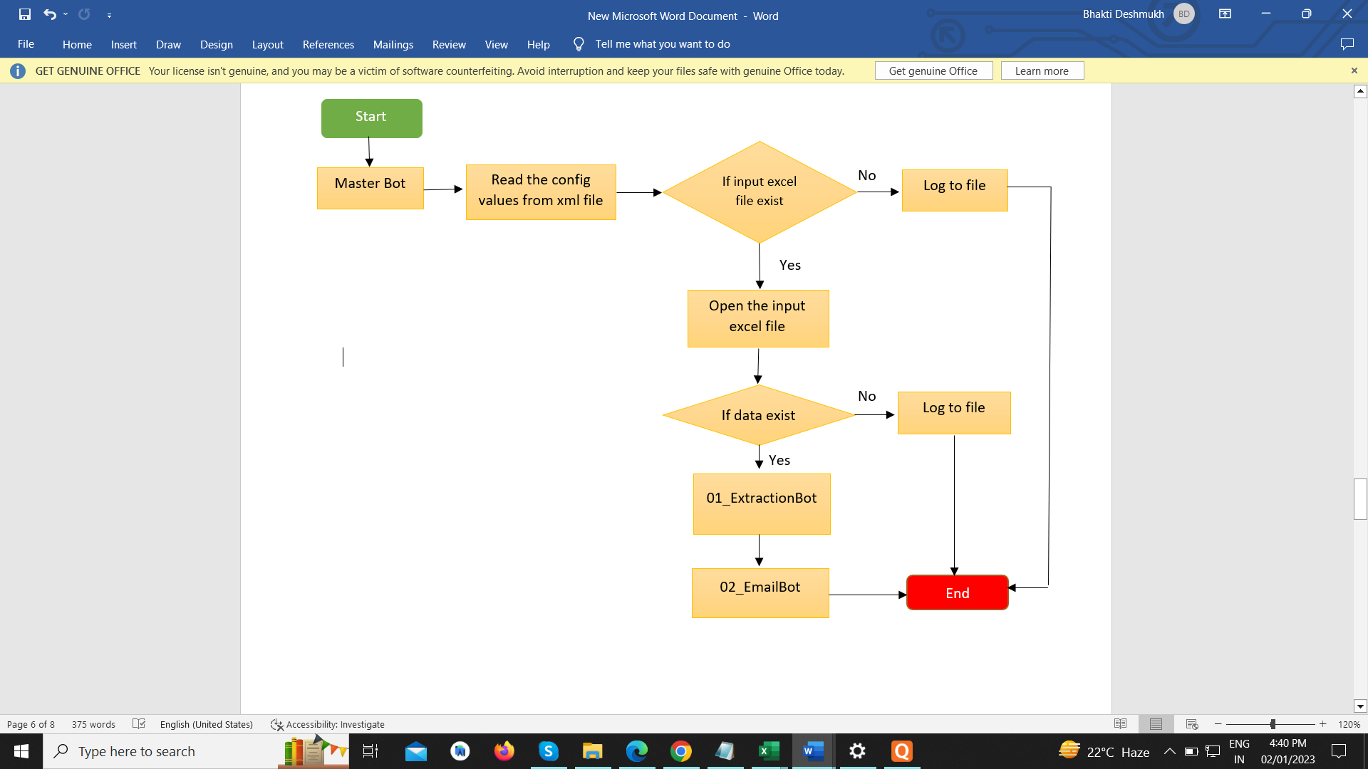

The bot will record audit and error logs at all possible levels during the process run. These log files will help in tracking the bot activity during troubleshooting of the process. All the process of accessing E-challan details will be done by automation.

Diagram 1: Initialization and Extraction Bot

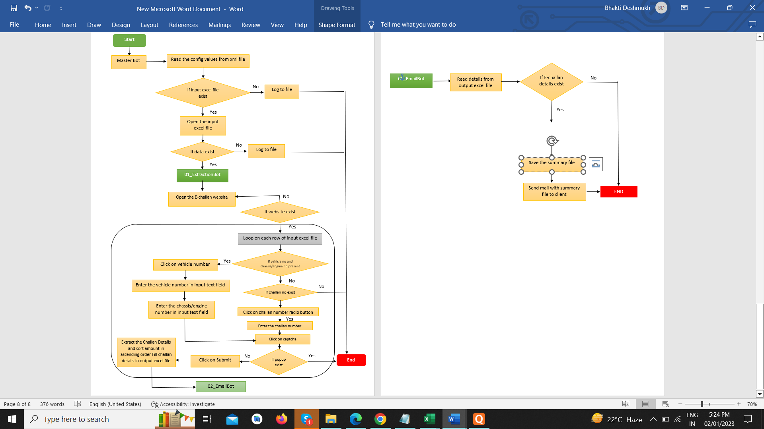

**Diagram 1: Initialization and Data Extraction**

**Diagram 1: Initialization and Extraon of Data**

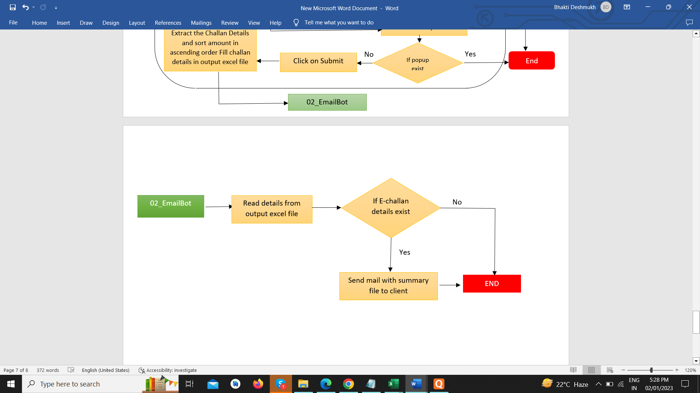

**Diagram 2: Send Mail**

## **BOTs Detailed Workflow**

The high-level steps to perform the Mahatrafficechallan Website process:

1. Read the config file named “config.xml”.
2. If the input “VehicleInput.xlsx” excel file exists then Open the input “VehicleInput.xlsx” excel file.

2.1 If the file does not exist then write a log and stop the process.

1. Read the input “VehicleInput.xlsx” excel file.

3.1 If input excel file does not contain records, then end the process.

1. Browse the e-challan website at <https://mahatrafficechallan.gov.in/>
2. If a web page exists, loop on each row of the input excel file.
3. If a vehicle number and chassis number is present in the input excel file then click on the vehicle number
   1. Click on vehicle number then enter the vehicle number and chassis/engine number as input.
   2. Click on captcha if a popup exists then stop working.
   3. Click on submit.

Else If a challan number present in input excel file, then click on challan number

* 1. Click on challan number then enter the challan number.
  2. Click on captcha if a popup exists then stop working.
  3. Click on submit.

1. The e-challan details will be displayed on the page.
2. Use a loop to Extract the E-challan data having amount, Towing amount+GST(18%), challan number, challan date and time, driver name, vehicle number, license number and payment status by using capture recorder action.
3. Extracted data written in an output excel file named as “OutputExcel.xlsx”.
4. Arrange the E-challan details according to the amount on the basis of ascending order in “OutputExcel.xlsx” file.
5. Then send the output summary excel file named “OutputExcel.xlsx” as an attachment to the client via email.

## **Configuration Details**

Configuration Details are stored in the XML File. These details will be provided to the Master Bot for using the variables as inputs.

Below are the details of the Configuration File:

1. Host_Email (This will provide host email address)
2. To_EmailAddress (This will provide email address to whom mail will be send)
3. EmailServerHost (This will provide email server host)
4. EmailServerPort (This will provide email server port)
5. OutputExcelFile_Path (This will provide output excel file path)
6. InputExcelFile_Path (This will provide input excel file path)
7. AuditLogFile_Path (This will provide audit log file path)
8. ErrorLogFile_Path (This will provide error log file path)
9. EChallan_Website_URL (This will provide client website URL)

## **b. Error/ Audit Log**

1. Vehicle number is not available in the input file.
2. URL not found.
3. Email not sent.
4. Challan details not found.
5. Any other unhandled exception.
6. Captcha not validated.

# **Technical Design**

## **Technical Architecture**

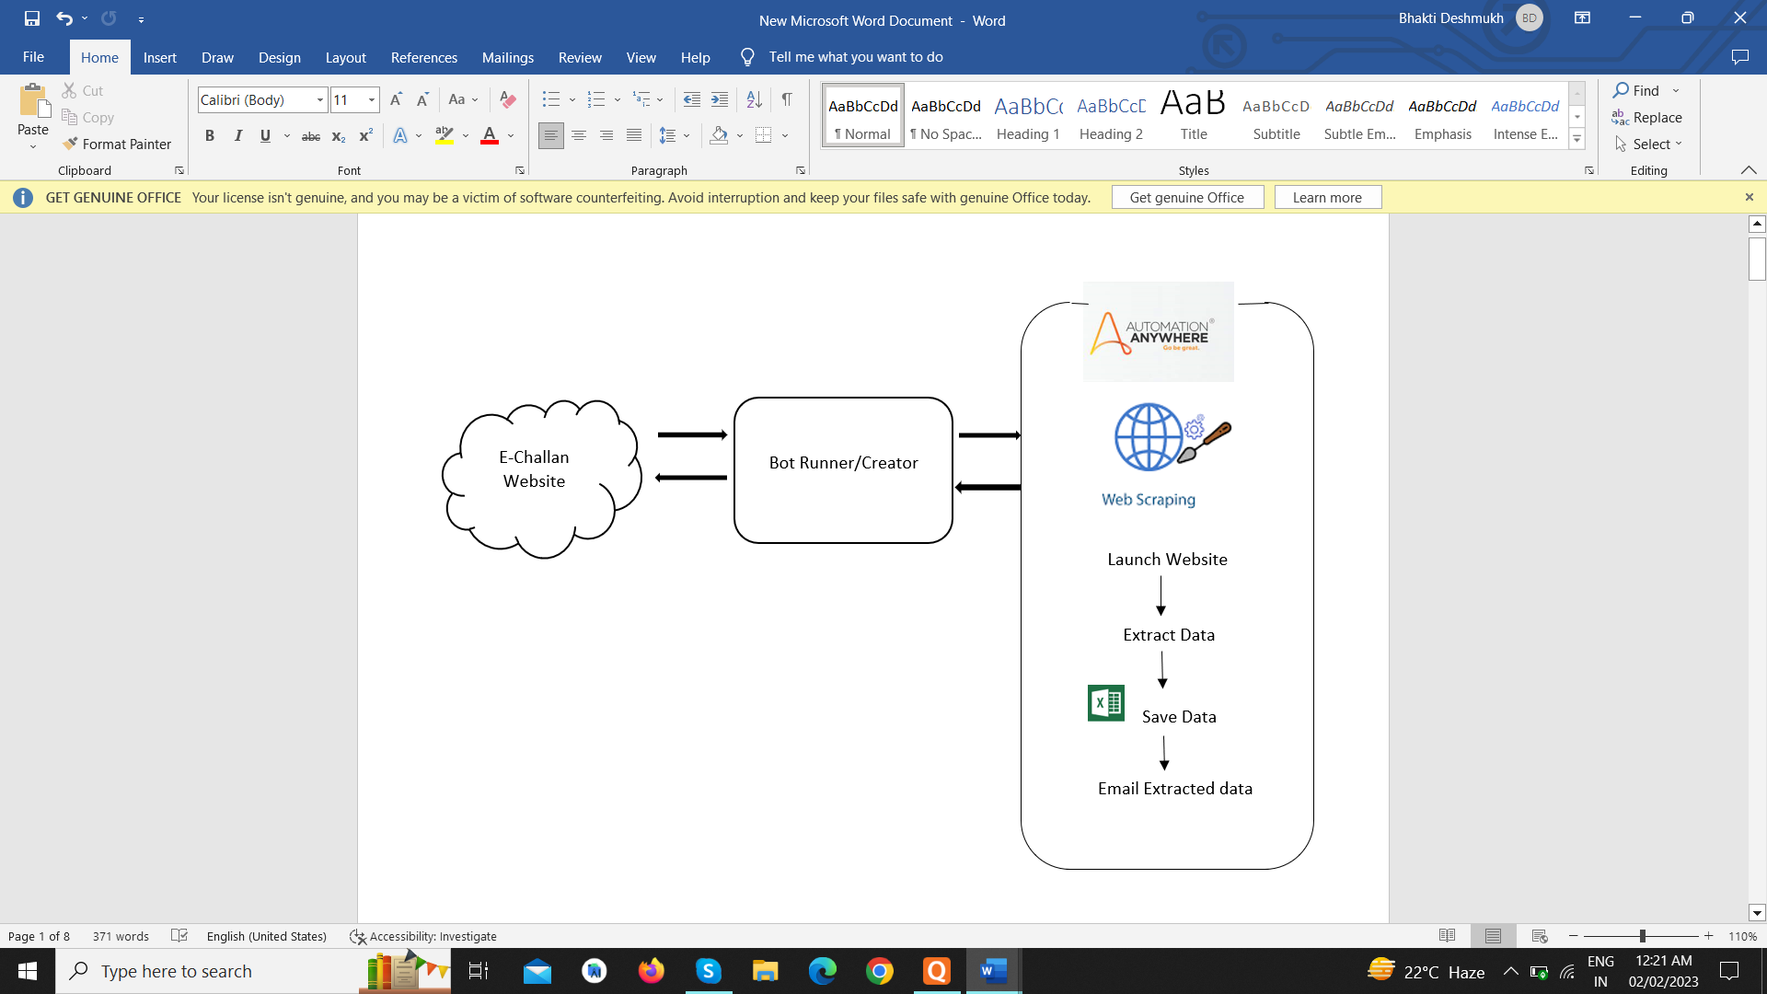

## **Target System**

|  |  |
| --- | --- |
| System Requirement | |
|  | **Bot Agents (Creators and Runners)** |
| **Operating System** | Windows 2010 and above |
| **Hard Disk Space** | 100 GB or more |
| **RAM** | 8GB or more |
| **System Resolution** | HD (1920 X 1080) and above 1080p recommended |
| **Processor** | Intel Core i3 2.6 GHz |
| **Credential Management** | Credential Vault of Control Room |
| **Network** | 5Mbps (Minimum)  20Mbps or higher (Recommended) |

|  |  |
| --- | --- |
| Application Pre-Requisites on all Creators | Application Pre-Requisites on all Runners |
| Automation Anywhere Control Room & Agent | Automation Anywhere Control Room & Agent |
| Microsoft Edge/ Chrome 90.0.44+ | Microsoft Edge/ Chrome 90.0.44+ |
| Microsoft Office 2016 | Microsoft Office 2016 |

**Note:** All the applications on Creators and Runners need not be the same.

**Environment Design:**

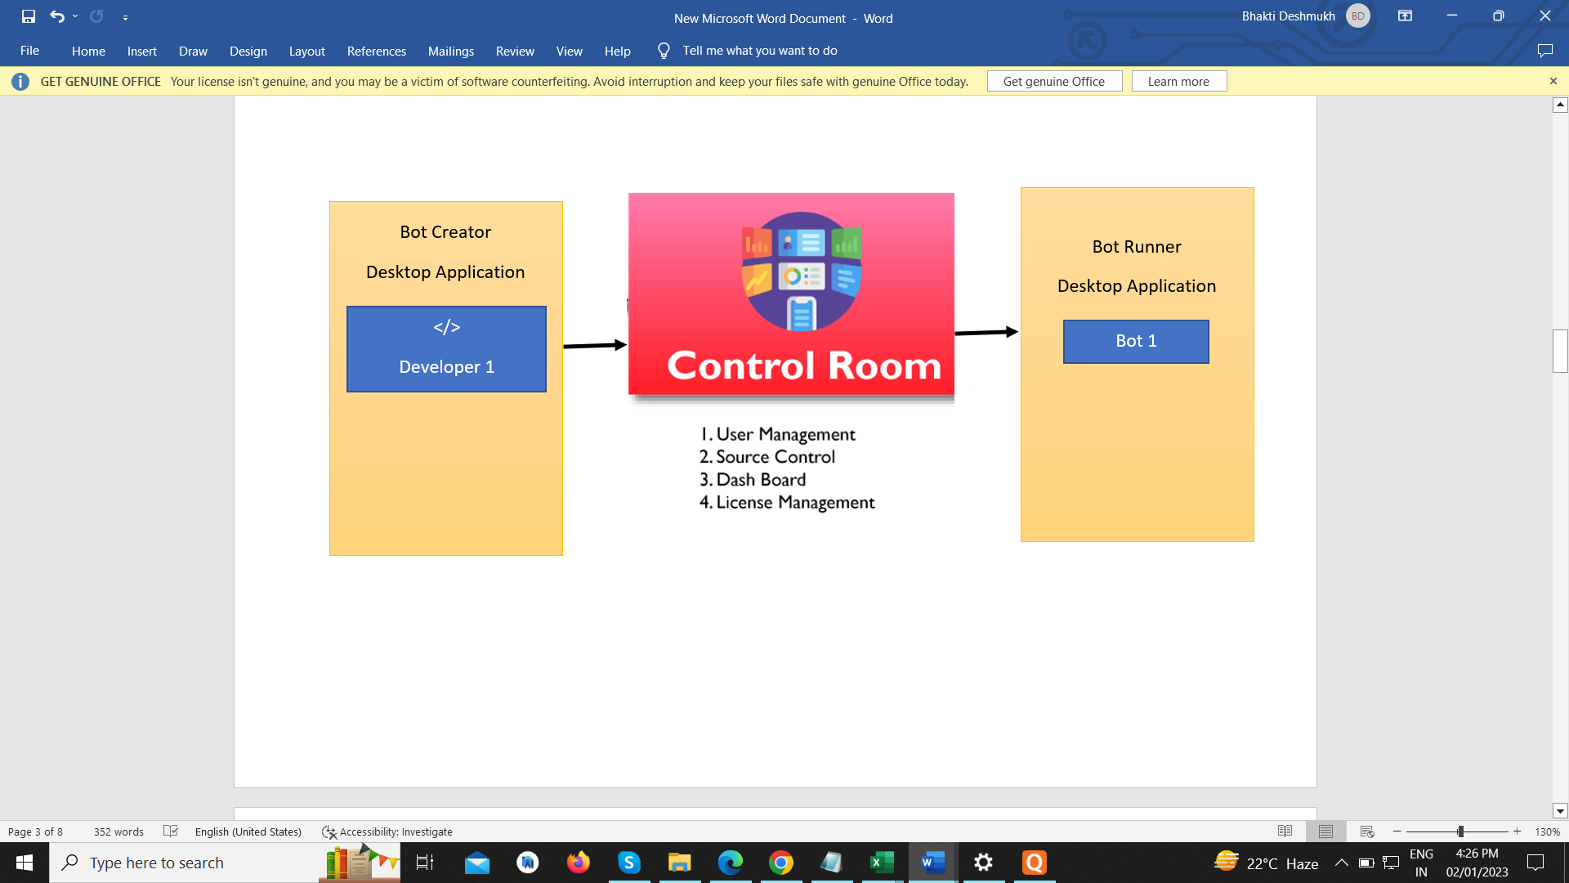

# **Non-Functional Requirements**

Security

Bot requires detailed information vehicle number, chassis/engine number or challan number from which the data needs to be extracted for processing. Also, any updates in these details, if required, can be done without making any changes to the Bot.

A separate User ID shall be created for the execution of bot to have only limited access and permissions assigned to the User ID.

## **Availability Requirements**

BOT execution shall happen as per the schedule defined on the production server.

## **Volume and Performance Expectations**

Based on the initial understanding, the following volume and performance parameters are predicted.

|  |  |
| --- | --- |
| Bot Frequency | Every Day |
| Avg. Estimated Time Taken for Execution | 40 sec per Vehicle Detail |

These would vary in the production and depend on parameters such as infra, website response times, processing time, etc.

# **Key Assumptions & Dependencies**

The process execution will be **dependent** on following factors:

1. URL of e-challan website (<https://mahatrafficechallan.gov.in/> ) must be accessible.
2. Any changes in the e-challan payment website (<https://mahatrafficechallan.gov.in/> ) will have direct impact on the process.
3. SMTP details must be provided which will be used to send the summary email to the client.
4. Email credentials must be provided to send the summary email to the client.

The following **assumptions** are made while automating the process:

1. Valid input parameters like vehicle number, chassis/engine number and challan number are required to get challan details.
2. For same vehicle, if searched by vehicle number and searched by challan number then it will consider the different records in output file.
3. Input and output file extension should be .xlsx
4. Required folders needs to create at a time of deployment
5. Folder structure should be there shown as below:
   * + - 1. E-challan Project

1)InputFolder:

i)VehicleDetails.xlsx

2)OutputFolder:

i)ChallanDetails.xlsx

3)ErrorLogFolder:

i)ErrorLogFile.txt

4)AuditLogFolder:

i)AuditLogFile.txt

# 

# **6.Error Handling**

Errors and Exceptions will be handled as follows:

1. Check condition if input file does not exist then stop the process.
2. Check condition if input file does not contain any record, then stop the process.
3. In case of incomplete vehicle information, current vehicle will be skipped and next vehicle in iteration will be picked.
4. In case of error while accessing the local machine configuration file, stop the process.
5. In case of issue with Captcha (site is down) stop the process
6. In case of e-challan portal error, such as portal down for maintenance etc., stop the process.