**IR Based Wireless Audio Transmission System**

Team Members:

Ankur Mishra(23ECE1005)

Aryan Satyendra Kumar(23ECE1006) Bhakti Sushant Prabhu Dessai(23ECE1007)

Bhukya Hema Sri(23ECE1008)

To:

Dr. Anirban Chatterjee Associate Professor

Department of Electronics and Communication Engineering National Institute of Technology, Goa.

**Contents**

* Component Description
* Circuit
* Working Principle
* Future scope
* Conclusion
* References
* Contribution

**Component Description**

# TRANSMITTER SECTION



1. IR LED (Infrared Light Emitting Diode)

* Description: A diode that emits infrared light when current flows through it.



* Function: It transmits audio signal as modulated infrared light.
* Note: Connect the longer leg (Anode) to the transistor’s collector.



2. S8050 (NPN Transistor)

* Description: A general-purpose NPN transistor.



* Function: It acts as a current amplifier and switch — it modulates the IR LED based on the audio signal.
* Pinout (Flat side facing you, legs pointing down): Left → Emitter | Middle → Base | Right → Collector.



3. 4.7 µF Electrolytic Capacitor

* Description: A polarized capacitor used for AC coupling (blocking DC).



* Function: Couples the audio signal into the transistor base while blocking any DC.



4. 100 Ω Resistor

Description: Fixed resistor.



* Function: Limits the current through the IR LED to protect it.



5. Audio Input (e.g., from mobile, MP3 player)

* Description: Signal source for the audio to be transmitted.



* Function: Provides the audio signal that modulates the IR LED.

# RECEIVER SECTION



6. Phototransistor

* Description: A light-sensitive transistor that conducts when exposed to IR light.
* Function: Detects IR light from the IR LED and converts it into a small electrical signal.



7. 620 kΩ Resistor

* Description: High-value fixed resistor.



* Function: Pulls up the phototransistor collector to Vcc, forming a voltage divider to detect signal.



8. 0.001µF Capacitor

* Description: Ceramic or polyester capacitor.



* Function: Blocks DC, passes audio signal from phototransistor to LM386.



9. LM386 (Low Voltage Audio Amplifier IC)

* Description: Integrated audio amplifier chip.



* Function: Amplifies the weak audio signal detected by the phototransistor to drive a speaker.



10. 10 µF Electrolytic Capacitor

* Description: Polarized capacitor connected between Pin 1 and Pin 8 of LM386.



* Function: Sets maximum gain (~200×) for the LM386.



11. 100 µF Electrolytic Capacitor

* Description: Large polarized capacitor.



* Function: Couples audio output to speaker, blocks DC.



12. 100 µF Electrolytic Capacitor (Power Filter)

* Description: Large polarized capacitor.



* Function: Helps stabilize power supply near LM386.



13. 0.01µF Capacitor (Decoupling)

* Description: Small ceramic capacitor.



* Function: Filters out high-frequency noise on the power supply near LM386.



14. Speaker (8Ω mini speaker)

* Description: Converts amplified electrical signal into sound.
* Function: Outputs the received and amplified audio.



15 .Power Supply

* Typically 5V DC (e.g., from USB, battery pack or voltage regulator).
* Ensure all grounds (GND) are common across transmitter and receiver if sharing power

16. Breadboard and Jumper Wires

* **Description**: A breadboard is a construction base for prototyping electronics. Jumper wires are used to connect different components on the breadboard.
* **Function**: The breadboard allows for easy circuit assembly, and jumper wires connect all components (Arduino, counters, LCD, buttons) without soldering

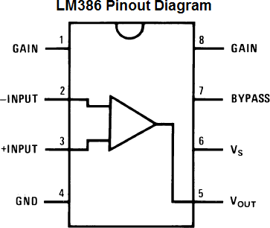

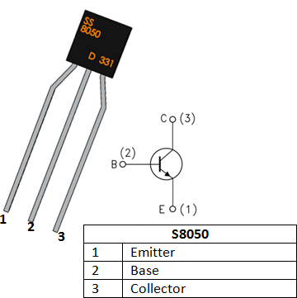

**Circuit**

Transmitter:

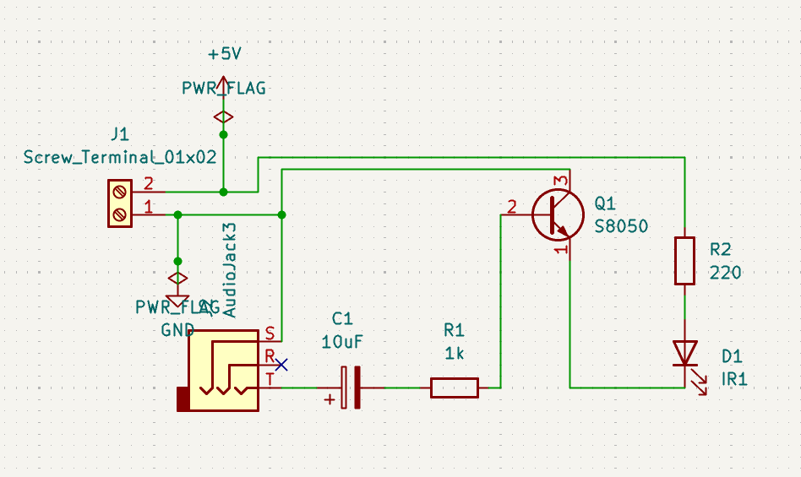

Receiver:

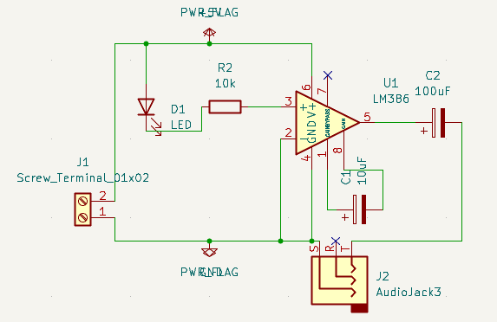

PCB Design:

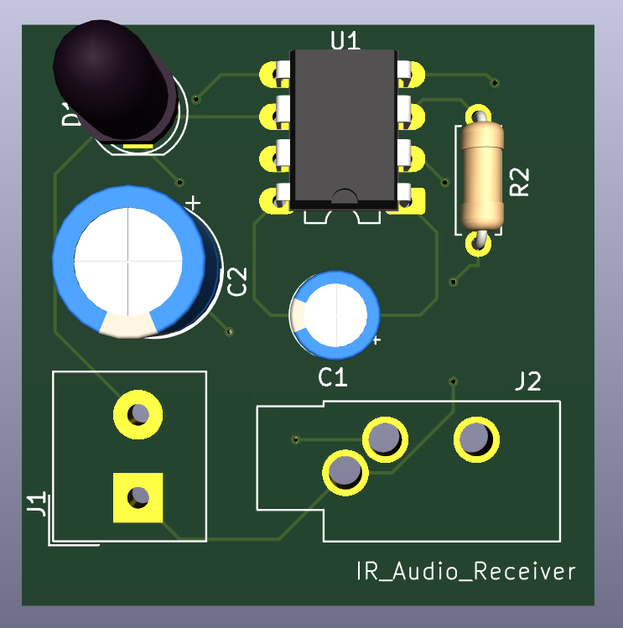

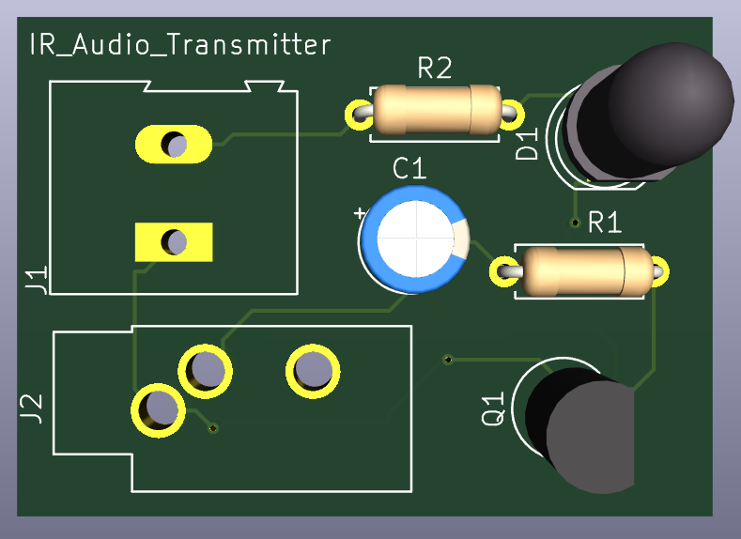

**Working principle**

The sound signal from a phone, MP3 player, is converted into light signals using an IR LED on the transmitter side and then converted back into sound using a phototransistor and audio amplifier on the receiver side.

# TRANSMITTER SIDE

1. Audio Source (like a mobile phone headphone output) provides a small electrical audio signal.
2. This signal passes through a capacitor (4.7µF) to block DC and allow only the AC part (the actual sound).
3. The capacitor connects to the base of an NPN transistor (S8050), which works like a switch.
4. The transistor controls current through an IR LED. The louder the sound (signal), the more current flows → the brighter the IR LED shines.
5. This causes the IR LED to blink very fast in rhythm with the sound signal — this is called modulation.

# RECEIVER SIDE

1. A phototransistor faces the IR LED. It detects the rapid blinking light and produces a small, corresponding electrical signal.
2. The signal is weak, so it's passed through a capacitor (220nF) into an LM386 audio amplifier.
3. The LM386 boosts the signal’s strength significantly.
4. The amplified signal is sent to a speaker, which converts the electrical signal back into audible sound.

**Future scope**

* Range Enhancement: Use more powerful IR LEDs and sensors for increased range. Add optical focusing elements (lenses or reflectors).
* Dual-LED System: Implement a system with multiple LEDs or photodiodes for improved signal reception.
* Digital Modulation: Switch to digital modulation (e.g., PWM or ASK) for better data integrity and resistance to noise.
* Signal Quality Improvements: Add filters and signal processing to reduce noise. Use shielded enclosures to mitigate interference.
* Portability: Design a battery-powered version using SMD components and create a custom PCB for miniaturization.
* Application Expansion: Expand the use of the system to secure audio transmission in environments like hospitals, classrooms, or museums.

**Conclusion**

This project successfully demonstrates the wireless transmission of audio signals using an infrared (IR) communication system. By modulating an IR LED with an analog audio input and receiving the signal with a phototransistor, the circuit enables short-range wireless audio transfer. The LM386 audio amplifier effectively boosts the received signal for playback through a speaker. The project is low-cost, easy to build, and provides hands-on experience in analog signal modulation, IR communication, and basic audio amplification.

**References**

[https://electronicsforu.com](https://electronicsforu.com/)

<https://www.electronicshub.org/> [https://youtube.com](https://youtube.com/)