SIH26034 • LEGAL METROLOGY / REGULATORY COMPLIANCE TECHNOLOGY
Label Sentinel
AI-Assisted Legal Metrology Compliance Support Platform
Week 1 Project Planning & System Architecture Report
Requirements • Workflows • Architecture • Data Model • API • Security • Roadmap
Project details
Project reference | SIH26034
Portals | Citizen • Officer • Admin
Document version | 1.0
Date | 03 November 2026
Submitted for | Internship evaluation — Week 1
Prepared by | Label Sentinel project team
This document describes a proposed system at the design stage. It does not describe an implemented or deployed application.

Document Control
Table 1: Document information
Item | Details
Document title | Week 1 Project Planning & System Architecture Report
Project | Label Sentinel — AI-Assisted Legal Metrology Compliance Support Platform
Project reference | SIH26034
Domain | Legal Metrology / Regulatory Compliance Technology
Document type | Planning and architecture report (design stage)
Version | 1.0
Date | 03 November 2026
Status | Submitted for Week 1 evaluation
Prepared by | Label Sentinel project team
Classification | Internal — internship evaluation

Table 2: Revision history
Version | Date | Description of change
0.1 | 29 Oct 2026 | Initial outline, scope and portal feature list
0.5 | 01 Nov 2026 | Architecture, data model, API and security sections drafted
1.0 | 03 Nov 2026 | Diagrams, wireframes, roadmap and quality review completed

Design-stage notice. This report describes a proposed system. No component described here is claimed to be implemented or deployed. Rule examples, thresholds and API contracts are design proposals that will be validated in later weeks.

Table of Contents
Document Control 2
1. Executive Summary 4
2. Project Overview 4
3. Background and Problem Statement 5
3.1 Background 5
3.2 Problem Statement 5
3.3 Need for the System 5
4. Proposed Solution 5
4.1 Result Statuses 6
5. Project Objectives 6
6. Project Scope 7
6.1 In Scope 7
6.2 Out of Scope 7
7. Stakeholders and User Roles 7
8. Functional Requirements 8
8.1 Citizen Portal 8
8.2 Officer Portal 9
8.3 Admin Portal 10
9. Non-Functional Requirements 10
10. Detailed Citizen Portal Workflow 11
11. Detailed Officer Portal Workflow 13
12. Detailed Admin Portal Workflow 15
13. Overall System Workflow 16
14. High-Level System Architecture 18
15. Detailed Architecture Components 19
15.1 Key Interaction Sequence 19
16. Database Design 20
17. Entity Relationship Diagram (ERD) 21
18. Database Collection Structure 22
19. API Design 26
19.1 Endpoint Specifications 27
20. Technology Stack and Justification 31
21. AI/OCR Extraction Architecture 32
21.1 Extraction Pipeline 32
21.2 Adapter Interface (Proposed) 32
21.3 Guardrails 32
22. Deterministic Compliance Rule Engine 33
22.1 Applicability Selection 33
22.2 Rule Definition Example (Illustrative) 33
22.3 Evaluation Logic 33
22.4 Versioning and Governance 34
23. Security and Privacy Architecture 34
23.1 Illustrative Firestore Rule 35
24. UI/UX Design and Wireframes 36
25. Testing and Validation Strategy 40
26. Risks and Mitigation Plan 40
27. Week-wise Implementation Roadmap 41
28. Design Decisions and Assumptions 41
28.1 Design Decisions 41
28.2 Assumptions 42
29. Expected Outcomes 42
30. Conclusion 42
Appendix A – Proposed GitHub Repository Structure 43

1. Executive Summary
Packaged commodities sold in India must carry specific declarations — such as net quantity, retail sale price, manufacturer or packer identity, date of manufacture or packing, and consumer care details — under the Legal Metrology Act, 2009 and the Legal Metrology (Packaged Commodities) Rules, 2011. Checking these declarations is largely manual today, for both consumers and enforcement officers, and is harder still for products sold through online listings.
Label Sentinel is a proposed web platform that helps citizens and Legal Metrology officers check product declarations against applicable requirements in a consistent, explainable and auditable way. The platform has exactly three portals — Citizen, Officer and Admin — built on a single Next.js application with Firebase Authentication, Firestore and Storage.
The central design decision is a strict separation of responsibilities:
- AI/OCR extracts candidate text and declarations from label images and listing screenshots, with confidence scores. It never decides compliance.
- An applicability selection layer decides which rules apply to a given product, channel and jurisdiction.
- A deterministic, version-controlled rule engine evaluates each applicable rule and returns PASS, FAIL, NOT_APPLICABLE or NEEDS_REVIEW.
- Human officers review every uncertain or flagged finding before it becomes a recorded enforcement outcome.
Every finding is traceable to the evidence it was based on, the rule that was applied and the exact rule version. This report defines the scope, requirements, workflows, architecture, Firestore data model, proposed REST API, security model, user interface wireframes, test strategy, risks and an eight-week implementation roadmap.

2. Project Overview
Table 3: Project at a glance
Attribute | Description
Project name | Label Sentinel
Reference | SIH26034
Type | AI-assisted Legal Metrology compliance support platform
Primary users | Citizens (consumers), Legal Metrology officers, platform administrators
Portals | Citizen Portal, Officer Portal, Admin Portal (three portals only)
Inputs | Product label photographs, online listing URLs and screenshots, officer inspection evidence
Core outputs | Per-rule compliance findings with evidence and rule version; complaints; cases; reports; audit trail
Proposed stack | Next.js (App Router), React, TypeScript, Tailwind CSS, shadcn/ui, Firebase Auth/Firestore/Storage, provider-agnostic OCR adapter
Duration | Eight weeks (Week 1: planning and architecture)

The platform supports two evidence channels. In the in-store channel, a citizen or officer photographs the label of a physical package. In the online channel, the user submits the listing URL together with screenshots of the product page, because e-commerce listings are also expected to display key declarations. Both channels feed the same extraction, applicability and rule-evaluation pipeline.

3. Background and Problem Statement

3.1 Background
Legal Metrology regulation protects consumers by ensuring that packaged goods state what they contain and what they cost in a standard, verifiable form. State Legal Metrology departments carry out inspections and act on consumer complaints. The volume of packaged products and the growth of e-commerce make purely manual checking slow and inconsistent.

3.2 Problem Statement
- Consumers lack an easy check. Most citizens do not know which declarations are mandatory or how to tell whether a label or listing is deficient.
- Complaints arrive without structured evidence. Complaints are often free text without clear images, product identifiers or a reference to the requirement involved.
- Inspection records are inconsistent. Different officers may record the same deficiency differently, which makes reporting and follow-up difficult.
- Rules change over time. Amendments to requirements must be applied from their effective dates, while past results must remain explainable under the rule version used at the time.
- Fully automated AI verdicts are not acceptable. OCR and vision models can misread text. A legal compliance decision must be explainable, reproducible and reviewable by an accountable officer.

3.3 Need for the System
A platform is needed that captures evidence in a structured way, extracts declarations with measurable confidence, applies the correct and current version of each requirement deterministically, routes uncertain findings to officers and keeps a complete audit trail.

4. Proposed Solution
Label Sentinel combines evidence management, AI-assisted extraction, deterministic rule evaluation and officer workflows in a single role-based web application.
Table 4: Solution capabilities
Capability | How Label Sentinel provides it
Evidence capture | Guided image capture and listing screenshot upload; files stored in Firebase Storage with a SHA-256 hash for integrity
Extraction | Provider-agnostic OCR/vision adapter returns candidate fields, raw text, bounding boxes and confidence scores
Field validation | Schema, unit and format checks; user or officer confirmation of low-confidence fields
Applicability | Rules selected by product category, sales channel, jurisdiction and effective date — not by the AI
Evaluation | Deterministic TypeScript rule engine; identical inputs and rule version always give identical output
Explainability | Each finding shows the evidence region, extracted value, rule reference, rule version and reason
Human review | NEEDS_REVIEW and flagged findings enter an officer review queue; decisions require a recorded justification
Enforcement support | Complaint inbox, case management, documents and jurisdiction reports for officers
Governance | Admin-controlled users, jurisdictions, rule versions, modules and thresholds; append-only audit log

4.1 Result Statuses
Every applicable rule evaluated for a scan produces exactly one of four statuses:
Table 5: Compliance result statuses
Status | Meaning | Typical trigger | What the user sees
PASS | The required declaration is present and satisfies the rule's conditions | Net quantity found with a valid unit and value; all checks satisfied | Green indicator with the evidence and rule reference
FAIL | The rule applies and the evidence clearly shows the requirement is not met | Mandatory declaration absent from a clear, complete label image | Red indicator, reason and option to raise a complaint
NOT_APPLICABLE | The rule does not apply to this product, channel or jurisdiction | An e-commerce display rule for an in-store scan; an exempted category | Grey indicator with the applicability reason
NEEDS_REVIEW | The engine cannot reach a reliable PASS or FAIL | Confidence below threshold, conflicting values, partly hidden text, unknown category | Amber indicator; finding is routed to an officer

A citizen-facing result is informational. It is not a legal determination. Only an officer's recorded decision in the Officer Portal forms part of an enforcement record.

5. Project Objectives
- Design a three-portal platform (Citizen, Officer, Admin) with role-specific navigation and access.
- Provide structured evidence capture for physical labels and online listings, with integrity hashing.
- Build a provider-agnostic AI/OCR extraction service that returns candidate fields with confidence scores.
- Implement a controlled applicability layer and a deterministic, version-controlled rule engine.
- Produce explainable, traceable results with four statuses, including NEEDS_REVIEW.
- Route uncertain findings to officers and record every review decision with a justification.
- Support complaints, cases, documents and jurisdiction-level reporting.
- Enforce security through authentication, RBAC, record-level authorization and an append-only audit log.
- Deliver a tested, demonstrable prototype within eight weeks.

6. Project Scope

6.1 In Scope
- Citizen Portal: Dashboard, Scan Product, Online Listing, Compliance Result, Know More AI, Complaints, History, Profile.
- Officer Portal: Dashboard, Inspection, Batch Scan, Review Queue, Complaint Inbox, Case Management, Documents, Reports.
- Admin Portal: Dashboard, Users, Jurisdictions, Rule Registry, Modules, Thresholds, Analytics, Audit Logs.
- Evidence upload, AI/OCR extraction, candidate validation, applicability selection, deterministic rule evaluation.
- A starter rule set covering core packaged-commodity declarations, to be validated with domain guidance.
- Responsive web interface usable on mobile browsers for image capture.

6.2 Out of Scope
- A separate portal for manufacturers, packers or sellers.
- Issuing legally binding notices or penalties automatically; officers remain responsible for enforcement actions.
- Automated crawling or scraping of e-commerce sites; listings are submitted by users as URL plus screenshots.
- Native mobile applications; the prototype is a responsive web application.
- Integration with existing government case systems or payment systems (possible future work).
- Weighing or measuring physical quantities; the system checks declarations, not actual contents.

7. Stakeholders and User Roles
Table 6: Stakeholders and roles
Stakeholder / role | Portal | Responsibilities | Key permissions
Citizen | Citizen | Scans products and listings, reads results, raises complaints | Create own scans and complaints; read only own records
Officer | Officer | Inspects products, verifies extraction, reviews findings, manages complaints and cases | Read and act on records in assigned jurisdiction(s) only
Senior officer (optional sub-role) | Officer | Approves case closure and escalations; views jurisdiction reports | Officer permissions plus approval actions
Administrator | Admin | Manages users, jurisdictions, rule versions, modules, thresholds | Configuration access; cannot alter findings or audit events
Rule approver (admin sub-role) | Admin | Second-person approval of rule versions before publication | Approve or reject draft rule versions
Internship evaluators / mentors | — | Review design, progress and demonstration | No system access required

Roles are stored as Firebase custom claims and mirrored in the users collection. A user holds one primary role; sub-roles are expressed as additional permission flags assigned by an administrator.

8. Functional Requirements
Requirements are identified as FR-C (Citizen), FR-O (Officer) and FR-A (Admin). Each module is described by purpose, user actions, inputs, processing and expected outputs.

8.1 Citizen Portal
Table 7: Citizen Portal functional requirements
ID / Module | Purpose & user actions | Inputs | Processing | Outputs
FR-C1 Dashboard | Overview of the citizen's activity; start a new scan | Signed-in user | Fetch the user's recent scans and complaint statuses | Summary cards, recent scans, quick actions
FR-C2 Scan Product | Photograph a physical package to check its label | Front/back/side label images; optional product category and purchase location | Image quality check, upload to Storage, hash, create scan, trigger extraction | Scan record in status EXTRACTING; progress indicator
FR-C3 Online Listing | Check an e-commerce product listing | Listing URL, one or more page screenshots, platform name | URL format validation; screenshots processed as evidence; channel set to ONLINE | Scan record for the listing; same pipeline as FR-C2
FR-C4 Compliance Result | Understand which requirements were met | Scan ID | Read findings with evidence regions, rule references and versions | Per-rule PASS / FAIL / NOT_APPLICABLE / NEEDS_REVIEW with explanation; informational disclaimer
FR-C5 Know More AI | Learn what a declaration means in plain language | Free-text question, optional context of a finding | Informational assistant with guardrails; cannot read or change findings | Explanatory answer marked "information only, not a compliance decision"
FR-C6 Complaints | Report a non-compliant product to the relevant jurisdiction | Linked scan (optional), description, location, consent | Attach scan evidence, route by jurisdiction, create complaint record | Complaint ID, status timeline (Submitted, Under review, Closed)
FR-C7 History | Review past scans and complaints | Filters: date, status, channel | Paginated queries on the user's own records | Searchable list with links to results and complaints
FR-C8 Profile | Manage account and preferences | Name, contact, language, consent choices | Validate and update profile; consent changes logged | Updated profile; option to request data deletion

8.2 Officer Portal
Table 8: Officer Portal functional requirements
ID / Module | Purpose & user actions | Inputs | Processing | Outputs
FR-O1 Dashboard | Daily work overview for the officer's jurisdiction | Officer identity and jurisdiction | Aggregate queue size, open cases, new complaints, SLA alerts | KPI cards, review queue preview, assigned cases
FR-O2 Inspection | Record an on-site inspection of a single product | Images, premises details, product category, notes | Same pipeline as citizen scans with officer source; mandatory field verification | Inspection scan with officer-verified fields and findings
FR-O3 Batch Scan | Inspect many products during one visit | Multiple image sets grouped under one batch, premises details | Queue each item through extraction and evaluation; summarise flagged items | Batch summary with per-item status; flagged items sent to review
FR-O4 Review Queue | Resolve uncertain or flagged findings | Finding with evidence, extracted values, rule and version | Officer confirms or overrides status; justification mandatory; audit event written | Reviewed finding (final status, reviewer, timestamp, reason)
FR-O5 Complaint Inbox | Triage citizen complaints in the jurisdiction | Complaint record with linked evidence | Validate, request information, reject with reason, or link to a case | Updated complaint status visible to the citizen
FR-O6 Case Management | Track enforcement follow-up | Linked scans and complaints, assignee, notes, due dates | Create, assign, update status (Open, In progress, Escalated, Closed) | Case record with full timeline
FR-O7 Documents | Store case documents | Inspection memos, notices, correspondence (PDF/images) | Upload to Storage under the case; versioned metadata; access limited to jurisdiction | Document list attached to the case
FR-O8 Reports | Summarise activity and outcomes | Date range, jurisdiction, category filters | Aggregate scans, findings, complaints and cases | On-screen charts; CSV and PDF export

8.3 Admin Portal
Table 9: Admin Portal functional requirements
ID / Module | Purpose & user actions | Inputs | Processing | Outputs
FR-A1 Dashboard | Platform health and pending approvals | Admin identity | Aggregate users, rules, jobs and audit volume | KPI cards, pending approvals, alerts
FR-A2 Users | Manage accounts and roles | Invite email, role, jurisdiction | Set custom claims, update user record, suspend or reactivate | User list; role change written to audit log
FR-A3 Jurisdictions | Define enforcement areas | Name, state, level, officer assignments | Create and update jurisdiction; map officers | Jurisdiction list used for routing and access control
FR-A4 Rule Registry | Maintain versioned compliance rules | Rule logic (JSON), applicability conditions, legal reference, effective dates, test cases | Draft, test against reference cases, second-admin approval, publish; published versions immutable | Rule versions with status Draft / Pending approval / Published / Retired
FR-A5 Modules | Control which extraction and rule modules are active | Module identifier, version, enabled flag | Only approved modules can be enabled; change audited | Active module configuration
FR-A6 Thresholds | Tune review triggers | OCR confidence threshold, image quality limits, review triggers | Validate ranges; versioned settings; audited | Thresholds used by validation and rule engine
FR-A7 Analytics | Monitor platform usage and outcomes | Date range, jurisdiction | Aggregate counts and rates (scans, statuses, review rate, overrides) | Charts and tables (Recharts)
FR-A8 Audit Logs | Inspect the history of sensitive actions | Filters: actor, action, entity, date | Read-only queries on append-only audit events | Searchable log; CSV export

9. Non-Functional Requirements
Table 10: Non-functional requirements
ID | Category | Requirement (proposed target)
NFR-1 | Determinism | The same confirmed fields and rule versions must always produce the same findings (verified by regression tests).
NFR-2 | Traceability | Every finding stores scan ID, evidence IDs, rule ID, rule version and evaluation timestamp.
NFR-3 | Performance | Result page loads within 3 s after evaluation; single-scan evaluation (excluding OCR provider time) under 2 s.
NFR-4 | Scalability | Serverless Firebase services and stateless API handlers scale horizontally; batch scans processed per item.
NFR-5 | Availability | Target 99% availability for the prototype demonstration environment.
NFR-6 | Security | Authentication on every route; RBAC and record-level checks on server and in Firestore rules.
NFR-7 | Privacy | Collect only data needed for the purpose; location optional; citizen identity hidden from public views.
NFR-8 | Auditability | Append-only audit events for review decisions, role changes, rule publication and threshold changes.
NFR-9 | Usability | Responsive layout from 360 px width; clear status colours plus text labels (not colour alone).
NFR-10 | Accessibility | Target WCAG 2.1 AA for contrast, keyboard navigation and form labels.
NFR-11 | Maintainability | TypeScript strict mode, modular services, linting and CI checks on each pull request.
NFR-12 | Portability | OCR provider behind an adapter interface so providers can be changed without changing the rule engine.

10. Detailed Citizen Portal Workflow
Figure 1 shows the citizen journey from sign-in to result, complaint and history.
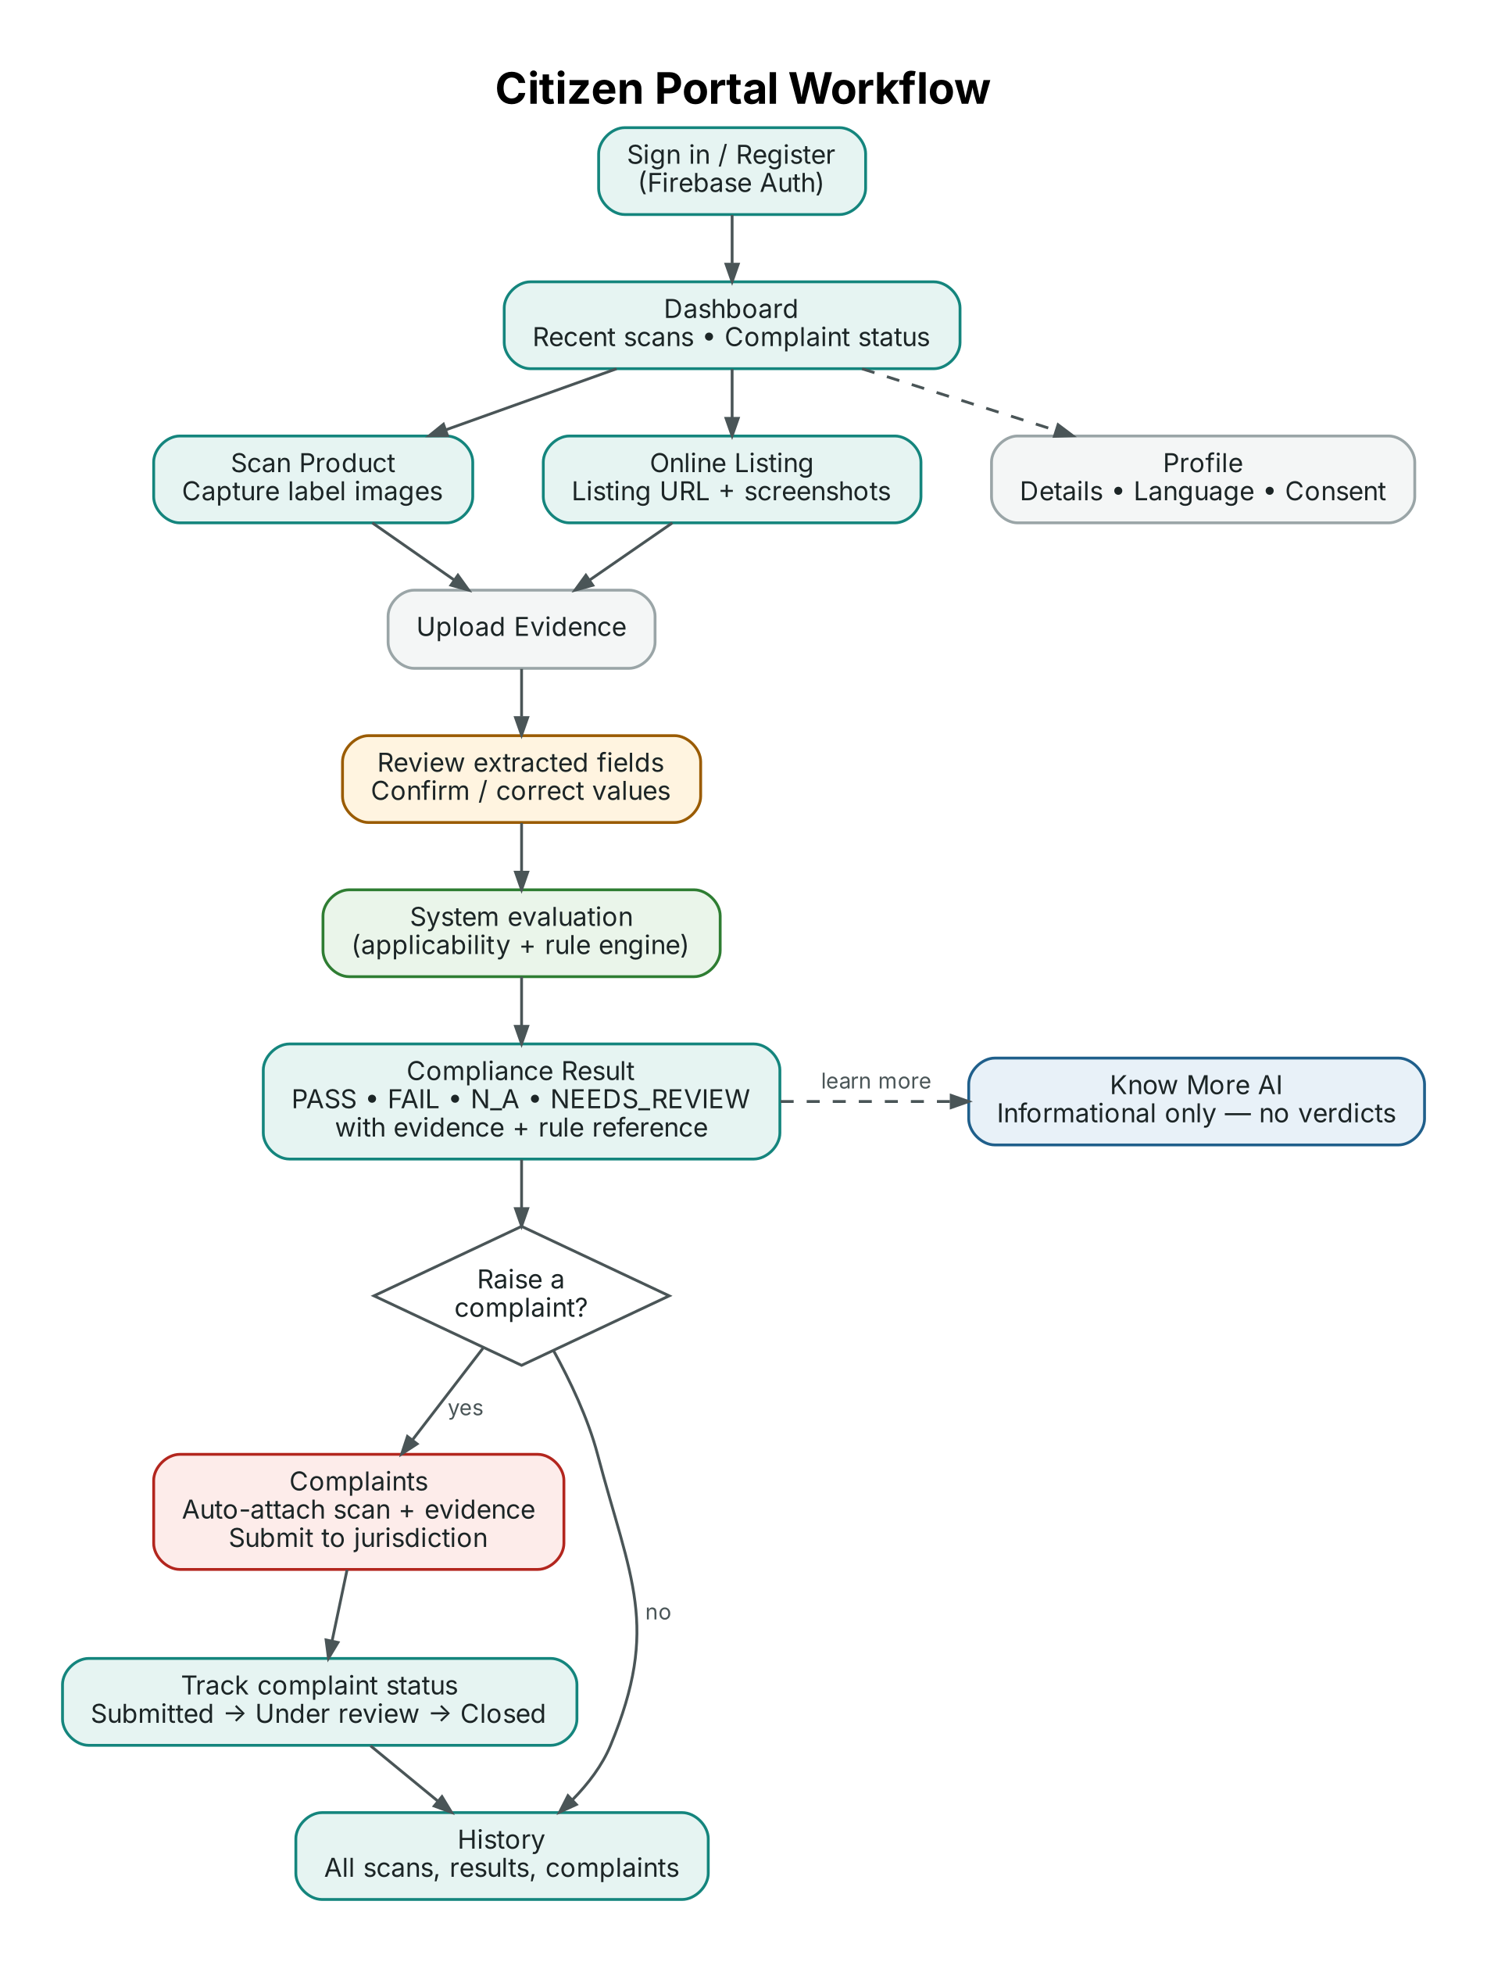
Figure 1: Citizen Portal workflow
- The citizen signs in or registers using Firebase Authentication and lands on the Dashboard.
- The citizen chooses Scan Product (photographs of a package) or Online Listing (URL plus screenshots).
- Images are checked for basic quality (resolution, blur, glare) and uploaded as evidence; each file is hashed.
- The extraction service returns candidate fields. Low-confidence fields are highlighted, and the citizen may confirm or correct them. Corrections are stored separately from the original extraction.
- The system selects applicable rules and runs the deterministic rule engine.
- The Compliance Result page shows each rule with its status, evidence region, rule reference and version. Know More AI is available for plain-language explanation only.
- If the citizen believes the product is non-compliant, they raise a Complaint; scan evidence is attached automatically and the complaint is routed to the correct jurisdiction.
- The scan and any complaint appear in History, where complaint status can be tracked.

11. Detailed Officer Portal Workflow
Officers work only on records within their assigned jurisdiction(s). Figure 2 shows the main paths.
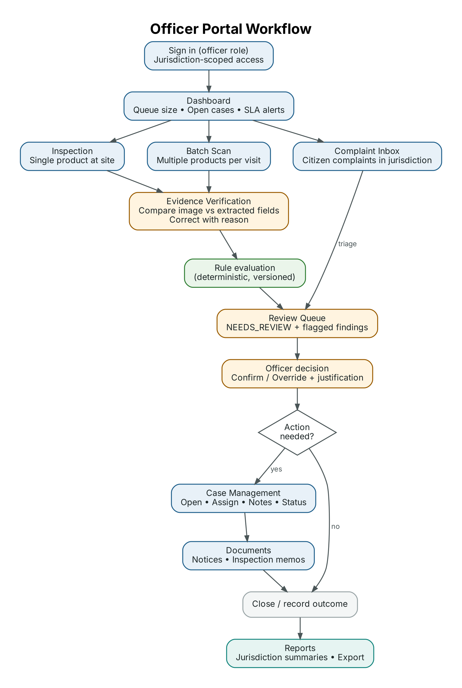
Figure 2: Officer Portal workflow
- The officer signs in and sees the jurisdiction Dashboard (review queue, open cases, new complaints).
- For field work, the officer starts an Inspection (single product) or a Batch Scan (several products during one visit).
- During evidence verification, the officer compares each extracted value with the image and corrects it if needed; every correction requires a reason.
- The rule engine evaluates the verified fields. Findings with NEEDS_REVIEW, or flagged by thresholds, enter the Review Queue. Complaints from the Complaint Inbox are triaged into the same queue.
- For each queued finding the officer confirms or overrides the status with a written justification. The original engine result is preserved alongside the officer decision.
- If follow-up is needed, the officer opens or updates a Case, assigns it, and attaches Documents such as inspection memos and notices.
- Closed cases and reviewed findings feed Reports for the jurisdiction.

12. Detailed Admin Portal Workflow
Administrators configure the platform but cannot change findings or audit events. Every administrative change writes an audit event (Figure 3).
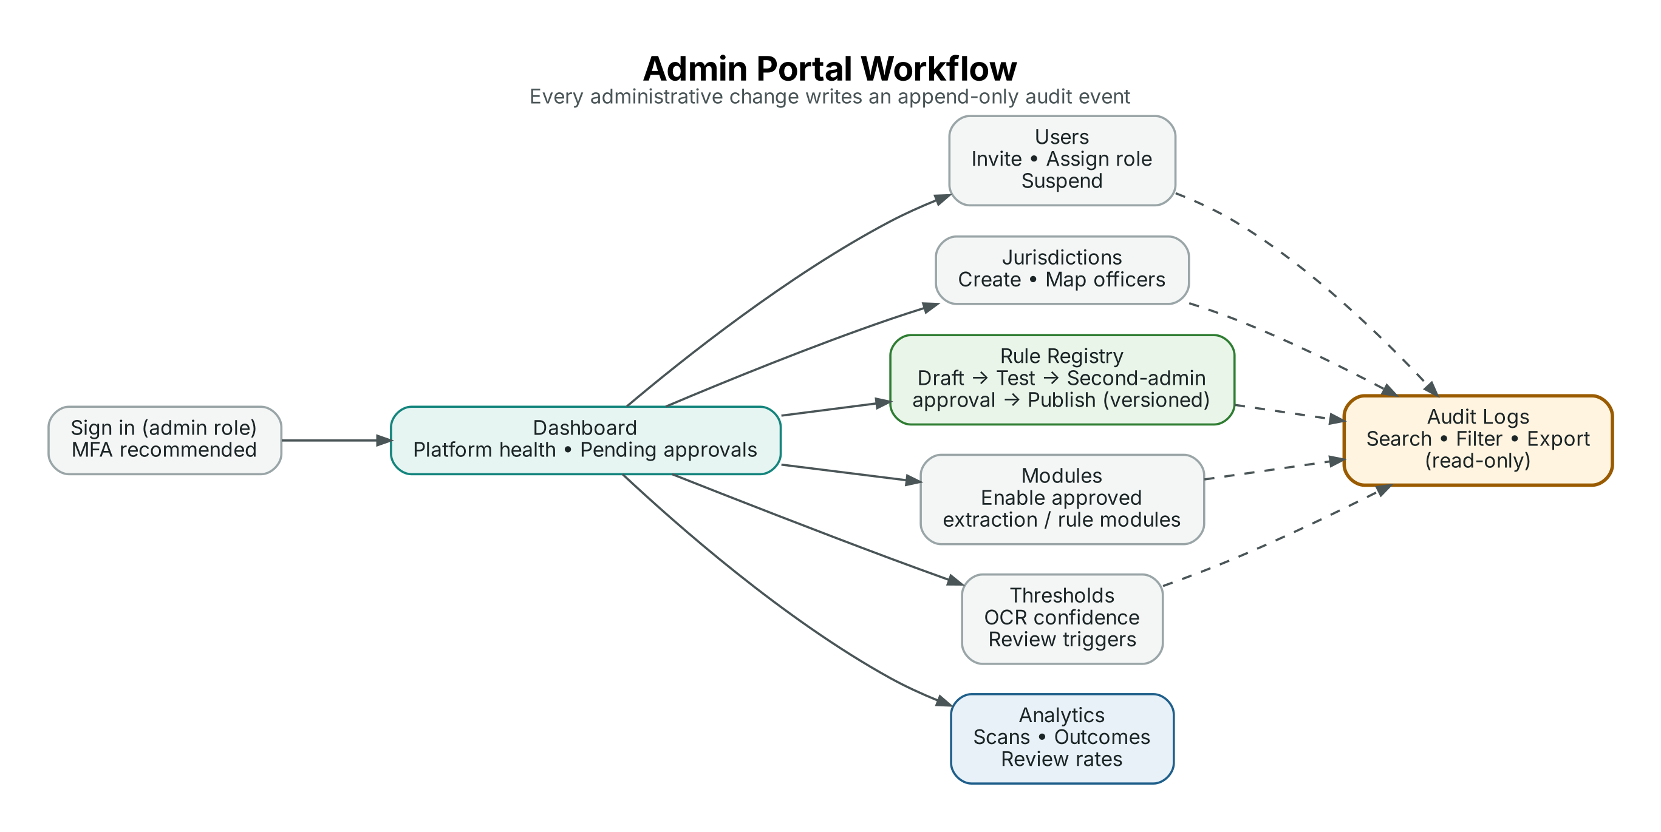
Figure 3: Admin Portal workflow
- Users and Jurisdictions: invite users, assign roles and jurisdictions, suspend accounts. Role changes update Firebase custom claims and are audited.
- Rule Registry: a rule change is created as a new draft version, tested against reference cases, approved by a second administrator, and published with an effective date. Published versions are never edited.
- Modules and Thresholds: enable only approved extraction or rule modules; set confidence and quality thresholds that trigger NEEDS_REVIEW.
- Analytics and Audit Logs: monitor usage and outcomes; search and export the read-only audit log.

13. Overall System Workflow
Figure 4 shows the end-to-end processing pipeline shared by citizen scans, online listings and officer inspections.
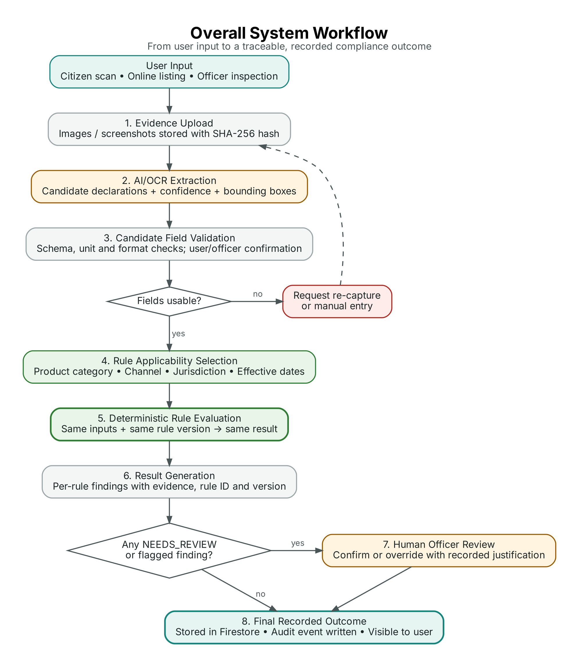
Figure 4: Overall system workflow
Table 11: Pipeline stages and outputs
Stage | Responsible component | Output stored
1. Evidence upload | Next.js client + Firebase Storage | evidenceFiles document with storage path and SHA-256
2. AI/OCR extraction | Extraction service (adapter) | Raw text, candidate fields, confidence, bounding boxes, provider and model version
3. Candidate field validation | Validation module + user/officer | Validated field set; corrections kept with reason
4. Applicability selection | Applicability layer | List of applicable rule IDs and versions, with reasons for non-applicable rules
5. Rule evaluation | Deterministic rule engine | One finding per evaluated rule
6. Result generation | API layer | Scan status and summary
7. Human review (when needed) | Officer Portal | Review decision, reviewer, justification
8. Final recorded outcome | Firestore + audit service | Final status and audit event

14. High-Level System Architecture
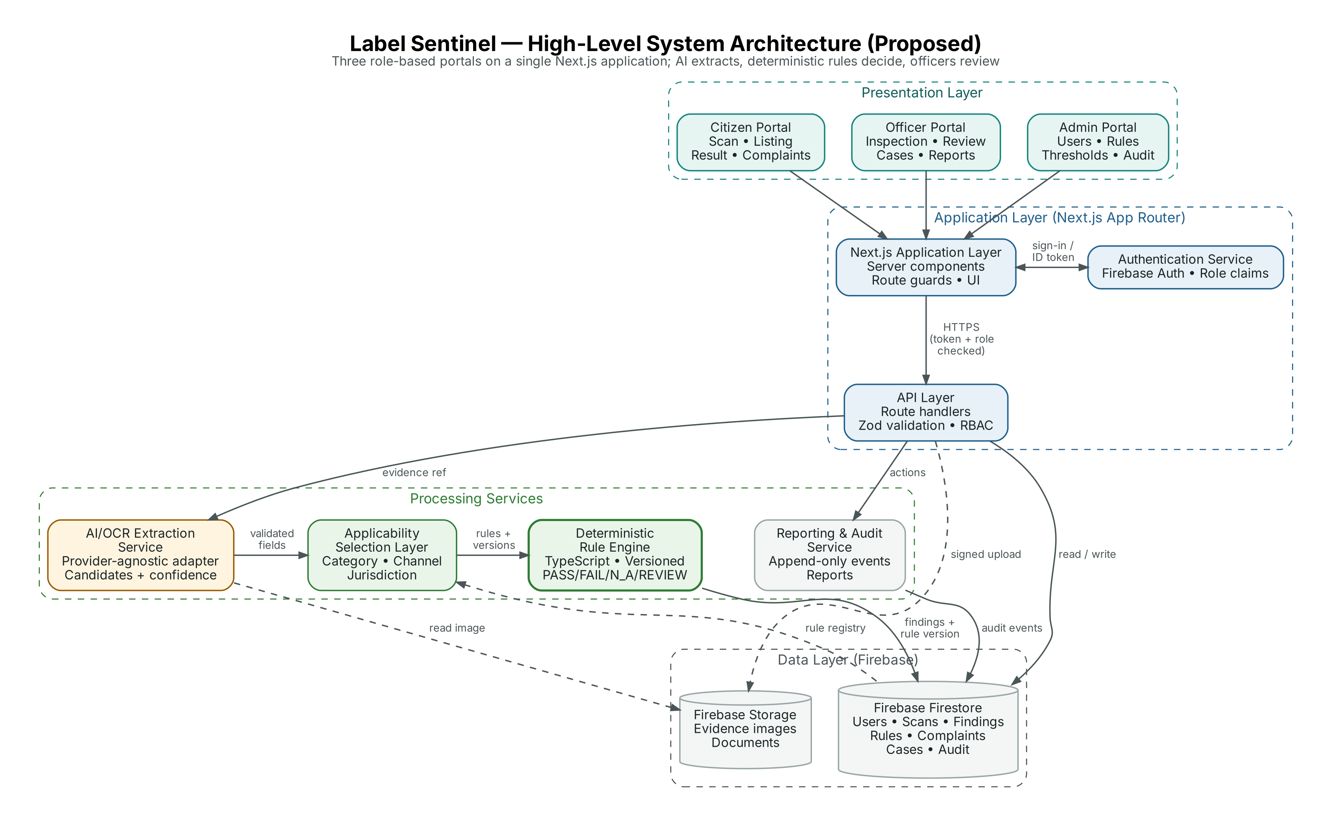
Figure 5: High-level system architecture (proposed)
The architecture is layered. The three portals are route groups within one Next.js application, so they share components, authentication and the API layer while presenting distinct navigation. Processing services run server-side; the client never calls the OCR provider or writes findings directly. Firestore holds structured records and the rule registry; Firebase Storage holds evidence files.

15. Detailed Architecture Components
Table 12: Architecture components
Component | Responsibility | Key design notes
Citizen / Officer / Admin Portals | Role-specific user interfaces | Next.js route groups (citizen), (officer), (admin); layout-level role guard; shared design system
Next.js Application Layer | Rendering, routing, session handling | Server components for data-heavy pages; client components for capture and interactive tables
Authentication Service | Identity and roles | Firebase Authentication; role and jurisdiction in custom claims; ID token verified server-side with Firebase Admin SDK
API Layer | Single entry point for business operations | Route handlers under /api/v1; Zod request validation; RBAC and record-level checks; consistent error format
AI/OCR Extraction Service | Convert images to candidate fields | ExtractionProvider interface; implementations for candidate providers; output normalised to one schema with confidence
Candidate Field Validation | Make extracted data usable | Unit parsing (g, kg, ml, L, number), date and price formats, required-field presence, threshold checks
Applicability Selection Layer | Choose which rules apply | Evaluates rule applicability conditions against category, channel, jurisdiction and scan date; records reasons
Deterministic Rule Engine | Evaluate applicable rules | Pure TypeScript functions over a JSON rule definition; no network or AI calls; returns status, reason and evidence references
Rule Registry | Store versioned rules | rules/{ruleId}/versions/{n}; published versions immutable; effective-from and effective-to dates
Reporting & Audit Service | Reports and audit events | Server-only writes to auditEvents; aggregation for dashboards; CSV/PDF export
Firebase Firestore | Structured data | Collections per entity; security rules mirror server RBAC; composite indexes for queues and reports
Firebase Storage | Evidence and documents | Path per scan or case; size and type limits; access only through authorised reads

15.1 Key Interaction Sequence
For a typical scan: (1) the client requests an upload slot from the API; (2) the file is uploaded to Storage and registered as evidence; (3) the API calls the extraction service; (4) validated fields are passed to the applicability layer; (5) the rule engine evaluates the selected rule versions; (6) findings are written to Firestore in a batched write together with an audit event; (7) the client reads the result.

16. Database Design
Firebase Firestore is a NoSQL document database. It does not support SQL joins or enforce foreign keys. The design therefore uses:
- Top-level collections for entities that are queried independently (users, scans, findings, complaints, cases, rules, audit events).
- Document references stored as string IDs (for example scan.userId) to express logical relationships.
- Subcollections where data is always read in the context of a parent (for example rules/{ruleId}/versions/{version}).
- Selective denormalisation (for example storing ruleVersion and jurisdictionId on each finding) so queues and reports can be served by single queries.
- Server-side batched writes and transactions to keep related documents consistent.
The ERD in Section 17 is a logical model that shows how entities relate. It does not imply relational tables; the physical structure is defined in Section 18.
Table 13: Data design principles
Design principle | Application in Label Sentinel
Immutability of evidence | Evidence documents and files are never overwritten; replacements create new evidence records
Immutability of results | Engine findings are kept; officer decisions are stored as review fields, preserving the original result
Version pinning | Findings store the exact rule version used, so historical results remain explainable after rule updates
Jurisdiction scoping | jurisdictionId on scans, complaints, cases and findings enables both access control and reporting
Append-only audit | Audit events can be created only by the server and never updated or deleted

17. Entity Relationship Diagram (ERD)
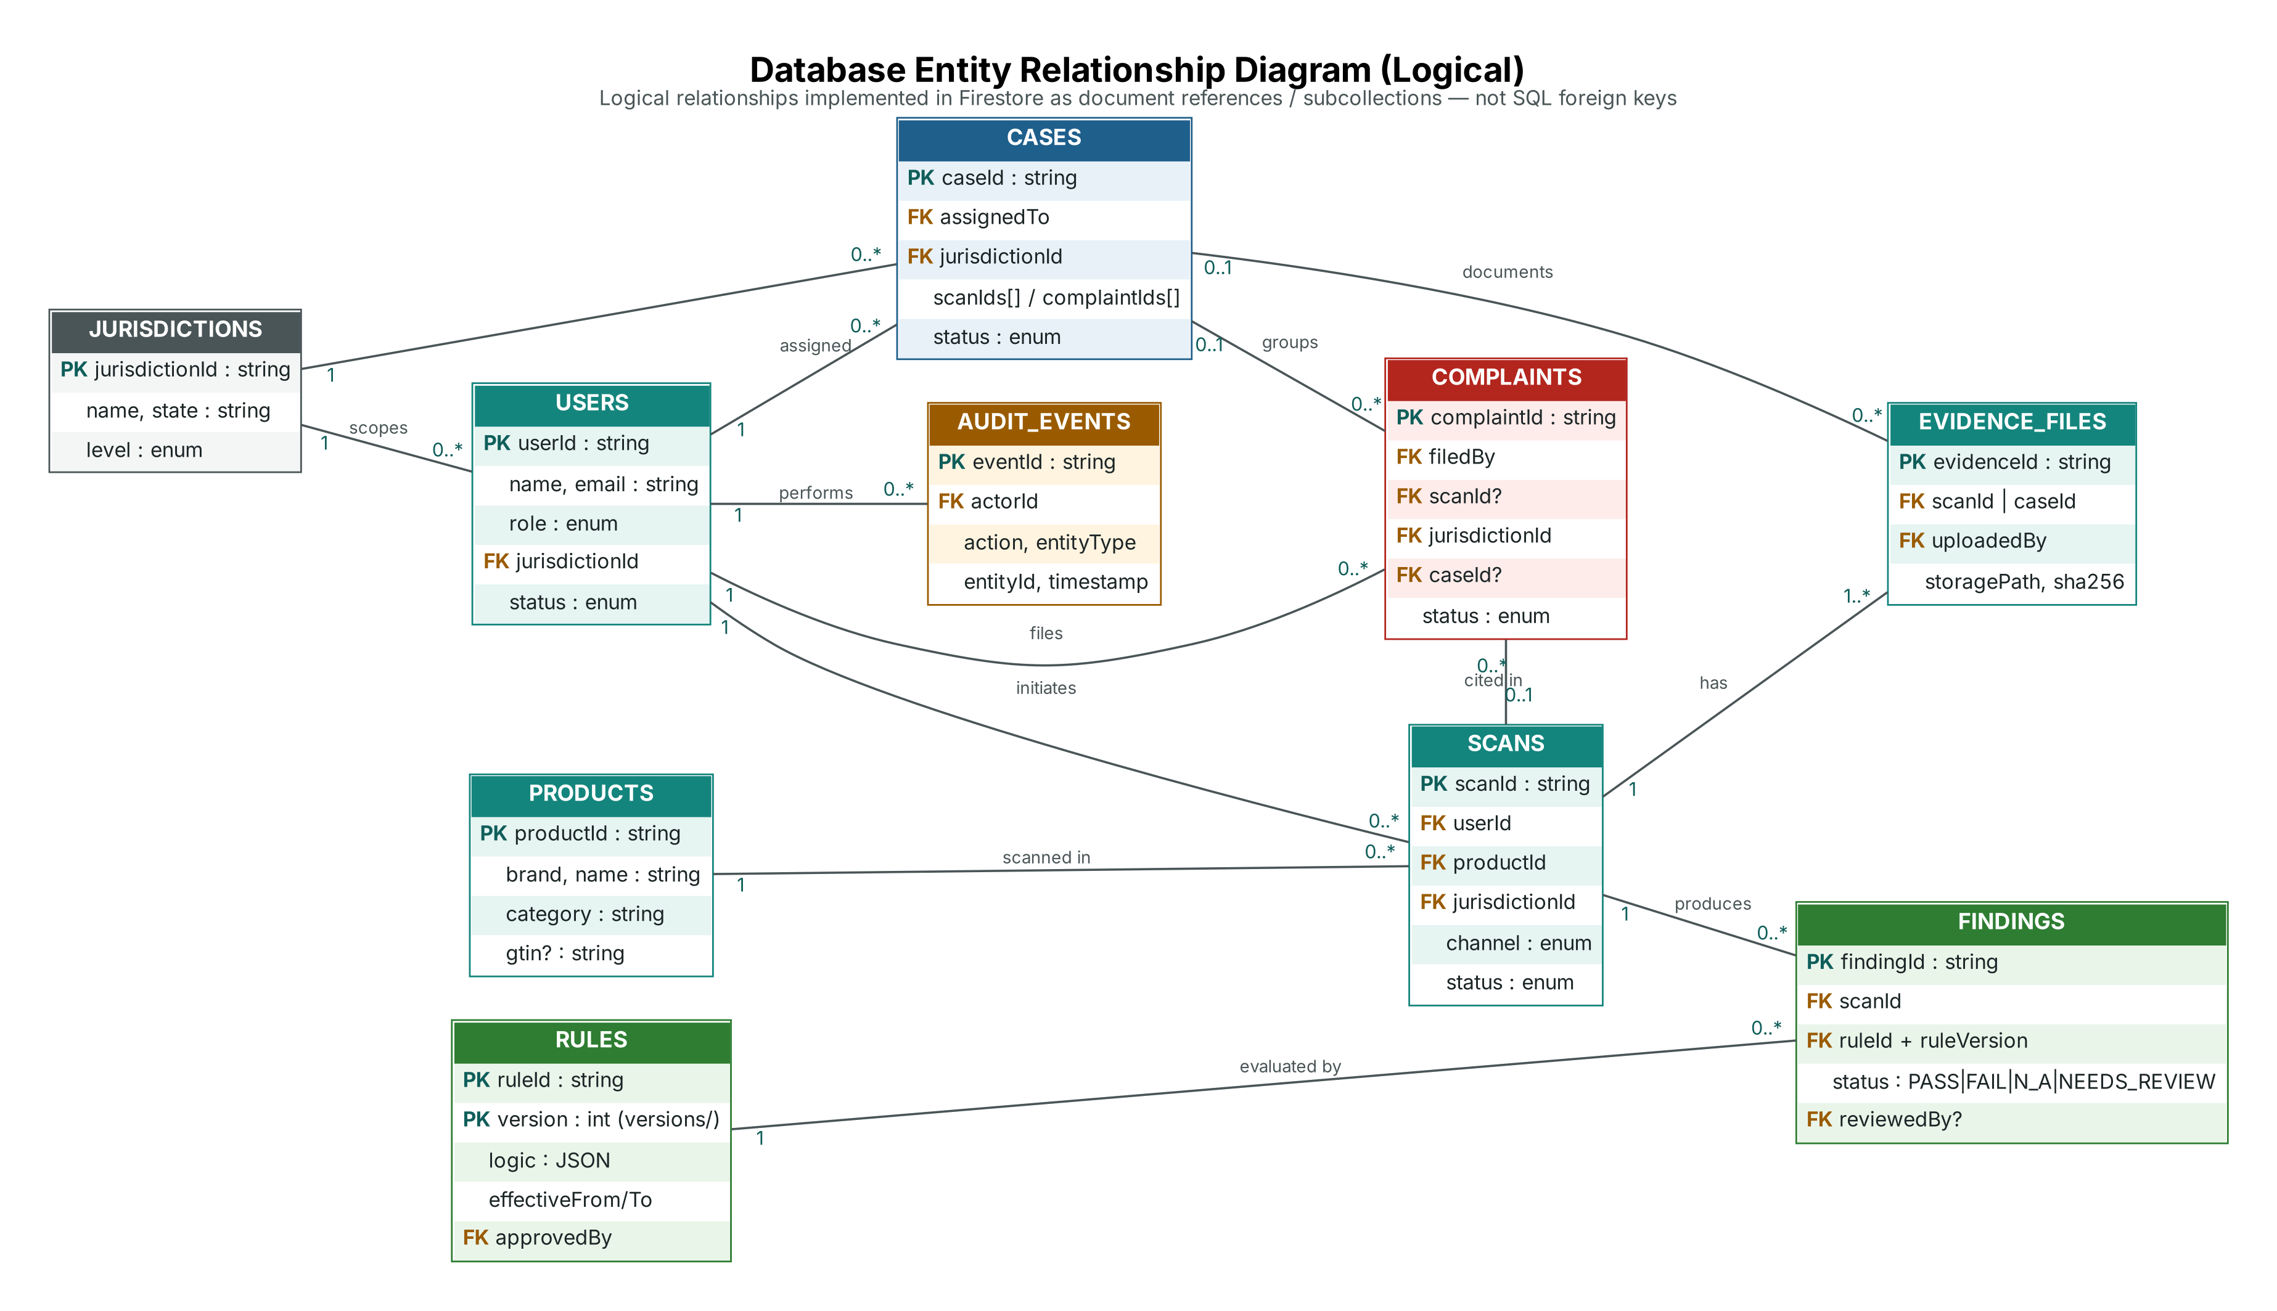
Figure 6: Logical entity relationship diagram
PK marks the document identifier; FK marks a logical reference stored as a document ID. Cardinalities: a user initiates many scans; a scan has one or more evidence files and produces many findings; each finding references exactly one rule version; a complaint may cite one scan and may be grouped into one case; a case can group many complaints and evidence documents; every user action may generate audit events.

18. Database Collection Structure
The following collections are proposed. Field types use Firestore types (string, number, boolean, timestamp, map, array, reference stored as string ID).

users
Document ID: Firebase Auth UID. Purpose: User profile and role mirror. Relationships: Belongs to one jurisdiction (officers); referenced by scans, complaints, cases, audit events.
Table 14: Collection users
Field | Type | Description
uid | string | Same as Auth UID
name, email, phone | string | Profile details (phone optional)
role | string (enum) | CITIZEN | OFFICER | ADMIN
permissions | array<string> | Sub-role flags, e.g. SENIOR_OFFICER, RULE_APPROVER
jurisdictionIds | array<string> | Assigned jurisdictions (officers)
status | string (enum) | ACTIVE | SUSPENDED
preferences | map | Language, notification settings
consent | map | Consent flags with timestamps
createdAt, updatedAt | timestamp | Lifecycle timestamps

jurisdictions
Document ID: Auto ID. Purpose: Enforcement area used for routing and access control. Relationships: Referenced by users, scans, complaints, cases.
Table 15: Collection jurisdictions
Field | Type | Description
name | string | Display name
state | string | State or UT
level | string (enum) | STATE | DISTRICT | ZONE
parentId | string | null | Parent jurisdiction
active | boolean | Whether routing is enabled

products
Document ID: Auto ID. Purpose: Product identity reused across scans. Relationships: One product has many scans.
Table 16: Collection products
Field | Type | Description
brand, name | string | As confirmed from evidence
category | string | Category code used by applicability
gtin | string | null | Barcode, if captured
createdBy | string | User who first recorded the product
createdAt | timestamp

scans
Document ID: Auto ID. Purpose: One evaluation request (citizen scan, listing check or officer inspection). Relationships: References user, product, jurisdiction, optional batch; parent of evidence and findings.
Table 17: Collection scans
Field | Type | Description
userId | string | Initiating user
source | string (enum) | CITIZEN | INSPECTION | BATCH
channel | string (enum) | IN_STORE | ONLINE
listingUrl | string | null | For online listings
productId, jurisdictionId, batchId | string | Logical references
status | string (enum) | CREATED | EXTRACTING | AWAITING_CONFIRMATION | EVALUATED | IN_REVIEW | FINALISED
extraction | map | Provider, model version, raw text ref, candidate fields with confidence and boxes
confirmedFields | map | Validated field values with source (EXTRACTED | USER_CORRECTED | OFFICER_VERIFIED)
summary | map | Counts by status
createdAt, evaluatedAt | timestamp

evidenceFiles
Document ID: Auto ID. Purpose: Metadata for an uploaded image, screenshot or document. Relationships: Belongs to a scan or a case.
Table 18: Collection evidenceFiles
Field | Type | Description
scanId | caseId | string | Parent record
uploadedBy | string | User ID
kind | string (enum) | LABEL_IMAGE | LISTING_SCREENSHOT | CASE_DOCUMENT
storagePath | string | Firebase Storage path
sha256 | string | Integrity hash
mimeType, sizeBytes | string, number | Validated file metadata
quality | map | Resolution, blur and glare scores
createdAt | timestamp

findings
Document ID: Auto ID. Purpose: Result of evaluating one rule version for one scan. Relationships: References scan, rule version, evidence and reviewer.
Table 19: Collection findings
Field | Type | Description
scanId, jurisdictionId | string | Parent scan; jurisdiction for queues
ruleId, ruleVersion | string, number | Exact rule version applied
engineStatus | string (enum) | PASS | FAIL | NOT_APPLICABLE | NEEDS_REVIEW
reasonCode, explanation | string | Machine code and readable explanation
evidenceRefs | array<map> | Evidence ID, field name and bounding box
inputsHash | string | Hash of inputs for reproducibility checks
review | map | null | finalStatus, reviewedBy, justification, reviewedAt
createdAt | timestamp

rules
Document ID: Rule ID, e.g. LM-NQ-01. Purpose: Rule header; versions stored in subcollection versions. Relationships: Rule versions referenced by findings.
Table 20: Collection rules
Field | Type | Description
title, legalReference | string | Short title and citation of the source provision
currentVersion | number | Latest published version
versions/{n}.status | string (enum) | DRAFT | PENDING_APPROVAL | PUBLISHED | RETIRED
versions/{n}.applicability | map | Categories, channels, jurisdictions, exemptions
versions/{n}.logic | map (JSON) | Declarative checks evaluated by the engine
versions/{n}.effectiveFrom/To | timestamp | Validity window
versions/{n}.createdBy, approvedBy | string | Two different admins required
versions/{n}.testCases | array<map> | Reference inputs and expected outputs

complaints
Document ID: Auto ID. Purpose: Citizen report about a product or listing. Relationships: References citizen, optional scan, jurisdiction and optional case.
Table 21: Collection complaints
Field | Type | Description
filedBy, scanId, jurisdictionId, caseId | string | Logical references (scanId and caseId optional)
description | string | Citizen's account (length-limited)
location | map | null | Optional premises or city
status | string (enum) | SUBMITTED | UNDER_REVIEW | INFO_REQUESTED | LINKED_TO_CASE | CLOSED | REJECTED
timeline | array<map> | Status changes with actor and time
createdAt | timestamp

cases
Document ID: Auto ID. Purpose: Enforcement follow-up grouping scans and complaints. Relationships: References officer, jurisdiction, scans, complaints, documents.
Table 22: Collection cases
Field | Type | Description
title | string | Short case title
assignedTo, jurisdictionId | string | Responsible officer and area
scanIds, complaintIds | array<string> | Linked records
status | string (enum) | OPEN | IN_PROGRESS | ESCALATED | CLOSED
notes | subcollection | Case notes with author and time
dueDate, closedAt | timestamp

auditEvents
Document ID: Auto ID. Purpose: Append-only record of sensitive actions. Relationships: References actor and any entity.
Table 23: Collection auditEvents
Field | Type | Description
actorId, actorRole | string | Who performed the action
action | string | e.g. FINDING_REVIEWED, ROLE_CHANGED, RULE_PUBLISHED
entityType, entityId | string | Affected record
before, after | map | null | Changed values (sensitive fields excluded)
timestamp | timestamp | Server timestamp
requestId | string | Correlates with API logs

settings
Document ID: Fixed IDs: thresholds, modules. Purpose: Versioned platform configuration managed in the Admin Portal. Relationships: Read by validation and extraction services.
Table 24: Collection settings
Field | Type | Description
thresholds.ocrMinConfidence | number | Proposed default 0.85; below this a field triggers review
thresholds.imageQuality | map | Minimum resolution and blur limits
modules | array<map> | Module ID, version, enabled, approvedBy
version, updatedBy, updatedAt | number, string, timestamp | Configuration history

19. API Design
Proposed design. The endpoints below are a design specification for implementation in Weeks 2–7. They are not implemented endpoints.
All endpoints are served under /api/v1, accept and return JSON, and require a Firebase ID token in the Authorization: Bearer <token> header. Request bodies are validated with Zod. Errors use a common format: { "error": { "code": "FORBIDDEN", "message": "…" } }.
Table 25: Proposed API endpoint summary
# | Method | Endpoint (prefix /api/v1) | Purpose | Access
1 | POST | /scans | Create a scan (in-store, online listing or inspection) | Citizen, Officer
2 | POST | /scans/{scanId}/evidence | Register evidence and obtain an upload path | Scan owner, Officer (jurisdiction)
3 | POST | /scans/{scanId}/extract | Run AI/OCR extraction on the scan's evidence | Scan owner, Officer
4 | PATCH | /scans/{scanId}/fields | Confirm or correct candidate fields | Scan owner, Officer
5 | POST | /scans/{scanId}/evaluate | Select applicable rules and run the rule engine | Scan owner, Officer
6 | GET | /scans/{scanId}/result | Retrieve result with findings and evidence references | Scan owner, Officer (jurisdiction)
7 | GET | /scans?mine=true&cursor=… | List a user's scan history | Citizen (own), Officer (jurisdiction)
8 | POST | /complaints | Raise a complaint | Citizen
9 | PATCH | /complaints/{complaintId} | Update complaint status (triage) | Officer (jurisdiction)
10 | GET | /officer/review-queue | List findings awaiting officer review | Officer
11 | POST | /findings/{findingId}/review | Confirm or override a finding | Officer
12 | POST | /batches | Create a batch inspection | Officer
13 | POST | /cases | Open a case | Officer
14 | PATCH | /cases/{caseId} | Update, assign, escalate or close a case | Officer, Senior officer (close/escalate)
15 | POST | /cases/{caseId}/documents | Attach a case document | Officer (jurisdiction)
16 | GET | /reports?jurisdictionId=…&from=…&to=… | Generate jurisdiction report data | Officer, Admin
17 | POST | /admin/rules/{ruleId}/versions | Create a draft rule version | Admin
18 | POST | /admin/rules/{ruleId}/versions/{v}/approve | Approve and publish a rule version | Admin with RULE_APPROVER
19 | PATCH | /admin/users/{uid} | Change role, jurisdiction or status | Admin
20 | PATCH | /admin/settings/thresholds | Update review thresholds | Admin
21 | GET | /admin/audit-events | Search audit log | Admin
22 | POST | /know-more | Ask the informational assistant | Citizen, Officer

19.1 Endpoint Specifications
API-01 POST /api/v1/scans
Purpose: Create a scan (in-store, online listing or inspection). Access: Citizen, Officer.
Request
{ "channel": "IN_STORE", "source": "CITIZEN",
"categoryHint": "FOOD_PACKAGED", "listingUrl": null }
Response
201 { "scanId": "scn_8f2a", "status": "CREATED" }
Validation & authorization: channel and source enums validated; source INSPECTION allowed only for officers; jurisdiction derived server-side.
API-02 POST /api/v1/scans/{scanId}/evidence
Purpose: Register evidence and obtain an upload path. Access: Scan owner, Officer (jurisdiction).
Request
{ "kind": "LABEL_IMAGE", "mimeType": "image/jpeg",
"sizeBytes": 2483112, "sha256": "9c1e…" }
Response
201 { "evidenceId": "evd_41c0",
"uploadPath": "evidence/scn_8f2a/evd_41c0.jpg" }
Validation & authorization: Only JPEG/PNG/WebP up to 10 MB (proposed); hash re-computed after upload and compared.
API-03 POST /api/v1/scans/{scanId}/extract
Purpose: Run AI/OCR extraction on the scan's evidence. Access: Scan owner, Officer.
Request
{ }
Response
202 { "status": "EXTRACTING" }
→ later: { "candidates": { "netQuantity":
{ "value": "500 g", "confidence": 0.93 } } }
Validation & authorization: Requires at least one evidence file; idempotent per evidence set; provider chosen by Modules setting.
API-04 PATCH /api/v1/scans/{scanId}/fields
Purpose: Confirm or correct candidate fields. Access: Scan owner, Officer.
Request
{ "fields": { "netQuantity": { "value": "500 g",
"source": "USER_CORRECTED", "reason": "Glare on digit" } } }
Response
200 { "status": "AWAITING_EVALUATION" }
Validation & authorization: Unit and format validation; reason required for officer corrections; original extraction preserved.
API-05 POST /api/v1/scans/{scanId}/evaluate
Purpose: Select applicable rules and run the rule engine. Access: Scan owner, Officer.
Request
{ }
Response
200 { "summary": { "PASS": 5, "FAIL": 1,
"NOT_APPLICABLE": 1, "NEEDS_REVIEW": 1 } }
Validation & authorization: Runs only on confirmed fields; uses rule versions effective at scan time; writes findings and audit event in one batch.
API-06 GET /api/v1/scans/{scanId}/result
Purpose: Retrieve result with findings and evidence references. Access: Scan owner, Officer (jurisdiction).
Request
—
Response
200 { "scanId": "scn_8f2a", "findings": [ {
"ruleId": "LM-NQ-01", "ruleVersion": 3,
"status": "PASS", "evidenceRefs": [ … ] } ] }
Validation & authorization: Citizens see informational disclaimer; officers additionally see review fields.
API-07 GET /api/v1/scans?mine=true&cursor=…
Purpose: List a user's scan history. Access: Citizen (own), Officer (jurisdiction).
Request
Query: status, channel, from, to, cursor
Response
200 { "items": [ … ], "nextCursor": "…" }
Validation & authorization: Cursor pagination, page size ≤ 50; filters validated.
API-08 POST /api/v1/complaints
Purpose: Raise a complaint. Access: Citizen.
Request
{ "scanId": "scn_8f2a", "description": "Net quantity
missing on pack", "location": { "city": "Pune" }, "consent": true }
Response
201 { "complaintId": "cmp_0142",
"status": "SUBMITTED" }
Validation & authorization: scanId must belong to the citizen; description 20–2000 characters; consent required; jurisdiction resolved server-side.
API-09 PATCH /api/v1/complaints/{complaintId}
Purpose: Update complaint status (triage). Access: Officer (jurisdiction).
Request
{ "status": "UNDER_REVIEW", "note": "Assigned" }
Response
200 { "status": "UNDER_REVIEW" }
Validation & authorization: Allowed transitions enforced by a state machine; citizen notified.
API-10 GET /api/v1/officer/review-queue
Purpose: List findings awaiting officer review. Access: Officer.
Request
Query: jurisdictionId, ruleId, cursor
Response
200 { "items": [ { "findingId": "fnd_77", "engineStatus":
"NEEDS_REVIEW", "reasonCode": "LOW_CONFIDENCE" } ] }
Validation & authorization: Restricted to the officer's jurisdictions; sorted by age.
API-11 POST /api/v1/findings/{findingId}/review
Purpose: Confirm or override a finding. Access: Officer.
Request
{ "finalStatus": "FAIL", "justification":
"Net quantity not declared on any panel" }
Response
200 { "findingId": "fnd_77", "finalStatus": "FAIL",
"reviewedBy": "uid_o12" }
Validation & authorization: Justification mandatory (min. 15 characters); engine result kept; audit event FINDING_REVIEWED.
API-12 POST /api/v1/batches
Purpose: Create a batch inspection. Access: Officer.
Request
{ "premises": "Retail outlet, Ward 4",
"jurisdictionId": "jur_pune_01" }
Response
201 { "batchId": "bat_0112" }
Validation & authorization: Officer must be assigned to the jurisdiction; scans then created with batchId.
API-13 POST /api/v1/cases
Purpose: Open a case. Access: Officer.
Request
{ "title": "Undeclared net quantity – outlet W4",
"scanIds": ["scn_8f2a"], "complaintIds": ["cmp_0142"] }
Response
201 { "caseId": "case_0031", "status": "OPEN" }
Validation & authorization: Linked records must be in the same jurisdiction.
API-14 PATCH /api/v1/cases/{caseId}
Purpose: Update, assign, escalate or close a case. Access: Officer, Senior officer (close/escalate).
Request
{ "status": "CLOSED", "note": "Corrected stock verified" }
Response
200 { "status": "CLOSED" }
Validation & authorization: Closure requires a note; escalation and closure restricted by permission flag.
API-15 POST /api/v1/cases/{caseId}/documents
Purpose: Attach a case document. Access: Officer (jurisdiction).
Request
{ "kind": "CASE_DOCUMENT", "mimeType": "application/pdf",
"sizeBytes": 183220, "title": "Inspection memo" }
Response
201 { "evidenceId": "evd_9d10", "uploadPath": "…" }
Validation & authorization: PDF/JPEG/PNG only; size limit; stored under the case path.
API-16 GET /api/v1/reports?jurisdictionId=…&from=…&to=…
Purpose: Generate jurisdiction report data. Access: Officer, Admin.
Request
Query parameters
Response
200 { "scans": 412, "statusCounts": { … },
"complaints": 38, "casesClosed": 11 }
Validation & authorization: Date range ≤ 1 year; officers limited to own jurisdictions; CSV via Accept header.
API-17 POST /api/v1/admin/rules/{ruleId}/versions
Purpose: Create a draft rule version. Access: Admin.
Request
{ "applicability": { "channels": ["IN_STORE","ONLINE"] },
"logic": { "requireField": "netQuantity" },
"effectiveFrom": "2026-12-01", "testCases": [ … ] }
Response
201 { "ruleId": "LM-NQ-01", "version": 4,
"status": "DRAFT" }
Validation & authorization: Logic validated against the rule schema; test cases must pass before approval is possible.
API-18 POST /api/v1/admin/rules/{ruleId}/versions/{v}/approve
Purpose: Approve and publish a rule version. Access: Admin with RULE_APPROVER.
Request
{ "decision": "APPROVE" }
Response
200 { "status": "PUBLISHED" }
Validation & authorization: Approver must differ from author; published version becomes immutable; audit event RULE_PUBLISHED.
API-19 PATCH /api/v1/admin/users/{uid}
Purpose: Change role, jurisdiction or status. Access: Admin.
Request
{ "role": "OFFICER", "jurisdictionIds": ["jur_pune_01"] }
Response
200 { "uid": "uid_o12", "role": "OFFICER" }
Validation & authorization: Admins cannot change their own role; custom claims refreshed; audit event ROLE_CHANGED.
API-20 PATCH /api/v1/admin/settings/thresholds
Purpose: Update review thresholds. Access: Admin.
Request
{ "ocrMinConfidence": 0.85 }
Response
200 { "version": 6 }
Validation & authorization: Value range 0.5–0.99; new settings version created; audited.
API-21 GET /api/v1/admin/audit-events
Purpose: Search audit log. Access: Admin.
Request
Query: actorId, action, entityType, from, to, cursor
Response
200 { "items": [ { "action": "FINDING_REVIEWED", … } ] }
Validation & authorization: Read-only; no update or delete endpoint exists.
API-22 POST /api/v1/know-more
Purpose: Ask the informational assistant. Access: Citizen, Officer.
Request
{ "question": "What does 'net quantity' mean?" }
Response
200 { "answer": "…", "disclaimer":
"Information only – not a compliance decision" }
Validation & authorization: Rate-limited; no access to findings or personal data; answers never change result statuses.

20. Technology Stack and Justification
Table 26: Technology stack
Layer | Technology | Role in Label Sentinel | Why it is suitable
Frontend | Next.js (App Router) | Routing for three portals, server rendering, API route handlers | One codebase for UI and API; route groups and layouts make role-based portals straightforward
Frontend | React | Component model for dashboards, forms, capture screens | Mature ecosystem; works natively with Next.js
Frontend | TypeScript | Typed models shared by UI, API and rule engine | Type safety for rule definitions and findings reduces logic errors
Frontend | Tailwind CSS | Styling and responsive layout | Consistent spacing and theming; fast iteration
Frontend | shadcn/ui | Accessible tables, dialogs, forms, badges | Source-owned components built on accessible primitives; easy to theme in the light teal/grey palette
Frontend | Lucide Icons | Navigation and status icons | Consistent, lightweight icon set
Backend | Next.js API Routes / server services | Validation, RBAC, orchestration of extraction and evaluation | Keeps secrets and business logic on the server; deploys with the frontend
Backend | Firebase Authentication | Sign-in, ID tokens, custom role claims | Managed identity with email and phone options; integrates with Firestore rules
Backend | Firebase Firestore | Users, scans, findings, rules, complaints, cases, audit events | Serverless scaling, real-time listeners for queues, security rules
Backend | Firebase Storage | Evidence images and case documents | Secure object storage with rule-based access
AI | Provider-agnostic OCR/vision adapter | Single interface for extraction providers | Avoids lock-in; providers can be compared on the same test set
AI | Gemini Vision or ML Kit (to be selected) | Candidate text and field extraction | Both are candidates; final choice after accuracy, cost and latency testing in Week 4
Compliance | Custom TypeScript rule engine | Deterministic evaluation of rule versions | Pure functions are testable, reproducible and explainable
Compliance | Version-controlled rule registry | Draft, approve, publish and pin rule versions | Historic results stay explainable; changes are reviewed
Compliance | Applicability selection layer | Determines which rules apply | Separates "does this rule apply?" from "is it satisfied?"
Other | Recharts | Charts for officer reports and admin analytics | React-native charting with simple API
Other | Vitest or Jest | Unit tests for rule engine, validators, API handlers | Fast TypeScript testing; final choice in Week 2
Other | Playwright | End-to-end tests of portal workflows | Cross-browser automation including mobile viewports
Other | GitHub Actions | CI: lint, type-check, test, build | Automated quality gate on every pull request

21. AI/OCR Extraction Architecture
The extraction service turns evidence images into candidate declarations. Its output is always treated as unverified input to validation and never as a compliance decision.

21.1 Extraction Pipeline
- Pre-processing: orientation correction, resizing, and quality scoring (resolution, blur, glare). Images below the quality threshold prompt re-capture.
- Provider call: the adapter sends the image to the configured provider and receives text blocks with positions.
- Field mapping: text is mapped to a fixed field schema (for example net quantity, retail sale price, manufacturer/packer name and address, month and year of manufacture or packing, consumer care details, country of origin, common or generic name).
- Normalisation: units, numbers, dates and currency are parsed into structured values.
- Confidence scoring: each field receives a confidence value; missing or ambiguous fields are marked explicitly.
- Recording: provider name, model version, raw text and processing time are stored for traceability.

21.2 Adapter Interface (Proposed)
interface ExtractionProvider {
id: string; // e.g. "gemini-vision" | "mlkit"
version: string;
extract(images: EvidenceImage[]): Promise<ExtractionResult>;
}
interface ExtractionResult {
rawText: string;
candidates: Record<FieldName, { value: string | null;
confidence: number; evidenceId: string; box?: BoundingBox }>;
provider: { id: string; version: string; latencyMs: number };
}

21.3 Guardrails
- The extraction service has no access to rule definitions or result statuses.
- Model output is parsed against a strict schema; non-conforming output is discarded and the field is marked missing.
- Fields below ocrMinConfidence (proposed default 0.85, configurable by Admin) require confirmation or lead to NEEDS_REVIEW.
- Provider selection is controlled through the Admin Modules setting; only approved providers can be enabled.
- Know More AI is a separate component with no write access to scans or findings.

22. Deterministic Compliance Rule Engine
The rule engine is a pure TypeScript module. Given the same confirmed fields, scan context and rule versions, it always returns the same findings. It makes no network calls and uses no AI.

22.1 Applicability Selection
Before evaluation, the applicability layer filters the published rule versions effective on the scan date. A rule is applicable only if the product category, sales channel and jurisdiction match its applicability conditions and no exemption applies. Rules that are filtered out are recorded as NOT_APPLICABLE with the reason, so the user can see why a requirement was not checked.

22.2 Rule Definition Example (Illustrative)
{
"ruleId": "LM-NQ-01",
"version": 3,
"title": "Net quantity must be declared with a standard unit",
"legalReference": "Packaged Commodities Rules – net quantity declaration (to be verified)",
"applicability": { "channels": ["IN_STORE", "ONLINE"], "excludeCategories": ["LOOSE_GOODS"] },
"logic": {
"all": [
{ "field": "netQuantity", "check": "present" },
{ "field": "netQuantity.unit", "check": "inSet", "values": ["g","kg","ml","L","N"] }
]
},
"reviewWhen": [ { "field": "netQuantity", "confidenceBelow": "threshold" } ],
"effectiveFrom": "2026-10-01"
}

22.3 Evaluation Logic
Table 27: Status decision order
Order | Condition | Resulting status
1 | Rule filtered out by applicability | NOT_APPLICABLE
2 | A required field has confidence below threshold, conflicting values, or poor evidence quality | NEEDS_REVIEW
3 | All checks in the rule logic succeed | PASS
4 | Any check fails on clear, sufficient evidence | FAIL
5 | Any unexpected condition (unknown category, missing evidence panel) | NEEDS_REVIEW (fail-safe)

22.4 Versioning and Governance
- Rule versions move through Draft → Pending approval → Published → Retired.
- A published version is immutable; a correction creates a new version with a new effective date.
- Publication requires all attached reference test cases to pass and approval by a second administrator.
- Each finding stores ruleId, ruleVersion and an inputsHash, so any result can be re-evaluated and compared later.
- The legal content of each rule will be validated against official Legal Metrology texts and mentor guidance before publication.

23. Security and Privacy Architecture
Table 28: Security and privacy controls
Area | Proposed control
Authentication | Firebase Authentication (email/password and phone OTP for citizens; email with multi-factor authentication recommended for officers and admins). ID tokens verified server-side on every API call.
Role-Based Access Control | Role and permission flags stored in custom claims; enforced in Next.js layouts (UI), API handlers (server) and Firestore/Storage rules (data).
Record-level authorization | Citizens access only records where userId == auth.uid; officers only records whose jurisdictionId is in their claims; admins cannot modify findings.
Firestore Security Rules | Deny by default; clients may read permitted documents but writes to findings, rules, settings and auditEvents are server-only (Admin SDK).
Storage Security Rules | Paths scoped by scan or case; content-type and size checks; no public read access; reads only for authorised users.
Evidence protection | SHA-256 hash stored at upload and verified; evidence never overwritten; EXIF location data stripped from citizen images unless explicitly shared.
Data validation | Zod schemas on all requests; file type sniffing; output encoding in UI; length limits on free text; rate limiting on uploads and Know More AI.
Audit logging | Append-only auditEvents for review decisions, role changes, rule publication, threshold and module changes, data exports.
Data retention (proposed) | Citizen scans and evidence retained for a configurable period (e.g. 24 months) unless linked to an open case; case records follow departmental retention policy; deletion requests honoured where no legal hold applies.
Privacy | Data minimisation, purpose-specific consent, optional location, masking of citizen identity in reports, alignment with the Digital Personal Data Protection Act, 2023 to be reviewed.
Secrets & transport | HTTPS only; provider keys held server-side in environment secrets; no keys in the client bundle.

23.1 Illustrative Firestore Rule
match /scans/{scanId} {
allow read: if request.auth != null && (
resource.data.userId == request.auth.uid ||
(request.auth.token.role == "OFFICER" &&
resource.data.jurisdictionId in request.auth.token.jurisdictionIds));
allow write: if false; // all writes via server API (Admin SDK)
}

24. UI/UX Design and Wireframes
The interface follows a light, professional compliance-dashboard style: white and soft neutral backgrounds, teal primary accents, grey text hierarchy and clear status badges. Status is always shown with both colour and text (PASS, FAIL, NOT_APPLICABLE, NEEDS_REVIEW) for accessibility. Each portal has its own sidebar navigation and role-specific dashboard; sample values in the wireframes are illustrative only.
Table 29: UI design specification
Design element | Specification (proposed)
Palette | Background #F6F8F8, surfaces #FFFFFF, primary teal #14857D, text #1C2526; status: green PASS, red FAIL, amber NEEDS_REVIEW, grey NOT_APPLICABLE
Typography | Inter (or system sans-serif); 14 px body, 20–24 px page titles; tabular numbers in tables
Layout | Fixed left sidebar (collapsible on mobile), top bar with search, language switch and profile; 8 px spacing grid
Components | KPI cards, data tables with filters and pagination, status badges, evidence viewer with highlighted regions, stepper for scans
Responsiveness | Sidebar becomes bottom navigation below 768 px; camera capture optimised for mobile browsers

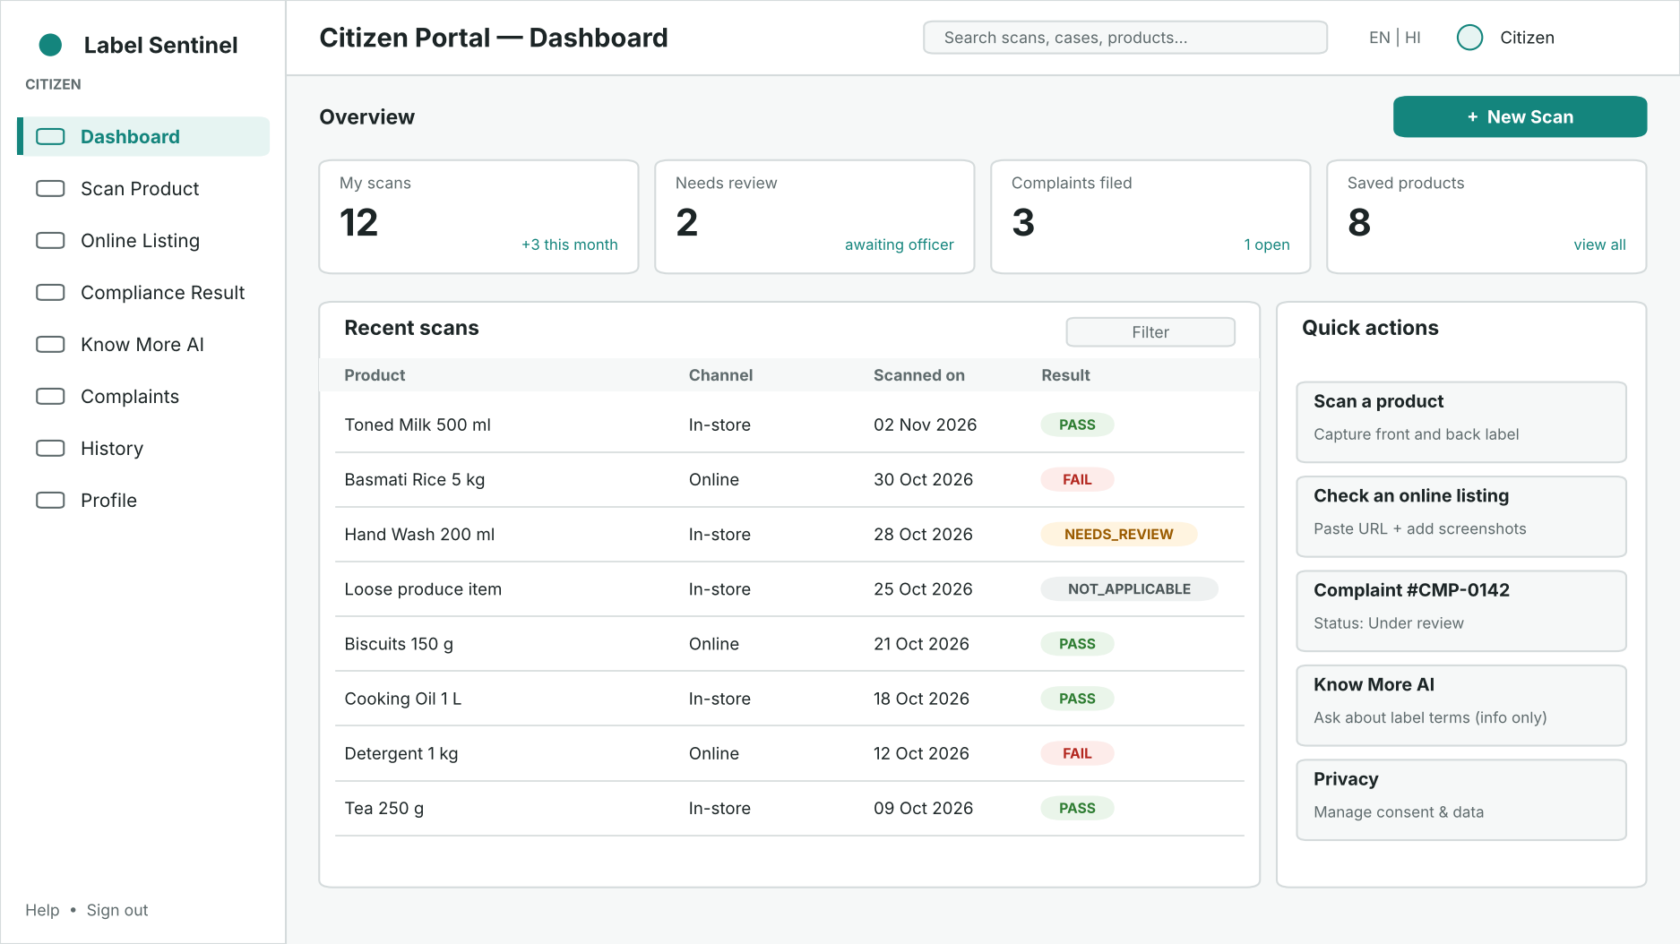
Figure 7: Citizen Portal wireframe — dashboard

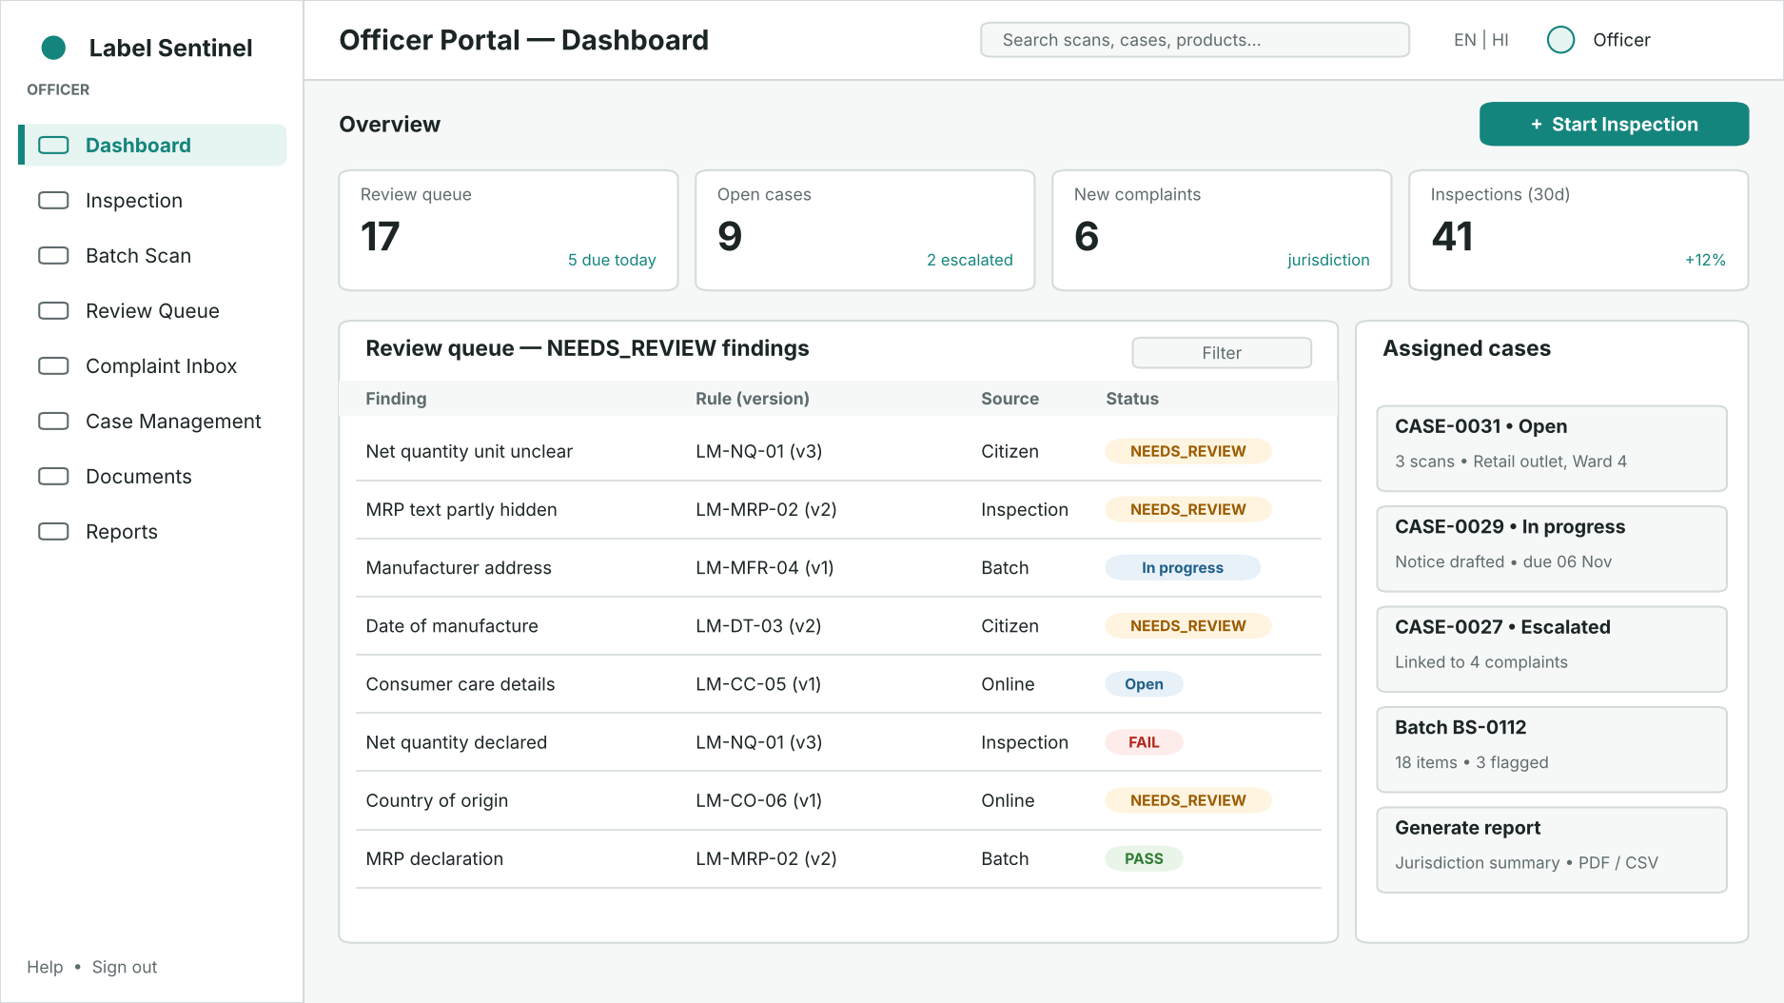
Figure 8: Officer Portal wireframe — dashboard with review queue

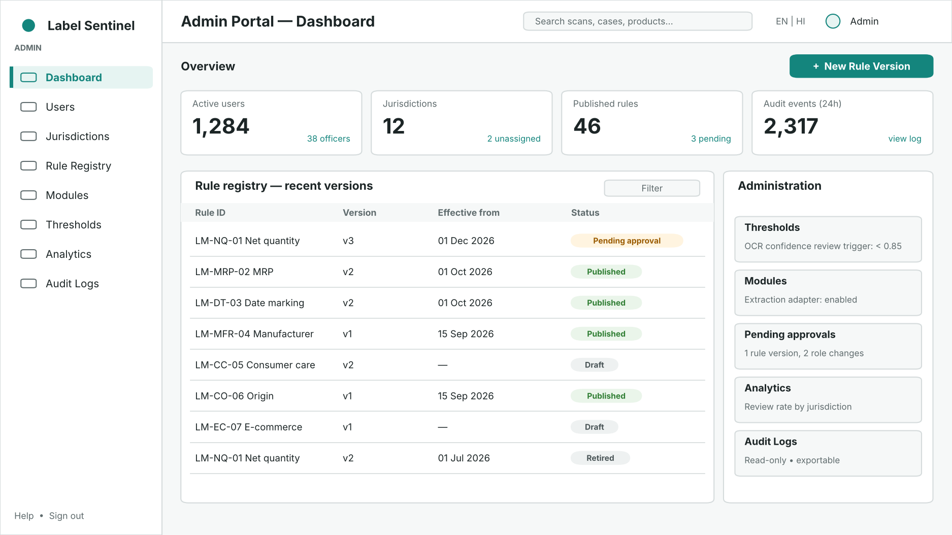
Figure 9: Admin Portal wireframe — dashboard with rule registry

25. Testing and Validation Strategy
Table 30: Testing strategy
Test level | Scope | Tools | Exit criteria (proposed)
Unit | Rule engine, applicability, validators, unit parsers | Vitest or Jest | ≥ 90% line coverage for rule engine and validators
Rule regression | Reference test cases for every rule version | Vitest/Jest fixtures | All cases pass before publication; identical output across repeated runs
Extraction benchmark | Labelled set of label images and listing screenshots | Custom evaluation script | Field-level precision and recall reported per provider; threshold tuned on results
API / integration | Route handlers with Firebase emulators | Vitest/Jest + Firebase Emulator Suite | All endpoints return documented responses and errors
Security rules | Firestore and Storage rules | Emulator rules tests | Each role can access only permitted records
End-to-end | Key workflows in all three portals | Playwright (desktop and mobile) | Citizen scan→result→complaint, officer review→case, admin rule publish pass
Usability | Task-based walkthroughs with sample users | Moderated sessions | Key tasks completed without assistance
Accessibility | Contrast, keyboard, labels | axe checks + manual review | No critical WCAG 2.1 AA violations

A labelled evaluation dataset of product images (taken by the team, with varied lighting, angles and packaging types) will be prepared in Weeks 3–4. It will be used both to compare OCR providers and to set the confidence threshold. Determinism will be verified by evaluating the same inputs repeatedly and comparing inputsHash and outputs.

26. Risks and Mitigation Plan
Table 31: Risk register
# | Risk | Impact | Likelihood | Mitigation
R1 | OCR misreads values (glare, curved packs, small fonts) | High | High | Quality checks, user confirmation, confidence threshold, NEEDS_REVIEW routing
R2 | Incorrect interpretation of legal requirements | High | Medium | Rules validated against official text and mentor guidance; two-person approval; legal reference stored per rule
R3 | Citizens treat results as legal verdicts | Medium | Medium | Clear disclaimers; only officer decisions form enforcement records
R4 | OCR provider cost, quota or availability | Medium | Medium | Adapter pattern, provider fallback, caching per evidence hash, usage limits
R5 | Unauthorised access to evidence or personal data | High | Low | Deny-by-default rules, server-only writes, jurisdiction scoping, rules tests
R6 | Abuse: spam or false complaints | Medium | Medium | Rate limits, required evidence, officer triage, account suspension
R7 | Firestore query limits for reports | Low | Medium | Denormalised fields, composite indexes, pre-aggregated counters
R8 | Schedule slip within eight weeks | Medium | Medium | Prioritised MVP scope, weekly demos, buffer in Week 8
R9 | Insufficient test images | Medium | Medium | Begin dataset collection in Week 3; include listing screenshots

27. Week-wise Implementation Roadmap
Table 32: Eight-week implementation roadmap
Week | Focus | Key deliverables
1 | Planning and System Architecture | This report; requirements; workflows; architecture; ERD; Firestore design; API specification; wireframes; roadmap
2 | Project Setup, Authentication and Base UI | Next.js + TypeScript repository; Tailwind and shadcn/ui theme; Firebase project and emulators; sign-in; role claims; three portal shells with sidebars; CI pipeline
3 | Citizen Portal and Evidence Upload | Dashboard, Scan Product, Online Listing, History, Profile; image quality checks; Storage upload with hashing; scan records; start of test image dataset
4 | AI/OCR Extraction | Extraction adapter; provider integration and comparison; field mapping and normalisation; confidence scoring; field confirmation UI
5 | Applicability and Deterministic Rule Engine | Rule schema; applicability layer; rule engine; starter rule set with test cases; Compliance Result page; Know More AI (informational)
6 | Officer Portal and Case Management | Inspection, Batch Scan, Review Queue, Complaint Inbox, Case Management, Documents; citizen Complaints module
7 | Admin Portal and Audit System | Users, Jurisdictions, Rule Registry with approval flow, Modules, Thresholds, Analytics, Audit Logs; officer Reports
8 | Testing, Integration and Demo Preparation | End-to-end tests, security rules tests, performance checks, bug fixes, demo dataset, user guide, final presentation

28. Design Decisions and Assumptions

28.1 Design Decisions
Table 33: Key design decisions
Decision | Rationale
Exactly three portals in one Next.js application | Shared authentication, components and API; separate route groups provide distinct experiences
AI limited to extraction | Legal outcomes must be reproducible and explainable; model output is variable
Deterministic engine with versioned rules | Consistent results; historical findings stay valid after rule changes
Separate applicability layer | Makes non-applicable rules explicit and keeps rule logic simple
NEEDS_REVIEW as fail-safe status | Avoids false PASS or FAIL when evidence or extraction is uncertain
Firestore with logical references | Managed, scalable and integrated with Firebase Auth and security rules
Server-only writes for findings and audit | Prevents tampering from the client
Listings submitted by users (no scraping) | Avoids legal and technical issues with automated crawling

28.2 Assumptions
- The starter rule set will be derived from the Legal Metrology Act, 2009 and the Legal Metrology (Packaged Commodities) Rules, 2011 as amended; exact provisions will be verified before rules are published.
- The OCR provider (Gemini Vision or ML Kit) will be selected after Week 4 benchmarking; costs and quotas are not yet confirmed.
- Jurisdiction structure for the prototype will use sample jurisdictions; real departmental boundaries are not confirmed.
- The proposed thresholds (e.g. OCR confidence 0.85), file-size limits and retention periods are starting values to be tuned.
- Officer and admin accounts will be created by administrators; there is no public sign-up for these roles.
- Deployment target (for example Firebase Hosting or another Next.js host) will be finalised in Week 2.

29. Expected Outcomes
- A working prototype with three role-specific portals demonstrating the complete scan → result → complaint → review → case flow.
- Explainable results linked to evidence, rule and rule version for every finding.
- A versioned rule registry with a two-person approval process.
- A measured comparison of OCR providers on a labelled dataset, with a justified threshold.
- Structured complaints and inspection records that support consistent officer follow-up and reporting.
- A complete audit trail of sensitive actions.
- Automated tests and CI demonstrating determinism, security rules and key workflows.

30. Conclusion
This Week 1 report establishes the plan and architecture for Label Sentinel. The design deliberately separates evidence extraction by AI from legal evaluation by a deterministic, version-controlled rule engine, and places accountable officers in control of uncertain findings and enforcement records. The three-portal structure gives citizens a simple way to check products and raise complaints, gives officers structured tools for inspection, review and case management, and gives administrators governance over users, rules, thresholds and audit history.
The requirements, workflows, data model, API design and security controls described here are consistent with one another and provide a clear basis for implementation. Work in Week 2 will begin with project setup, authentication and the base user interface for all three portals.

Appendix A – Proposed GitHub Repository Structure
The repository will be created in Week 2. The structure below is a proposal; no repository URL exists yet.
label-sentinel/
├── app/
│ ├── (auth)/sign-in/ # Sign-in and registration
│ ├── (citizen)/citizen/ # dashboard, scan, listing, result,
│ │ # know-more, complaints, history, profile
│ ├── (officer)/officer/ # dashboard, inspection, batch, review,
│ │ # complaints, cases, documents, reports
│ ├── (admin)/admin/ # dashboard, users, jurisdictions, rules,
│ │ # modules, thresholds, analytics, audit
│ └── api/v1/ # Route handlers (scans, findings, complaints,
│ # cases, reports, admin, know-more)
├── components/
│ ├── ui/ # shadcn/ui components
│ ├── layout/ # Sidebars, top bar, role guards
│ └── domain/ # StatusBadge, EvidenceViewer, FindingCard
├── lib/
│ ├── firebase/ # client.ts, admin.ts
│ ├── auth/ # token verification, RBAC helpers
│ ├── validation/ # Zod schemas
│ ├── extraction/ # ExtractionProvider interface + adapters
│ ├── applicability/ # Rule applicability selection
│ ├── rule-engine/ # Deterministic evaluator
│ └── audit/ # Audit event writer
├── rules/ # Seed rule definitions (JSON) + test cases
├── firestore.rules
├── storage.rules
├── firestore.indexes.json
├── tests/
│ ├── unit/ # Rule engine, validators
│ ├── rules/ # Security rules tests (emulator)
│ └── e2e/ # Playwright specs per portal
├── docs/ # Reports, diagrams, ADRs
├── .github/workflows/ci.yml # Lint, type-check, test, build
├── .env.example
├── package.json
└── README.md

