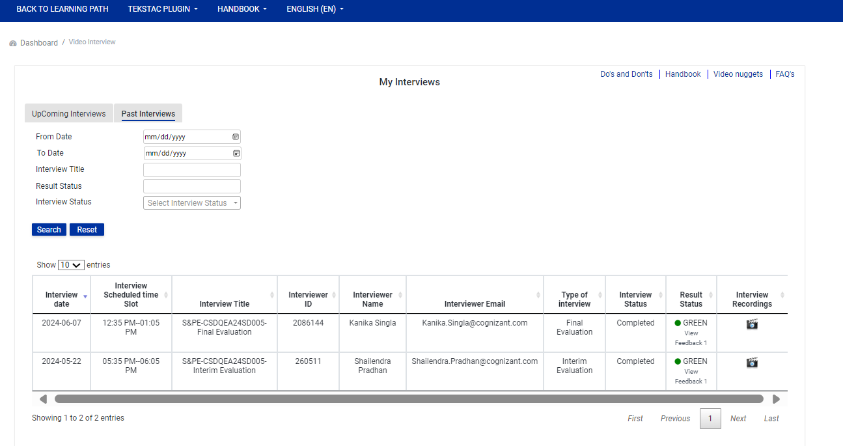

Overall she is excellent till date.

Bhakti is doing good in Selenium automation testing training, she knows the concept and code.also well explained the flow.

Considering, Java basics are good, she is yet to complete TestNG, POM and Cucumber training , I have advised her to deep dive more in these topics.

