INSURANCE UNDERWRITING
& CLAIMS ANALYSIS
SQL Project Documentation

Database | CLAIMS
Table | insurance_data
Tool | MySQL Workbench
Dataset size | 20 records

Prepared as a learning and portfolio project

1. Project Overview
This project uses SQL to explore a sample insurance dataset containing applicant, policy, risk, underwriting and claims information. The goal is to answer practical business questions and turn query results into clear observations that may support insurance operations and decision-making.

2. Project Details
Item | Description
Database | CLAIMS
Table | insurance_data
Database tool | MySQL Workbench
Dataset size | 20 records (sample dataset)
Analysis questions | 12

Note: The dataset contains only 20 records. Findings describe this sample and should not be generalised to the entire insurance industry or customer population.

3. Table Structure

The dataset used in this project is dummy/sample insurance data obtained from Kaggle.com. It is not real customer or company data. The insurance_data table includes applicant details, address, policy information, premium and coverage fields, claim information, risk category, underwriting decision, previous claim count, and claim filing and resolution dates.

4. SQL Business Questions and Analysis

Question 1: Which gender has the highest number of claims?
SQL Query
SELECT
gender,
COUNT(claim_id) AS total_claims
FROM insurance_data
WHERE claim_id IS NOT NULL
GROUP BY gender
ORDER BY total_claims DESC;

Result
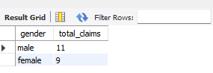
Business Insight: Male customers accounted for 55% of the total claims, while female customers accounted for 45%. This shows that male customers had slightly more claims in the given dataset.

Question 2: Which two countries have the lowest number of claims?
SQL Query
SELECT
address_country,
COUNT(claim_id) AS total_claims
FROM insurance_data
WHERE claim_id IS NOT NULL
GROUP BY address_country
ORDER BY total_claims ASC
LIMIT 2;

Result
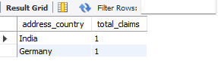

Business Insight: India and Germany have the lowest claim counts in this sample, with one claim each.

Question 3: Which city has the highest number of claims?
SQL Query
SELECT
address_city,
COUNT(claim_id) AS total_claims
FROM insurance_data
WHERE claim_id IS NOT NULL
GROUP BY address_city
ORDER BY total_claims DESC
LIMIT 1;

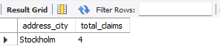

Business Insight: Stockholm had the highest claim count, with 4 claims, making it the city with the most claims in the sample.

Question 4: Which policy type is purchased most frequently?
SQL Query
SELECT
policy_type,
COUNT(policy_id) AS total_policies
FROM insurance_data
WHERE policy_id IS NOT NULL
GROUP BY policy_type
ORDER BY total_policies DESC
LIMIT 1;

Result
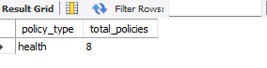
Business Insight: Health insurance is the most frequently represented policy type in the sample, with 8 policies.

Question 5: What is the distribution of policies by status, and which statuses have the highest and lowest counts?
SQL Query
SELECT
policy_status,
COUNT(policy_id) AS total_policies
FROM insurance_data
WHERE policy_id IS NOT NULL
GROUP BY policy_status
ORDER BY total_policies DESC;

Result
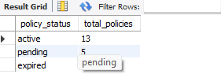

Business Insight: Out of 20 policies, 13 (65%) are active, 5 (25%) are pending, and 2 (10%) are expired. This shows that most policies are currently active, while 7 policies still need attention due to pending or expired status.

Question 6: What is the percentage distribution of claims by status?
SQL Query
SELECT
claim_status,
COUNT(claim_id) AS total_claims,
ROUND(
COUNT(claim_id) * 100.0 /
(SELECT COUNT(claim_id)
FROM insurance_data
WHERE claim_id IS NOT NULL),
2
) AS percentage
FROM insurance_data
WHERE claim_id IS NOT NULL
GROUP BY claim_status
ORDER BY percentage DESC;

Result
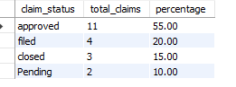
Business Insight: Out of 20 claims, 11 (55%) have been approved, while 4 (20%) are filed, 3 (15%) are closed, and 2 (10%) are pending. This shows that more than half of the claims have been approved, while the remaining claims require monitoring to ensure timely processing and closure..

Question 7: How are insurance applications distributed across different risk categories?
SQL Query
SELECT
risk_category,
COUNT(applicant_id) AS total_applications,
ROUND(
COUNT(applicant_id) * 100.0 /
(SELECT COUNT(applicant_id)
FROM insurance_data),
2
) AS percentage
FROM insurance_data
GROUP BY risk_category
ORDER BY total_applications DESC;

Result
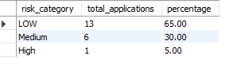

Business Insight: Out of 20 insurance applications, 13 (65%) fall under the low-risk category, 6 (30%) are medium-risk, and only 1 (5%) is high-risk. This indicates that the majority of applicants are classified as low risk, suggesting a relatively lower-risk profile in the given dataset.

Question 8: How many claims has each customer submitted?
SQL Query
SELECT
applicant_id,
COUNT(claim_id) AS total_claims
FROM insurance_data
WHERE claim_id IS NOT NULL
GROUP BY applicant_id
ORDER BY total_claims DESC;

Result
Result summary | Finding
All customers in this sample | 1 claim each

Business Insight: Every customer in the current sample has one claim record. No customer has more than one claim in this query.

Question 9: How many applications are approved, pending, or require further underwriting review?
SQL Query
SELECT
underwriting_decision,
COUNT(applicant_id) AS total_applications
FROM insurance_data
GROUP BY underwriting_decision
ORDER BY total_applications DESC;

Result

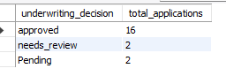
Business Insight: Out of 20 insurance applications, 16 (80%) were approved, 2 (10%) require further underwriting review, and 2 (10%) are pending. This shows that most applications were successfully approved, while 4 applications still need further action before a final decision can be made.

Question 10: What is the average time taken by the insurance company to process and resolve claims?
SQL Query
SELECT
ROUND(
AVG(
DATEDIFF(
STR_TO_DATE(claim_resolution_date, '%Y-%m-%d'),
STR_TO_DATE(claim_filing_date, '%Y-%m-%d')
)
),
2
) AS average_processing_days
FROM insurance_data
WHERE claim_filing_date IS NOT NULL
AND claim_resolution_date IS NOT NULL;

Result

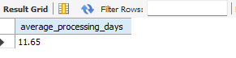
Business Insight: The average time taken by the insurance company to process and resolve a claim is 11.65 days. This indicates that, on average, customers wait approximately 12 days for their claims to be resolved. Monitoring processing time can help the company identify delays and improve claim settlement efficiency.

Question 11: How many policies are there under each insurance policy type?
SQL Query
SELECT
policy_type,
COUNT(policy_id) AS total_policies
FROM insurance_data
WHERE policy_id IS NOT NULL
GROUP BY policy_type
ORDER BY total_policies DESC;

Result
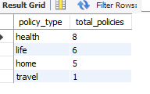

Business Insight: Health insurance has the highest number of policies, with 8 out of 20 policies (40%), followed by Life insurance with 6 (30%) and Home insurance with 5 (25%). Travel insurance has the lowest count, with only 1 policy (5%). This indicates that Health insurance is the most popular policy type in the given dataset.

Question 12: How many customers have more than one previous claim?
SQL Query
SELECT
COUNT(*) AS customers_with_more_than_one_previous_claim
FROM insurance_data
WHERE previous_claim_count > 1;

Result

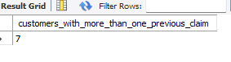

Business Insight: The analysis shows that 7 out of 20 customers (35%) have more than one previous claim. This indicates that a significant portion of customers have a history of multiple claims, which may require closer attention during risk assessment and underwriting decisions.

5. Key Findings

• The dataset contains four insurance policy types: Health, Life, Home and Travel.
• Health insurance is the most common policy type, with 8 policies (40%).
• Stockholm recorded the highest number of claims, with 4 claims.
• Male customers accounted for 55% of claims, while female customers accounted for 45%.
• Most policies (65%) are active, while 25% are pending and 10% are expired.
• Low-risk applications represent 65% of the total applications, followed by medium-risk (30%) and high-risk (5%).
• 80% of insurance applications have an approved underwriting decision.
• 55% of claims have an approved status, while the remaining claims are filed, closed or pending.
• The average claim processing and resolution time is 11.65 days.
• Each customer in the current dataset has one recorded claim.
• Seven customers have more than one previous claim recorded.
.

6. Conclusion

This project provided practical experience in using SQL to analyse insurance data and answer business-related questions. It helped me understand how to use filtering, grouping, sorting, aggregate functions, subqueries and date calculations to extract meaningful information.

The analysis provided insights into policy distribution, customer claims, risk categories, underwriting decisions and claim processing time. These findings can help an insurance company understand its data, monitor business performance and identify areas that may require further attention.

7. Skills Demonstrated

MySQL • SELECT • WHERE • GROUP BY • ORDER BY • COUNT • DISTINCT • ROUND • AVG • DATEDIFF • STR_TO_DATE • Subqueries • CASE expressions • Business question analysis

