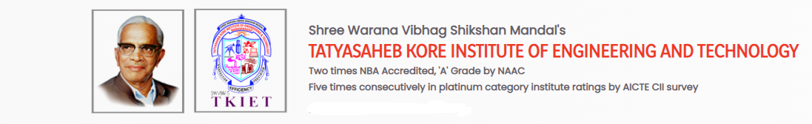

***Department of Electronics & Telecommunication Engineering***

***Silver Jubilee Alumni Meet-1999 Report***

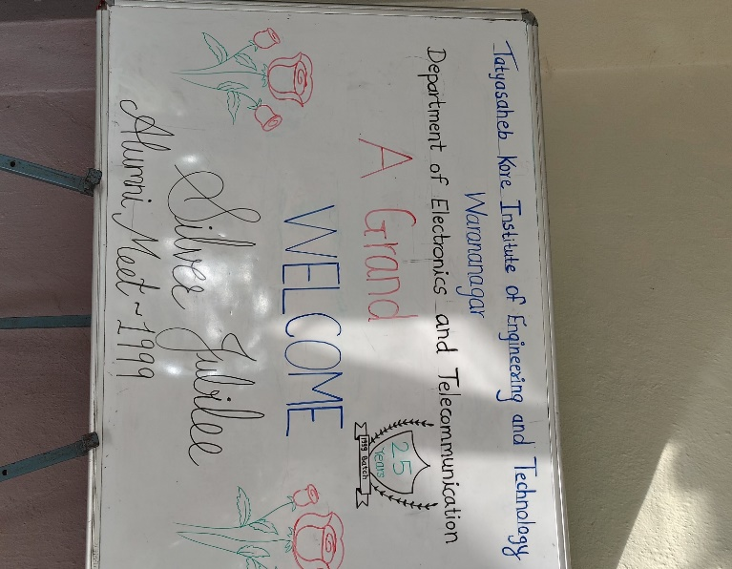

Tatyasaheb Kore Institute of Engineering and Technology has organized the Alumni Meet on 21/12/2024 (Saturday) in Department of Electronics & Telecommunication Engineering. The alumni meet is conducted every year in order to reconnect with the Alumni and celebrate their success and various achievements***.***

The Alumni started arriving in college by 9.00 a.m. and they were received by the registration team and were taken on a campus tour where they revisited the familiar place where they had studied and were shown the various developments that had taken place since then.

**Welcome**

|  |  |
| --- | --- |
|  |  |

They have been asked to fill the registration form. Our HOD Dr. S. T. Jadhav sir welcomed all the dignitaries and all the alumni for responding to the invitation from college and being present for the alumni meet in spite of their busy schedule.

**Address by Head of Department**

|  |  |
| --- | --- |
|  |  |
|  |  |

HOD Dr. S. T. Jadhav sir proceeded with presenting the department report highlighting the various milestones reached in the past year. He told about the department’s total strength of the students. He mentioned new facilities added in department and college. He spoke about technical fest and placement in recent years.

**Interaction by Faculty**

|  |  |
| --- | --- |
|  |  |

Prof. C. P. Shinde sir, Prof. S. S. Patil sir and Prof. S. H. More sir have interacted with the alumni about departmental academics and activities to be held to the students.

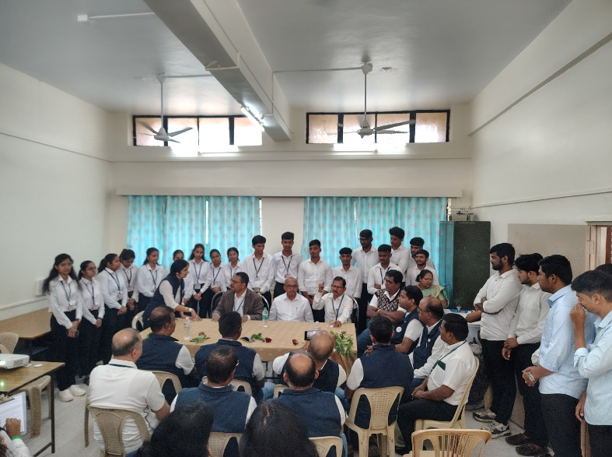**Interaction by Alumni**

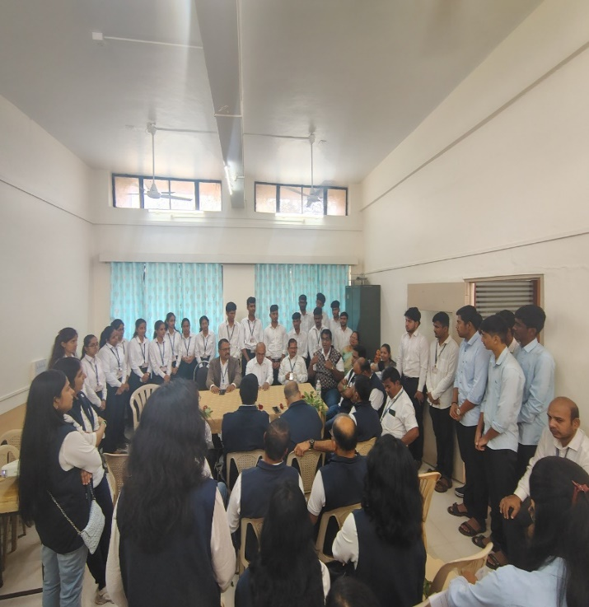

|  |  |
| --- | --- |
|  |  |

Alumni also interacted with the students and gave motivational talk regarding preparing for higher studies and placements. Students asked many questions regarding placements and the alumni shared their views.

**Group Photo**

|  |  |
| --- | --- |
|  |  |

Vote of thanks proposed by Prof. K. D. Patil. He proposed heartful thanks to the Alumni for taking the time to come for the Alumni Meet who have made it a very special and memorable one. He appreciated the various organizers of the event (teaching, non-teaching staff and the enthusiastic student volunteers) whose hard work and dedication made the event possible.