CHAPTER 1
INTRODUCTION

1.1 Introduction
Losing personal belongings such as mobile phones, wallets, identity cards, keys, books and bags is a very common problem in colleges, hostels, bus stands, railway stations, offices and other public places. In most cases the search for a lost item depends on notice boards, word of mouth or scattered messages in social media groups. Such methods are unstructured, cannot be searched or filtered, reach only a small group of people and are quickly forgotten. As a result, many items that were actually found never reach their real owners.
The Smart Lost & Found System is a full-stack web application developed using the MERN stack (MongoDB, Express.js, React and Node.js) to solve this problem. It provides a single, centralised online board where any person can report an item as Lost or Found by giving its title, description, category, location, date, contact details and up to five photographs. Anyone can browse and filter the reports without logging in, which increases the chance that somebody recognises the item. Registered users can additionally report items, claim a found item as their own and manage their reports through a simple status lifecycle of Open, Claimed and Resolved.
In addition to storing and displaying reports, the system suggests smart matches. For every lost report it automatically ranks the open found reports (and vice versa) using category, location, description similarity and date proximity, so that the owner does not have to scan the whole list manually. The application is secured with JWT-based authentication, and strict validation rules are enforced both in the browser and on the server.

1.2 Technology Stack
The application follows a three-tier architecture in which the React front end communicates with the Express back end through REST APIs, and the back end stores its data in MongoDB. The technologies used are listed below.
(i) MongoDB: a NoSQL document database used to store users and item reports. Text indexes on title, description and location support keyword search.
(ii) Express.js: a minimal Node.js web framework used to build the REST API, route requests and apply middleware such as CORS, JSON parsing and authentication.
(iii) React (Vite): a component-based JavaScript library used to build the single-page user interface; Vite provides the fast development server and build tooling. React Router handles client-side navigation and Axios is used for API calls.
(iv) Node.js: the JavaScript runtime on which the back-end server runs.
(v) Supporting libraries: Mongoose (object modelling and schema validation), jsonwebtoken (JWT authentication), bcryptjs (password hashing), Multer (image upload handling), dotenv (environment configuration) and Nodemon (auto-restart during development).

1.3 Scope of the System
The system is intended for campuses, organisations and local communities that need a common place to publish and recover lost belongings. Visitors can search reports by keyword, type, category, location, status and date range without an account. Registered users can report items with photographs, claim found items, edit or delete their own reports and mark them as resolved. The system does not use any machine-learning model; the matching feature is a lightweight rule-based heuristic. Photographs are stored on the local disk of the server, and notifications by e-mail or SMS are not part of the current version.

CHAPTER 2

METHODOLOGY

2.1 Objective
The main objective of this project is to design and develop a secure, easy-to-use web application that helps people report, search and recover lost and found items. The specific objectives are:
(i) To provide a centralised platform where lost and found items can be reported with title, description, category, location, date, contact details and photographs.
(ii) To allow public browsing and advanced filtering of reports by keyword, type, category, location, status and date range without requiring login.
(iii) To implement JWT-based user registration and login so that only authenticated users can report, edit, delete or claim items.
(iv) To suggest probable matches automatically between lost and found reports using category, location, text similarity and date proximity.
(v) To manage the complete life cycle of a report (Open, Claimed and Resolved) with proper ownership and claim rules.
(vi) To enforce input and file validation (field lengths, no future dates, image type and size limits) on both the client and the server.
2.2 Problem Statement
In colleges, workplaces and public places, lost and found information is normally shared through notice boards, verbal announcements or chat groups. These methods have several drawbacks: the information is scattered and disappears quickly, it cannot be searched by category, place or date, there is no proof or record of who claimed an item, and a person who finds an item has no easy way to reach its owner. Owners often do not know that their item has already been found, and finders do not know whom to contact.
There is therefore a need for a web-based system that stores every lost and found report in one place, allows anyone to search and filter it, automatically connects related lost and found reports, and controls who can post, edit and claim items so that the process stays reliable and traceable.
2.3 Project Description
The Smart Lost & Found System is divided into a React front end and an Express/MongoDB back end. This section describes the architecture, modules, database design, REST API, matching algorithm and security measures of the project.
2.3.1 System Architecture
The React application (port 5173) runs in the browser and sends HTTP requests through a configured Axios instance to the Express server (port 5001). The server authenticates requests using a JWT sent in the Authorization header, processes the business logic, stores data in MongoDB through Mongoose models and saves uploaded photographs in the uploads folder, which is served publicly under the /uploads path. Cross-origin access is restricted to the front-end origin through the CLIENT_ORIGIN environment variable.
2.3.2 Modules
(i) User Authentication Module: handles registration, login and retrieval of the current user. Passwords are hashed using bcrypt and a JWT valid for seven days is issued. On the front end the AuthContext stores the token and user details and exposes login, register and logout functions; ProtectedRoute restricts the Report and My Items pages to logged-in users.
(ii) Item Reporting Module: allows a logged-in user to create a Lost or Found report with details and up to five photographs (multipart form upload). The reporter can later edit or delete the report; the type of a report cannot be changed after creation.
(iii) Browse and Filter Module: the home page lists reports as cards and provides a filter bar with keyword, type, category, location, status, from-date and to-date. Filter changes are debounced before the API is called.
(iv) Smart Matching Module: the item detail page displays possible matches from the opposite list along with a percentage score.
(v) Claim and Resolution Module: a logged-in user can claim an open found item with an optional note. The reporter can see the claimant details and mark the item Resolved after handing it over, or reopen it if the claim does not work out.
(vi) My Items Module: shows only the reports created by the logged-in user so that they can manage them easily.
2.3.3 Database Design
Two collections are used: User and Item. Both use Mongoose schemas with automatic createdAt and updatedAt timestamps. Photographs are stored as embedded sub-documents inside an item.
Table 2.1 User Collection
Field | Type | Constraints
name | String | Required, 2 to 60 characters
email | String | Required, unique, lower-cased, valid e-mail format
phone | String | Optional, up to 20 characters
password | String | Required, minimum 6 characters (stored as a bcrypt hash)
Table 2.2 Item Collection
Field | Type | Constraints
type | String | Required, either lost or found
title | String | Required, 3 to 100 characters
description | String | Required, 10 to 1000 characters
category | String | Required, one of Electronics, Documents, Jewelry, Bags & Wallets, Clothing, Keys, Pets, Books, Sports Equipment, Other
location | String | Required, 2 to 150 characters
date | Date | Required, cannot be in the future
images | Array | Maximum 5 images, each storing original name, stored name, MIME type and size
contactName | String | Required, up to 60 characters
contactPhone / contactEmail | String | Optional, up to 20 and 100 characters
reportedBy | ObjectId | Required, reference to User
status | String | open (default), claimed or resolved
claimedBy / claimNote | ObjectId / String | Reference to the claiming User; note up to 500 characters
2.3.4 REST API
The back end exposes the following endpoints. Endpoints marked as protected need a valid JWT.
Table 2.3 API Endpoints
Method | Endpoint | Description
POST | /api/auth/register | Create a new account and return a token
POST | /api/auth/login | Authenticate a user and return a token
GET | /api/auth/me | Get the logged-in user (protected)
GET | /api/items | List items with filters: type, category, location, status, q, from, to, mine
GET | /api/items/categories | Return the fixed category list
GET | /api/items/:id | Get one item with reporter and claimant details
GET | /api/items/:id/matches | Get ranked matches from the opposite type
POST | /api/items | Create a report with images (protected)
PUT | /api/items/:id | Edit a report (owner only)
DELETE | /api/items/:id | Delete a report and its image files (owner only)
POST | /api/items/:id/claim | Claim an open found item with an optional note (protected)
PATCH | /api/items/:id/status | Mark as resolved or reopen (owner only)
2.3.5 Smart Matching Algorithm
For a selected report, the system fetches all open reports of the opposite type and calculates a score out of 100 for each of them. The score is a weighted sum of four components: category match (40%), overlap of words in the location (30%), closeness of the dates within a 14-day window (20%) and overlap of words in the title and description (10%). Words are converted to lower case, punctuation is removed and words shorter than three characters are ignored. Only candidates scoring at least 25 are returned, sorted in descending order of score, and at most the top 10 are displayed.
2.3.6 Validation, Security and Status Life Cycle
(i) Passwords are hashed with bcrypt before storage and are never returned by the API.
(ii) JWT authentication protects creating, editing, deleting and claiming; browsing routes are public but optionally read the token.
(iii) Ownership checks ensure that only the reporter can edit, delete, resolve or reopen a report (HTTP 403 otherwise).
(iv) Images must be JPG, PNG, WEBP or GIF, at most 5 MB each and at most 5 per item; they are checked in the browser and again by Multer on the server. Files are saved with random names.
(v) A claim is allowed only for found items whose status is open, and a user cannot claim their own report.
(vi) Status life cycle: Open, then Claimed when someone claims it, then Resolved when the owner confirms the hand-over; the owner can reopen a claimed item, which clears the claimant and note.
2.3.7 Execution Environment
The project needs Node.js 18 or above, npm and a MongoDB instance (local or MongoDB Atlas). In the backend folder the dependencies are installed with npm install, a .env file is created with PORT, MONGO_URI, JWT_SECRET and CLIENT_ORIGIN, and the server is started with npm run dev. In the frontend folder npm install and npm run dev start the Vite server, and the application is opened at http://localhost:5173.

CHAPTER 3

RESULTS AND DISCUSSION

3.1 Screenshots

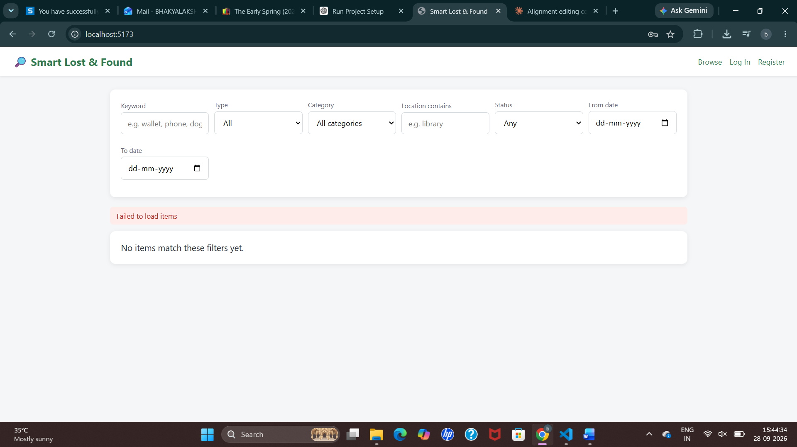
Figure 3.1 Home Page - Browse and Filter Reports
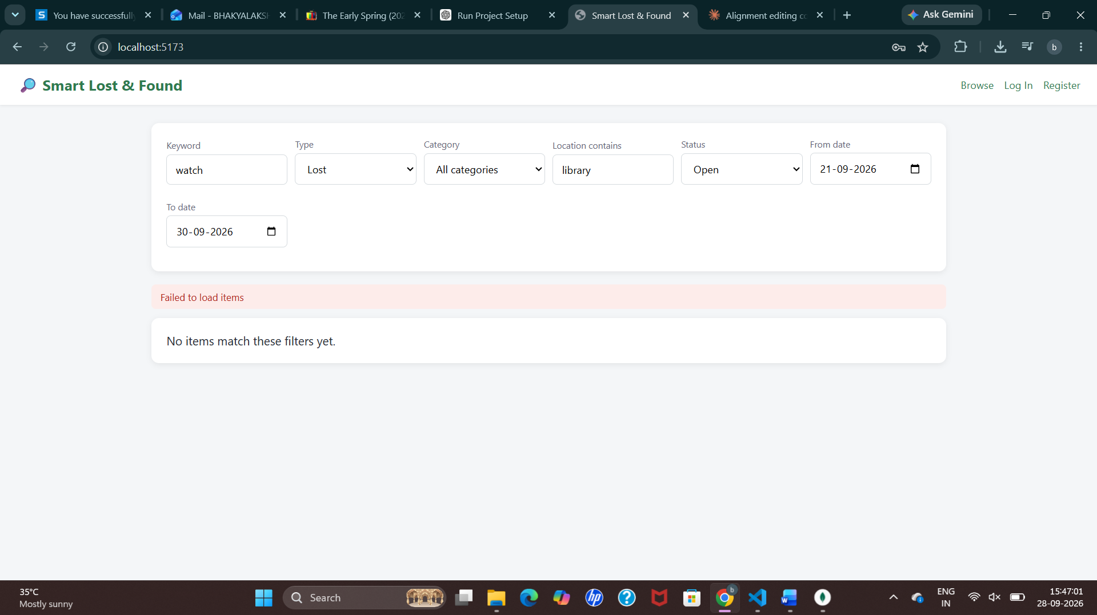
Figure 3.2 Home Page - Search with Filters Applied
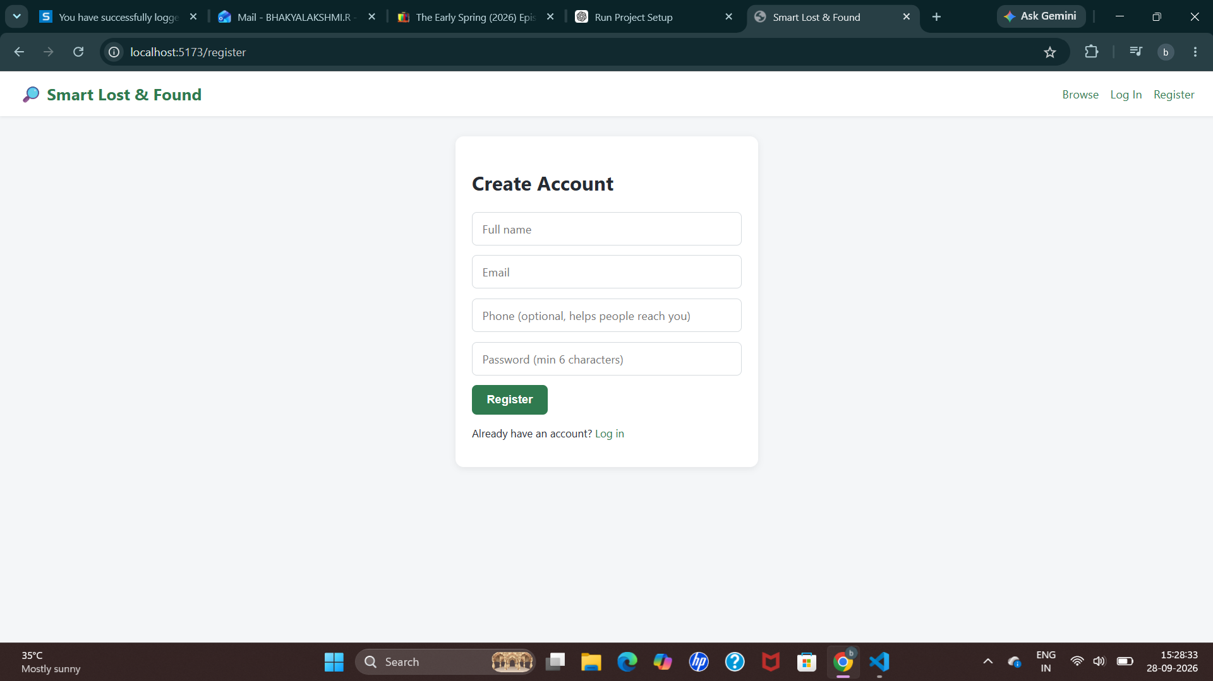
Figure 3.3 User Registration
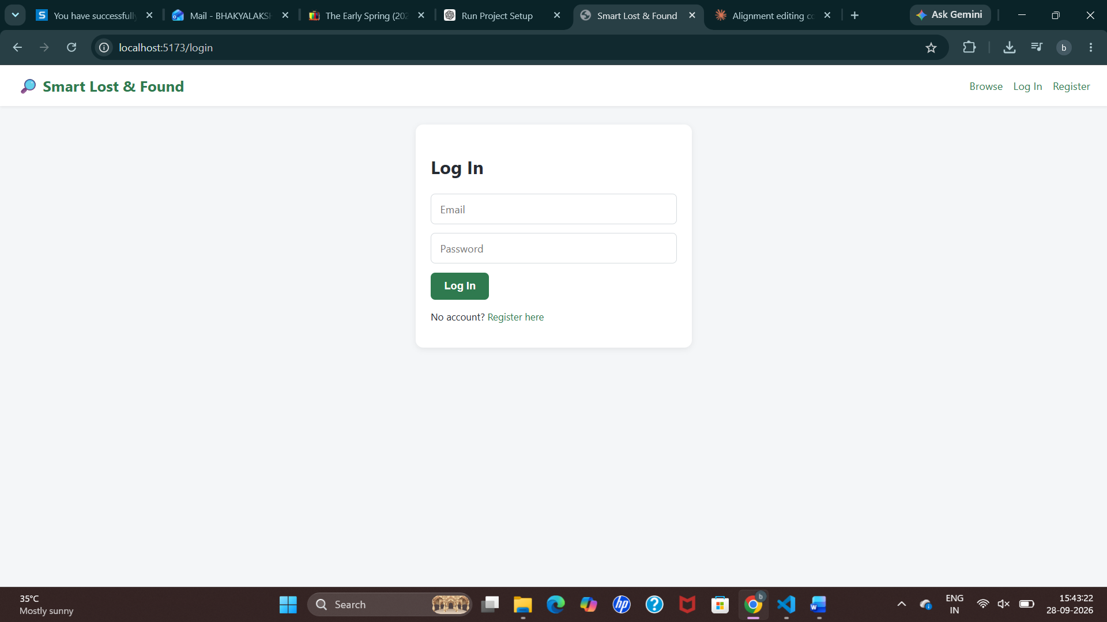
Figure 3.4 User Login
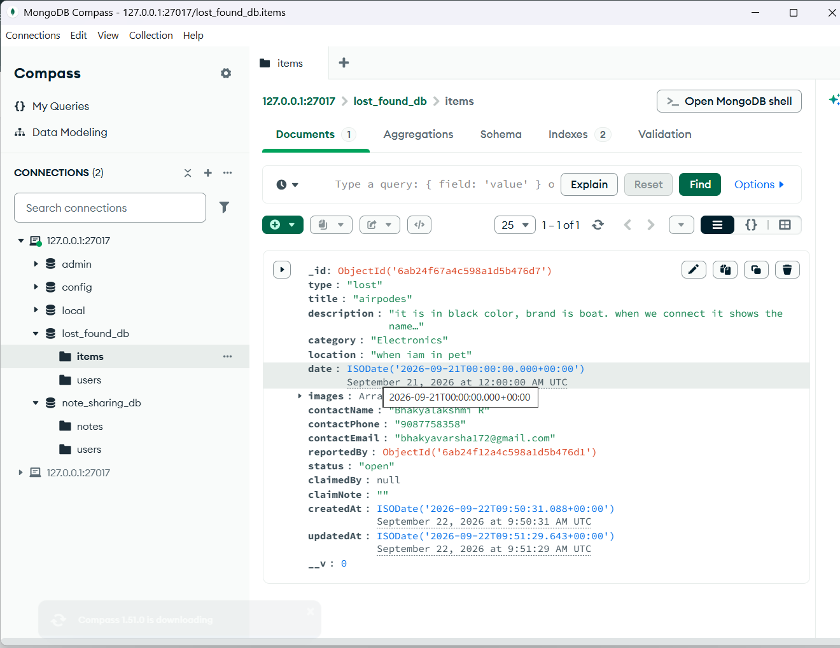
Figure 3.5 Item Document Stored in MongoDB (Compass)
3.2 Discussion
The application was designed so that every rule stated in the objectives is enforced by the software itself. The home page loads all reports without login and refreshes the list shortly after any filter is changed. A visitor who tries to open the Report or My Items page is redirected to the login page. When a report is submitted, the server validates the fields and images and stores the item with the status Open. Opening a report shows its details and photographs together with the ranked list of possible matches from the opposite type, which helps owners and finders find each other without scanning the whole board. Table 3.1 lists the main functional test cases and the behaviour expected from the implemented rules.
Table 3.1 Functional Test Cases
No. | Test case | Expected result
1 | Register with an already used e-mail | Request rejected with "Email already registered" (409)
2 | Register with a password shorter than 6 characters | Request rejected with a validation message (400)
3 | Login with a wrong password | Request rejected with "Invalid credentials" (401)
4 | Create a report without a token | Access denied (401)
5 | Create a report with a future date | Validation error "Date cannot be in the future"
6 | Upload a PDF file or an image larger than 5 MB | File rejected by the browser check and by Multer
7 | Upload more than 5 images for one item | Upload rejected (maximum 5 images)
8 | Edit or delete another user's report | Rejected with "Only the reporter can ..." (403)
9 | Claim a lost-type item or own report | Rejected (400)
10 | Claim an open found item | Status changes to Claimed and the claimant and note are stored
11 | Owner marks a claimed item as Resolved / reopens it | Status becomes Resolved / Open (claimant cleared on reopen)
12 | Open a lost item with a similar found item in the same category and place | The found item appears in possible matches with a high score
The matching feature gives higher scores when the category, place and date agree, which reflects how items are usually described in real life. Because it is a rule-based heuristic, it can only suggest likely matches and the final decision always stays with the owner and the reporter.

3.3 GitHub Link:
[Paste the GitHub repository link here]

CHAPTER 4

CONCLUSION
The Smart Lost & Found System successfully provides a centralised, searchable and secure platform for reporting and recovering lost belongings. Using the MERN stack, the project delivers a responsive React interface, a well-structured REST API and a MongoDB database with proper validation. Public browsing with detailed filters makes the reports easy to find, while JWT authentication, ownership checks and claim rules keep the data reliable. The smart matching feature reduces the effort of searching by ranking the most likely lost and found pairs, and the Open, Claimed and Resolved life cycle keeps a clear record of what happened to every item.
Through this mini project the team gained practical experience in full-stack development, including designing schemas, building REST APIs, handling file uploads, implementing authentication, managing state and routing in React and integrating the front end with the back end.
Future Enhancements
(i) Add rate limiting and stricter server-side validation (for example express-validator) before public deployment.
(ii) Send e-mail or SMS notifications when an item is claimed or when a strong match is found.
(iii) Move photograph storage to cloud storage such as Amazon S3.
(iv) Provide an administrator dashboard to moderate reports and users.
(v) Replace the rule-based matching with an image and text similarity model.

REFERENCES

[1] MongoDB Inc., "MongoDB Manual", https://www.mongodb.com/docs/manual/
[2] Mongoose Documentation, "Schemas, Validation and Indexes", https://mongoosejs.com/docs/
[3] Express.js Documentation, "Express - Node.js web application framework", https://expressjs.com/
[4] OpenJS Foundation, "Node.js Documentation", https://nodejs.org/en/docs
[5] Meta Open Source, "React Documentation", https://react.dev/
[6] React Router Documentation, https://reactrouter.com/
[7] Vite Documentation, "Getting Started", https://vitejs.dev/guide/
[8] M. Jones, J. Bradley and N. Sakimura, "JSON Web Token (JWT)", RFC 7519, IETF, 2015, https://datatracker.ietf.org/doc/html/rfc7519
[9] Express.js, "Multer - Middleware for handling multipart/form-data", https://github.com/expressjs/multer
[10] N. Provos and D. Mazieres, "A Future-Adaptable Password Scheme", Proceedings of the USENIX Annual Technical Conference, 1999.
[11] Axios Documentation, https://axios-http.com/docs/intro

