TECHNICAL REPORT

A HYBRID QUANTUM CIRCUIT SIMULATOR

Phoenix Association IT Team
Induction Task
Submitted By:
S A BHAKYASHREE
BITS ID:
2025AAPS0253H
IMPLEMENTATION APPROACH AND GATE EXPLANATION

1.1 QUANTUM STATE REPRESENTATION
In this project, quantum states are represented using NumPy arrays. A single qubit is represented using a two-element state vector. The state |0> is represented as [1,0] and the state |1> is represented as [0,1]. Multiple qubits are combined using the tensor product operation.

1.2 HADAMARD GATE (H)
The Hadamard Gate is used to create superposition. When applied to |0> state, produces an equal probability of measuring 0 or 1. The gate is implemented using a 2x2 matrix and applied through matrix multiplication. In this project, the Hadamard gate was used in both the Quantum Coin Toss and Bell State circuits.

1.3 X GATE
The Pauli X Gate acts as a quantum NOT gate. It flips the state |0> to |1> and |1> to |0>. This gate demonstrates basic quantum state manipulation.

1.4 CNOT GATE
The Controlled-NOT Gate (CNOT) operates on two qubit states. The first qubit acts as the control qubit and the next qubit acts as the target qubit. The CNOT gate applies an X gate to the target qubit if the control qubit is 1. This gate is used to create entanglement in the Bell State circuit.
CIRCUIT EXPLANATION AND
KPI DISCUSSION

2.1 QUANTUM COIN TOSS
The Quantum coin toss begins with the |0> state. A Hadamard Gate (H) is applied to create a superposition state. Upon measurement, the outcome is either 0 or 1 with equal probability.

2.2 BELL STATE GENERATION
The bell state begins with the |00> state. A Hadamard Gate is applied to the first qubit, creating a superposition. A CNOT gate is then applied to entangle the two qubits. The resulting Bell state is (|00>+|11>)/√2.
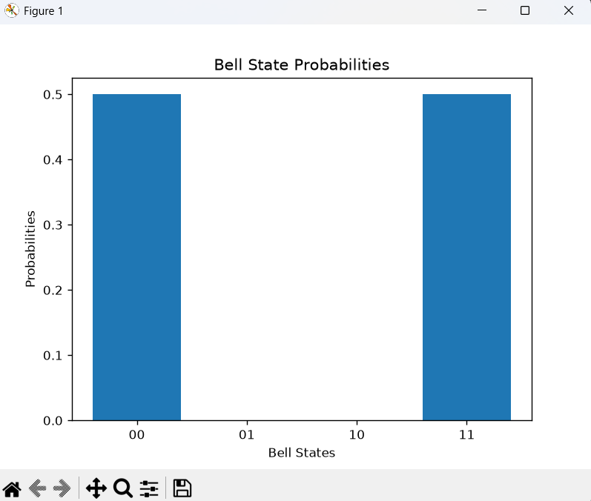
Figure 1: Bell State Probability Distribution
The graph shows that only the |00> and |11> states have non-zero probabilities, each having a probability of 0.5. This confirms the successful generation of Bell State.

2.3 EXECUTION TIME
The execution takes place quickly for one or two qubit states because the state vectors are small. The execution time increases as the number of qubits grows.

2.4 MEMORY USAGE
The memory usage increases as the number of qubits increase. A n-qubit system requires a state vector having 2ⁿ amplitudes.
2.5 PROBABILITY CORRECTNESS
The probabilities are the squared amplitudes. The sum of all probabilities must add up to 1.

2.6 STATE VECTOR SIZE
The size of the state vector grows exponentially with the number of qubits. This is one of the major challenges to be dealt in classical computers.

HARDWARE ANALYSIS, LIMITATIONS AND
FUTURE IMPROVEMENTS

3.1 HARDWARE ANALYSIS
The simulator was implemented by using NumPy and python on a classical computer. Quantum gate operations were performed using matrix multiplication. Since this project deals with one qubit and two qubit states, this approach is efficient and easy to understand. As the size of the state vector grows exponentially with the number of qubits, this approach increase both computation time and memory usage.

3.2 FPGA ACCELERATION
FPGA stands for Field Programmable Gate Array. Classical computers are efficient to handle small scale simulations, but larger quantum systems may require hardware acceleration. FPGAs can perform multiple arithmetic operations simultaneously and may accelerate matrix operations used in quantum simulation. This can improve performance for larger quantum systems.

3.3 FAILURE ANALYSIS AND LIMITATIONS
During the development of the quantum circuit simulator, several challenges and limitations were encountered.

- FLOATING-POINT PRECISION
Probability calculations produced values such as 0.4999999994 instead of 0.5. This occurs because floating-point numbers cannot represent certain decimal values precisely. Although these small numerical errors are visible in the output, they do not affect the correctness of the program.

- STATE VECTOR GROWTH

As the number of qubit increases, the size of the state vector grows exponentially. An n qubit state system, require 2ⁿ amplitudes to be stored. This significantly increases the computation time and memory usage, slowing down the simulation.

- MATRIX DIMENSION MISMATCH
During development, matrix dimension mismatch errors were encountered when applying H gate on a two-qubit state. The issue was resolved by using tensor products to expand the gate dimension appropriately before applying on state.

3.4 FUTURE IMPROVEMENTS
These improvements can be made to enhance the simulator in the future:
- Explore FPGA and GPU for faster matrix operations.
- Support additional quantum gates such as Z gate, phase gates.
- Expand the simulator to handle larger quantum system with more qubits.
- Introduce optimization techniques to reduce memory consumption for larger simulations.

CONCLUSION

The project implemented a basic quantum simulator using NumPy and Python. The simulator demonstrated fundamental quantum computing concepts such as quantum state representation, superposition, gate representation and operations, entanglement, probability-based measurements.
Two quantum circuits were analyzed and implemented: Bell state generation and Quantum coin toss. The project involved experience in representing quantum state vectors, applying quantum gates through matrix operations and simulating measurement on a classical computer.
The analysis also highlighted the limitations and challenges such as exponential memory growth, computational complexity and floating-point precisions. Overall, the project provided a strong introduction to the quantum computing concepts and demonstrated the workings on the classical hardware.

