***Radhe photography***



PREFACE

As a student of Bachelor of Computer Application according to the syllabus subscribed by Bhakta Kavi Narsinh Mehta Universiy, Junagadh(Gujarat), In 6th semester of B.C.A. to prepare a project on any particular subject of student choice. The project should be selected on precise subject that will fulfil the requirements.

The project report Training is under taken by Dr.V.R.Godhaniya College of information technology in porbandar. Project report has been prepared on the base of information we collected. We sincerely apologise if any wrong information is given.

index

|  |  |  |
| --- | --- | --- |
| NO | **TOPIC NAME** | **PG NO** |
| 1 | Certificate | 0 |
| 2 | Preface | 1 |
| 3 | Index | 2 |
| 4 | Acknowledgement | 3 |
| 5 | Project Profile | 5 |
| 6 | Preliminary Invastigation | 7 |
| 7 | System Analysis and Designing   * Use Case Diagram * Class Diagram (OOP) | 10 |
| 8 | Project Life Cycle   * E-R Diagram * Activity Diagram | 13 |
| 9 | Database Creation | 14 |
| 10 | Software Testing | 15 |
| 11 | User Interface Designs (Snapshots) | 18 |
| 12 | Code |  |
|  | **THANK YOU** |  |

ACKNOWLEGEMENT

It is our great pleasure to present our project report on **RADHE PHOTOGRAPHY** which we conceived during the BCA 6th Sem affiliated to Bhakta Kavi Narsinh Mehta University.

We take this opportunity to express our sincere gratitude and we feel immense pleasure to thank our faculty, philosopher and guideNIRAV DATTANI who helped us and gave full support in each and every way to fulfil and accomplish our website of **RADHE PHOTOGRAPHY.**

|  |  |
| --- | --- |
| **Project name** | RADHE PHOTOGRAPHY |
| **Front end** | HTML,CSS,JS |
| **Back end** | PHP,MYSQL SERVER |
| **Developed by** | VARSHA PARMAR,  RIDDHI GOHEL,  MAHEK BHALIYA. |
| **Tools** | Microsoft Visual code 2012 |
| **Testing** | Manual |
| **Task** | Analysis, Designing, Coding,  Testing |
| **Guided by** | NIRAV DATTANI |
| **Developed at** | Dr.V.R.Godhaniya IT College  Porbandar |

PROJECT PROFILE

ABSTRACT OF PROJECT (BRIEF SYSTEM BACKGROUND)

**Project Title:**  Development of Radhe studio Website

Radhe photography aims to establish a robust online presence through a user-friendly, informative, and engaging news website. The platform will provide engagement,pre-wedding,wedding and photography.

**System Overview:**

The proposed system will:

1. for the photography

2. Offer categorized photos sections (engagement,pre-wedding,wedding and photography..)

3. Provide inquiry and information

4. Support multimedia content (images, videos, podcasts)

**Key Objectives:**

1. Enhance user experience through intuitive navigation and content organization

2. Increase website traffic and engagement

3. Provide seamless integration with social media platforms

5. Ensure scalability and reliability

**Functional Requirements:**

1. User registration and login

2. Content management system (CMS)

3. Search functionality

4. Social media integration

5. Analytics and performance tracking

This abstract provides a concise overview of the project's background, objectives, and requirements. It serves as a foundation for the project brief, which will outline the scope, timeline, and budget in greater detail.

**Reports:**

Name of Organization : RADHE PHOTOGRAPHY

Project Time Duration: 3 months.

Prepared By : Varsha Parmar .

Prepared By : Riddhi Gohel.

Prepared By : Mahek Bhaliya

**Summary :**

RADHE PHOTOGRAPHY aims to create a user-friendly, informative PHOTOS website providing real-time updates, categorized photo sections, searchable archives, and multimedia content. Key objectives include enhancing user experience, increasing traffic and engagement, establishing credibility, seamless social media integration, and scalability.

PRELIMINARY INVASTIGATION

This preliminary investigation aims to identify the feasibility, requirements, and potential challenges of developing the Rival News Website.

This preliminary investigation provides a foundation for further project planning and development.

**Technical Feasibility:**

1. Front-end: JavaScript, HTML5, CSS3 are suitable for responsive design and user interface.

2. Back-end: PHP is a popular choice for web development, suitable for dynamic content management.

3. Database: MySQL is a reliable and scalable database management system.

**Functional Requirements:**

1. Real-time photo updates: RSS feeds, API integration, or custom development.

2. Categorized photo sections: categorization feature.

3. Searchable archives: Database indexing, search algorithms.

4. Multimedia content support: Media library integration.

5. User registration/login: Authentication and authorization mechanisms.

6. Social media integration: API integration.

**Non-Functional Requirements:**

1. Security: SSL encryption, secure authentication.

2. Scalability: load balancing.

3. Usability: User-friendly interface, accessibility.

4. Performance: Optimization techniques, caching.

**Potential Challenges**:

1. Content management and updates.

2. Ensuring real-time updates.

3. Integrating social media platforms.

Next Steps:

1. Finalize project scope and timeline.

2. Assemble development team.

3. Begin detailed design and development.

**Feasibility Studies:**

**1.Technical Feasibility Study**

A study of resource availability that my effect the ability to achieve an acceptable system. This evaluationdetermines whether the technology needed for the proposed system is available or not. Can the work for the project be done with current equipment existing software technology & available personal? Can the system be upgraded if developed?

**2. Economics Feasibility Study**

Economic analysis is the most frequently used method for evaluating the effectiveness of a proposed system. In this feasibility we decide the proposed system as on the basis of cost, benefit analysis. Whether the proposed system is feasible according to the economic factors.

The benefit that this system has are many including the working speed of the system queries are stored in a faster manner, the data are stored in the database that can be used whenever required.

**3.Operational Feasibility Study**

The assessment made id the system will be used or not once it is developed. According to the project the material sharing application will use. The operational feasibility if the system is developed and implemented to measure. How well our project solution is will work in the organization.

*SYSTEM ANALYSIS AND DESIGNING*

Requirement Analysis

* **Function Requirement:**

The software must allow input of product data from administrator at secured access, and from the data streaming real-time monitoring equipment.

* **Non-function Requirement:**

The software interface must follow design conventions which allow for familiar location of menus etc.

.

* **MINIMUM HARDWARE REQUIREMENT**

|  |  |
| --- | --- |
| **COMPONENT** | **MINIMUM REQUIREMENT** |
| PROCESSOR | Intel(R) Core(TM) i3 |
| SUPPORTED | 32 BIT |
| ARCHITECTURE | 64 BIT |
|  |  |
|  |  |
| HARD DISK | INSTALLING 250 GB OR HIGHER |
| RAM | 4.00 GB OR HIGHER |

* **MINIMUM SOFTWARE REQUIRMENT**

|  |  |
| --- | --- |
| **COMPONENT** | **MINIMUM REQUIREMENT** |
| *OPERATING SYSTEM* | *WINDOW 10* |
| *PROJECT DEVLOP SOFTWARE* | *MICROSOFT VISUAL CODE 2012* |
| *WEB BROWSERS* | *OPERA INTERNET BROWSER, GOOGLE CHROME,INTERNET EXPLORER, FIREFOX* |

Class Diagram (OOP)

|  |
| --- |
| **Order details** |
| Customer Name |
| Customer Email id |
| Address |
| Number |
| Date |
| Order Details |

Use Case Diagram

**Manage account**

l

**Update website**

**Confirm order**

**ADMIN**

**View website**

**USER**

**Give order**

**order**

**Log out**

Project Life Cycle

* E-R Diagrae

admin

**user**

Activity Diagram

Start

USER

REGISTERED NOT REGISTERED

BOOK ORDER

SHOW WEBSITE

INTERSTED

VALID NOT VALID

CONFIRM ORDER

DATABASE CREATION

**ADMIN**

**1.LOGIN/SIGNUP**

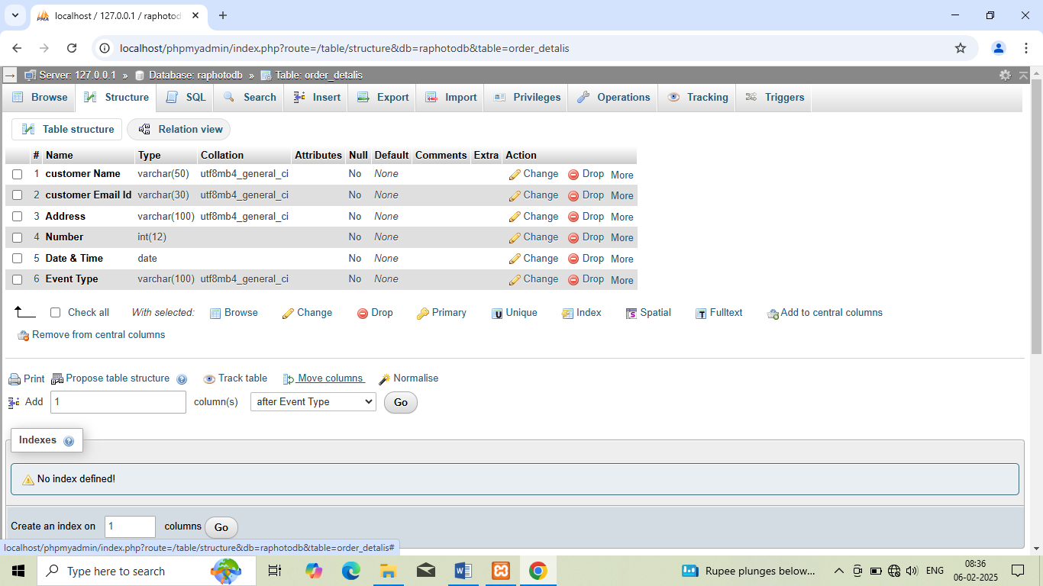

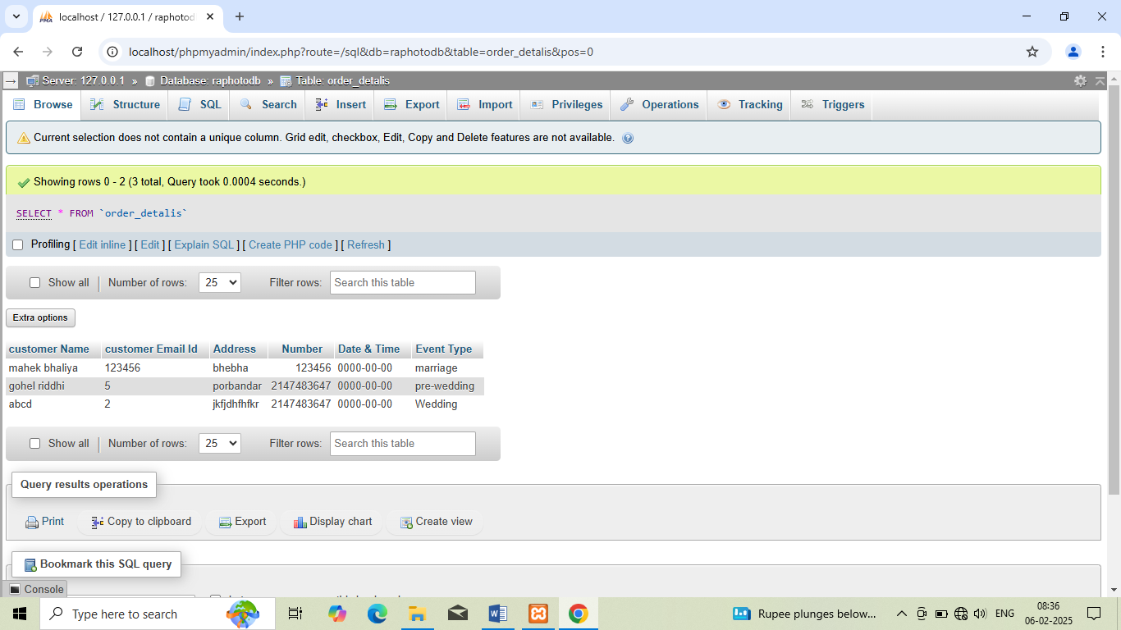

SOFTWARE TESTING

Before actual implementation the new system into operations, a test run of the system is done for removing all the bugs. After codifying the whole program of the system, a test plan should be developed and run on a given set of test data. The output of the test run should be match with the expected results. Sometimes, system testing is considered as a part of implementation process.

Using the test data following test run are carried out:

* **Program test**
* **System test**

**Program test:** When the programs have been coded and complied and brought to working conditions, they must be individually tested with prepared test data.

All verification and validation be checked and if any undesirable things happening it must be noted and debugged (error corrected).

**System test:** After carrying out the program test and removing errors, system test is done. At this stage the test is done on actual data. The complete system is executed on actual data.

USER INTERFACE DESIGNS (SNAPSHOTS)

**HOME SCREEN**

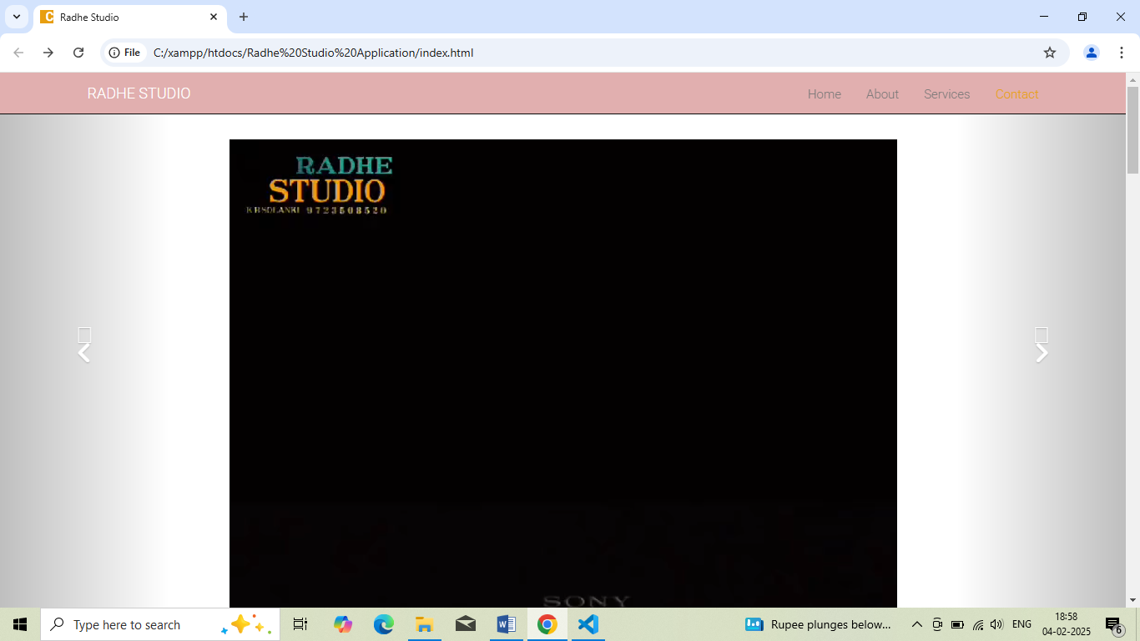

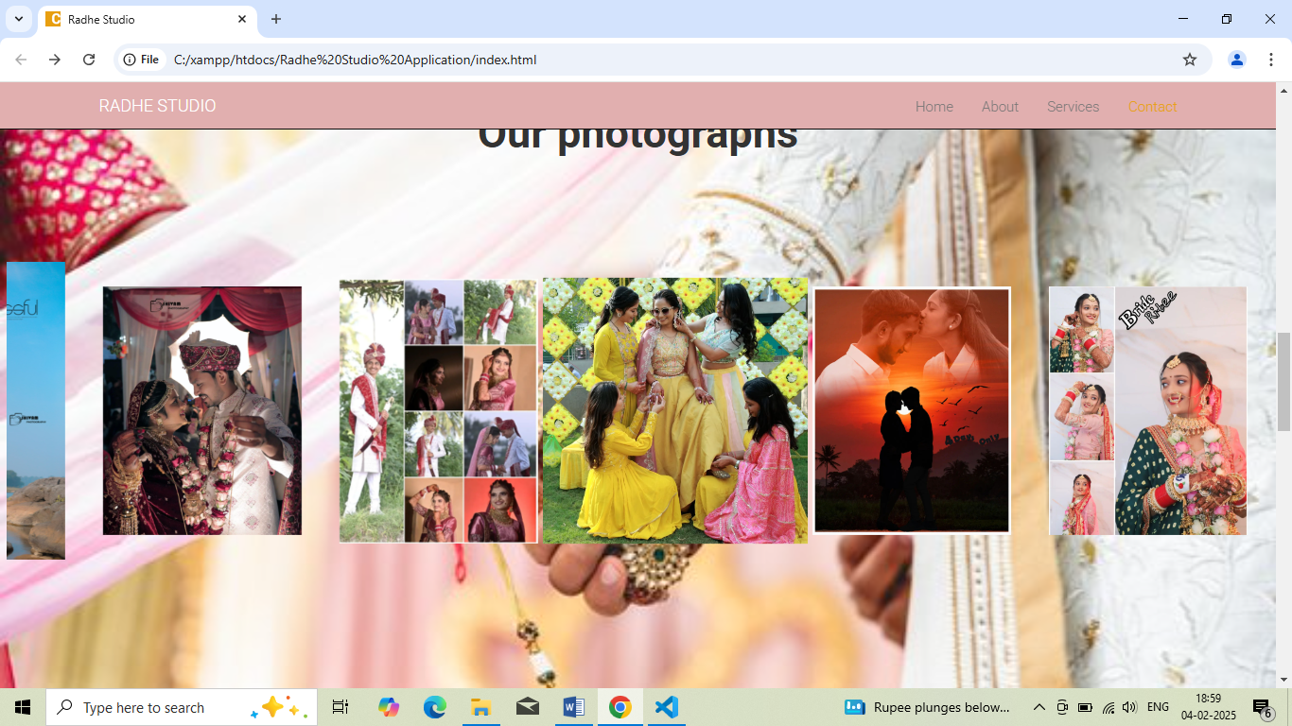

**BOOK YOUR ORDER(ORDER DETAILS)**

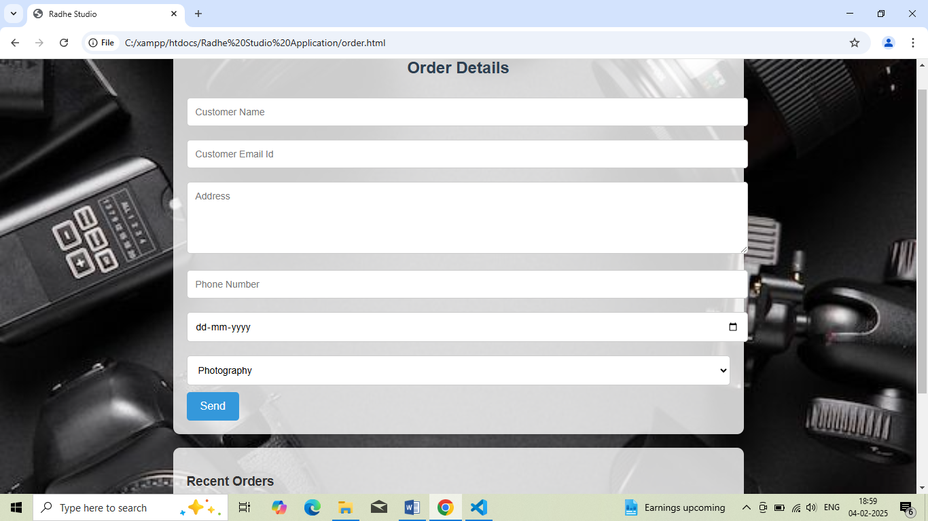

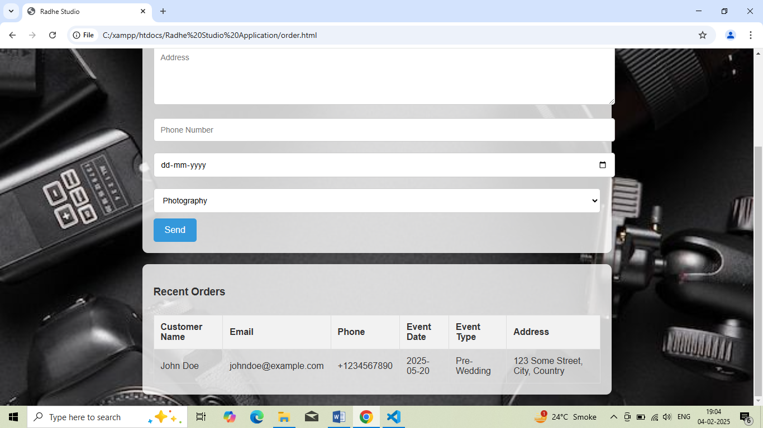

**1 INDEX.HTML**

<!DOCTYPE html>

<html lang="en">

<head>

  <meta charset="UTF-8" />

  <meta http-equiv="Content-Type" content="text/html; charset=utf-8" />

  <meta name="viewport" content="width=device-width, initial-scale=1, maximum-scale=1, user-scalable=no">

  <title>Radhe Studio</title>

  <!-- Google fonts -->

  <link href='http://fonts.googleapis.com/css?family=Roboto:400,300,700' rel='stylesheet' type='text/css'>

  <!-- font awesome -->

  <!-- <link href="//maxcdn.bootstrapcdn.com/font-awesome/4.2.0/css/font-awesome.min.css" rel="stylesheet"> -->

  <link rel="stylesheet" href="https://cdnjs.cloudflare.com/ajax/libs/font-awesome/6.0.0-beta3/css/all.min.css">

  <!-- bootstrap -->

  <link rel="stylesheet" href="assets/bootstrap/css/bootstrap.min.css" />

  <!-- animate.css -->

  <link rel="stylesheet" href="assets/animate/animate.css" />

  <link rel="stylesheet" href="assets/animate/set.css" />

  <style>

    .social-icons {

        display: flex;

        gap: 15px;

    }

    .social-icon {

        font-size: 2rem;

        color: #333;

        text-decoration: none;

        transition: color 0.3s;

    }

    .social-icon:hover {

        color: #007bff; /* Change to whatever color you prefer */

    }

  </style>

  <!-- gallery -->

  <link rel="stylesheet" href="assets/gallery/blueimp-gallery.min.css">

  <!-- favicon -->

  <link rel="shortcut icon" href="images/favicon.ico" type="image/x-icon">

  <link rel="icon" href="images/favicon.ico" type="image/x-icon">

  <link rel="stylesheet" href="assets/style.css">

</head>

<body>

  <!--<div class="topbar animated fadeInLeftBig"></div>-->

  <!-- Header Starts -->

  <div class="navbar-wrapper">

    <div class="container">

      <div class="navbar navbar-inverse navbar-fixed-top" role="navigation" id="top-nav">

        <div class="container">

          <div class="navbar-header">

            <!-- Logo Starts -->

            <a class="navbar-brand" href="#home">RADHE STUDIO</a>

            <!-- #Logo Ends -->

            <button type="button" class="navbar-toggle collapsed" data-toggle="collapse" data-target=".navbar-collapse">

              <span class="sr-only">Toggle navigation</span>

              <span class="icon-bar"></span>

              <span class="icon-bar"></span>

              <span class="icon-bar"></span>

            </button>

          </div>

          <!-- Nav Starts -->

          <!-- <div class="navbar-collapse  collapse">-->

          <ul class="nav navbar-nav navbar-right scroll">

            <li class="active"><a href="#home">Home</a></li>

            <li><a href="#about">About</a></li>

            <li><a href="#services">Services</a></li>

            <li><a href="#contact">Contact</a></li>

          </ul>

        </div>

        <!-- #Nav Ends -->

      </div>

    </div>

  </div>

  </div>

  <!-- #Header Starts -->

  <div id="home">

    <!-- Slider Starts -->

    <div id="myCarousel" class="carousel slide banner-slider animated bounceInDown" data-ride="carousel">

      <div class="carousel-inner">

        <!-- Item 1 -->

        <div class="item active">

         <!-- <video src="video/demo9.mp" ></video> -->

         <video controls>

          <source src="images/demoD.mp4" type="video/mp4">

          Your browser does not support the video tag.

      </video>

      <style>

      video {

        width: 100%; /* Make the video responsive */

        max-width: 800px; /* Optional: Limit the maximum width */

        height: auto; /* Maintain the aspect ratio */

        margin-top: 20px;

        display: block;

        margin-left: auto;

        margin-right: auto; /* Center the video */

    }

  </style>

        </div>

        <!-- #Item 1 -->

        <!-- Item 1 -->

        <!--<div class="item">-->

          <!--<img src="images/bg.jpeg" alt="banner">-->

        </div>

        <!-- #Item 1 -->

        <!-- Item 1 -->

        <div class="item">

          <img src="images/aaru.jpeg" alt="banner">

        </div>

        <!-- #Item 1 -->

        <!-- Item 1 -->

        <div class="item">

          <img src="images/back3.jpg" alt="banner">

        </div>

        <!-- #Item 1 -->

      </div>

      <a class="left carousel-control" href="#myCarousel" data-slide="prev"><span class="glyphicon-chevron-left"><i

            class="fa fa-angle-left"></i></span></a>

            <a class="right carousel-control" href="#myCarousel" data-slide="next"><span class="glyphicon-chevron-right"><i

              class="fa fa-angle-right"></i></span></a>

            </div>

            <!-- #Slider Ends -->

          </div>

          <div class="main">

            <div class="inner-div1">

              <div class="col-sm-12 wowload fadeInLeft">

                  <h4><i class="fa fa-camera-retro"></i> <b>Introduction </b></h4>

                  <p><b>Hi, I'm Kuashik, a passionate photographer and videographer with a love for capturing life's most

                    authentic

                    and beautiful moments. Whether it's a stunning landscape, a vibrant event, or a personal portrait, I

                    thrive on

                    telling stories through the lens.

                    With 7 years of experience, I bring a blend of creativity, technical expertise, and a keen eye for detail

                    to

                    every project. No matter the assignment, I approach each with the same dedication to quality and

                    excellence.

                    I believe that photography and videography are more than just taking pictures or recording videos-they are

                    about crafting a visual narrative that resonates with people. My goal is always to not only meet your

                    expectations but to exceed them, delivering timeless visuals that you can cherish forever..</b></p>

              </div>

            </div>

            <div class="inner-div2">

              <img src="images/about.jpeg" alt="">

              <div class="social-icons">

                <!-- Instagram Icon -->

                <a href="https://www.instagram.com/k.b.solanki____4/" target="_blank" class="social-icon">

                    <i class="fab fa-instagram"></i>

                </a>

                <a href="https://www.facebook.com/https://www.facebook.com/share/16DzDjaBuw/" target="_blank" class="social-icon">

                <!-- Facebook Icon -->

                    <i class="fab fa-facebook-f"></i>

                </a>

            </div>

            </div>

          </div>

        <h2 class="text-center  wowload fadeInUp" id="services"><b>Services</b></h2>

        <h4 class="text-center">

        <li>

          <!--<span><i class="fa fa-camera-retro"></i><b>Photography</b></span>-->

          <button style="width: 00px; height: 00px; border: none;""alert('Button clicked!')"><a

              href="Photography.html">Photography</a></button>

        </li>

        <li>

          <!--<span><i class="fa fa-graduation-cap"></i><b>Prewedding</b></span> -->

          <button style="width: 00px; height: 00px; border: none;" onclick="alert('Button clicked!')"><a

              href="Prewedding.html" .html">Prewedding</a></button>

          <!--<button id="preweddingBtn" data-price="15000">Prewedding Package - ₹15000</button>-->

        </li>

        <li>

          <!--<span><i class="fa fa-umbrella"></i><b>Engagement</b></span> -->

          <button style="width: 00px; height: 00px; border: none;" onclick="alert('Button clicked!')"><a

              href="Engagement.html" .html">Engagement</a></button>

        </li>

        <li>

          <!--<span><i class="fa fa-heart-o"></i><b>Wedding</b></span> -->

          <button style="width: 00px; height: 00px; border: none;" onclick="alert('Button clicked!')"><a

              href="Wedding.html" .html">Wedding</a></button>

        </li>

      </h4>

      </div>

  </div>

  </div>

  </div>

  <section id="portfolioo" class="portfolioo">

    <h2><b>Our photographs</b></h2>

    <div>

      <div class="ex">

        <div class="sliderrr">

          <div class="slide-trackkk">

            <div class="slidee"><img src="images/demo1.jpeg" alt=""></div>

            <div class="slidee"><img src="images/demo2.jpeg" alt=""></div>

            <div class="slidee"><img src="images/demo3.jpeg" alt=""></div>

            <div class="slidee"><img src="images/demo4.jpeg" alt=""></div>

            <div class="slidee"><img src="images/demo5.jpeg" alt=""></div>

            <div class="slidee"><img src="images/demo6.jpeg" alt=""></div>

            <div class="slidee"><img src="images/demo7.jpeg" alt=""></div>

            <div class="slidee"><img src="images/demo10.jpg" alt=""></div>

            <div class="slidee"><img src="images/demo2.jpeg" alt=""></div>

            <div class="slidee"><img src="images/haldi (1).jpeg" alt=""></div>

            <div class="slidee"><img src="images/demo11.jpg" alt=""></div>

            <div class="slidee"><img src="images/demo12.jpg" alt=""></div>

            <div class="slidee"><img src="images/demo13.jpg" alt=""></div>

            <div class="slidee"><img src="images/demo15.jpg" alt=""></div>

            <div class="slidee"><img src="images/demo16.JPG" alt=""></div>

            <div class="slidee"><img src="images/demo18.jpg" alt=""></div>

            <div class="slidee"><img src="images/demo17.jpg" alt=""></div>

            <div class="slidee"><img src="images/demoM.jpg" alt=""></div>

          </div>

        </div>

      </div>

    </div>

  </section>

  <div id="partners" class="container spacer ">

    <h2 class="text-center  wowload fadeInUp"><b>Some of our happy clients</b></h2>

    <div class="clearfix">

      <!--<div class="col-sm-6 partners  wowload fadeInLeft">

       <img src="images/partners/1.jpg" alt="partners">

       <img src="images/partners/2.jpg" alt="partners">

       <img src="images/partners/3.jpg" alt="partners">

       <img src="images/partners/4.jpg" alt="partners">

      </div>-->

      <div class="col-sm-6">

        <div id="carousel-testimonials" class="carousel slide testimonails  wowload fadeInRight" data-ride="carousel">

          <div class="carousel-inner">

            <div class="item active animated bounceInRight row">

              <div class="animated slideInLeft col-xs-2"><img alt="portfolio" src="images/demoC.jpeg" width="100"

                  class="img-circle img-responsive"></div>

              <div class="col-xs-10">

                <p> I must explain to you how all this mistaken idea of denouncing pleasure and praising pain was born

                  and I will give you a complete account of the system, and expound the actual teachings of the great

                  explorer of the truth, the master-builder of human happiness. </p>

                <span>Angel Smith - <b>eshop Canada</b></span>

              </div>

            </div>

            <div class="item  animated bounceInRight row">

              <div class="animated slideInLeft col-xs-2"><img alt="portfolio" src="images/demoC.jpeg" width="100"

                  class="img-circle img-responsive"></div>

              <div class="col-xs-10">

                <p>No one rejects, dislikes, or avoids pleasure itself, because it is pleasure, but because those who do

                  not know how to pursue pleasure rationally encounter consequences that are extremely painful.</p>

                <span>John Partic - <b>Crazy Pixel</b></span>

              </div>

            </div>

            <div class="item  animated bounceInRight row">

              <div class="animated slideInLeft  col-xs-2"><img alt="portfolio" src="images/team/3.jpg" width="100"

                  class="img-circle img-responsive"></div>

              <div class="col-xs-10">

                <p>On the other hand, we denounce with righteous indignation and dislike men who are so beguiled and

                  demoralized by the charms of pleasure of the moment, so blinded by desire, that they cannot foresee

                  the pain and trouble that are bound to ensue.</p>

                <span>Harris David - <b>Jet London</b></span>

              </div>

            </div>

          </div>

          <!-- Indicators -->

          <ol class="carousel-indicators">

            <li data-target="#carousel-testimonials" data-slide-to="0" class="active"></li>

            <li data-target="#carousel-testimonials" data-slide-to="1"></li>

            <li data-target="#carousel-testimonials" data-slide-to="2"></li>

          </ol>

          <!-- Indicators -->

        </div>

      </div>

    </div>

    <!-- About Starts -->

    <div class="highlight-info">

      <div class="overlay spacer">

        <div class="container">

          <div class="row text-center  wowload fadeInDownBig">

            <!--<div class="col-sm-3 col-xs-6">

              <i class="fa fa-smile-o  fa-5x"></i><h4>24 Clients</h4>

            </div>

  <div class="col-sm-3 col-xs-6">

  <i class="fa fa-rocket  fa-5x"></i><h4>75 Projects</h4>

</div>

<div class="col-sm-3 col-xs-6">

  <i class="fa fa-cloud-download  fa-5x"></i><h4>454 Downloads</h4>

</div>

<div class="col-sm-3 col-xs-6">

  <i class="fa fa-map-marker fa-5x"></i><h4>2 Offices</h4>

</div>-->

          </div>

        </div>

      </div>

    </div>

    <!-- About Ends -->

    <div id="contact" class="spacer">

      <!--Contact Starts-->

      <div class="container contactform center">

        <form method="post" action="index_code.php">

          <h2 class="text-center  wowload fadeInUp"><b>Order Details</b></h2>

          <div class="row wowload fadeInLeftBig">

            <div class="col-sm-6 col-sm-offset-3 col-xs-12">

              <input type="text" placeholder="customer Name" name="cname">

              <input type="text" placeholder="customer Email Id" name="Eid">

              <textarea rows="5" placeholder="Address" name="caddress"></textarea>

              <input type="number" placeholder="Number" name="cnumber">

              <input type="date" placeholder="Date " name="cdate">

              <!-- <input type="" placeholder="Event Type" name="cevent"> -->

               <select name="" id="">

                <option value="Photography">photography</option>

                <option value="Pre-Wedding">pre-Wedding</option>

                <option value="Engagement">Engagement</option>

                <option value="Wedding">Wedding</option>

               </select>

              <input type="submit" value="send">

            </div>

          </div>

        </form>

      </div>

    </div>

    <!--Contact Ends-->

    <!-- Footer Starts

    <div class="footer text-center spacer">

      <p class="wowload flipInX"><a href="#"><i class="fa fa-facebook fa-2x"></i></a> <a href="#"><i class="fa fa-instagram fa-2x"></i></a> <a href="#"><i class="fa fa-twitter fa-2x"></i></a> <a href="#"><i class="fa fa-flickr fa-2x"></i></a> </p>

      Best Photography Making....!!!

    </div>

    # Footer Ends

    <a href="#home" class="gototop "><i class="fa fa-angle-up  fa-3x"></i></a>-->

    <footer>

      <p>&copy; 2025 Photography. All Rights Reserved. ~ Developed by <a href="https://www.instagram.com/k.b.solanki____4/">

        Riddhi Gohel& Varsha Parmar & Mahek Bhaliya </a></p>

    </footer>

    <!-- The Bootstrap Image Gallery lightbox, should be a child element of the document body -->

    <div id="blueimp-gallery" class="blueimp-gallery blueimp-gallery-controls">

      <!-- The container for the modal slides -->

      <div class="slides"></div>

      <!-- Controls for the borderless lightbox -->

      <h3 class="title">Title</h3>

      <a class="prev">‹</a>

      <a class="next">›</a>

      <a class="close">×</a>

      <!-- The modal dialog, which will be used to wrap the lightbox content -->

    </div>

    <!-- jquery -->

    <script src="assets/jquery.js"></script>

    <!-- wow script -->

    <script src="assets/wow/wow.min.js"></script>

    <!-- boostrap -->

    <script src="assets/bootstrap/js/bootstrap.js" type="text/javascript"></script>

    <!-- jquery mobile -->

    <script src="assets/mobile/touchSwipe.min.js"></script>

    <script src="assets/respond/respond.js"></script>

    <!-- gallery -->

    <script src="assets/gallery/jquery.blueimp-gallery.min.js"></script>

    <!-- custom script -->

    <script src="assets/script.js"></script>

</body>

</html>

**2.STYLE.CSS**

body {  color:#333; font:300 15px/15px Roboto,Arial,Helvetica;background:url(../images/bg.jpg) right no-repeat fixed #fff; -webkit-font-smoothing:antialiased;}

/*a{color:#00a9c6; text-decoration:none;}

a:hover{color:#666;}

.btn,a,.btn:hover,a:hover {

-webkit-transition: all 0.3s ease-in-out;

-moz-transition: all 0.3s ease-in-out;

-ms-transition: all 0.3s ease-in-out;

-o-transition: all 0.3s ease-in-out;

transition: all 0.3s ease-in-out;

outline: none !important;

}*/

h1,h2,h3,h4{margin: 0;line-height: 1em;}

h1{font:700 5em Roboto,Arial,Helvetica;margin:0.25em 0;text-transform: uppercase;}

h2{font:300 3em Roboto,Arial,Helvetica;margin-bottom: 1.5em;}

h3{font:300 2em Roboto,Arial,Helvetica;margin:2em 0 1em 0;}

h4{font:300 1.5em Roboto,Arial,Helvetica;margin-bottom: 1em;}

h4 i{margin-right: 0.5em;}

p{font-size:1em;line-height: 1.7em; margin-bottom: 1.7em;}

.spacer{padding: 6em 0;}

.btn{border:none;border-radius: 0;padding: 1em 4em;background: rgba(0,0,0,0.5);text-transform: uppercase;}

.btn:hover,.btn:active{color: #fff;}

.btn-default{color: #ccc;border: 1px solid #aaa;}

.btn-default:hover,.btn-default:active{background: rgba(0,0,0,0.8);}

.btn-primary{color: #fff;background:#e89f10;width: 100%;outline: none;}

.btn-primary:hover,.btn-primary:active,.btn-primary:focus{background:#f3c024;box-shadow: none;}

/*.topbar {background:url(../images/lines.png); height:5px;position: fixed;top: 0;width: 100%;z-index: 1000;}*/

.navbar-nav > li > a{font-size: 1em;line-height: 1.5em;}

.navbar-inverse{background: #e1afaf; height: 20px;}

.navbar-inverse .navbar-nav>.active>a, .navbar-inverse .navbar-nav>.active>a:hover, .navbar-inverse .navbar-nav>.active>a:focus{background: none;color: #E89F10;}

.navbar-inverse .navbar-brand{

    color: #fff;

}

#head,.carousel{margin-top: 0;}

#home{padding-top: 4em;height: 100vh;

overflow: hidden;}

/*about*/

.about.spacer{padding-left: 4em; padding-right: 4em;padding-bottom: 0;}

.services ul li{width: 10em;height: 10em;border: 1px solid #ccc;padding: 0;border-radius: 50%;margin: 0 1.25em;line-height: 13.5em;color: #999;}

.services ul li span{line-height: 2em;display: inline-block;font-weight: 300;}

.services ul li span i{font-size: 3em;}

.services ul li span b{display: block;font-size: 1em;font-weight: 300;}

/* Style for the main container */

.main {

    display: flex;

    justify-content: center; /* Horizontally center the inner divs */

    align-items: center; /* Vertically center the inner divs */

    height: 100vh; /* Full viewport height */

    background-color:; /* Just to make it visible */

    width: 100%;

  }

  /* Style for the inner divs */

  .inner-div1 {

    background-color: ;

    color:black (36, 212, 162);

    padding: 20px;

    margin: 10px;

    text-align: center;

    width: 49%;

    height: 80%;

  }

  .inner-div2 {

    background-color:;

    color: white;

    padding: 20px;

    margin: 10px;

    text-align: center;

    width: 45%;

    height: 70%;

  }

  .icon-link{

    background-color:;

    height: 10%;

    width: 80%;

  }

  .inner-div2 img{

    height: 60%;

    width: 60%;

  }

/*testimonials*/

.partners img{float: left;margin:0 75px 30px 0;}

.testimonails{min-height: 195px;}

.testimonails img{margin-top: 5px;}

.testimonails span{color: #888;}

.testimonails span b{font-weight: 400;}

.carousel-indicators li{border: 1px solid #f3c024;}

.carousel-indicators{bottom: 0;}

.portfolioo{

    background-image: url("hand.jpeg");

    text-align: center;

    background-size: cover;

 width: 100%;

 height: 100vh;

}

/*Portfolio Section

.portfolio {

    height: 75vh;

    padding: 50px 20px;

    text-align: center;

    background-color: #5C7285;

}*/

.portfolioo h2 {

    padding-top: 20px;

    font-size: 3em;

}

.ex{

    min-height: 50vh;

    display: grid;

    place-items: center;

}

.sliderrr{

    height: 400px;

    margin: auto;

    position: relative;

    width: 99%;

    display: grid;

    place-items: center;

    overflow: hidden;

}

.slide-trackkk{

    display: flex;

    width: calc(250px * 18);

    animation: scroll 40s linear infinite;

}

.slide-trackkk:hover{

    animation-play-state: paused;

}

@keyframes scroll{

    0%{

        transform: translateX(0);

    }

    100%{

        transform: translateX(calc(-250px * 9));

    }

}

.slidee{

    height: 200px;

    width: 250px;

    display: flex;

    align-items: center;

    padding: 20px;

    perspective: 100px;

}

.slidee img{

    width: 100%;

    transition: transform 1s;

}

.slidee img:hover{

    transform: translateZ(25px);

}

/*services

#works{padding-top:6em;}

#works figcaption a{border:1px solid #fff;margin-top: 1em;display: inline-block;color: #fff;padding: 0 2em;}

#works figcaption a:hover{text-decoration: none;padding: 0 3em;}

services*/

/*team*/

.team figure{width: 100%;}

.team img{width: 100%;}

.team b{font-size: 1.2em;display: block;}

.team a i.fa{color: #fff; font-size: 2em;}

.team a i.fa:hover{color: #E89F10;}

.highlight-info{ background:url(../images/WhatsApp\ Image\ 2025-01-22\ at\ 8.14.30\ PM.jpeg) center fixed; background-size: cover; color:#fff;}

.highlight-info .overlay{background: rgba(16, 232, 164, 0.7);}

.highlight-info h4{color: #fff;margin:0.5em 0 0 0;}

/*about us*/

/*contact*/

.contactform textarea,

.contactform input,.contactform select{width: 100%;padding:1em;border:1px solid #ccc;margin-bottom: 1em;border-radius: 0;outline: none;}

/*contact*/

/*.footer{background-color: #111; color: #fff; font-size: 1em;color: #aaa;}

.footer a{color: #aaa;margin: 0 1em; }*/

.gototop{position: fixed;bottom: 20px; right: 20px;background: rgba(54, 213, 32, 0.5);padding: 10px;color: #fff;}

.gototop i{line-height: 0.5em;}

@media (max-width: 1200px) {

    body{font:300 13px/13px Roboto,Arial,Helvetica;}

    .navbar-brand{padding-top: 11px;}

    .services ul li{margin:0 0.5em; }

    .grid figure h2{font: 700 1.5em Roboto,Arial,Helvetica;}

    figure.effect-oscar figcaption{padding: 12%;}

    figure.effect-oscar figcaption::before,figure.effect-chico figcaption::before{top: 20px;right: 20px;bottom: 20px;left: 20px;}

    .partners img{margin: 0 25px 25px 0;}

}

@media (max-width: 900px) {

    h1{font: 700 3.5em Roboto,Arial,Helvetica;}

    h4 {font: 300 1.3em Roboto,Arial,Helvetica;}

    .btn{padding: 1em 2em;}

    .partners img{margin: 0 15px 25px 0;width: 157px;}

    .services ul li{width: 9em;height: 9em;}

figure.effect-chico figcaption {padding: 2em;}

    figure.effect-oscar figcaption {padding: 20%;}

    figure.effect-chico figcaption::before{top: 10px;right: 10px;bottom: 10px;left: 10px;}

    .grid figure.effect-chico p{font-size: 0.6em;line-height: 1.5em;}

}

@media (max-width: 767px) {

    body{font:300 12px/12px Roboto,Arial,Helvetica;}

    .navbar-nav > li > a {line-height: 1em;}

    .navbar-brand{padding: 7px;}

    .navbar-brand img{height: 37px;}

    .navbar-toggle{margin-top: 12px;}

    .carousel-caption,.carousel-control,.carousel-indicators{display: none;}

    h2.text-center{text-align: left;font-size: 1.7em;}

    h4 {font: 300 1.2em Roboto,Arial,Helvetica;}

    #partners h2{padding: 0 1em;}

    #home {padding-top: 5em;}

    .partners{display: block;float: left;}

    .partners img{width: 120px;}

    .about.spacer{padding-left: 2em;padding-right: 2em;}

    .spacer{padding:2em 0 0 0;}

    .services ul li{margin-bottom: 1em;}

    .highlight-info .overlay{padding-bottom: 2em;}

.grid.team div{margin: 0;padding: 0;}

    figure.effect-chico figcaption {padding: 1.5em;}

    .footer{margin-top: 2em;padding-bottom: 2em;}

}

**3.Index_code.php**

<?php

  $conn=mysqli_connect("localhost","root","","raphotodb");

  $nm=$_POST['cname'];

  $id=$_POST['Eid'];

  $add=$_POST['caddress'];

  $cno=$_POST['cnumber'];

  $datetime=$_POST['cdate'];

  $event=$_POST['cevent'];

  //$event = "photography";

  $ins="insert into order_detalis

        values('$nm','$id','$add',$cno,'$datetime','$event')";

        mysqli_query($conn,$ins);

        echo "<script> alert('Record Inserted');</script>";

       // header("location:orders.php");

?>

<html>

<body>

    <center>

      <img src="images/sccaner.jpeg" alt="Make your payment here" width="500px" height="500px">

     <br/> <a href="orders.php"><input type="button" value="Go to Your Orders"></a>

    </center>

  </body>

</html>

**4.Orders.php**

<!DOCTYPE html>

<html lang="en">

<head>

<meta charset="UTF-8" />

    <meta http-equiv="Content-Type" content="text/html; charset=utf-8" />

    <meta name="viewport" content="width=device-width, initial-scale=1, maximum-scale=1, user-scalable=no">

    <title>Radhe Studio</title>

    <style>

        /* Basic Reset */

        body, h2, p, input, select, textarea {

            margin: 0;

            padding: 0;

            font-family: Arial, sans-serif;

        }

        /* Page background */

        body {

            background-image: url('images/cemera.jpg'); /* Replace with your background image */

            background-size: cover;

            background-position: center;

            background-attachment: fixed;

            color: #333;

            font-family: Arial, sans-serif;

        }

        /* Main container */

        .container {

            max-width: 800px;

            margin: 20px auto;

            padding: 20px;

            background-color: rgba(255, 255, 255, 0.8); /* White with slight transparency */

            border-radius: 10px;

            box-shadow: 0 2px 8px rgba(0, 0, 0, 0.1);

        }

        /* Contact form title */

        h2 {

            text-align: center;

            font-size: 24px;

            margin-bottom: 20px;

            color: #2c3e50;

        }

        /* Form Fields */

        input[type="text"],

        input[type="email"],

        input[type="number"],

        input[type="date"],

        select,

        textarea {

            width: 100%;

            padding: 12px;

            margin: 10px 0;

            border: 1px solid #ccc;

            border-radius: 5px;

            font-size: 14px;

        }

        textarea {

            resize: vertical;

        }

        input[type="submit"] {

            background-color: #3498db;

            color: white;

            border: none;

            padding: 12px 20px;

            font-size: 16px;

            cursor: pointer;

            border-radius: 5px;

            transition: background-color 0.3s ease;

        }

        input[type="submit"]:hover {

            background-color: #2980b9;

        }

        /* Table styles for displaying contact details */

        table {

            width: 100%;

            margin-top: 30px;

            border-collapse: collapse;

        }

        table, th, td {

            border: 1px solid #ddd;

        }

        th, td {

            padding: 12px;

            text-align: left;

        }

        th {

            background-color: #f2f2f2;

        }

        /* Responsive design for mobile devices */

        @media screen and (max-width: 768px) {

            .container {

                padding: 10px;

                margin: 10px;

            }

        }

    </style>

</head>

<body>

    <!-- Table for displaying orders -->

    <div class="container">

        <h3>Recent Orders</h3>

        <table>

            <thead>

                <tr>

                    <th>Customer Name</th>

                    <th>Email</th>

                    <th>Phone</th>

                    <th>Event Date</th>

                    <th>Event Type</th>

                    <th>Address</th>

                </tr>

            </thead>

            <tbody>

               <?php

                    $conn=mysqli_connect("localhost","root","","raphotodb");

                    $res=mysqli_query($conn,"select * from order_detalis");

                    while ($row=mysqli_fetch_row($res)) {

               ?>

                <tr>

                    <td><?php echo $row[0];?></td>

                    <td><?php echo $row[1];?></td>

                    <td><?php echo $row[3];?></td>

                    <td><?php echo $row[4];?></td>

                    <td><?php echo $row[5];?></td>

                    <td><?php echo $row[2];?></td>

                </tr>

                <?php

                    }

                ?>

            </tbody>

        </table>

    </div>

</body>

</html>