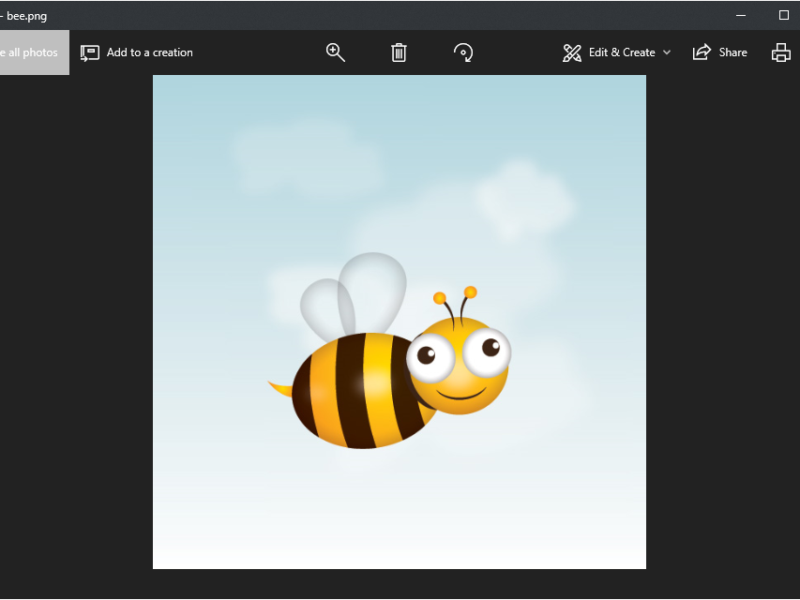

David Doppelganger | 888-888-8888 | david@doppelganger.com |

# About Me

I like to code things

# Work Experience

**Exon Mobile** *July 2000-Dec 2020*I sucked oil out of the ground

**Moxies** *July 1995-July 2000*Dining Room Server and Manager

# My Skills

* Excel
* Python
* MySql
* Power Query
* PowerBI