Indian dynamic yield curve prediction and dashboard Journal
This project aimed at developing end to end Ml analysis and dashboard for dynamic visualisation of Indian Sovereign Yield data extracted by official website of RBI (dbie) across multiple maturities.
I started things off by downloading Yield data of various government securities for different maturities from dbie for past 30 years for further analysis. Now the dataset was in raw form where there were a lot of structural bottlenecks ranging from coulumn and row placement issues and garbage rows to NA values. Hence the next natural step was data cleaning and engineering for future analysis. The thing with ML models is that it need the data set in a very specific way otherwise its predictions and accuracies can fail.
Libraries needed for this projects were mainly pandas, numpy, matplotlib and streamlit later on for dashboard construction.
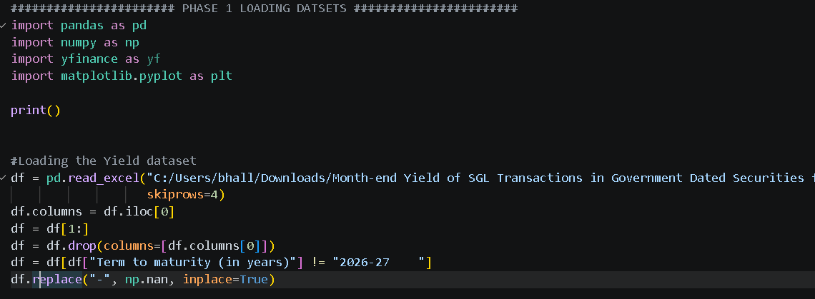
To begin with data cleaning part, I first converted string(word) values to numeric(number) values for the column “term to maturity” as well as “month” as some numeric could have been read as string so to be on a safe side I went ahead with this practice. Now in case the program encounters a word(string) in dataset which cannot be converted to numeric, say apple, we also used line error = “coerce” in our code which basically forces our program to force a string which cannot be converted to numeric as null and just move on to next point.
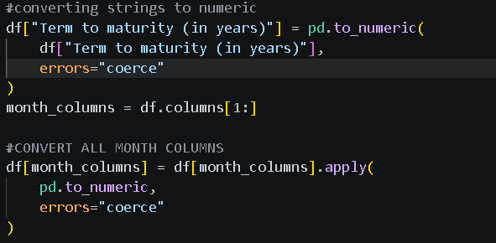
Now I had to reset the index as it could be in any order say,
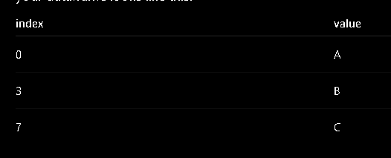
But what we actually want is,
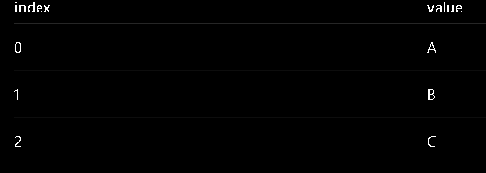
The code that helps achieve this is
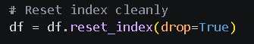
Now I went head and visualized the yield curve by plotting term to maturity
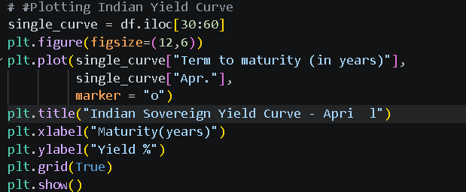
Df.iloc(30:60) means locate integer/value from 30 to 59 from the data frame for the month april and made a plotted a single curve as multiple in same graph would look messy.
Now I went ahead and defined what fiscal years and target tenors(yield maturity year) I want. I took every year in fiscal year but for target tenors I only took 1,2,3,45,,7,10 and 13
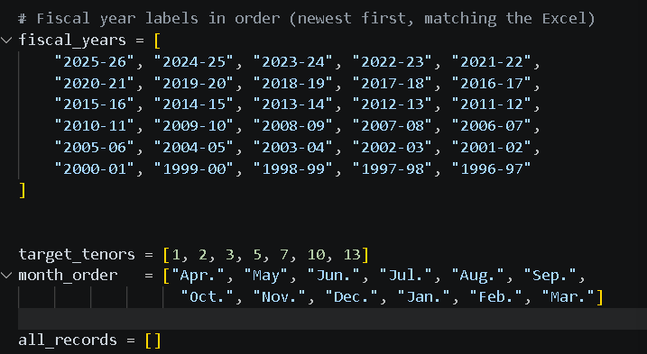
Now I have to make blocks of different-different years so I had to looping.
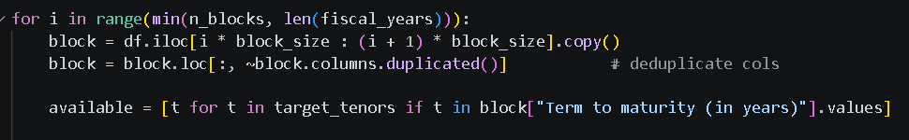
“for I in range()” is the line used for looping. Range tells from where to where the program is going to create blocks. The first block line simply assigns equal sizes to blocks which was previously determined as 30. When i=0, block is 30 to 60 { (0+1)x30=30 hence 30 to 60}, when i=1, then block is 60 to 90{ (1+1)x30=60 hence 60 to 90} and so on and so forth.
1=0 --- df.iloc[0:30]
I=1 --- df.iloc[30:60]
I=2 --- df.iloc[60:90], etc
The second block code is for removing duplicate column names if the appear more than once.
The last line is to check for what all target tenors are actually available in raw data.
Up until now most of the data cleaning is done but the data isn’t ml ready so we need to make a last huge structural change i.e, transpose the dataset because we want term to maturity or tenors on top top to down(as rows) and months as column because this is the standard way to present financial data for further ml stages.
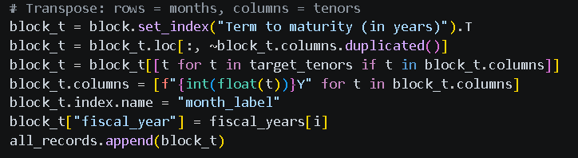
The set index in first line is used to assign labels to rows like serial number. .T is used to transpose the dataset. Second line is to removes duplicates. Third line keeps only those tenors which we include in our df that is [1,2,3,4,5,7,10 and 13]. Line 5 renames index names(Sno) to month_label, line 6 creates a new column assigning respective fiscal year to each row, and the last line lets this new processed structure of data to master list.
And with that I am done with data cleaning and structuring. This was the end of data engineering and now we come to feature engineering which will later be used in my ML models. Most of it will be handled by numpy library.
The first feature that I used is 2s10s and 5s10s spread. S is short form for a particular year’s govt bond yield. Yield is nothing but the current rate of return based on the market price of the bond. Coupon rate is the specified constant periodic interest incomes received on bond. YTM is that rate of return or yield rate which makes the pv of sum of all the future cashflows equal to the initial investment or current mkt price of the bond. 2s10s would essentially mean 10 year bon yield minus 2 years bond yield which will give the spread between the 2 yield and same with 5s10s. This would tell us how steep the yield curve will be. Short term bonds will have lower yield as compared to long term ones as investors simply demand more compensation to longer maturity market risks. Very steep curve(higher amounts of spreads) usually indicates strong growth expectations, inflation expectations, economic expansion. While flat curves(lower spreads) usually represent slow economy and maybe tight monetary policy. Negative spreads on the other hand means there could be recession expectations, future rate cuts and economic slowdowns.
2nd feature we included was 2s10s and 5s10s change. This basically show the movement of curve rather spread between a time frame. It tell will the curve steepen or flatten as we move ahead in time. Its very much similar to change in basis risk. It measures res relationships between long-term and short-term yields changes over time. If the change is positive it means the curve is steepening(relatively) with time. If it is negative then mean curve is flattening(negatively). Spread tells what is the curve shape right now. Spread change tells how is the curve evolving. It is much more dynamic than a static feature.
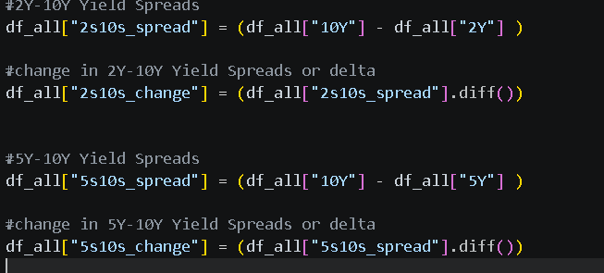
.diff simply subtract previous row from current row.
Then I also visualised 2s10s and 5s10 spread using plt function
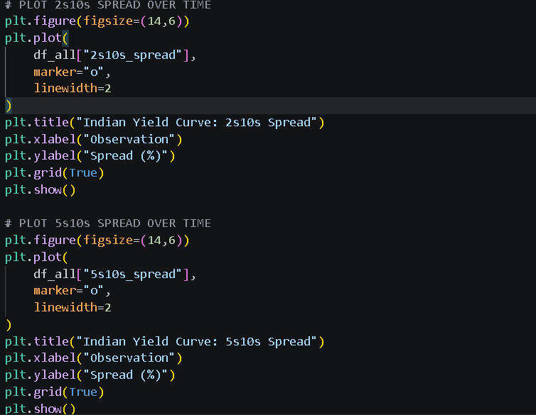
After this the 3rd feature for the project was none other than the lagged variables in order to capture the essence of time series. I used lag1(value from 1 month ago) and lag 3(lag from 3 months) ago. This is because financial markets have memory and behaviour of previous market which includes policies, spread, curve structure, etc can affect today’s market behaviour. Practically what lag does with data is that is shift the entire spread column 1 or 3 months back depending on what lag you use. For example,
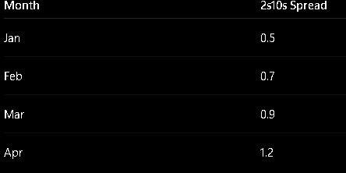
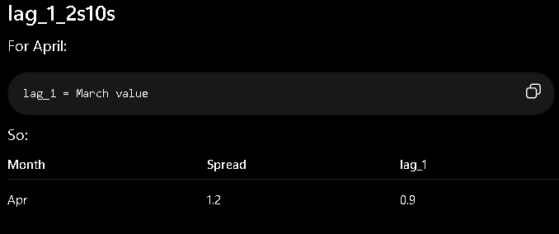
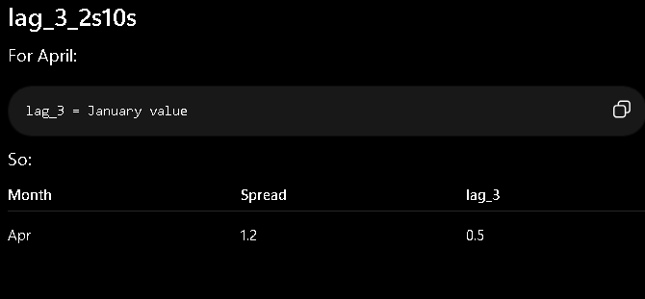
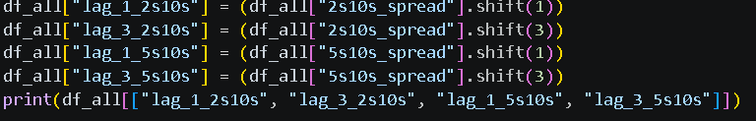
Lags can be created by using .shift, .shift(1) means lag1 or shift 1 row back and shift(3) means lag3 or shift 3 rows back.
Now the 4th feature in the model is rolling volatility. Rolling volatility is more of a dynamic measure than the normal or static volatility (which is calculated on entire dataset as a one whole) as it does not show local trend of fluctuations and volatilities. Rolling volatility calculates continuously over the observations in a set of windows(number of observations to take into account at once). In this case I have taken the rolling window as 3 as each row represent 1 month so 3 month is sufficient for 1 window.
This helps in telling at what phases the volatility has been higher and what phases have been relatively calm. It is mathematically calculated by standard deviation.
Now I am moving forward toward the next and the most important phase of the project that is supervised ML target engineering.
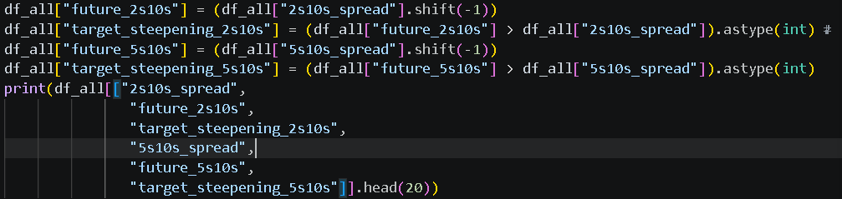
Now this is the first code of this phase which simply makes a new table future_2s10s to shift(1)(one month forward) of 2s10_spread. Next of this part is making new table of target_steepening_2s10s and this table is which is type of categorical data i.e, it gives produces value as 1 is future_2s10s > 2s10_spread and 0 otherwise. astype(int) means it converts true to 1 and false to 0. Same process is done for 5s10s_spread as well. At last all the these metrics involved are stored I df_all as integer.
In the next part I created a features_column under which all the inputs/features I have created will be stored.
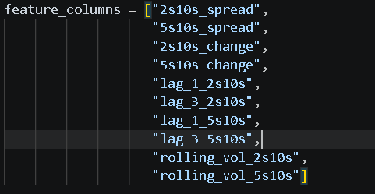
Next I created another table under which I included the previous table I created that is feature_column and also target_steepening_2s10s and also applied .dropna() to drop all the na values
I then assigned features_column as X and target_steepening_2s10s as Y
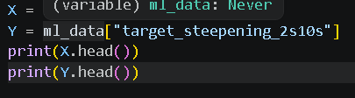
After this I performed train test split on both X and Y datasets and split is 20:80
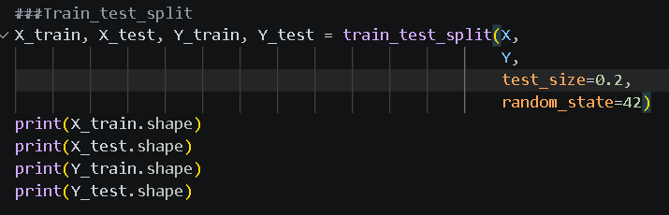
The first model I applied to the dataset was logistic regression model which is similar to lpm but better as it always produces probability between 0 and 1 and predictions on the test set classified future curve movements into steepening (1) or flattening (0) categories. Also logistic regression estimates using MLE
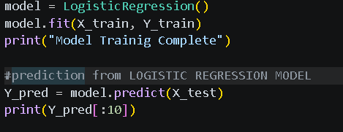
Model is fitted or trained using X_train and Y_train and Y is predicted using X_test data. So the model is learning that Given today's yield curve characteristics (X), can I predict next month's curve movement (Y)? Also we didn’t use Y_test for prediction of Y because that will be cheating. We only use Y_test data for model evaluation where we compare Y_test and Y_pred. After this I have evaluated the model by accuracy score, classification report and confusion matrix on Y_test vs Y_pred.
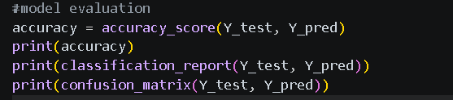
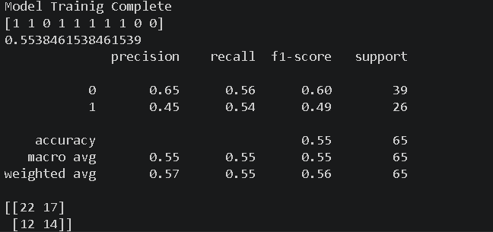
The model has achieved an accuracy of around 55%. Accuracy simply means
$$Accuracy=\frac{Correct Prediction}{Total Predictions}$$
Out of 65 observations, the model correctly predicted 36 observations.
$$Accuracy=\frac{TP+TN}{TP+TN+FP+FN}$$
Confusion matrix –
 | Predicted 0 | Predicted 1
Actual 0 | 22(TN) | 17(FP)
Actual 1 | 12(FN) | 14(TP)
True means both predicted and actual is same that is either both are positive(1) or negative(0). On the other hand false means predicted and actual is different that is predicted is positive and actual is negative or vice versa. Positive or negative is determined by what the predicted value says. If predicted is 1 then it is either TP or FP and if it is 0 then it is either TN or FN.
Now comes the concept of precision and recall.
Precision simply determines out of the total predicted positives/negatives, how many of them are actually positive/negative.
$$Precision=\frac{TP}{TP+FP}$$
In our model, precision is 45% as 14/(14+17) = 45%. Hence it means out of total predicted positives, 45% are actually positive.
Recall on the other hand determines out of the actual positives/negatives, how many of them our model was able to catch.
$$Recall=\frac{TP}{TP+FN}$$
In our model recall is 54% as 14/(14+12) = 54%. Hence out of total actual positives, our model was able to catch only 54% of them correctly.
Next 2 models I’ll be using are ensemble models. Ensemble literally means a group working together instead of one individual working alone. Group prediction > Individual prediction. This is the core philosophy of ensemble learning. In other word it combines opinions. Ensemble models can be categorised into 2 broad categories, bagging and boosting
Bagging – Just like bootstrapping philosophy where we train many models independently and the average/vote their predictions.
Example
Suppose 5 trees predict:
Tree 1 → Steepening
Tree 2 → Flattening
Tree 3 → Steepening
Tree 4 → Steepening
Tree 5 → Flattening
Vote:
Steepening = 3
Flattening = 2
Final prediction:
Steepening
Bagging reduces variance so less sensitivity to noise. Random forest belongs to bagging family.
Boosting – It is a completely different philosophy. Instead of training many models simultaneously on different- different samples from the same dataset, we run one model on the entire dataset, then make another model which fixes previous model’s mistake and again make a model and so on and so forth. Each model learns from past model’s mistake and is a little bit better from the previous one
Model 1
↓
Model 2 fixes Model 1's mistakes
↓
Model 3 fixes Model 2's mistakes
↓
Model 4 fixes remaining mistakes
Think of a student.
Attempt 1:
Score = 50
Look at mistakes.
Attempt 2:
Focus only on mistakes
Score improves.
Attempt 3:
Focus on remaining mistakes
Improves again.
Eventually:
Weak learners
↓
Strong learner
Boosting reduces bias and helps model learn more complex relationships
XGBoost or EXTREME GRADIENT BOOSTING belongs to boosting family

Both random forest and xgboost uses decision tree as their building blocks
Example of decision tree –
2s10s > 1?
YES
↓
Volatility > 0.5?
YES
↓
Steepening
This branching and asking different questions to reach an answer while assigning different weights and probabilities to different questions structure is called a decision tree.
In random forest each of the different multiple tree uses different combinations and sets of features and each tree then votes their predictions but the amount of features taken by each tree remains the same. If one tree uses three random features, all other trees in the forest will also use exactly three features; otherwise, the number of features per tree would vary. Final prediction is decisded by majority voting.
On the other hand XGBoost’s philosophy and working remains the same just as boosting philosophy. Talking about its trees, each tree may do subsampling of features or use all the available features to it and thus it is less random than random forest.
Random forest asks how can I make my trees different while XGBoost asks how can I minimize the remaining errors.
Now the next model I used after logistic regression and also the first ML model of the project is none other than Random Forest.
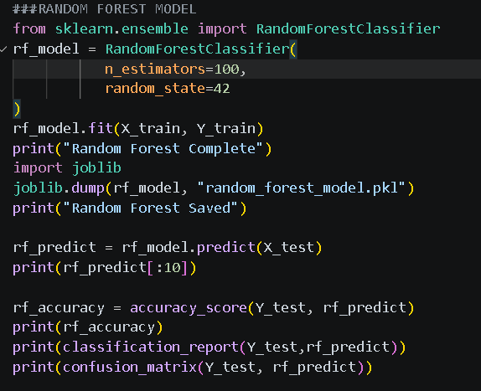
N = 100 means build 100 decision trees, each tree votes and majority vote becomes prediction Random state = 42 is simply for reproducibility(42 is the joke from hitchhiker’s guide to the galaxy where the super computer calculated answer of life and everything as 42). This lead to same randomness and hence the same answer everytime. The code rf_predict = rf_model.predict(X_test) simple runs 100 trees, does voting and finally predicts.
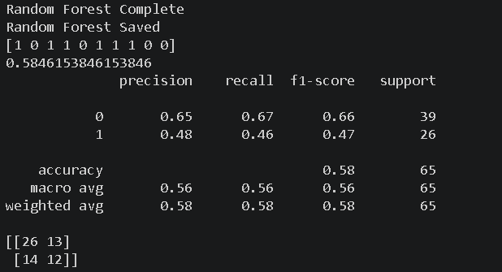

The output is result of the rf_predict code. Note that each and every observation of the output is a result of 100 trees working together. Lets say if I talk about the first observation “1”, this “1” is a result of voting of 100 different trees. The accuracy of random forest is 58%, 3% more than logistic. This is because Yield curve behaviour is unlikely to be linear Random Forest captures nonlinear relationships, Interactions and threshold effects.
Confusion matric-
Actual | Predicted 0 | Predicted 1
0 | 26(TN) | 13(FP)
1 | 14(FN) | 12(TP)
Correct flattening predictions = 26
Correct steepening predictions= 12
Incorrect flattening predictions = 14
Incorrect steepening predictions= 12

Feature importance-
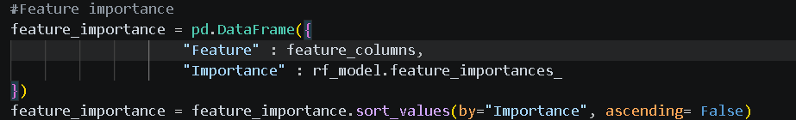
This is how I got the weightage of different features of my model and I went ahead and plotted it.
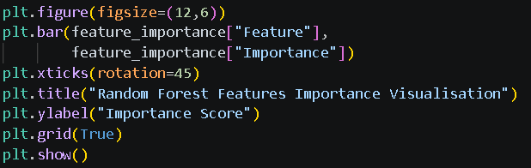
Feature | Importance
2s10s_spread | 0.1279
5s10s_spread | 0.1253
rolling_vol_2s10s | 0.1157
5s10s_change | 0.0999
rolling_vol_5s10s | 0.0943
lag_1_5s10s | 0.0918
lag_1_2s10s | 0.0886
lag_3_2s10s | 0.0877
lag_3_5s10s | 0.0876
2s10s_change | 0.0813
The model found current yield spread more useful than the other and hence assigned comparitively higher weightage than the other features
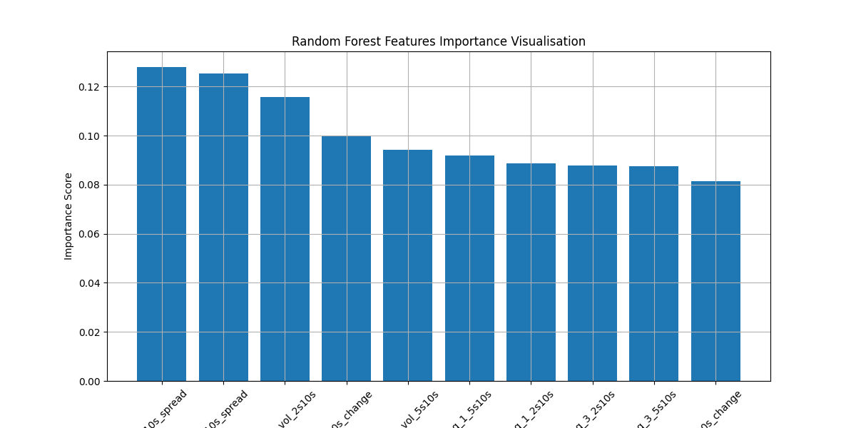
The last ML model used in this project is none other than XGBoost. The parameters of XGBoost are more than that of random forest. As compared to random forest which has only 2 parameters(n estimators and random state), XGBoost uses atleast 4 parameters namely n estimators, max depth, Learning rate and random state.
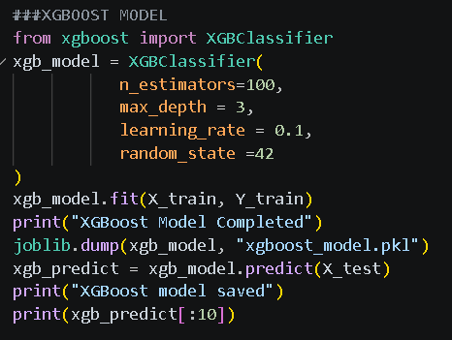
Max_depth means how many splits are there from root node to leaf node. The higher the node the more complex is the decision tree. XGBoost usually has higher number of trees and simpler and lower depth of each tree.
Learning rate is one the most important parameters for this model. It the the amount of contribution taken while calculating final decision. For example,
Suppose Tree 1 says:
Steepening Probability = 80%
XGBoost doesn't fully trust Tree 1. Instead Take only 10% of Tree 1 contribution because learning rate = 0.1
Then Tree 2 adds a little more, Tree 3 adds a little more, Tree 4 adds a little more and so on.
Analogy:
Random Forest: 100 people shouting opinions
XGBoost: 100 people whispering corrections
After creating the model, I trained it by fitting X_train and Y_train by the code (xgb_model.fit(X_train,Y_train)
Finally I predicted using the model I trained earlier using xgb_model.fit(X_train,Y_train)
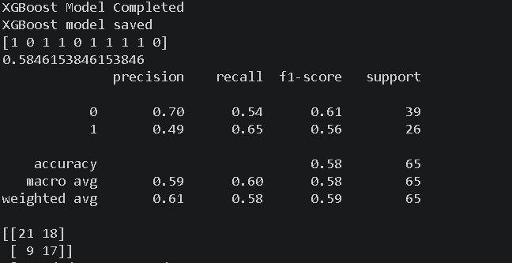
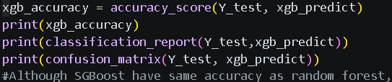
The accuracy is exactly the same as random forest i.e, 58%
But does that mean there was no benefit of using this model, not exactly. The accuracy only tells a little about how good the model is in prediction. To analyse that we’ll have to dig a little deeper and check other metrics of the classification report and confusion matrix.
The precision in this model is 49% which means out of the total predicted positives, 49% of them are actually positive in actual data and recall is 65% which means out of the total actual positives in actual data, our model was able to catch 65%. If we compare the results of random forest and XGBoost,
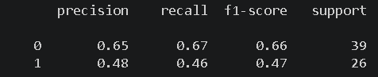
Random Forest
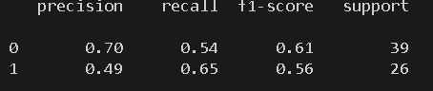
XGBoost
If we compare the two models, we can see that although XGBoost decreased precision by 1%, it significantly increased its recall by a massive jump of 18% from 46% to 65%. This means XGBoost catches more actual positives as compared to Random Forest, thus indicating better detection of actual steepening periods.
The confusion matrix of XGBoost is as follows
Actual | Predicted 0 | Predicted 1
0 | 21(TN) | 18(FP)
1 | 9(FN) | 17(TP)
Correct flattening predictions = 21
Correct steepening predictions= 17
Incorrect flattening predictions = 9
Incorrect steepening predictions= 17

Correct flattening predictions = 26 Correct flattening predictions = 21
Correct steepening predictions 12 Correct steepening predictions= 17
Incorrect flattening predictions = 14 Incorrect flattening predictions = 9
Incorrect steepening predictions= 12 Incorrect steepening predictions= 17
Random Forest XGBoost
Confusion matrix also entails the same story, correct steepening is the strength of XGBoost model and it also has lower rate of incorrect flattening.

Phase 2 – Yield Curve Dashboard (Yield_curve_dashboard.py)
With all the heavy lifting done in the main script — data cleaning, feature engineering, and training the three ML models — the final phase of this project was to package everything into an interactive, user-facing dashboard. For this I used Streamlit, which is a Python library specifically designed to turn data scripts into shareable web applications with minimal effort. Unlike Flask or Django which require you to write HTML and handle routing manually, Streamlit lets you build the entire front-end purely in Python, making it extremely practical for data science projects like this one. The dashboard loads the cleaned CSV file and the two saved model files (the Random Forest .pkl and the XGBoost .pkl) to power all its panels.
Libraries and Setup
The dashboard script imports a focused set of libraries. Streamlit (st) handles all UI rendering and interactivity. Pandas is used to read the cleaned CSV. Matplotlib is used to render the charts inline inside the Streamlit app via st.pyplot(). Joblib is what loads the pre-trained .pkl model files that were saved at the end of the main script. Think of joblib as the bridge between the training script and the dashboard — without it, the models would have to be retrained from scratch every time the app is launched, which would be both slow and pointless. The Plotly imports (express and graph_objects) are present in the script but I ended up using Matplotlib for the actual charts as it integrated more cleanly with Streamlit’s st.pyplot() function.
Panel 1 – Data Preview
The first thing the dashboard does after loading the data is call st.dataframe(df.head(100)), which renders an interactive, scrollable table of the first 100 rows of the cleaned dataset directly in the browser. This is a useful sanity check at the top of the dashboard — any analyst opening the app can immediately verify the data has loaded correctly, check the column names, and see the fiscal year and month labels before interacting with any of the charts. st.dataframe() is one of Streamlit’s native widgets and supports sorting and column resizing out of the box without any additional code.
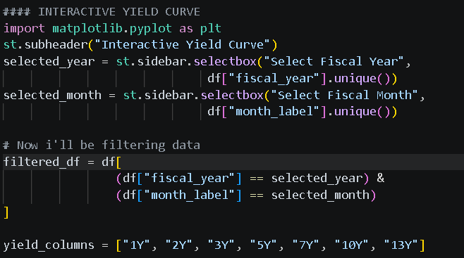
The Sidebar – Dashboard Controls
The sidebar is the control panel of the entire dashboard. In Streamlit, anything placed inside st.sidebar appears in a collapsible panel on the left side of the app, keeping the main canvas clean. I added three selectbox widgets to the sidebar. The first two are Select Fiscal Year and Select Fiscal Month, which together let the user drill down to a specific single month’s yield curve snapshot for Panel 2. The third is Select Spread, which controls which spread (2s10s or 5s10s) is plotted in Panel 3. A selectbox in Streamlit is a dropdown widget. When a user changes the selection, Streamlit automatically re-runs the entire script from top to bottom with the new value, which is how the charts update in real time without needing any callback functions or event listeners as you would in traditional web development. The options are populated directly from the dataframe’s unique values using df[“fiscal_year”].unique() and df[“month_label”].unique(), which means as long as the underlying CSV is correct, the dropdowns will always reflect exactly what data is available.
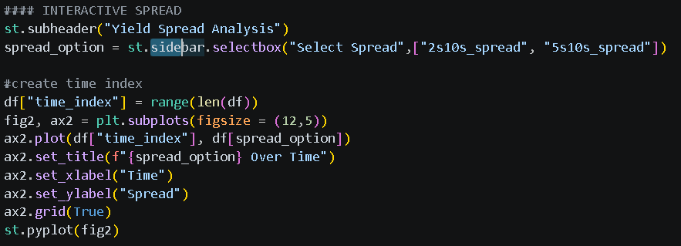

Panel 2 – Interactive Yield Curve
This is the centrepiece panel of the dashboard. It takes the fiscal year and month selected in the sidebar and filters the dataframe down to that single row using a boolean mask on both the fiscal_year and month_label columns. The filtered dataframe is then reduced to only the seven yield columns — 1Y, 2Y, 3Y, 5Y, 7Y, 10Y, and 13Y — which are our target tenor maturities from the original data engineering phase.
From this single filtered row, Matplotlib plots a yield curve with maturity on the X-axis (the tenor labels) and yield percentage on the Y-axis, with circular markers at each data point. The chart title dynamically updates to show the selected month and year, so the analyst always knows exactly which period they are looking at. The call filtered_df[yield_columns].iloc[0] selects the first (and only) row of the filtered dataframe and converts the seven yield columns into a single series for plotting. The chart is then passed to Streamlit using st.pyplot(fig), which renders the Matplotlib figure directly inside the browser. This panel essentially democratises the yield curve — rather than looking at static plots in a Jupyter notebook, any user can now navigate 30 years of Indian sovereign yield curve history by simply changing the dropdowns.
Panel 3 – Yield Spread Analysis
While Panel 2 gives a cross-sectional snapshot of the curve at a single point in time, Panel 3 takes a longitudinal view. It plots either the 2s10s spread or the 5s10s spread across the entire dataset, depending on which option the user selected in the sidebar. This turns the spread — which was one of the key features engineered in the main script — into a time-series chart, making it easy to visually spot periods of curve steepening, flattening, and inversion across three decades of Indian monetary history.
Because this chart uses the full dataframe (not the filtered one), I had to create an artificial time index using df[“time_index”] = range(len(df)). This simply numbers every row from 0 to the end of the dataset, giving the X-axis a clean numeric sequence to plot against. The reason I used this instead of a proper date column is that the dataset uses fiscal year labels and month labels rather than a single parsed datetime column. The time_index therefore acts as a proxy for chronological order, preserving the sequential nature of the data across the plot. The chart title also updates dynamically to show whichever spread has been selected, and the result is effectively a macro regime chart — a high level view of how the term structure of Indian interest rates has evolved over time.
Panel 4 – ML Curve Prediction
This is the most technically interesting panel of the dashboard as it is where the trained ML models actually come to life and make predictions in real time. The workflow here is as follows. After the user selects a fiscal year and month in the sidebar, the dashboard has already filtered the data down to that single row (stored as filtered_df). The code then takes that single row and extracts the same ten feature columns that were used to train both models in the main script — the two spreads, their respective changes, four lag variables, and two rolling volatility figures. These features are wrapped into a one-row Pandas DataFrame called latest_feature, which is the exact input format both models expect.
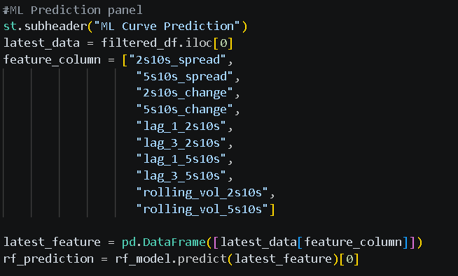
Both the Random Forest model and the XGBoost model then independently run .predict() on this single feature row, each outputting either a 1 (steepening) or a 0 (flattening). The dashboard displays each model’s verdict using Streamlit’s built-in colour-coded alert widgets. If the prediction is 1 (steepening), st.success() renders a green banner. If the prediction is 0 (flattening), st.error() renders a red banner. This colour coding is deliberate — green for steepening and red for flattening maps intuitively to the economic interpretation, where steepening generally signals a healthier growth-oriented environment and flattening may signal tighter conditions ahead. The two banners appear side by side for the Random Forest and XGBoost models respectively, allowing the user to quickly see whether both models agree or diverge on their prediction for the selected period.
It is worth noting that this panel is essentially a live inference engine. The models were trained on historical data from the main script, but the dashboard feeds them any month and year the user selects. When a user picks a recent period such as 2024-25, April, the models are applying patterns learned from 30 years of historical yield curve behaviour to make a prediction about that specific month’s curve movement. This closes the loop on the entire project — from raw RBI data, through cleaning and engineering, to trained ML models, and finally to real-time predictions accessible through an interactive browser interface.
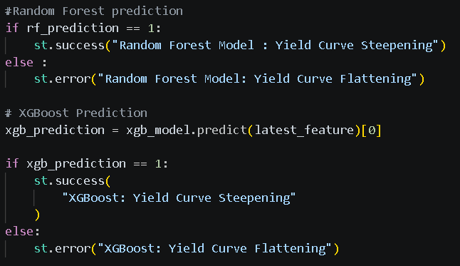
Overall Reflections on the Project
This project brought together fixed income theory and applied machine learning in a way that I found genuinely instructive. The most important lesson from the modelling phase was that accuracy alone is a poor benchmark in financial classification. Both the Random Forest and XGBoost models achieved 58% accuracy, but XGBoost was clearly the stronger model in practice because its recall for actual steepening events was 65% versus only 46% for Random Forest. In a real fixed income desk context, missing a steepening event (a false negative) is typically more costly than falsely predicting one (a false positive), so maximising recall matters more than maximising raw accuracy. This is the classic precision-recall tradeoff and this project made it very concrete.
The feature importance analysis from Random Forest also produced a genuinely interesting economic finding. The current level of the spreads (2s10s and 5s10s) were ranked as the most predictive features, followed closely by rolling volatility, ahead of the lagged values and spread changes. This suggests that the structural level of the yield curve at a given moment in time is more informative about where the curve is heading next than the recent rate of change. The presence of meaningful lag importance also confirms that Indian sovereign yield curve movements exhibit autocorrelation, meaning the curve’s past behaviour does influence its future behaviour — a key assumption that justified the inclusion of lag features in the first place.
The dashboard itself adds genuine value beyond what static notebook outputs can provide. Being able to select any month from 30 years of Indian yield curve history and immediately see the curve shape alongside a live ML prediction turns this from a one-time analysis into a reusable analytical tool. Future improvements to this project could include adding a proper datetime index to enable better time-series X-axis labelling on the spread chart, incorporating additional macro features such as RBI policy rate changes or inflation data, and potentially adding a third model comparison panel that shows the probability scores (not just the binary prediction) from each model side by side.

