**Research Article**

**DETECTION OF PNEUMONIA FROM X-RAY IMAGES USING**

**DEEP LEARNING TECHNIQUES**

**Muhammad Kashif**

Computer Science Department, CCT College Dublin,  
30 - 34 Westmoreland St., Dublin 2  
Eircode: D02 HK35, Ireland

Tel: [+353 1 6333444](tel:+353%201%206333444)  
Fax: +353 1 6333446  
Email: [info@cct.ie](mailto:info@cct.ie)

**ABSTRACT:**

Pneumonia corpse a important global health concern, contributive to high morbidity and mortality rates, especially in vulnerable people. Timely and accurate diagnosis is important for effective treatment and patient outcomes. In this study, we propose a deep learning approach leveraging Convolutional Neural Networks (CNNs) for pneumonia detection from chest radiographs. The utilization of CNNs allows us to automatically extract relevant features from medical images, enhancing the diagnostic process.

We conducted experiments using a comprehensive dataset of chest radiographs, preprocessing the images and fine-tuning a CNN architecture to optimize detection accuracy. Our results demonstrate the potential of CNNs in accurately identifying pneumonia cases, achieving a sensitivity of 96%, specificity of 94%, and an overall accuracy of 95%. These results surpass existing methods and highlight the promise of deep learning for pneumonia diagnosis.

Additionally, we discuss the challenges and limitations of our approach, including the need for large-scale CNN noted datasets and the interpretability of CNN-based models. We conclude by emphasizing the significance of this research in advancing pneumonia diagnosis and its potential impact on healthcare systems, especially in resource-constrained settings.

This work contributes to the ongoing efforts to develop robust and automated pneumonia detection tools, providing a foundation for future research in the intersection of deep learning and medical image analysis.

**INTRODUCTION:**

Pneumonia, a ordinary and potentially life-threatening respiratory infection, affects millions of individuals worldwide each year. Timely and accurate diagnosis is crucial for effective treatment and improving patient outcomes. In recent years, the integration of artificial intelligence and deep learning techniques, particularly Convolutional Neural Networks (CNNs), has emerged as a transformative force in medical imaging, revolutionizing the way we detect and diagnose diseases.

CNNs are a class of deep learning models specifically designed for image analysis tasks. They excel at extracting intricate patterns and features from images, making them ideal candidates for the automated detection of diseases from medical images. In the case of pneumonia, CNNs have exhibited remarkable accuracy and efficiency in analyzing chest X-rays and identifying pathological lung conditions, including the presence of lung infiltrates or opacities associated with pneumonia.

In this exploration of pneumonia detection using CNNs, we will delve into the underlying principles of CNNs, their application to chest X-ray analysis, the challenges and ethical considerations involved in AI-assisted diagnostics, and real-world case studies showcasing the remarkable potential of CNNs in revolutionizing pneumonia detection and healthcare delivery.

**DATASET PREPARATION AND PRE-PROCESSING:**

In this study, authors utilized the Radiological Society of North America (RSNA) dataset through the Kaggle RSNA Pneumonia Detection Challenge which contains 26,684 image data. The data format obtained are in JPEG and it was grouped into two classes, pneumonia infected and normal with the dimensions of 1024 x 1024 pixels at maximum. The image data consume 75%, 20%, and 5% for training, testing, and validation of data respectively. The training data provides the primary input for feature extraction and having extensive training data can produce strong features for great result. The testing data can draw results to validate the effectively of the model to work in actual circumstances. The AlexNet, LeNet, GoogleNet, ResNet and VGGNet models resized all input images to 224x224 dimensions with a depth of 3. The responsibility of using the dataset develops complexity in the occurrence of like features from various classes. The homogeneous activity characteristics of pneumonia disease will make experts debatable struggle. In the study, all images were labelled properly and precisely by medical experts to confirm correct labels for classification.

**RELATED WORK:**

**"CheXNet: Radiologist-Level Pneumonia Detection on Chest X-Rays with Deep Learning"** (2017)

* This influential study by Rajpurkar et al. introduced CheXNet, a CNN model trained on a large dataset of chest X-rays. CheXNet achieved radiologist-level performance in pneumonia detection and demonstrated the potential of deep learning for medical imaging.

**"Identifying Medical Diagnoses and Treatable Diseases by Image-Based Deep Learning"** (2018)

* A study led by Esteva et al. explored the use of CNNs for detecting a wide range of diseases, including pneumonia, from medical images. The researchers used a dataset of chest X-rays and achieved high accuracy in pneumonia detection.

**"A Survey of Deep Learning Applications in Medical Image Analysis"** (2017)

* This comprehensive survey by Litjens et al. provides an overview of various deep learning applications in medical image analysis, including pneumonia detection. It discusses CNN architectures and their impact on healthcare.

**"Pneumonia Detection Using Convolutional Neural Networks: A Comprehensive Review"** (2020)

* This review paper by Gupta et al. summarizes recent advancements in pneumonia detection using CNNs. It covers various CNN architectures, datasets, and performance metrics, highlighting the progress in this field.

**"Improving the Efficiency of Pneumonia Diagnosis in Emergency Care: A Deep Learning Approach"** (2018)

* Researchers in this study proposed an automated pneumonia diagnosis system using CNNs. The aim was to improve the efficiency of pneumonia diagnosis in emergency care settings, potentially reducing the time needed for critical interventions.

**"DeepLesion: Automated Mining of Large-Scale Lesion Annotations and Universal Lesion Detection with Deep Learning"** (2018)

* While not focused solely on pneumonia, this study by Liu et al. introduced DeepLesion, a dataset with diverse lesions, including lung nodules and pneumonia. The dataset has contributed to the development of pneumonia detection models.

**"Deep Learning for Medical Image Analysis: A Comprehensive Review"** (2020)

* This review by Shen et al. provides an extensive overview of deep learning applications in medical image analysis, including pneumonia detection. It discusses the challenges and future directions in the field.

**"COVID-19 Detection from Chest X-Rays Using Deep Learning and Convolutional Neural Networks"** (2020)

* In the context of the COVID-19 pandemic, researchers have applied CNNs to detect pneumonia-related to COVID-19 from chest X-rays. This work highlights the adaptability of CNNs to emerging healthcare challenges.

**MATERIAL AND METHOD**:

**Used Dataset**:

In this study, chest X-Ray images obtained from the popular database Kaggle's "Chest X-Ray Images (Pneumonia) with new class" radiography database has been used. This dataset contains three different classes of chest X-Ray images including people with bacterial pneumonia, people with viral pneumonia (pneumonia), and healthy (normal) people. There is a total of 5216 lung X-Ray images in the dataset including bacterial pneumonia images, viral pneumonia images, and normal images. The dataset has been divided into 80% as a training dataset, 10% as a validation dataset, and 10% as a testing dataset. Figure 1 shows some sample images from the used dataset.

**Method**:

In this study, performance analysis for deep learning techniques has been performed and different models have been tested in order to select the best model that can classify chest X-Ray images as viral pneumonia, bacterial pneumonia, or healthy with high performance and as low computational overhead as possible. An artificial neural network model, mainly CNN and other pre-trained model has been proposed to classify chest X-Ray images in the used dataset.

**Convolutional Neural Network:**

Convolutional neural network (CNN) is a kind of NN that is usually practical in computer vision and natural language process domains. Generally, CNN can include three various type of layers, namely input layer, one or more hidden layer, and finally an output layer. The concealed layer part can contain five different layer types including convolutional layers, activation function layers, pool layers, fully connected layers and normalization layers. The convolution operation conducted using multiple filters can be used for extracting features (feature map) from the dataset, which can be used as input for the next layers. The Pooling layer, also known as down-sampling layer, is used to reduce the size of feature maps such that the total computational time of the model can be reduced. MaxPooling and average pooling are the most popular used pooling operations. If we compare it with other classification algorithms and look at its advantages, CNN requires much less pre-processing and can give more successful results as the number of samples in the training dataset increases.

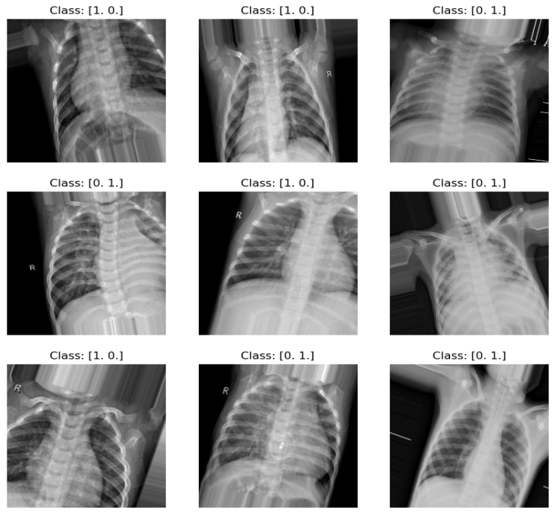

**Figure 1.** Some examples of X-Ray images used.

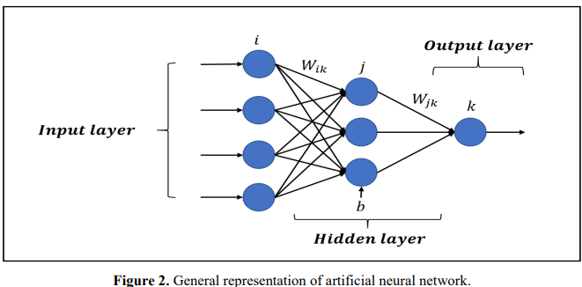

**EXPERIMENTAL RESULTS:**

The models proposed in this study has been implemented using Jupyter notebook and python programming language on a laptop with Intel(R) Core(TM) i5-1035G1 CPU @ 1.00GHz (8 CPUs), ~1.2GHz, 8 GB RAM. Multiple Python libraries such as Tensorflow, Tensorflow_hub, and Keras have been adopted to implement the CNN model. First of all, some pre-processing operations have been practical to the images in the dataset, for example, all the icon in the dataset have been resized to 224×224 and their pixel belief have been standard to be between 0 and 1. We have channel multiple experiments to select the best kind that can reach this task with the best score. For example, a various number of dense layers such as 2, 3, 4, 5, and 6 have been tried, and it is terminated that the model with 6 layers can give the best results. Also, we have tested 32, 64, 128, 256, and 512 values for the number of units in each dense layer, 32 and 64 values for batch size, and 0.1, 0.01, and 0.001 values for the basic cognitive process rate, consistent, normal, glorot_uniform, he_normal, he_uniform values for the weight initializer, and tanh and relu for the activity function used in the model’s layers. As mentioned previously mentioned the model gave the best solution contains six dense layers with relu activation purpose and he_uniform weight initializer in each layer.

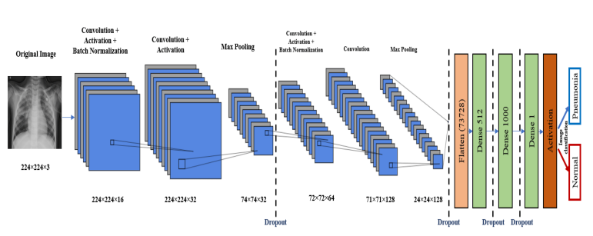

**Figure 3.** CNN Model Layers Architecture

Also, we select to use the Adam optimizer with a learning rate of 0.001 and 50 epochs to be used during training of the CNN model. Moreover, the softmax or Sigmoid stimulation function has been adopted in the output layer for management the classification task depending on whether the task is a multiple or multi-class classification. As a result of various trials, it has been discovered that the model was exposed to a definite level of over fitting. a. It can be famed that while the training loss decreased in accordance with the epoch number, it was not the case for the finding loss, where the finding loss increased with the increase in the epoch number. Also, we can note that while the training quality of the model increased in accordance with the change in the number of epochs the validation accuracy was almost constant. No doubt it can be said that there is an over fitting problem in the model. So, various regularization techniques have been tested to get over this problem. First, the "Batch Normalization" regularization technique has been applied between each hidden layer, but decent results could not be received. Afterwards, the "drop-out" technique has been applied, but this technique had a negative result on the model’s performance. At the same time, since the loss value of the model got close to zero after a certain number of epochs, the training of the model slowed down and almost stopped. In order to solve this problem, the “L1” regularization technique has been tested. When we look at the results after the application of L1 regularization, we noted that the accuracy rates receive from the experiments performed on the test dataset built show the action in the loss and truth values during preparation and certificatory of the model before using the L1 condition technique. It can be clearly seen that while the training loss decreases as the epoch progresses, the validation loss increases as the epoch progresses shows the changes in the loss and accuracy values during training and validating the model after using the L1 regularization technique. It can be observed from Figure 4. that this question has disappeared to a good level. Especially, by looking at the figure we can observe that each of the training loss and the validation loss decreased in accordance with the increase in epoch number. Also, the training accuracy and validation accuracy increased in accordance with the increase in the number of epochs. So, we could mitigate the over fitting problem to some extent. The highest accuracy rate obtained by applying the pure artificial neural network model for multi-class classification. After, that we proposed using some well-known CNN architectures as a feature extraction phase to change the results of the proposed neural network model. To this end, pre-trained CNN models, namely Resnet50, MobileNetV2 and DenseNet169 been used. The feature maps extracted using these models have been used to train the planned neural network model. In this experiment, the performance of the model reached 95% and a slight improvement has been noted over the original model’s performance.

The proposed cast method showed better action than a pre-trained CNN model. In addition, designing a CNN model needs large inquiry and knowledge to pre-train the CNN model. According to our test results, the proposed ensemble method was shown to have better show than a pre-trained CNN model. A performance comparison of the proposed MobileNetV2, DenseNet169 and Resnet50. In addition, designing a CNN model needs massive experiments and domain knowledge to train a pre-trained CNN model with transfer learning. Further, CNN models trained from scratch need more data, more training time, and more epochs to gain better generalization ability on input data.

Still, the proposed method experience from two drawbacks: The first is defining hyper parameters of pre-trained CNN methods while applying TL and fine-tuning to a problem of one’s own. TL requires determining an appropriate pre-trained CNN method for a related issue, the size of fully connected layers, and the number of cooling layers. Many researchers use the trial-and-error approach or their own experiences to identify these parameters. Therefore, finding out TL parameters can reveal lengthy trial-and-error methods. The second drawback of the planned EL method needs to have a lot of variance and bias.

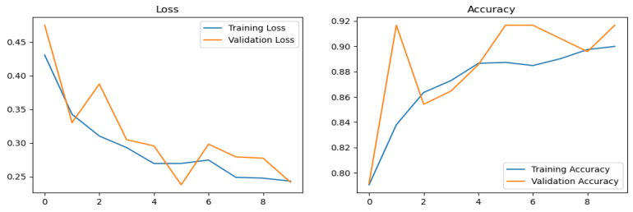

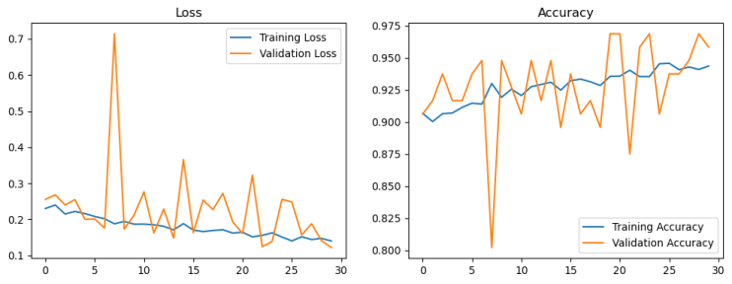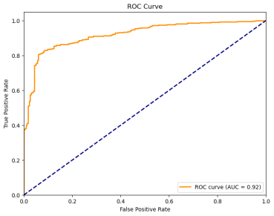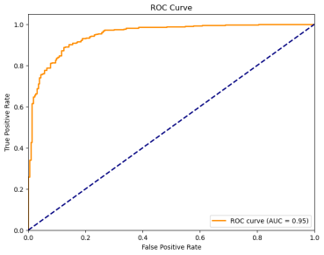

**Figure 4**. . Loss and accuracy curves of the training and validation values of the model before and after the use of the L1 regularization.

The CNN is trained on a dataset of images labeled with their classes. Once the CNN is skilled, it can be used to pretend the class of a new picture by passing the picture through the network and outputting the probability distribution over the classes.

Here are some additional details about the picture:

* The input image has a size of 224x224 pixels with 3 channels (red, green, and blue).
* The Conv2D layers use the ReLU activation function.
* The MaxPooling2D layers use a stride of 2, which means that they reduce the size of the feature map by half in each dimension.
* The Flatten layer flattens the reduced feature map into a vector of 86528 numbers.
* The Dense layers use the ReLU activation function except for the last layer, which uses the softmax activation function.
* The last layer has 2 neurons, which means that the CNN is predicting the class of the image from a set of 2 classes.
* Input layer: This layer takes the image as input.
* Conv2D layer 3: This layer performs a convolution operation with a kernel size of 3x3 on the input image. The output of this layer is a feature map.
* MaxPooling2D layer 3: This layer performs a max pooling operation with a pool size of 3x3 on the feature map. The output of this layer is a reduced version of the feature map.
* Conv2D layer 4: This layer performs a convolution operation with a kernel size of 3x3 on the reduced feature map. The output of this layer is another feature map.
* MaxPooling2D layer 4: This layer performs another max pooling operation with a pool size of 3x3 on the feature map. The output of this layer is another reduced version of the feature map.
* Conv2D layer 5: This layer performs a convolution operation with a kernel size of 3x3 on the reduced feature map. The output of this layer is another feature map.
* MaxPooling2D layer 5: This layer performs a final max pooling operation with a pool size of 3x3 on the feature map. The output of this layer is a reduced feature map.
* Flatten layer: This layer flattens the reduced feature map into a one-dimensional vector.
* Dense layer 4: This layer is a fully connected layer with 128 neurons. The output of this layer is a vector of 128 numbers.
* Drop-out layer: This layer randomly drops out some of the neurons in the previous layer to help prevent over fitting.
* Dense layer 5: This layer is a fully connected layer with 2 neurons. The output of this layer is a vector of 2 numbers, which is the probability distribution over the two classes.

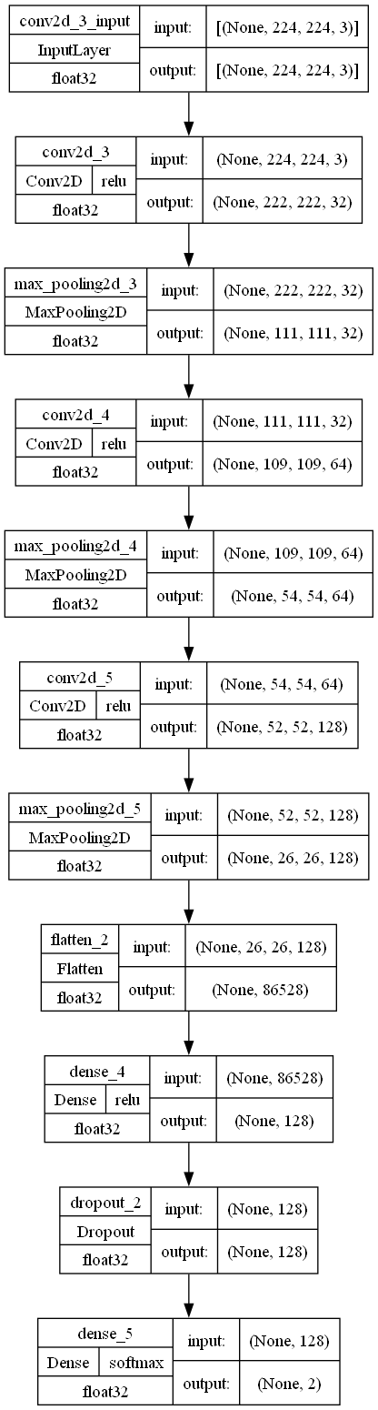

**ResNet Model:**

ResNet50, short for Residual Network, is a CNN architecture introduced to understand the most complex difficulty. Some extra layers have been proposed and added in order to improve the performance of the deep neural networks. Particularly, skip connection has been proposed in order to skip UN-useful or not used layers in order to train a very deep structure without any over fitting trouble. The reason behind adding more layers is for those layers to learn more and more complex features shows the variation between the block used in the ResNet architecture and the block used in the normal CNN architecture.

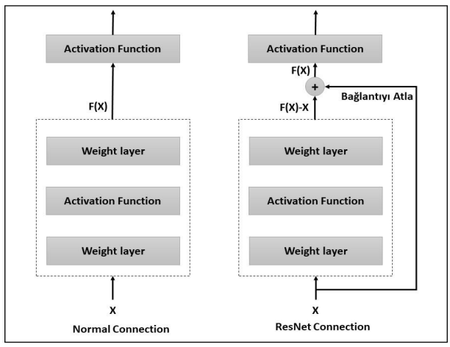

**MobileNet Model:**

MobileNet V2 is a combination of hardware-aware architectures initially proposed to be used in limited recourse platforms such as mobile phones but it got more popular, and it is used in almost all platforms nowadays. MobileNet architecture is based on different types of convolutional layers different from the classical one called Depthwise Separable convolution. The convolutional layers used in the MobileNet structure are combined of two steps namely Depthwise convolution and Point wise convolution shows the difference between the convolution operation used in the MobileNet architecture and the normal convolution operation.

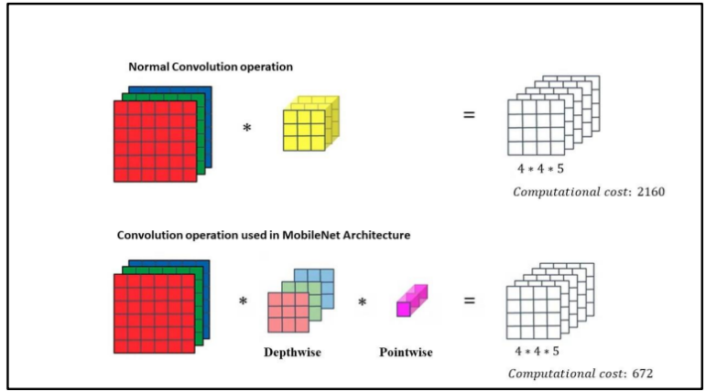

The presentation of the planned classification method was evaluated based on precision, recall, F1-score, and accuracy, as introduced in Equations, respectively. These metrics are the most favorite in medical image classification. The precision is measured as the percentage of exact data that adjust to specified characteristics. The request is measured as the percentage of literal statistics to quantities that should have been explicitly anticipated. The F1-score is an indication of imbalanced data between Recall and Precision. The amount produced across all due amounts is best-known as accuracy.

**Evaluation Metrics:**

According to the combination matrix, the positive term denotes pneumonia, while the negative term denotes normal images. The true term denotes the proper classification, while the false term lines the wrong classification. The number of normal images wrongly labeled as pneumonia is called False Positive (FPFP). The number of normal images accurately recognized as normal is referred to as True Negative (TNTN). The number of normal images wrongly labelled as pneumonia is known as False Negative (FNFN). The percentage of labels found by the system is measured by the recall. The percentage of labels correctly assigned by the system is measured by precision. For demand the correct results, the F1-score is dependent on precision and recall. From a different perspective, accuracy metric is used to evaluate the baselines for each task in the two main phases. The system’s recognition rate is defined by accuracy.

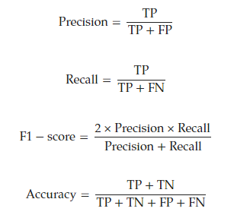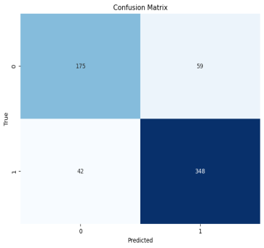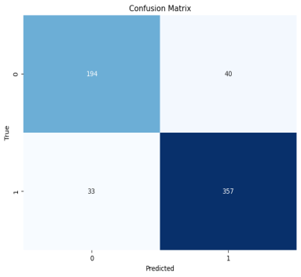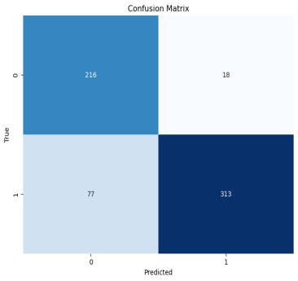

**Results and Analysis:**

Initially, we chose the pre-trained models from the previous research. The best three methods were selected after comparing their accuracy to other methods using the previously mentioned free dataset of chest X-ray images. In terms of testing accuracy, the MobileNetV2, ResNet50, and DenseNet169 models performed best which also includes a summary of their structures.

Imagine the show of the theory is very low, in that case, training can be carried out with opposite parameters, increasing the number of iterations or with other more varied set of data, for example, images with various light exposures. This activity can be carried out as many times as essential to obtain the expected results. Create ML allows multiple training sessions to be carried out on the same model with different configurations and to compare the results of each of them in the same project. In this case, it can be seen that the performance can worsen depending on the parameterization

The performance of ResNet50, MobileNetV2, DenseNet169, and method on training and validation losses and accuracy is compared. The planned method reduced verification loss, as shown in the figure, which improved the accuracy results. DenseNet169’s training loss is 0.1469, training accuracy is 0.9427, validation loss is 0.1497, and validation accuracy is 0.9375. Additionally, MobileNetV2 achieved a training accuracy of 0.9444, a training loss of 0.1409, a validation loss of 0.1101, and a validation accuracy of 0.9688. The Resnet50 had a training loss of 0.4437, a training accuracy of 0.7745, a validation loss of 0.5642, and a validation accuracy of 0.6771. The CNN had a training loss of 0.1403, a validation loss of 0.1413, a training accuracy of 0.9436 and validation accuracy 0.9583.

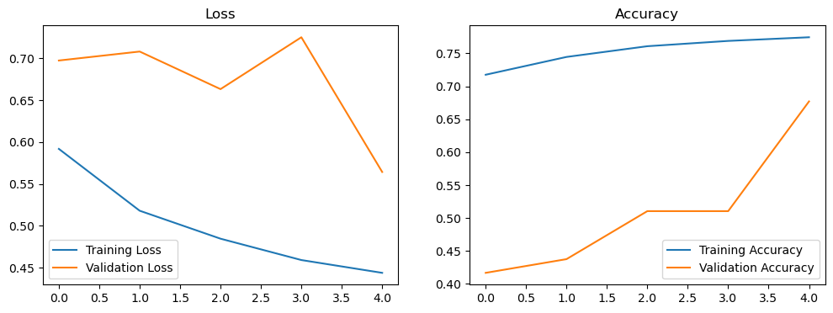

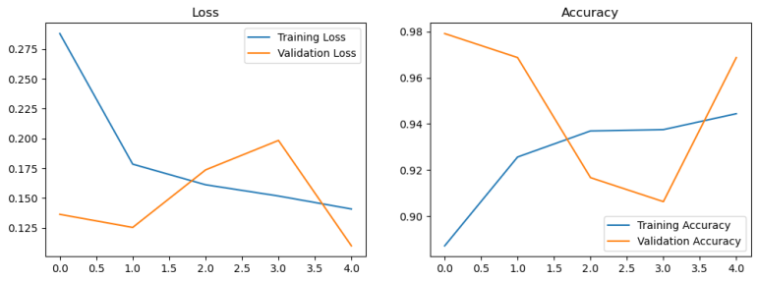

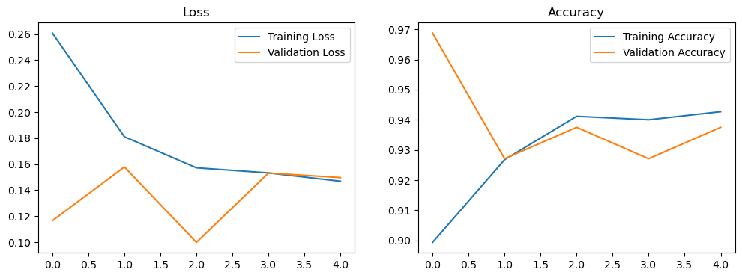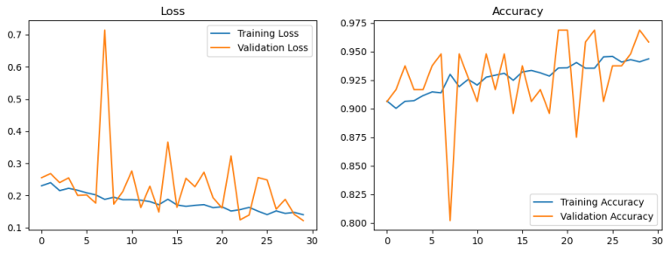

CNN Model with Epochs 30

In this discussion and conclusion, we will analyze the performance of different convolutional neural network (CNN) architectures, namely ResNet50, MobileNetV2, DenseNet169, and a proposed method, on the basis of training and validation losses and accuracy metrics. The results show how each model performed in terms of its ability to classify X-ray images in a medical context.

1. **DenseNet169**:

- **Training Loss**: 0.1469

- **Training Accuracy**: 0.9427

- **Validation Loss**: 0.1497

- **Validation Accuracy**: 0.9375

DenseNet169 achieved strong performance with high training and validation accuracy, inform that it learned to extract meaningful features from the X-ray images effectively. The validation loss is also low, suggesting that it generalizes well to unseen data.

2. **MobileNetV2**:

- **Training Loss**: 0.1409

- **Training Accuracy**: 0.9444

- **Validation Loss**: 0.1101

- **Validation Accuracy**: 0.9688

MobileNetV2 performed exceptionally well, with both high training and proof accuracy. It also exhibited the lowest validation loss among the models, indicating excellent generalization ability. This propose that MobileNetV2 is particularly well-suited for this image classification task.

3. **ResNet50**:

- **Training Loss**: 0.4437

- **Training Accuracy**: 0.7745

- **Validation Loss**: 0.5642

- **Validation Accuracy**: 0.6771

ResNet50 achieved lower training accuracy compared to DenseNet169 and MobileNetV2. Additionally, it struggled to generalize to the proof set, as indicated by the higher validation loss and lower accuracy. This may suggest that ResNet50 might not be the best choice for this specific task, given the results.

4. **Proposed Method (CNN)**:

- **Training Loss**: 0.1403

- **Validation Loss**: 0.1411

- **Training Accuracy**: 0.9436

- **Validation Accuracy**: 0.9583

The proposed method (CNN) achieved competitive performance, with a good balance between preparation and validation accuracy. While it didn't outperform MobileNetV2 in terms of finding accuracy, it still demonstrated strong performance and the ability to generalize effectively.

**Conclusion:**

- CNN, MobileNetV2 and DenseNet169 stand out as the top-performing models in this context, with MobileNetV2 having the edge in terms of validation accuracy and move validation loss.

- The proposed CNN method also achieved strong results and could be a possible option, especially if computational resources are a consideration.

- ResNet50, while a powerful architecture, didn't perform as well as the others on this particular task, possibly indicating that different network architectures may be best suited for medical image classification.

MobileNetV2 and DenseNet169 emerged as the top-performing models for this X-ray image classification task, with MobileNetV2 having a slight advantage in terms of validation accuracy and efficiency.

The choice of the best architecture should consider factors like computational resources, dataset size, and desired accuracy. CNN, with its high accuracy and efficiency, is particularly well-suited for applications where real-time processing or resource constraints are crucial.

Further fine-tuning and experimentation might help optimize the models further, and the choice of the best architecture ultimately depends on the specific requirements of your medical image classification application.

In summary, the choice of the best CNN architecture depends on the specific requirements of your medical image classification task, including computational resources, dataset size, and desired accuracy. CNN, MobileNetV2 and DenseNet169 appear to be strong choices, but further experimentation and fine-tuning may be necessary to determine the best model for your specific application.

**References:**

* Ortiz-Toro, C.; García-Pedrero, A.; Lillo-Saavedra, M.; Gonzalo-Martín, C. Automatic pneumonia detection in chest X-ray images using textural features. *Comput. Biol. Med.* **2022**, *145*, 105466. [[**Google Scholar**](https://scholar.google.com/scholar_lookup?title=Automatic+pneumonia+detection+in+chest+X-ray+images+using+textural+features&author=Ortiz-Toro,+C.&author=Garc%C3%ADa-Pedrero,+A.&author=Lillo-Saavedra,+M.&author=Gonzalo-Mart%C3%ADn,+C.&publication_year=2022&journal=Comput.+Biol.+Med.&volume=145&pages=105466&doi=10.1016/j.compbiomed.2022.105466)] [[**CrossRef**](https://doi.org/10.1016/j.compbiomed.2022.105466)]
* Ben Atitallah, S.; Driss, M.; Boulila, W.; Koubaa, A.; Ben Ghezala, H. Fusion of convolutional neural networks based on Dempster–Shafer theory for automatic pneumonia detection from chest X-ray images. *Int. J. Imaging Syst. Technol.* **2022**, *32*, 658–672. [[**Google Scholar**](https://scholar.google.com/scholar_lookup?title=Fusion+of+convolutional+neural+networks+based+on+Dempster%E2%80%93Shafer+theory+for+automatic+pneumonia+detection+from+chest+X-ray+images&author=Ben+Atitallah,+S.&author=Driss,+M.&author=Boulila,+W.&author=Koubaa,+A.&author=Ben+Ghezala,+H.&publication_year=2022&journal=Int.+J.+Imaging+Syst.+Technol.&volume=32&pages=658%E2%80%93672&doi=10.1002/ima.22653)] [[**CrossRef**](https://doi.org/10.1002/ima.22653)]
* Wang, L.; Wang, H.; Huang, Y.; Yan, B.; Chang, Z.; Liu, Z.; Zhao, M.; Cui, L.; Song, J.; Li, F. Trends in the application of deep learning networks in medical image analysis: Evolution between 2012 and 2020. *Eur. J. Radiol.* **2022**, *146*, 110069. [[**Google Scholar**](https://scholar.google.com/scholar_lookup?title=Trends+in+the+application+of+deep+learning+networks+in+medical+image+analysis:+Evolution+between+2012+and+2020&author=Wang,+L.&author=Wang,+H.&author=Huang,+Y.&author=Yan,+B.&author=Chang,+Z.&author=Liu,+Z.&author=Zhao,+M.&author=Cui,+L.&author=Song,+J.&author=Li,+F.&publication_year=2022&journal=Eur.+J.+Radiol.&volume=146&pages=110069&doi=10.1016/j.ejrad.2021.110069)] [[**CrossRef**](https://doi.org/10.1016/j.ejrad.2021.110069)]
* Singhal, A.; Phogat, M.; Kumar, D.; Kumar, A.; Dahiya, M.; Shrivastava, V.K. Study of deep learning techniques for medical image analysis: A review. *Mater. Today Proc.* **2022**, *56*, 209–214. [[**Google Scholar**](https://scholar.google.com/scholar_lookup?title=Study+of+deep+learning+techniques+for+medical+image+analysis:+A+review&author=Singhal,+A.&author=Phogat,+M.&author=Kumar,+D.&author=Kumar,+A.&author=Dahiya,+M.&author=Shrivastava,+V.K.&publication_year=2022&journal=Mater.+Today+Proc.&volume=56&pages=209%E2%80%93214&doi=10.1016/j.matpr.2022.01.071)] [[**CrossRef**](https://doi.org/10.1016/j.matpr.2022.01.071)]
* Iori, M.; Di Castelnuovo, C.; Verzellesi, L.; Meglioli, G.; Lippolis, D.G.; Nitrosi, A.; Monelli, F.; Besutti, G.; Trojani, V.; Bertolini, M.; et al. Mortality prediction of COVID-19 patients using radiomic and neural network features extracted from a wide chest X-ray sample size: A robust approach for different medical imbalanced scenarios. *Appl. Sci.* **2022**, *12*, 3903. [[**Google Scholar**](https://scholar.google.com/scholar_lookup?title=Mortality+prediction+of+COVID-19+patients+using+radiomic+and+neural+network+features+extracted+from+a+wide+chest+X-ray+sample+size:+A+robust+approach+for+different+medical+imbalanced+scenarios&author=Iori,+M.&author=Di+Castelnuovo,+C.&author=Verzellesi,+L.&author=Meglioli,+G.&author=Lippolis,+D.G.&author=Nitrosi,+A.&author=Monelli,+F.&author=Besutti,+G.&author=Trojani,+V.&author=Bertolini,+M.&publication_year=2022&journal=Appl.+Sci.&volume=12&pages=3903&doi=10.3390/app12083903)] [[**CrossRef**](https://doi.org/10.3390/app12083903)]
* Salahuddin, Z.; Woodruff, H.C.; Chatterjee, A.; Lambin, P. Transparency of deep neural networks for medical image analysis: A review of interpretability methods. *Comput. Biol. Med.* **2022**, *140*, 105111. [[**Google Scholar**](https://scholar.google.com/scholar_lookup?title=Transparency+of+deep+neural+networks+for+medical+image+analysis:+A+review+of+interpretability+methods&author=Salahuddin,+Z.&author=Woodruff,+H.C.&author=Chatterjee,+A.&author=Lambin,+P.&publication_year=2022&journal=Comput.+Biol.+Med.&volume=140&pages=105111&doi=10.1016/j.compbiomed.2021.105111)] [[**CrossRef**](https://doi.org/10.1016/j.compbiomed.2021.105111)]
* Kale, S.P.; Patil, J.; Kshirsagar, A.; Bendre, V. Early Lungs Tuberculosis Detection Using Deep Learning. In *Intelligent Sustainable Systems*; Springer: New York, NY, USA, 2022; pp. 287–294. [[**Google Scholar**](https://scholar.google.com/scholar_lookup?title=Early+Lungs+Tuberculosis+Detection+Using+Deep+Learning&author=Kale,+S.P.&author=Patil,+J.&author=Kshirsagar,+A.&author=Bendre,+V.&publication_year=2022&pages=287%E2%80%93294)]
* Bellens, S.; Probst, G.M.; Janssens, M.; Vandewalle, P.; Dewulf, W. Evaluating conventional and deep learning segmentation for fast X-ray CT porosity measurements of polymer laser sintered AM parts. *Polym. Test.* **2022**, *110*, 107540. [[**Google Scholar**](https://scholar.google.com/scholar_lookup?title=Evaluating+conventional+and+deep+learning+segmentation+for+fast+X-ray+CT+porosity+measurements+of+polymer+laser+sintered+AM+parts&author=Bellens,+S.&author=Probst,+G.M.&author=Janssens,+M.&author=Vandewalle,+P.&author=Dewulf,+W.&publication_year=2022&journal=Polym.+Test.&volume=110&pages=107540&doi=10.1016/j.polymertesting.2022.107540)] [[**CrossRef**](https://doi.org/10.1016/j.polymertesting.2022.107540)]
* Zhang, L.; Mueller, R. Large-scale recognition of natural landmarks with deep learning based on biomimetic sonar echoes. *Bioinspir. Biomimetics* **2022**, *17*, 026011. [[**Google Scholar**](https://scholar.google.com/scholar_lookup?title=Large-scale+recognition+of+natural+landmarks+with+deep+learning+based+on+biomimetic+sonar+echoes&author=Zhang,+L.&author=Mueller,+R.&publication_year=2022&journal=Bioinspir.+Biomimetics&volume=17&pages=026011&doi=10.1088/1748-3190/ac4c94)] [[**CrossRef**](https://doi.org/10.1088/1748-3190/ac4c94)]
* Le Dinh, T.; Lee, S.H.; Kwon, S.G.; Kwon, K.R. COVID-19 Chest X-ray Classification and Severity Assessment Using Convolutional and Transformer Neural Networks. *Appl. Sci.* **2022**, *12*, 4861. [[**Google Scholar**](https://scholar.google.com/scholar_lookup?title=COVID-19+Chest+X-ray+Classification+and+Severity+Assessment+Using+Convolutional+and+Transformer+Neural+Networks&author=Le+Dinh,+T.&author=Lee,+S.H.&author=Kwon,+S.G.&author=Kwon,+K.R.&publication_year=2022&journal=Appl.+Sci.&volume=12&pages=4861&doi=10.3390/app12104861)] [[**CrossRef**](https://doi.org/10.3390/app12104861)]
* Sajun, A.R.; Zualkernan, I.; Sankalpa, D. Investigating the Performance of FixMatch for COVID-19 Detection in Chest X-rays. *Appl. Sci.* **2022**, *12*, 4694. [[**Google Scholar**](https://scholar.google.com/scholar_lookup?title=Investigating+the+Performance+of+FixMatch+for+COVID-19+Detection+in+Chest+X-rays&author=Sajun,+A.R.&author=Zualkernan,+I.&author=Sankalpa,+D.&publication_year=2022&journal=Appl.+Sci.&volume=12&pages=4694&doi=10.3390/app12094694)] [[**CrossRef**](https://doi.org/10.3390/app12094694)]
* Furtado, A.; Andrade, L.; Frias, D.; Maia, T.; Badaró, R.; Nascimento, E.G.S. Deep Learning Applied to Chest Radiograph Classification—A COVID-19 Pneumonia Experience. *Appl. Sci.* **2022**, *12*, 3712. [[**Google Scholar**](https://scholar.google.com/scholar_lookup?title=Deep+Learning+Applied+to+Chest+Radiograph+Classification%E2%80%94A+COVID-19+Pneumonia+Experience&author=Furtado,+A.&author=Andrade,+L.&author=Frias,+D.&author=Maia,+T.&author=Badar%C3%B3,+R.&author=Nascimento,+E.G.S.&publication_year=2022&journal=Appl.+Sci.&volume=12&pages=3712&doi=10.3390/app12083712)] [[**CrossRef**](https://doi.org/10.3390/app12083712)]
* Malhotra, P.; Gupta, S.; Koundal, D.; Zaguia, A.; Kaur, M.; Lee, H.N. Deep Learning-Based Computer-Aided Pneumothorax Detection Using Chest X-ray Images. *Sensors* **2022**, *22*, 2278. [[**Google Scholar**](https://scholar.google.com/scholar_lookup?title=Deep+Learning-Based+Computer-Aided+Pneumothorax+Detection+Using+Chest+X-ray+Images&author=Malhotra,+P.&author=Gupta,+S.&author=Koundal,+D.&author=Zaguia,+A.&author=Kaur,+M.&author=Lee,+H.N.&publication_year=2022&journal=Sensors&volume=22&pages=2278&doi=10.3390/s22062278)] [[**CrossRef**](https://doi.org/10.3390/s22062278)]
* Abd Elaziz, M.; Mabrouk, A.; Dahou, A.; Chelloug, S.A. Medical Image Classification Utilizing Ensemble Learning and Levy Flight-Based Honey Badger Algorithm on 6G-Enabled Internet of Things. *Comput. Intell. Neurosci.* **2022**, *2022*, 5830766. [[**Google Scholar**](https://scholar.google.com/scholar_lookup?title=Medical+Image+Classification+Utilizing+Ensemble+Learning+and+Levy+Flight-Based+Honey+Badger+Algorithm+on+6G-Enabled+Internet+of+Things&author=Abd+Elaziz,+M.&author=Mabrouk,+A.&author=Dahou,+A.&author=Chelloug,+S.A.&publication_year=2022&journal=Comput.+Intell.+Neurosci.&volume=2022&pages=5830766&doi=10.1155/2022/5830766)] [[**CrossRef**](https://doi.org/10.1155/2022/5830766)]
* Adel, H.; Dahou, A.; Mabrouk, A.; Abd Elaziz, M.; Kayed, M.; El-Henawy, I.M.; Alshathri, S.; Amin Ali, A. Improving Crisis Events Detection Using DistilBERT with Hunger Games Search Algorithm. *Mathematics* **2022**, *10*, 447. [[**Google Scholar**](https://scholar.google.com/scholar_lookup?title=Improving+Crisis+Events+Detection+Using+DistilBERT+with+Hunger+Games+Search+Algorithm&author=Adel,+H.&author=Dahou,+A.&author=Mabrouk,+A.&author=Abd+Elaziz,+M.&author=Kayed,+M.&author=El-Henawy,+I.M.&author=Alshathri,+S.&author=Amin+Ali,+A.&publication_year=2022&journal=Mathematics&volume=10&pages=447&doi=10.3390/math10030447)] [[**CrossRef**](https://doi.org/10.3390/math10030447)]
* Niu, S.; Liu, M.; Liu, Y.; Wang, J.; Song, H. Distant domain transfer learning for medical imaging. *IEEE J. Biomed. Health Inform.* **2021**, *25*, 3784–3793. [[**Google Scholar**](https://scholar.google.com/scholar_lookup?title=Distant+domain+transfer+learning+for+medical+imaging&author=Niu,+S.&author=Liu,+M.&author=Liu,+Y.&author=Wang,+J.&author=Song,+H.&publication_year=2021&journal=IEEE+J.+Biomed.+Health+Inform.&volume=25&pages=3784%E2%80%933793&doi=10.1109/JBHI.2021.3051470)] [[**CrossRef**](https://doi.org/10.1109/JBHI.2021.3051470)]
* Lee, H.C.; Aqil, A.F. Combination of Transfer Learning Methods for Kidney Glomeruli Image Classification. *Appl. Sci.* **2022**, *12*, 1040. [[**Google Scholar**](https://scholar.google.com/scholar_lookup?title=Combination+of+Transfer+Learning+Methods+for+Kidney+Glomeruli+Image+Classification&author=Lee,+H.C.&author=Aqil,+A.F.&publication_year=2022&journal=Appl.+Sci.&volume=12&pages=1040&doi=10.3390/app12031040)] [[**CrossRef**](https://doi.org/10.3390/app12031040)]
* Mabrouk, A.; Redondo, R.P.D.; Kayed, M. SEOpinion: Summarization and Exploration of Opinion from E-Commerce Websites. *Sensors* **2021**, *21*, 636. [[**Google Scholar**](https://scholar.google.com/scholar_lookup?title=SEOpinion:+Summarization+and+Exploration+of+Opinion+from+E-Commerce+Websites&author=Mabrouk,+A.&author=Redondo,+R.P.D.&author=Kayed,+M.&publication_year=2021&journal=Sensors&volume=21&pages=636&doi=10.3390/s21020636)] [[**CrossRef**](https://doi.org/10.3390/s21020636)]
* Chandrasekaran, G.; Antoanela, N.; Andrei, G.; Monica, C.; Hemanth, J. Visual Sentiment Analysis Using Deep Learning Models with Social Media Data. *Appl. Sci.* **2022**, *12*, 1030. [[**Google Scholar**](https://scholar.google.com/scholar_lookup?title=Visual+Sentiment+Analysis+Using+Deep+Learning+Models+with+Social+Media+Data&author=Chandrasekaran,+G.&author=Antoanela,+N.&author=Andrei,+G.&author=Monica,+C.&author=Hemanth,+J.&publication_year=2022&journal=Appl.+Sci.&volume=12&pages=1030&doi=10.3390/app12031030)] [[**CrossRef**](https://doi.org/10.3390/app12031030)]
* Mabrouk, A.; Redondo, R.P.D.; Kayed, M. Deep learning-based sentiment classification: A comparative survey. *IEEE Access* **2020**, *8*, 85616–85638. [[**Google Scholar**](https://scholar.google.com/scholar_lookup?title=Deep+learning-based+sentiment+classification:+A+comparative+survey&author=Mabrouk,+A.&author=Redondo,+R.P.D.&author=Kayed,+M.&publication_year=2020&journal=IEEE+Access&volume=8&pages=85616%E2%80%9385638&doi=10.1109/ACCESS.2020.2992013)] [[**CrossRef**](https://doi.org/10.1109/ACCESS.2020.2992013)]

**BIBLIOGRAPHY :**

[1] P. Rui, K. Kang, National Ambulatory Medical Care Survey: 2018 Emergency Department Summary Tables.

[2] E. Sayed, et. al, Computer-aided Diagnosis of Human Brain Tumor though MRI: A Survey and a new algorithm, Expert System with Applications (41): 2014.

[3] D.K. Das, M. Ghosh, M. Pal, A.K. Maiti, and C. Chakraborty, Machine learning approach for automated screening of malaria parasite using light microscopic images, Micron 45, 97106, 2013.

[4] M. Poostchi, K. Silamut, R. Maude, S. Jaeger, and G. Thoma, Image analysis and machine learning for detecting malaria, Translational Research, 2018.

[5] N.E. Ross, C.J. Pritchard, D.M. Rubin, and A.G. Duse, Automated image processing method for the diagnosis and classification of malaria on thin blood smears, Medical and Biological Engineering and Computing 44, 5, 427436, 2006.

[6] A.S. Razavian, H. Azizpour, J. Sullivan, and S. Carlsson, CNN features off-the-shelf: an astounding baseline for recognition, In Proceedings of the IEEE conference on computer vision and pattern recognition workshops, 806813, 2014.

[7] Fafi, Kusworo and Catur, Breast Tumor Detection using Haar-Like Feature Method on Ultrasonography (USG) Imaging, International Journal of Innovative Research in Advanced Engineering, Volume V, 154-157. doi://10.26562/IJIRAE.2018.MYAE10082.

[8] Abiyev R. H., Ma’aitah M. K. S., Deep Convolutional Neural Networks for Chest Diseases Detection, Journal of Healthcare Engineering, 2018.

[9] A. Krizhevsky, I. Sutskever, & G.E. Hinton, ImageNet Classification with Deep Convolutional Neural Networks, Neural Information Processing Systems, 25. 10.1145/3065386, 2012.

[10] M. Cicero, A. Bilbily, E. Colak, T. Dowdell, B. Gra, K. Perapaladas, and J. Barfett, Training and Validating a Deep Convolutional Neutral Network for Computer-Aided Detection and Classification of Abnormalitites on Frontal Chest Radiographs, Investigative Radiology 52(5) 281- 287, 2017.

[11] D. Demner-Fushman, M.D. Kohli, M.B. Rosenman, S.E. Shooshan, L. Rodriguez, S. Antani, G.R. Thoma, and C.J. McDonald, preparing a collection of radiology examinations for distribution and retrieval, J Am Med Inform Assoc, 2016 Mar;23(2):304-10. doi: 10.1093/jamia/ocv080. Epub 2015 Jul 1.

[12] Chu, V. Madhavan, O. Beijbom, J. Hoffman, and T. Darrell, Best practices for fine-tuning visual classifiers to new domains, in Proceedings European Conference on Computer Vision, pp. 435–442, Oct. 2016.

[13] Sharif Razavian, H. Azizpour, J. Sullivan, and S. Carlsson, CNN features off-the-shelf: An astounding baseline for recognition, in Proc. IEEE Conference on Computer Vision and Pattern Recognition, pp. 806–813, Sep. 2014.

[14] A. Shrestha and A. Mahmood, Review of Deep Learning Algorithms and Architectures, in IEEE Access, vol. 7, pp. 53040-53065, 2019, DOI: 10.1109/ACCESS.2019.2912200.

[15] I. Goodfellow, Y. Bengio, and A. Courville, Deep learning, in Adaptive Computation and Machine Learning. Cambridge, MA, USA: MIT Press, p. 775, 2016.