
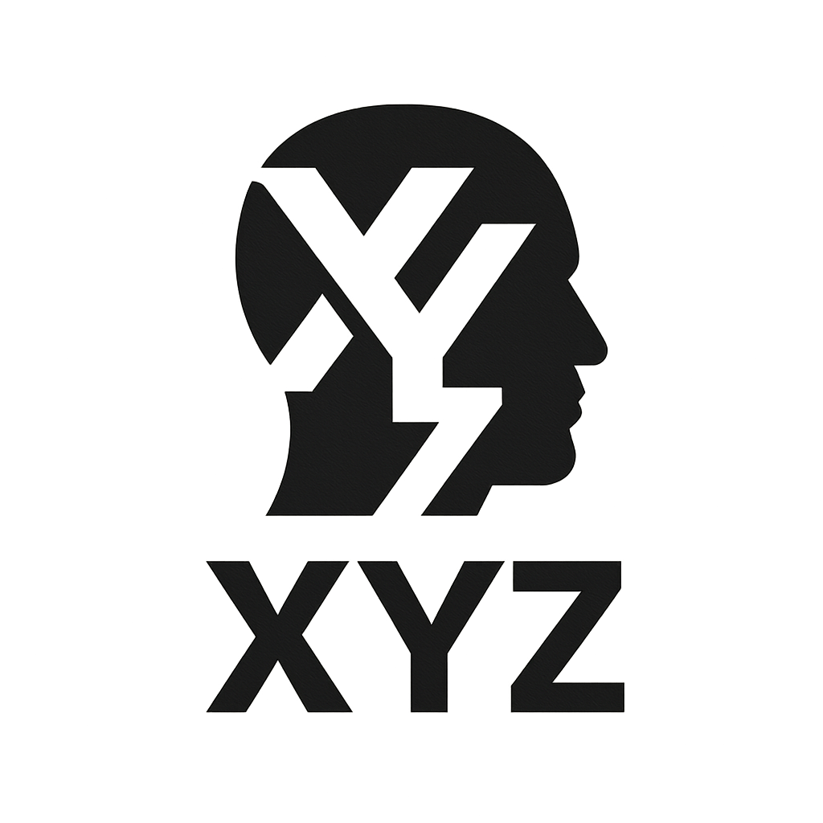

10 - 12 February 2026
BIBF
0
0
0

DELEGATE

