**Evaluation**

Your project will be evaluated by a Udacity reviewer according to the rubric below. Be sure to review it thoroughly before you submit. All criteria must "meet specifications" in order to pass.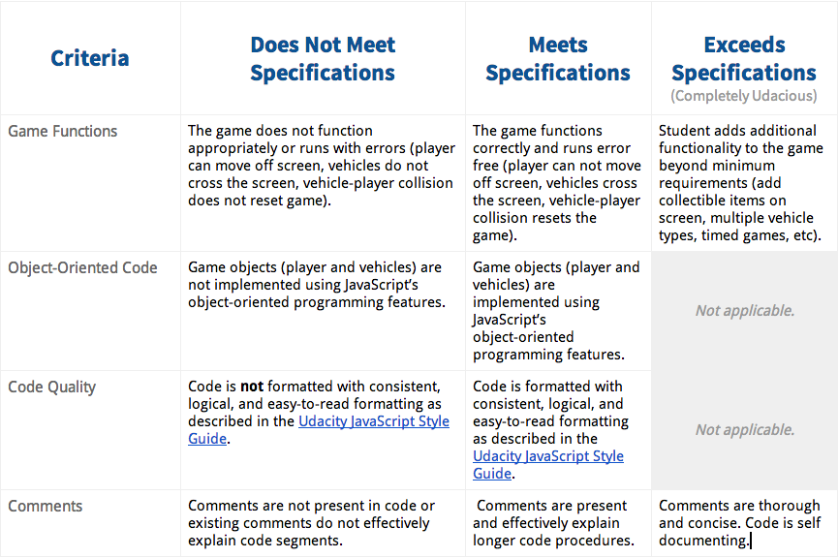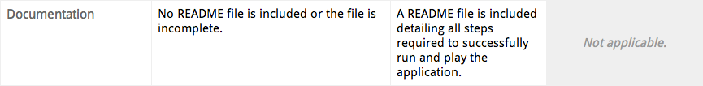

**Submission**

When you're ready to submit your project go back to your Nanodegree Portal, click on Project 3, and follow the instructions to submit.

* Start by creating a text file with a list of websites, books, forums, blog posts, Github repositories etc. that you referred to or used in this submission (Add N/A if you did not use such resources).
* By this point, you know how to work with Github so, please submit your code through "Link to Project" with a link to the appropriate Github repo, using a separate repository for this project.
* Please ignore the option to submit through "Upload a Zip".

It can take us up to 2 weeks to evaluate the project so keep checking back for updates.

If you are having any problems submitting your project or wish to check on the status of your submission, please email us at **frontend-project@udacity.com**.

**Next Steps**

Feel free to hop onto the forums to help your fellow students, or work on the next project while you wait to receive your evaluation.