Correlation of Object Detection Performance with Visual Saliency and Depth Estimation

Team: CAP-C6-Group 6
Team Members: Saranbabu, Hemanth, Bhamiesha and Anusha kankan

- Abstract

Accurate object detection remains a critical challenge in computer vision, particularly in complex scenes involving occlusion, scale variation, and small objects. Although modern deep learning models achieve high detection accuracy, understanding how complementary visual tasks contribute to detection performance remains an important research direction. Human visual perception relies on attention and spatial reasoning, motivating the exploration of auxiliary tasks such as visual saliency and depth estimation.

Previous research has explored multi-task learning approaches that combine object detection with saliency or depth estimation, but these studies mainly evaluate end-to-end performance rather than analysing the underlying relationships between tasks. Bartolo et al. (1) investigated correlations between object detection accuracy, visual saliency, and depth estimation using offline experiments and annotated datasets, showing stronger correlations between saliency and detection performance.

The VisualCue Framework extends that analysis by introducing a real-time, annotation-free framework integrating RT-DETR (3) for object detection, Score-CAM (4) for attention mapping, the Segment Anything Model (SAM) (2) for object segmentation, and Zoe Depth (5) for monocular depth estimation. Experiments conducted on the COCO 2017 unlabelled dataset evaluate spatial correlations between attention maps, segmentation masks, and depth representations. Results show stronger alignment between model attention and segmented object regions than with depth cues, supporting the effectiveness of the framework for practical computer vision applications.

2. Introduction

Object detection is a key component of modern computer vision systems used in autonomous driving, surveillance, robotics, and healthcare. Despite significant improvements in detection accuracy, real-world challenges such as occlusion, small objects, and varying lighting conditions make it difficult for models to consistently focus on the correct regions.

In real-time applications, high detection accuracy alone is not sufficient. Predictions must be based on meaningful visual information rather than background noise. Analysing the relationship between object detection, spatial attention, and scene structure provides deeper insight into model behaviour, supporting the development of more reliable computer vision solutions.

3. Literature Review:

This project is primarily inspired by the work of Bartolo et al. (2024) (1), which analyses the relationship between object detection performance, visual saliency, and depth estimation using offline experiments and annotated datasets. Their study provides valuable insights into how detection accuracy correlates with scene understanding, but it is limited to non–real-time analysis and depends on predefined saliency models and ground-truth annotations. Recent advances in object detection aim to overcome these limitations. RT-DETR, proposed by Zhao et al. (2024) (3), demonstrates that transformer-based detectors can achieve real-time performance while maintaining high accuracy, making them suitable for live inference scenarios. For model interpretability, Score-CAM (Wang et al., 2020) (4) offers a stable, gradient-free approach to generating attention maps, improving reliability over earlier saliency techniques. Object-level segmentation is enabled through the Segment Anything Model (SAM) introduced by Kirillov et al. (2023) (2), which allows accurate segmentation without manual annotations. Additionally, Zoe Depth (2023) (5) provides robust monocular depth estimation across diverse environments.

4. Materials and Method:

The VisualCue Framework shown in Figure 1 proposes a real-time, annotation-free pipeline that integrates object detection, attention mapping, segmentation, and depth estimation into a unified system. It is designed to operate end-to-end in near real-time, enabling analysis on unlabelled data and extending prior offline studies into a deployable and automated framework.

4.1 Dataset

The framework was evaluated on the COCO 2017 Unlabelled Dataset, a large-scale benchmark widely used in computer vision research. A subset of 100 images spanning 15 object categories was selected for analysis: Airplane, Bed, Elephant, Giraffe, Pizza, Person, Motorcycle, Parking Meter, Horse, Stop Sign, Zebra, Bear, Cake, Teddy Bear, and Hot Dog. These categories represent a diverse range of object shapes, sizes, and visual complexity. For full dataset details, refer to Appendix A.

Figure 1: VisualCue Framework - Pipeline Architecture
Base Paper
VisualCue Framework
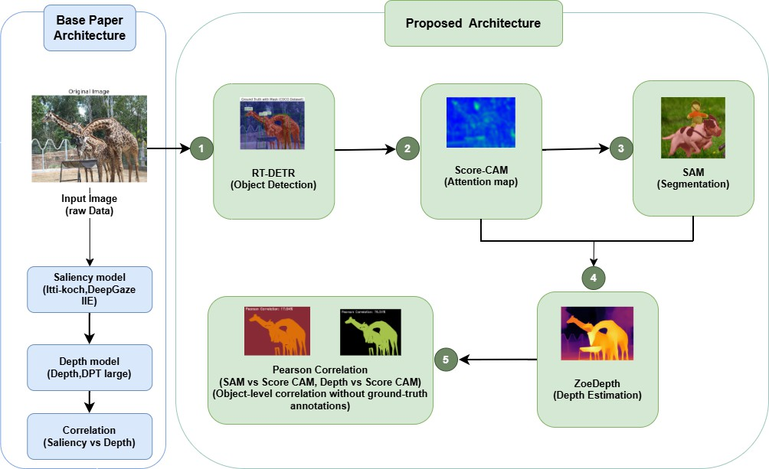
The pipeline consists of four components: (A) RT-DETR - Object Detection, (B) Score-CAM - Attention Mapping, (C) SAM - Segmentation, and (D) ZoeDepth - Depth Estimation, followed by Pearson Correlation Analysis.

Component A: RT-DETR (Object Detection) performs real-time object detection using RT-DETR. The input image is processed to generate bounding boxes and associated confidence scores. These bounding boxes serve as structural anchors for subsequent stages, ensuring object-level consistency throughout the pipeline.

Component B: Score-CAM (Attention Mapping) interpretability is incorporated by applying Score-CAM to the detection model. This produces attention maps that highlight spatial regions contributing most strongly to detection decisions. Unlike gradient-based saliency techniques, Score-CAM generates class-discriminative attention maps without modifying gradients, thereby improving stability and interpretability.

Component C: SAM (Segmentation) performs object-level segmentation using the Segment Anything Model (SAM). The bounding boxes generated by RT-DETR are used as prompts to guide SAM in producing precise segmentation masks. This eliminates the dependence on manually annotated masks, directly addressing a major limitation of the base study. As a result, the system can operate effectively on previously unseen or unlabelled datasets.

Component D: ZoeDepth (Depth Estimation) introduces spatial reasoning through depth estimation. Zoe Depth is applied to the same input image to produce a dense monocular depth map. Using the segmentation masks obtained from SAM, object-specific depth values are extracted from the depth representation. This integration enables the analysis of how spatial distance relates to model attention and detection confidence.

Component E: Pearson Correlation Analysis performs quantitative analysis by computing Pearson correlation coefficients to measure relationships between attention intensity, segmentation regions, detection confidence, and depth values. Pearson correlation was chosen for its interpretability and efficiency in measuring linear associations between spatial representations, maintaining continuity with the base paper while extending it into a real-time, automated framework suitable for practical deployment.

4.2 Experimental Setup

The Figure 2 shows sample outputs from the VisualCue Framework, including object detections, attention maps, segmentation masks, and depth maps for the same input image. The results demonstrate consistent alignment between model attention and object regions, confirming the effectiveness of the pipeline.

Figure 2: Representative Pipeline Results for a Sample Image

(a) RT-DETR Detection Output (First row left) - bounding boxes drawn around detected objects with confidence scores. (b) SAM Segmentation Mask (First row right) - white regions represent detected object areas; black regions are background. (c) Score-CAM Attention Map (Second row left) - a heatmap where warm colours (red/yellow) indicate regions the model focuses on most strongly, and cool colours (blue) indicate low attention. (d) ZoeDepth Depth Map (Second row right) - colours represent relative depth: colours like red and orange indicate regions closer to the camera, while colours like blue and purple indicate regions further away. The colour bar on the right shows the corresponding depth scale.

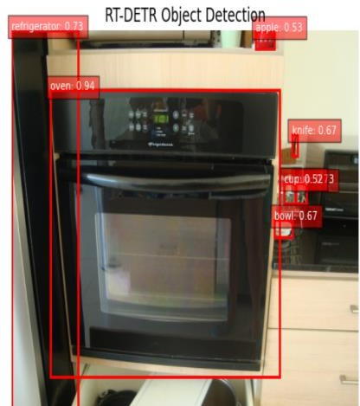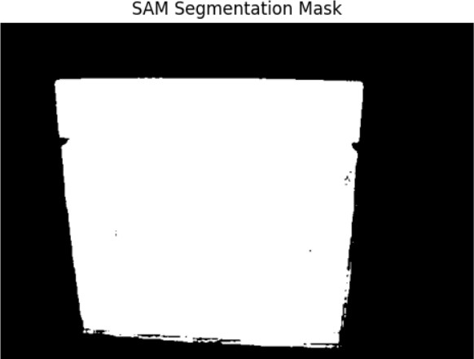
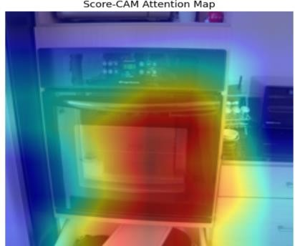
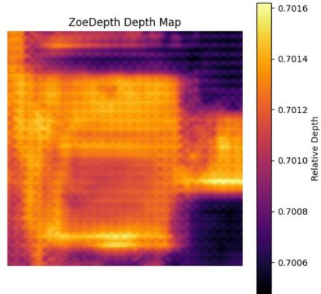

5. Results:
5.1 Graphical interface
The following screenshots in the Figure 3 illustrate the web-based graphical interface of the framework, demonstrating the end-to-end pipeline on sample inputs.
Figure 3: VisualCue Framework — Graphical User Interface
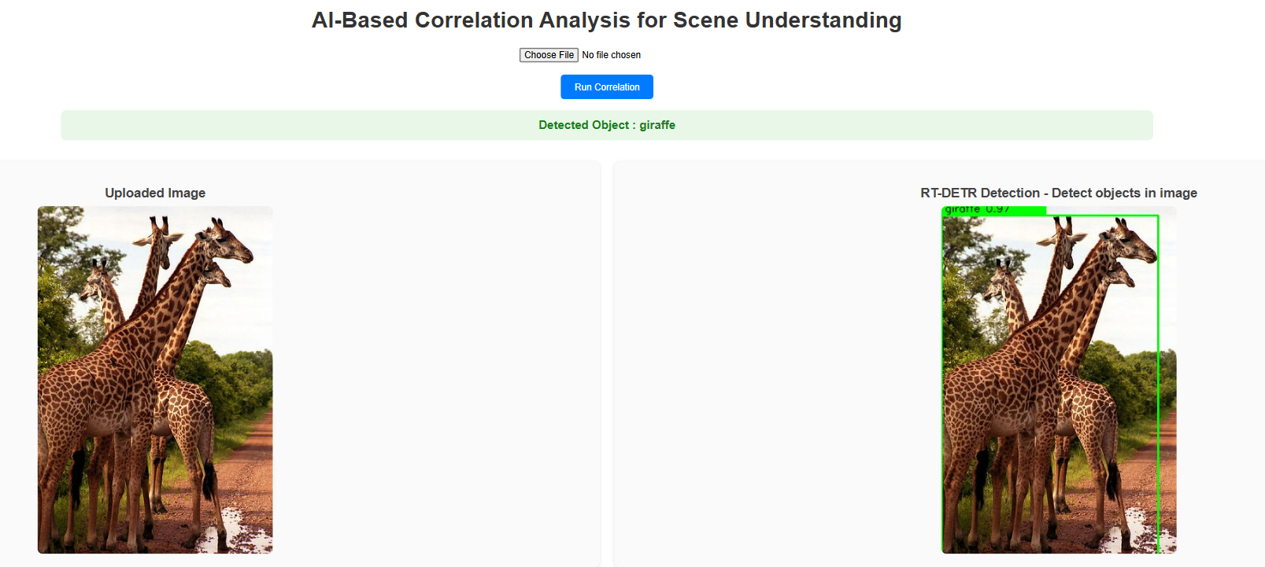
Figure 3a: Original Image (left) and RT-DETR Object Detection (Right) - The framework draws
green bounding boxes around all detected objects in the image, showing that the model has
successfully located it. The label at the top confirms the detected object class.

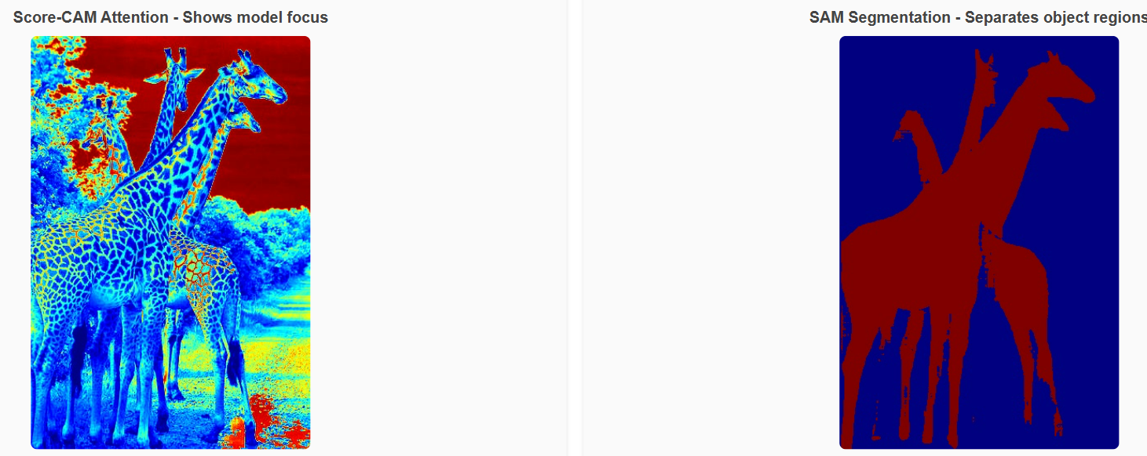
Figure 3b: Score-CAM attention map (left) and SAM segmentation mask (right), highlighting model focus regions and object boundaries
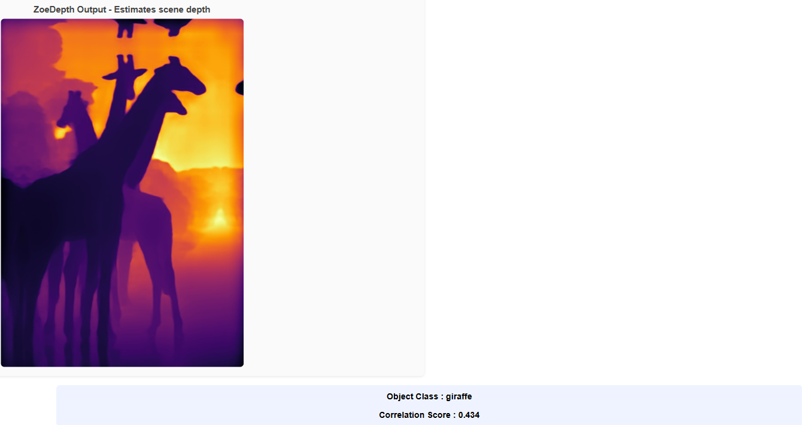
Figure 3c: This map estimates how far each part of the scene is from the camera.
The correlation score of 0.434 shown at the bottom indicates the degree of alignment between the model's attention and the depth distribution.

5.2 Evaluation Methodology

Compared to the base paper models, the VisualCue Framework achieves the highest Mean Pearson Correlation of 0.186 (SAM & Score-CAM), outperforming all baseline techniques including the best base model DeepGaze IIE (0.17). This indicates better alignment between model attention and object regions, meaning the model's focus is more consistent with the actual object areas in the image. The attention-depth correlation of 0.143 also shows stable spatial understanding within a real-time and annotation-free architecture. Overall, the results in the Table 1 highlight the novelty of the VisualCue Framework in transforming prior offline correlation analysis into a unified, automated, and deployable system while maintaining competitive analytical performance. The primary evaluation metric used was Pearson Correlation (ρ), which measures the linear relationship between two variables, indicating how strongly two spatial maps, such as an attention map and a segmentation mask, are related to each other. The formula is shown in Equation 1.
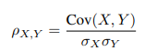
Equation 1: Pearson Correlation Coefficient

The value of ρ ranges from −1 to +1, where +1 indicates perfect positive correlation, 0 indicates no correlation, and −1 indicates perfect negative correlation. In this study, all reported values are positive, indicating a consistent alignment between the compared spatial maps.

Table 1: Comparison of Mean Pearson Correlation - Base Paper Models vs VisualCue Framework
A higher Mean Pearson Correlation value indicates stronger alignment. The best result is highlighted in bold.
Technique | Mean Pearson Correlation | Model Type
Depth Anything | 0.125 | Depth prediction
DPT-Large | 0.129 | Depth prediction
Itti-Koch Model | 0.13 | Saliency prediction
DeepGaze IIE | 0.17 | Saliency prediction
VisualCue Framework (ZoeDepth & Score CAM) | 0.143 | Attention-Depth
VisualCue Framework (SAM & Score CAM) | 0.186 | Attention-Segmentation

5.4 Category Metrics

The category-level analysis compares the Mean Pearson Correlation of the base paper models against the VisualCue Framework across 15 object categories shown in Table 2. It is important to note that the base paper used pre-annotated datasets with ground-truth labels to compute correlation results, whereas the VisualCue Framework operates entirely on unlabelled data, running the full pipeline automatically without any manual annotation. Despite this fundamental difference in approach, the VisualCue Framework achieves consistently higher correlation values across all 15 categories, demonstrating that annotation-free analysis can match and outperform traditional annotated methods.

Table 2: Category-Level Pearson Correlation - Base Model vs. VisualCue Framework
A higher value indicates stronger alignment between model attention and object regions. The VisualCue Framework column reflects annotation-free results.

Category Level Metrics
Category Name | Base Model | VisualCue Framework | No. of Images
Airplane | 0.326 | 0.388 | 100
Bed | 0.259 | 0.287 | 100
Elephant | 0.301 | 0.373 | 100
Giraffe | 0.326 | 0.425 | 120
Pizza | 0.228 | 0.303 | 100
Person | 0.241 | 0.32 | 100
Motorcycle | 0.254 | 0.312 | 100
parking meter | 0.304 | 0.355 | 97
Horse | 0.291 | 0.345 | 658
stop sign | 0.288 | 0.335 | 546
Zebra | 0.28 | 0.347 | 731
Bear | 0.279 | 0.345 | 776
Cake | 0.256 | 0.312 | 167
teddy bear | 0.243 | 0.292 | 434
hot dog | 0.243 | 0.297 | 110

6. Implementation and User Benefit:

The primary outcome of this project is a quantitative evaluation of object detection performance using appropriate analytical metrics. The focus is on systematically analysing the relationships between detection confidence, attention mechanisms, and depth information, rather than developing a fully user-facing application at this stage. While the findings provide insights applicable to real-time or practical deployment scenarios, any direct end-user benefits remain exploratory and will require further validation.

7. Limitations and Further Improvements:

This framework establishes a real-time, annotation-free pipeline for analysing the relationship between detection, attention, and depth. While the current evaluation has been conducted on a focused dataset to validate feasibility and performance, broader experimentation across diverse scenarios will further enhance robustness and generalisability. The use of linear correlation metrics provides clear and interpretable insights, and future work may extend this analysis to explore more advanced modelling approaches and large-scale deployment settings.

8. Bibliography and References:

(1) Bartolo et al., 2024 - Correlation of Object Detection Performance with Visual Saliency and
Depth Estimation. arXiv: https://arxiv.org/abs/2411.02844

(2) Kirillov et al., 2023 - Segment Anything (SAM). arXiv: https://arxiv.org/abs/2304.02643

(3) Zhao et al., 2024 -DETRs Beat YOLOs on Real-Time Object Detection.
arXiv: https://arxiv.org/abs/2304.08069

(4) H. Wang et al., “Score-CAM: Score-Weighted Visual Explanations for Convolutional Neural
Networks,” arXiv:1910.01279 [cs], Apr. 2020
arXiv: https://arxiv.org/abs/1910.01279

(5) S. F. Bhat, R. Birkl, D. Wofk, P. Wonka, and M. Müller, “Zoe Depth: Zero-shot Transfer by
Combining Relative and Metric Depth,” arXiv.org, Feb. 23, 2023.
arXiv: https://arxiv.org/abs/2302.12288

9. Individual Progress:
 | Task | Sub-task | Owner | Jira Board Ticket / Link
 | Task 1: Dataset Preparation &  Preprocessing | Collect COCO Unlabeled-2017 dataset | Hemanth | https://app.clickup.com/t/86d18xuvv
 |  | Preprocess images (resize, normalize, organize folder  structure) | Hemanth | https://app.clickup.com/t/86d18xv7n
Task 2: Object De-tection Module |  | Implement RT-  DETR for real-time object detection | Hemanth | https://app.clickup.com/t/86d18xvf1
 |  | Export bounding boxes for SAM Prompting | Bhamiesha | https://app.clickup.com/t/86d18xvn7
Task 3: Segmentation Module |  | Integrate SAM to generate object masks using RT-DETR outputs | Bhamiesha | https://app.clickup.com/t/86d18xvrf
Task 4: Attention Map Module |  | Implement Score-CAM to compute model attention regions | Saran | https://app.clickup.com/t/86d18xvuw
Task 5: Depth Es-timation Module |  | Integrate Zoe Depth for per-object depth  Prediction | Saran | https://app.clickup.com/t/86d18xvwh
Task 6: Correlation Analysis Module |  | Compute correlation between Score-CAM vs SAM, and Score-CAM vs Depth maps | Anusha | https://app.clickup.com/t/86d18xvxk
Task 7: System In-tegration |  | Combine all modules into a unified pipeline | Anusha & Saran | https://app.clickup.com/t/86d18xw39
Task 8: Final Re-porting & Evaluation |  | Prepare documentation, results, graphs, and final report | All team members | https://app.clickup.com/t/86d18xwj5

9.1 Parallel Work & Dependency Notes
Task 1 must be completed before Tasks 2–5 start.
Task 2 (RT-DETR) runs in parallel with Task 4 (Score-CAM) since both use the same input image.
Task 2 output (bounding boxes) is required for Task 3 (SAM segmentation).
Task 3 & Task 5 output maps that feed into Task 6 (Correlation Analysis).
Task 7 depends on completion of Tasks 2–6.
Task 8 is done after full system integration.

- Appendix A:
- Hardware configurations
GPU: NVIDIA RTX 3060 / 4060 / 4070 (recommended) - Required for RT-DETR, SAM, and Zoe Depth fast inference
CPU: Intel i5 / i7
RAM: Minimum 16 GB (32 GB recommended for large batches)
Storage: 50–80 GB for dataset + model outputs

- Platform/tools used
Programming Language: Python 3.8+
Deep Learning Frameworks: PyTorch (for RT-DETR, SAM, ZoeDepth, Score-CAM) & Torch vision
Libraries: NumPy, OpenCV, Matplotlib, Scipy (for Pearson correlation) & Pandas
Models Used: RT-DETR (real-time object detection), SAM (object segmentation), Score-CAM (attention heatmaps) & Zoe Depth (depth estimation)

- Data description The COCO 2017 Unlabelled Dataset was used to evaluate the framework in an annotation-free setting. A subset of 100 representative images was selected across 15 object categories like Airplane, Bed, Elephant, Giraffe, Pizza, Person, Motorcycle, Parking Meter, Horse, Stop Sign, Zebra, Bear, Cake, Teddy Bear, and Hot Dog to cover diverse object categories and scene complexity while maintaining computational feasibility. These images were used to analyse the correlation between detection attention, segmentation masks, and depth representations within the integrated pipeline.
Dataset Link: https://www.kaggle.com/datasets/awsaf49/coco-2017-dataset

- Model Architecture and hyper-parameters
The framework integrates multiple computer vision models into a unified pipeline to analyse the relationship between object detection, visual attention, segmentation, and depth estimation. RT-DETR performs real-time object detection and generates bounding boxes that act as spatial anchors for subsequent stages. Score-CAM produces attention maps highlighting image regions influencing detection decisions. These bounding boxes are used as prompts for the Segment Anything Model (SAM) to generate object-level segmentation masks. Zoe Depth then estimates monocular depth maps from the input image, allowing depth values to be extracted for segmented objects. Pearson correlation is applied to measure alignment between attention maps, segmentation masks, and depth representations.
Key hyper-parameters include detection confidence threshold, object query size, Score-CAM target layer, SAM bounding box prompts, and depth inference resolution.

- Training procedure
The framework operates using pretrained deep learning models and does not require end-to-end training. RT-DETR is used as a pretrained object detection model to generate bounding boxes and confidence scores from input images. Score-CAM is applied as a post-hoc interpretability technique to produce attention maps without additional training. SAM generates object segmentation masks using bounding box prompts from RT-DETR, enabling annotation-free segmentation. Zoe Depth produces dense depth maps from single RGB images using pretrained weights. After generating these spatial representations, Pearson correlation is computed to analyse relationships between attention maps, segmentation masks, and depth values. Experiments are conducted on 100 representative images from the COCO 2017 dataset in an end-to-end inference pipeline.

- Code Repository and Model Weights
The complete implementation of the VisualCue Framework is available on GitHub:
GitHub Repository: https://github.com/saransvijay/Project_UOA

Due to GitHub’s file size limitation of 100 MB per file, the pretrained model weights (e.g., SAM ViT-B with size ~375 MB) could not be uploaded directly to the repository. To address this, the model weights are accessed from the official source:
https://dl.fbaipublicfiles.com/segment_anything/sam_vit_b_01ec64.pth
Download the weights manually and place them in the appropriate weights/ directory before running the application. This approach ensures that the repository remains lightweight while maintaining full reproducibility of the framework.

- Evaluation metrics
Correlation Result:
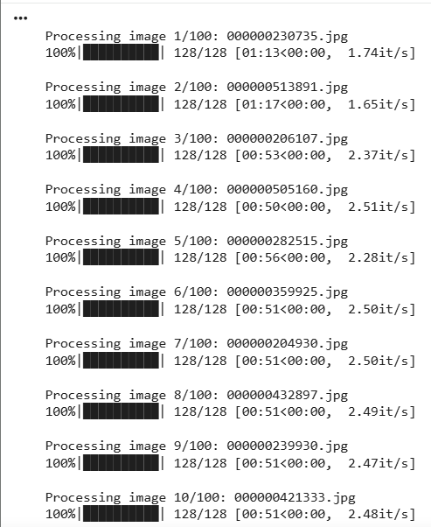
…..
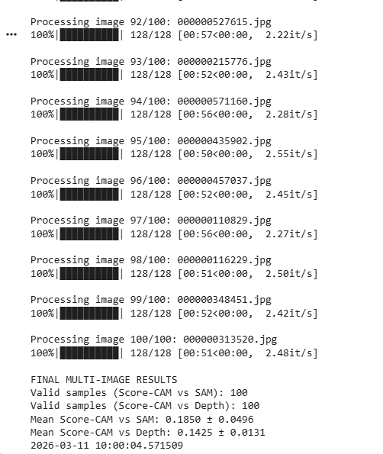

Category Level Result:
