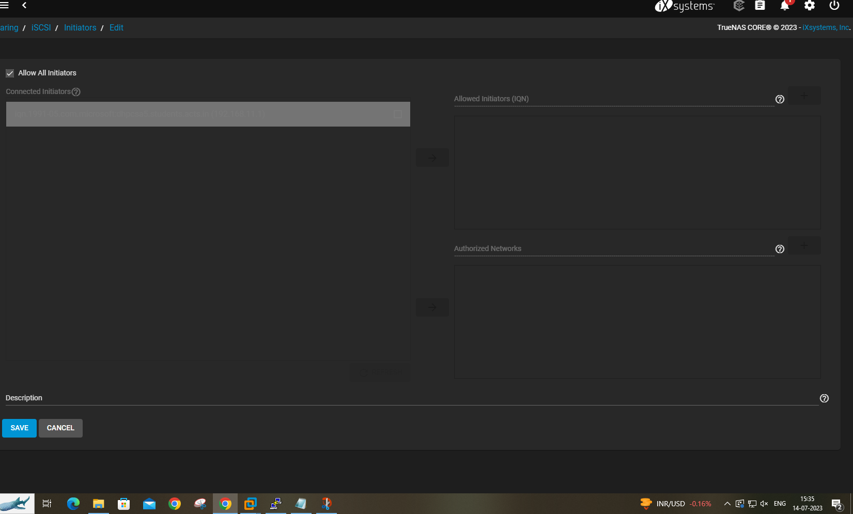

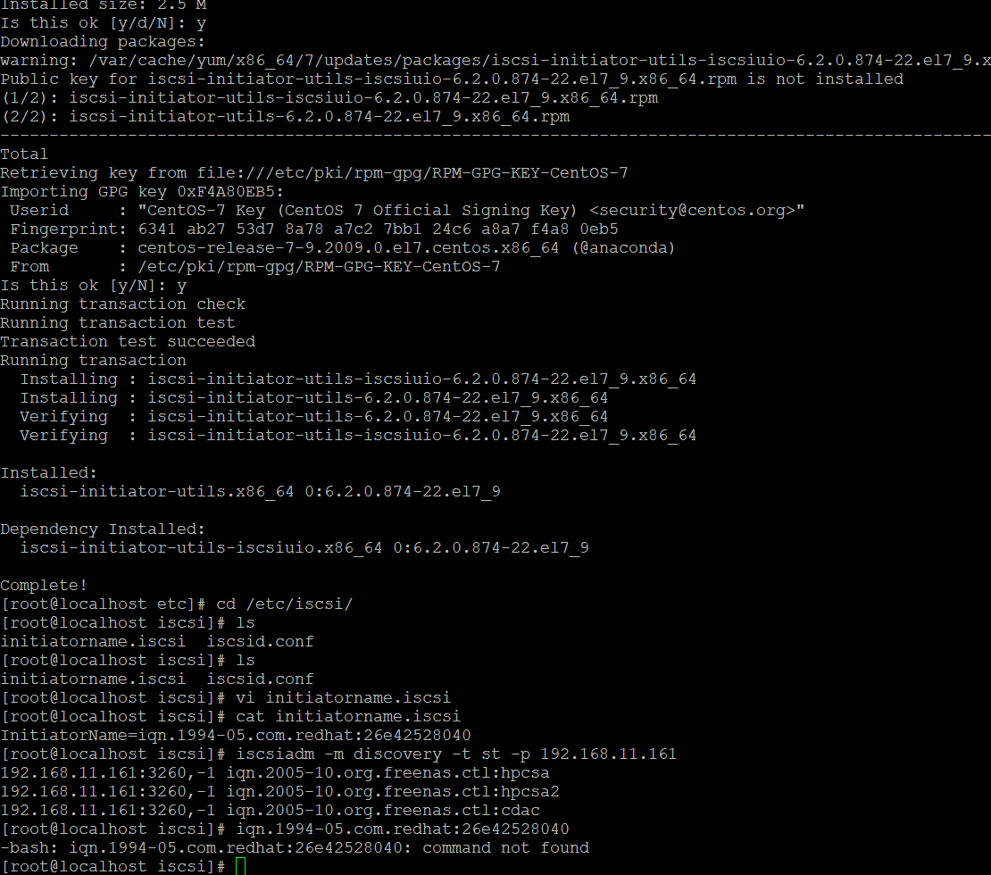

Copy the cat initiatorname output and paste in allowed initiator

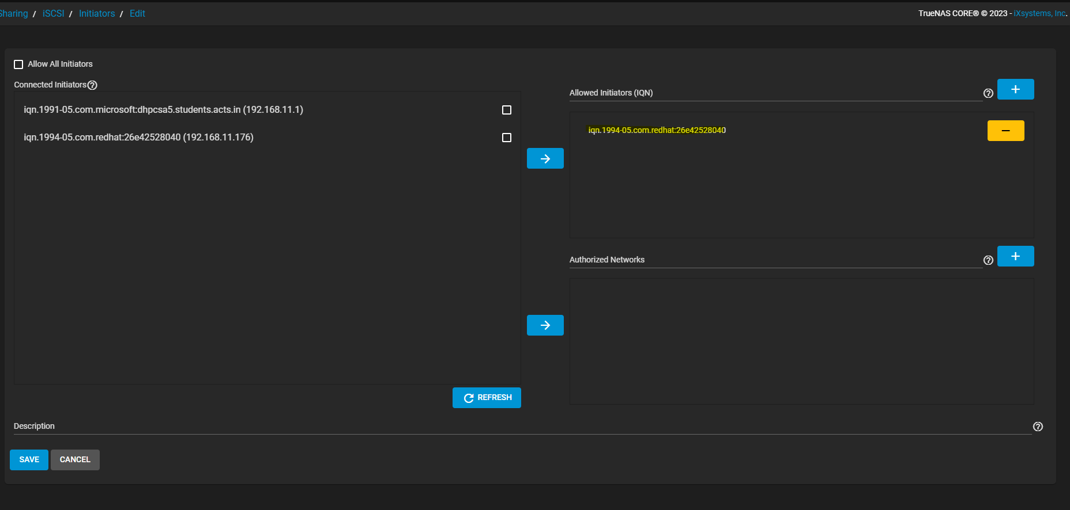

For windows

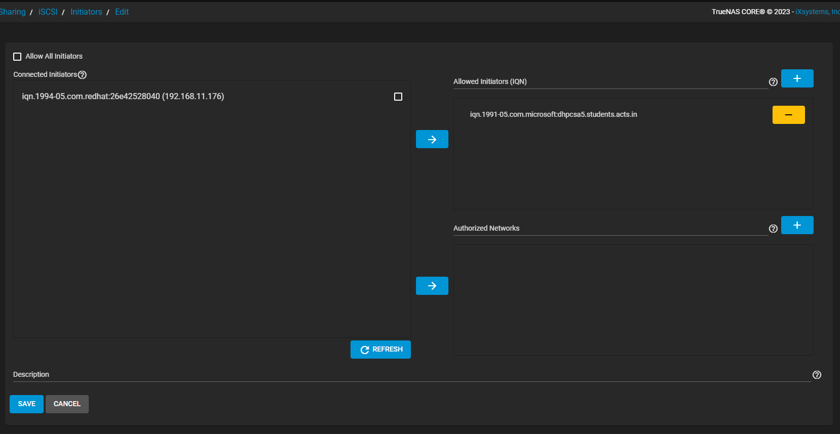

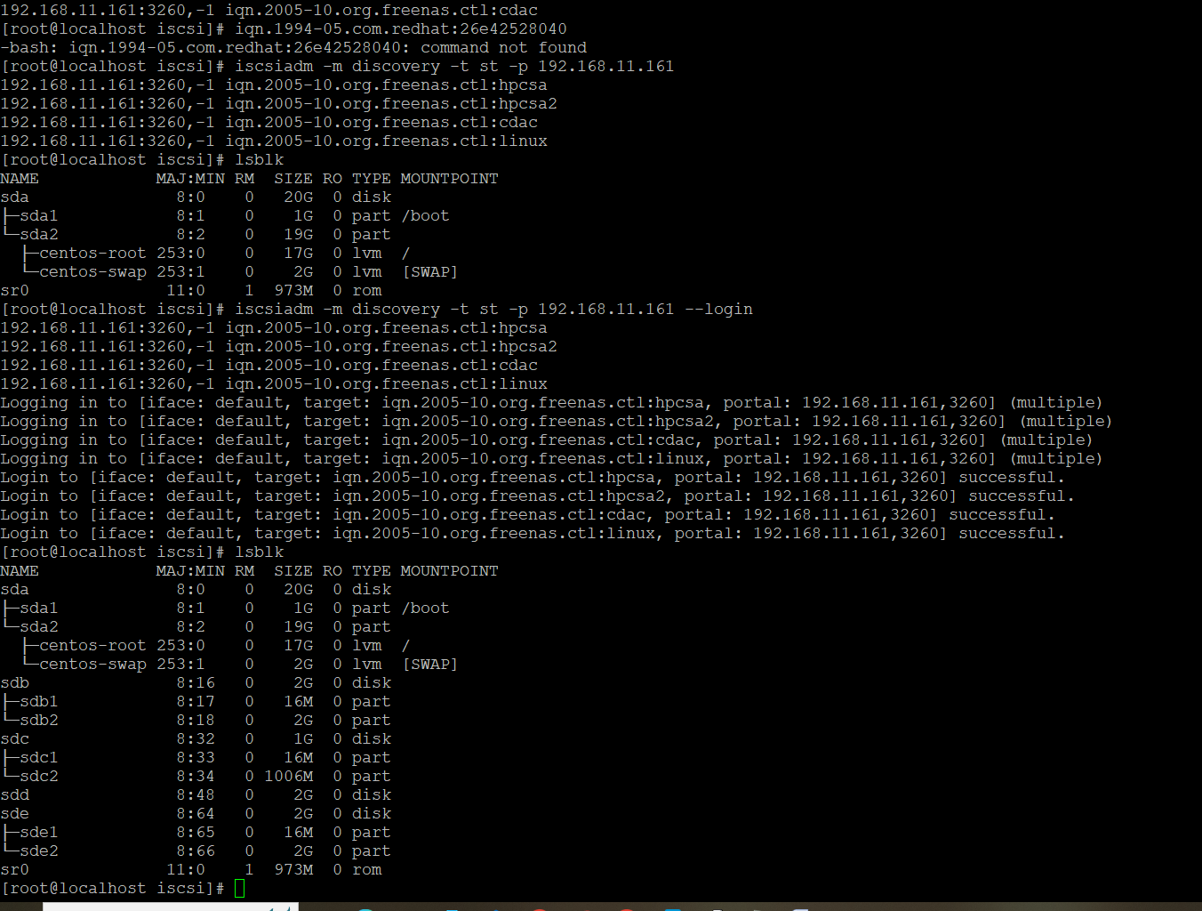

+++++++++++++++++++++++++++++++++++++++++++++++++++++++++++++++++++++++++++++++++++++++++++++++++++++++++++++++++++++++++++++++++++++++++++++++++++++++++++++++++++++

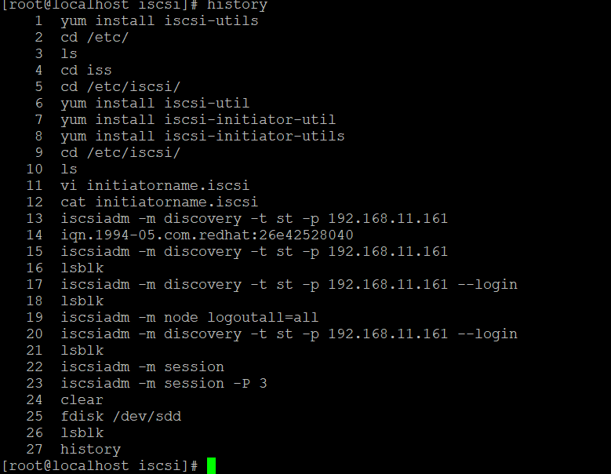

yum install iscsi-utils

2 cd /etc/

3 ls

4 cd iss

5 cd /etc/iscsi/

6 yum install iscsi-util

7 yum install iscsi-initiator-util

8 yum install iscsi-initiator-utils

9 cd /etc/iscsi/

10 ls

11 vi initiatorname.iscsi

12 cat initiatorname.iscsi

13 iscsiadm -m discovery -t st -p 192.168.11.161

14 iqn.1994-05.com.redhat:26e42528040

15 iscsiadm -m discovery -t st -p 192.168.11.161

16 lsblk

17 iscsiadm -m discovery -t st -p 192.168.11.161 --login

18 lsblk

19 iscsiadm -m node logoutall=all

20 iscsiadm -m discovery -t st -p 192.168.11.161 --login

21 lsblk

22 iscsiadm -m session

23 iscsiadm -m session -P 3

24 clear

25 fdisk /dev/sdd

26 lsblk