LOGISTICS DATA ANALYST INTERNSHIP
Week 4 – Predictive Modeling and Optimization in Logistics Systems
Delivery Delay Prediction using Random Forest Regression

Dataset: SCMS Delivery History | 10,324 shipment records
Prepared as a reproducible analytical project

1. Executive Summary
This Week 4 project extends the earlier logistics exploratory analysis into predictive modeling and operational decision support. The objective was to estimate delivery delay in days using shipment, commercial, vendor, country, transport-mode and fulfillment characteristics. The target variable was Delivery Delay Days. A Random Forest Regressor was trained using an 80/20 train-test split, with 8,259 records used for training and 2,065 for testing.
The model achieved a Mean Absolute Error (MAE) of 10.90 days, a Root Mean Squared Error (RMSE) of 24.29 days and an R² of 0.279 on the held-out test set. A simple mean-prediction baseline produced an MAE of 14.51 days and RMSE of 28.60 days, so the Random Forest captured useful predictive signal beyond the baseline. At the same time, the R² indicates that a substantial proportion of variation in delivery delay remains unexplained. The model should therefore be used as a risk-support tool rather than as an exact delivery-date predictor.
Feature-importance analysis showed that the encoded Shipment Mode_Air, Pack Price, Line Item Quantity, a vendor category, Freight Cost, Line Item Insurance, Line Item Value, Unit Price and Weight were among the features most heavily used by the fitted Random Forest. A shipment-mode scenario analysis was also prepared using predictions from the test set. These results can support prioritization, exception review, capacity planning and route/mode discussions, while final operational decisions should also consider service requirements, availability, geography and commercial constraints.

2. Project KPIs
Metric | Result
Total records | 10,324
Training records | 8,259
Testing records | 2,065
Model | Random Forest Regressor
MAE | 10.90 days
RMSE | 24.29 days
R² | 0.279
Baseline MAE | 14.51 days
Baseline RMSE | 28.60 days

3. Business Objective
The business objective was to move from descriptive logistics reporting toward a predictive workflow that can flag shipments with potentially higher delivery-delay risk. The analysis focuses on delivery delay as a continuous target because the historical dataset contains both early/negative delays and positive delays.
- Predict Delivery Delay Days for unseen shipment records.
- Evaluate predictive accuracy using MAE, RMSE and R².
- Compare the model against a simple mean-prediction baseline.
- Identify the variables most used by the model.
- Translate predictions into shipment-mode risk and operational planning considerations.

4. Data Preparation and Modeling Methodology
The cleaned SCMS Delivery History dataset from the previous internship stages was used. Records without a value for Delivery Delay Days were excluded from modeling. The target was kept separate from the input features. The model used numerical shipment/commercial variables and categorical logistics variables.
Numerical features:
- Line Item Quantity
- Line Item Value
- Pack Price
- Unit Price
- Weight (Kilograms)
- Freight Cost (USD)
- Line Item Insurance (USD)
Categorical features:
- Country, Shipment Mode, Product Group and Sub Classification
- Vendor, Manufacturing Site, First Line Designation and Managed By
- Fulfill Via and Vendor INCO Term
Missing numerical values were imputed using the median, while missing categorical values were imputed using the most frequent category. Categorical variables were one-hot encoded with unknown categories ignored at prediction time. The preprocessing and model were combined in a scikit-learn Pipeline and ColumnTransformer to keep the transformation workflow reproducible.

5. Model Selection
Random Forest Regression was selected because the logistics dataset contains a mixture of numerical and categorical variables and may contain nonlinear relationships and interactions. A tree-ensemble model can capture such patterns without requiring a linear relationship between every predictor and delivery delay. The model was configured with 200 trees, maximum depth 15, minimum leaf size 3, a fixed random state of 42, and parallel processing.
The selection was also checked against a simple baseline that predicts the mean delay for every test record. This baseline provides a transparent reference point rather than assuming that any trained model is automatically useful.

6. Model Evaluation
Evaluation Metric | Random Forest
Mean Absolute Error | 10.90 days
Root Mean Squared Error | 24.29 days
R-Squared | 0.279

The Random Forest achieved an MAE of 10.90 days. In practical terms, the absolute prediction error was about 10.9 days on average across the held-out test observations. The RMSE of 24.29 days is higher than the MAE because RMSE gives greater weight to larger errors. The R² of 0.279 indicates that the model explains some, but not most, of the variation in the target on the test set.
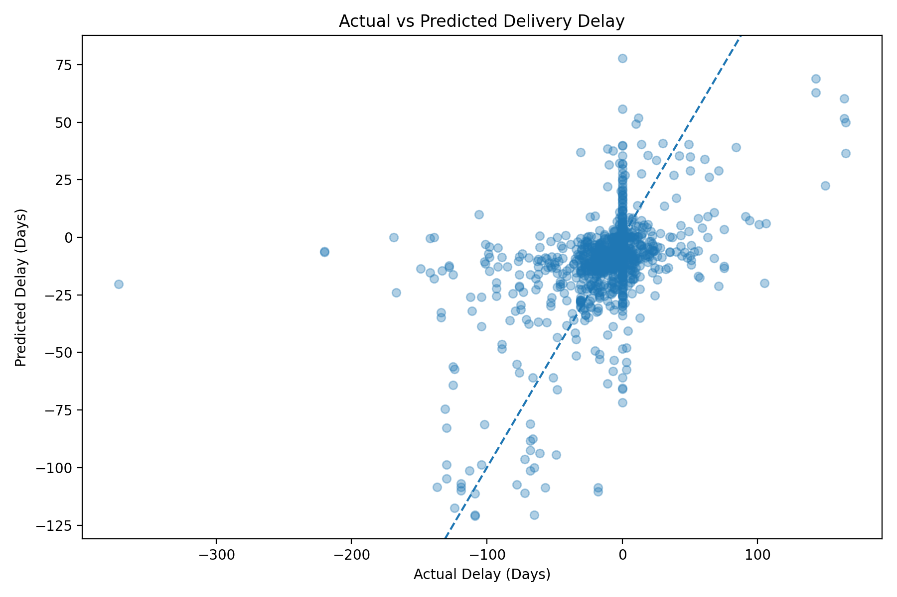
Figure 1. Actual versus predicted delivery delay on the test set.

7. Baseline Comparison
Model | MAE (Days) | RMSE (Days) | R²
Baseline (Mean Prediction) | 14.51 | 28.60 | 0.000
Random Forest | 10.90 | 24.29 | 0.279

Compared with the mean-prediction baseline, the Random Forest reduced MAE from 14.51 to 10.90 days and RMSE from 28.60 to 24.29 days. This indicates that the selected input variables contain predictive information that improves on a constant average-delay estimate.
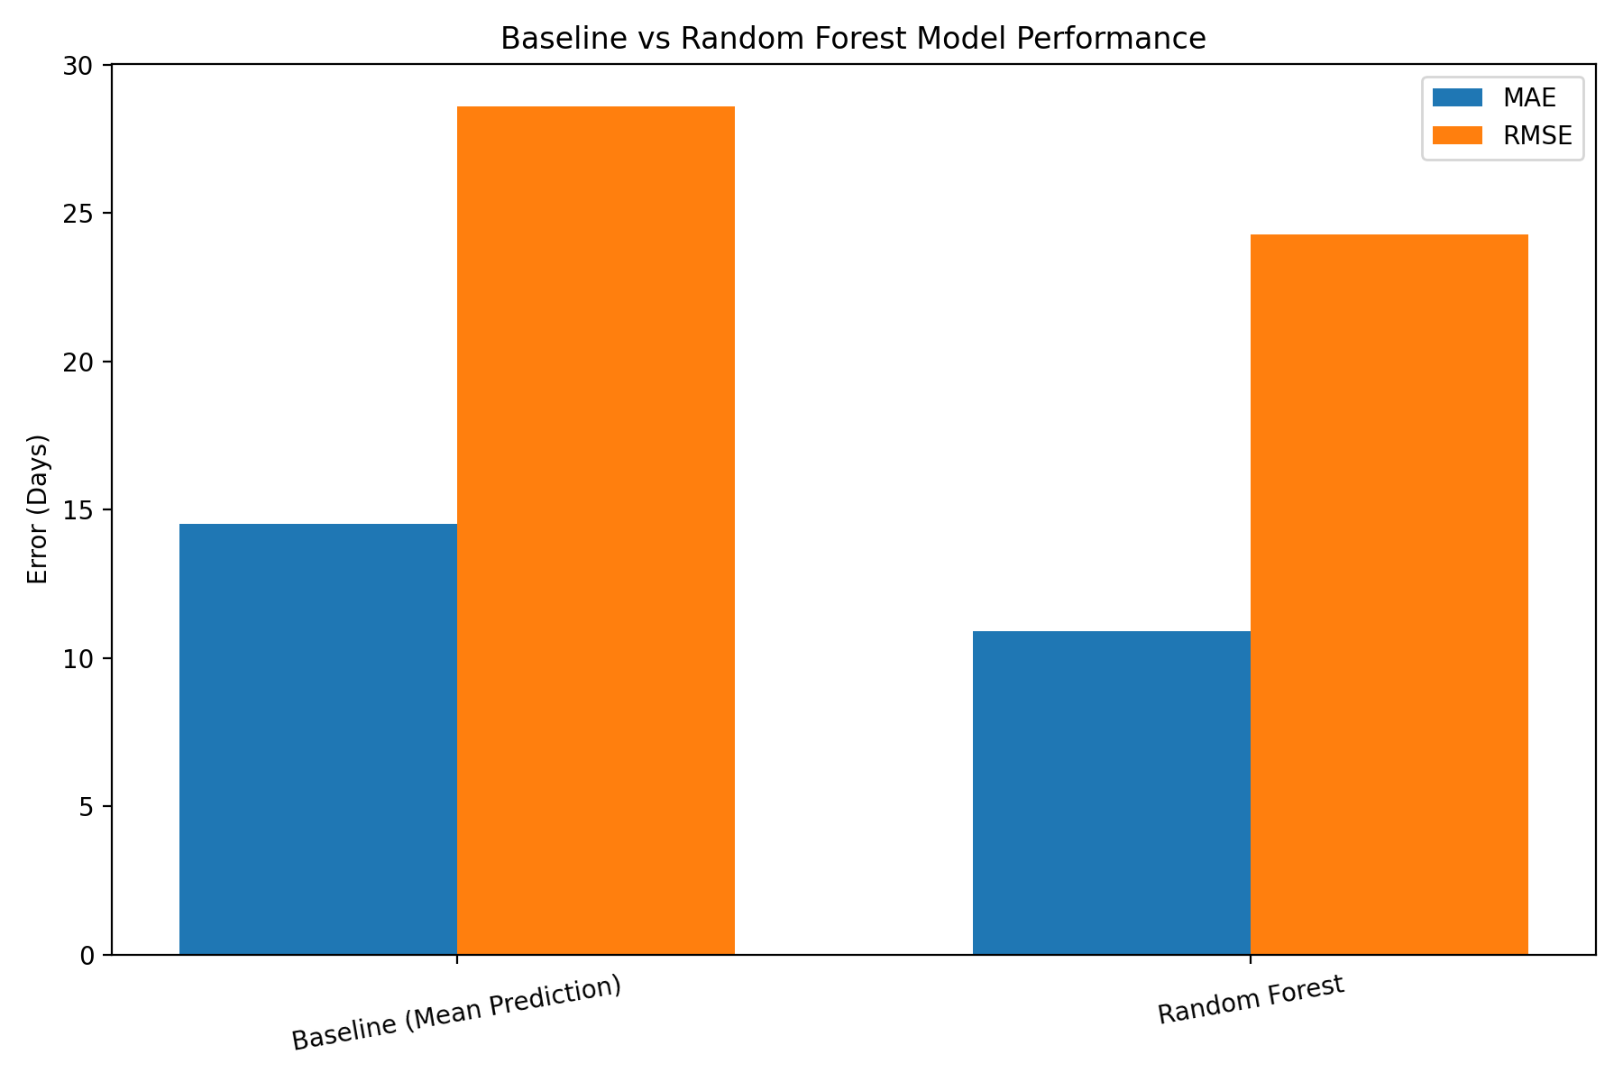
Figure 2. Comparison of baseline and Random Forest prediction errors.

8. Prediction Error Analysis
The actual-versus-predicted scatter plot shows a broad spread around the ideal 45-degree relationship, which is consistent with the model's moderate R². The residual distribution is concentrated near zero but has long tails, showing that some shipments have substantially larger prediction errors. These extreme observations should be treated as exceptions for investigation rather than ignored.
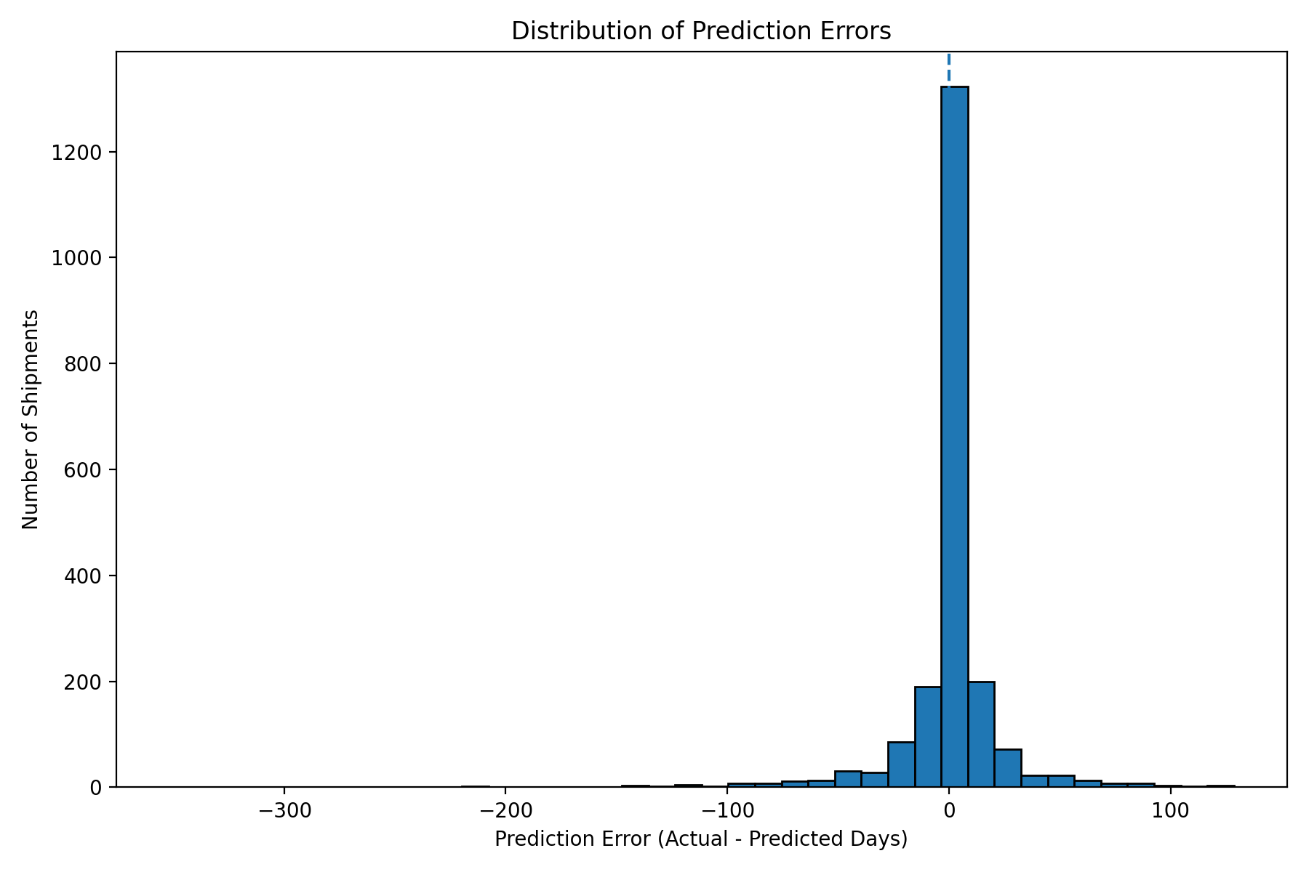
Figure 3. Distribution of prediction errors.

9. Feature Importance
Random Forest feature importance was calculated after preprocessing. Because categorical variables were one-hot encoded, individual category levels appear as separate features. Importance values represent how much the fitted forest used each transformed feature for reducing impurity; they should not be interpreted as causal effects.
Transformed Feature | Importance
categorical__Shipment Mode_Air | 0.1554
numeric__Pack Price | 0.1077
numeric__Line Item Quantity | 0.1033
categorical__Vendor_S. BUYS WHOLESALER | 0.0816
numeric__Freight Cost (USD) | 0.0734
numeric__Line Item Insurance (USD) | 0.0706
numeric__Line Item Value | 0.0630
numeric__Unit Price | 0.0558
numeric__Weight (Kilograms) | 0.0443
categorical__Country_Congo, DRC | 0.0294

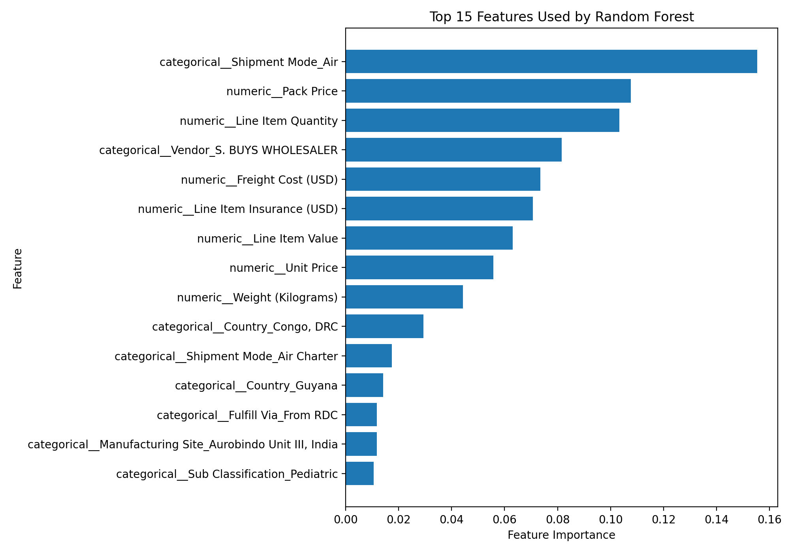
Figure 4. Top 15 transformed features by Random Forest importance.
The largest individual transformed feature was Shipment Mode_Air (0.1554), followed by Pack Price (0.1077), Line Item Quantity (0.1033), the vendor category S. BUYS WHOLESALER (0.0816), Freight Cost (0.0734) and Line Item Insurance (0.0706). Country_Congo, DRC also appeared among the top ten transformed features (0.0294). These findings indicate which variables the model relied on most within this dataset; they do not establish that changing a feature would independently change delivery performance.

10. Shipment Mode Optimization Analysis
To connect prediction with operational planning, the test-set predictions were grouped by Shipment Mode. The table compares actual historical delay, model-predicted delay and average freight cost within the held-out test observations. This is a scenario-review framework, not a causal experiment.
Shipment Mode | Test Shipments | Avg Actual Delay | Avg Predicted Delay | Avg Freight Cost
Ocean | 80 | 9.45 | 6.24 | $11,755.82
Air | 1210 | -3.42 | -3.78 | $10,845.89
Unknown | 72 | -1.21 | -8.86 | $6,417.93
Truck | 577 | -10.88 | -9.31 | $9,152.15
Air Charter | 126 | -22.02 | -18.20 | $23,815.63

In the test set, Ocean had an average predicted delay of 6.24 days, while Air, Unknown, Truck and Air Charter had average predicted delays of -3.78, -8.86, -9.31 and -18.20 days respectively. These values must be interpreted alongside the corresponding freight costs and the number of observations. In particular, the Unknown category represents missing or unspecified mode information and should not be treated as a genuine transport option.

11. Business Recommendations
- Use the model as a shipment-risk screening tool to prioritize manual review of potentially problematic orders.
- Review high-risk shipments using country, transport mode, vendor and commercial characteristics before dispatch.
- Use freight cost and shipment characteristics together when discussing mode selection; cost minimization should not be evaluated independently of service requirements.
- Improve data completeness for shipment mode, dates, weight, freight cost and other operational fields to strengthen future models.
- Investigate extreme prediction errors as exception cases, because they may represent unusual operational conditions or data-quality issues.
- Retrain and monitor the model periodically when newer shipment data become available, checking whether model accuracy changes over time.
- For future route optimization, combine predictive delay risk with route distance, capacity, lead time, service-level requirements and actual transport availability.

12. Limitations and Responsible Interpretation
- The model has an R² of 0.279, so a large share of delay variation is not captured by the current feature set.
- MAE of 10.90 days means predictions can still be materially different from actual delivery delays.
- Feature importance shows model reliance, not causation.
- The model uses a random train-test split; a time-based validation design would be preferable for deployment on future shipments.
- Some predictors, such as freight and commercial fields, may have different availability times in a real operational workflow. Their use should be aligned with the point at which a prediction is actually made.
- Historical shipment-mode comparisons are observational and should not be interpreted as controlled tests of transport-mode effectiveness.
- The Unknown shipment-mode category reflects incomplete information rather than a logistics strategy.

13. Conclusion
The Week 4 project demonstrates an end-to-end predictive analytics workflow for logistics delivery delay. A Random Forest regression pipeline was trained, evaluated on unseen test data, compared with a baseline, examined through feature importance and connected to an operational shipment-mode analysis. The model improved over the simple mean baseline but still leaves significant unexplained variation. The appropriate business use is therefore targeted risk screening and decision support rather than exact delivery-date prediction. Future improvements should focus on richer pre-dispatch features, time-aware validation, stronger data quality and additional modeling approaches.

14. Reproducibility and Project Outputs
- scripts/week4_predictive_model.py
- scripts/week4_model_comparison.py
- scripts/week4_visualizations.py
- scripts/week4_feature_importance.py
- scripts/week4_optimization_analysis.py
- week4_outputs/model_evaluation.csv
- week4_outputs/model_summary.csv
- week4_outputs/model_comparison.csv
- week4_outputs/predictions.csv
- week4_outputs/feature_importance.csv
- week4_outputs/shipment_mode_optimization.csv
All metrics and tables in this report are based on the Week 4 outputs generated from the cleaned SCMS Delivery History dataset. The workflow is designed to be reproducible from the project repository.

