LOGISTICS DATA ANALYSIS
Week 3 — Advanced Data Analysis & Visualization
SCMS Delivery History Dataset

Analysis Findings, Visualizations & Business Insights

1. Executive Summary
The Week 3 analysis examines shipment volume, delivery performance, shipment modes, freight costs, country-level activity, shipment weight, and year-wise shipment trends. The Python workflow performs exploratory data analysis (EDA), segmented analysis, correlation analysis, freight-cost outlier analysis, and visualization generation.
The strongest operational signal visible in the results is a high proportion of on-time deliveries, while freight cost varies substantially by shipment mode and contains extreme observations. The results therefore point to two parallel areas for management attention: maintaining delivery reliability and investigating transportation cost efficiency.

2. Key Performance Indicators
Metric | Result | Interpretation
Total shipments | 10,324 | Dataset supports segmented logistics analysis.
On-time shipments | 9,138 | Most recorded shipments met the delivery-status criterion.
Delayed shipments | 1,186 | A meaningful minority experienced delay.
On-time delivery rate | 88.51% | Overall delivery reliability is relatively high.
Average delivery delay | -6.02 days | Average actual delivery was recorded before scheduled delivery.
Total line item value | $1,627,584,457.29 | Large total value represented in the dataset.
Average freight cost | $11,103.23 | Average recorded freight cost per shipment.
Average cost per unit | $21.91 | Average calculated cost per unit.

3. Delivery Performance

3.1 On-time vs. Delayed Shipments
The on-time delivery chart shows 9,138 shipments marked 'Yes' and 1,186 marked 'No', corresponding to an overall on-time delivery rate of 88.51%. Most shipments therefore met the delivery-status criterion, but more than one thousand records represent delayed shipments and warrant root-cause analysis.
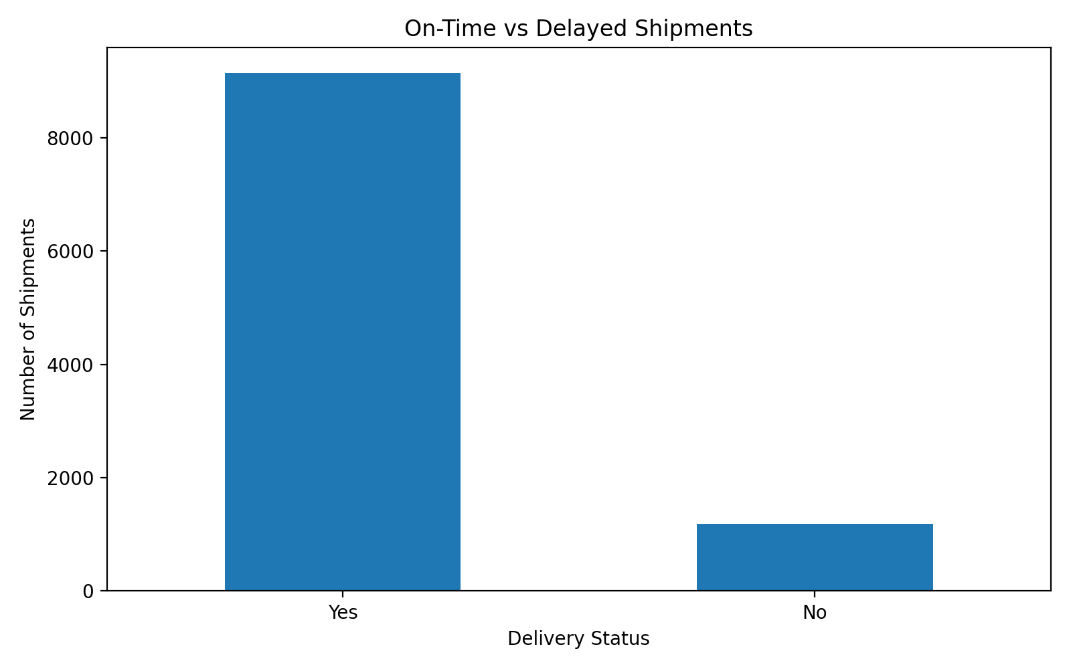
Figure 1. On-time vs. delayed shipments

3.2 Delivery Delay Distribution
The delay distribution is strongly concentrated around zero and contains a long tail in both directions. The data includes observations from approximately -372 days to +192 days. Extreme values should not automatically be treated as operational failures; they may reflect unusual shipments, date-entry issues, or differences between scheduled and actual delivery dates. They should be validated before being used for management decisions.
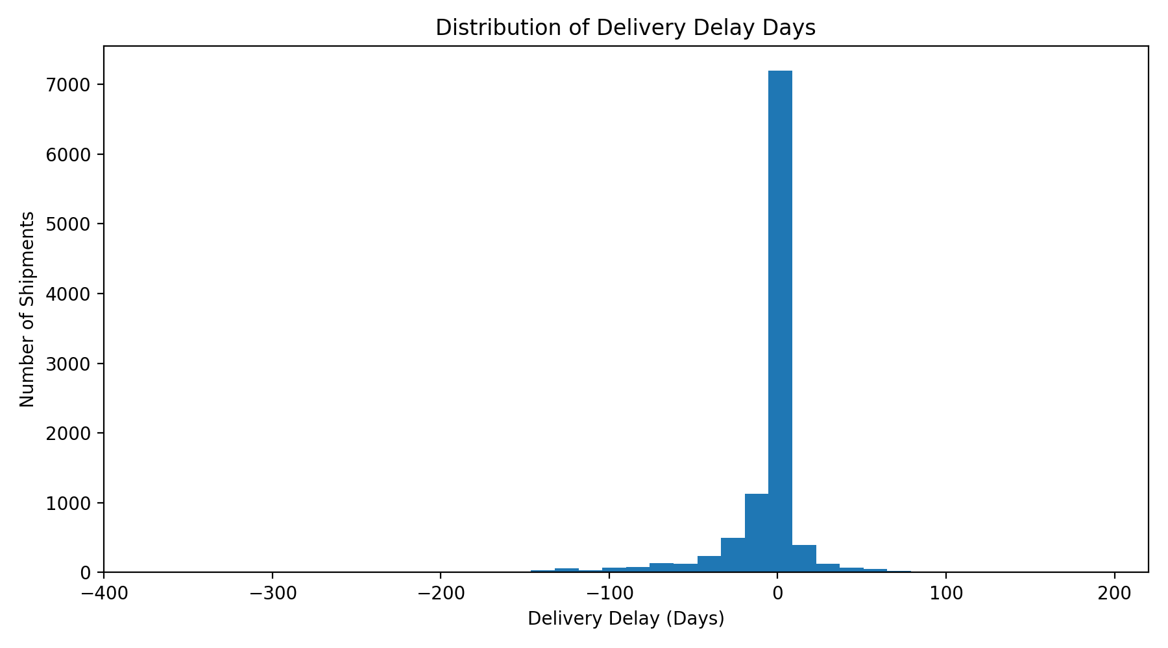
Figure 2. Distribution of delivery delay days

3.3 Average Delay by Shipment Mode
Average delay differs considerably across shipment modes. Air Charter is about -19 days, Truck about -10 days, Air about -4 days, Unknown about -2.5 days, while Ocean is positive at roughly +6 days. These mode-level averages are materially different and should be considered when evaluating the relationship between transport cost and delivery timing.
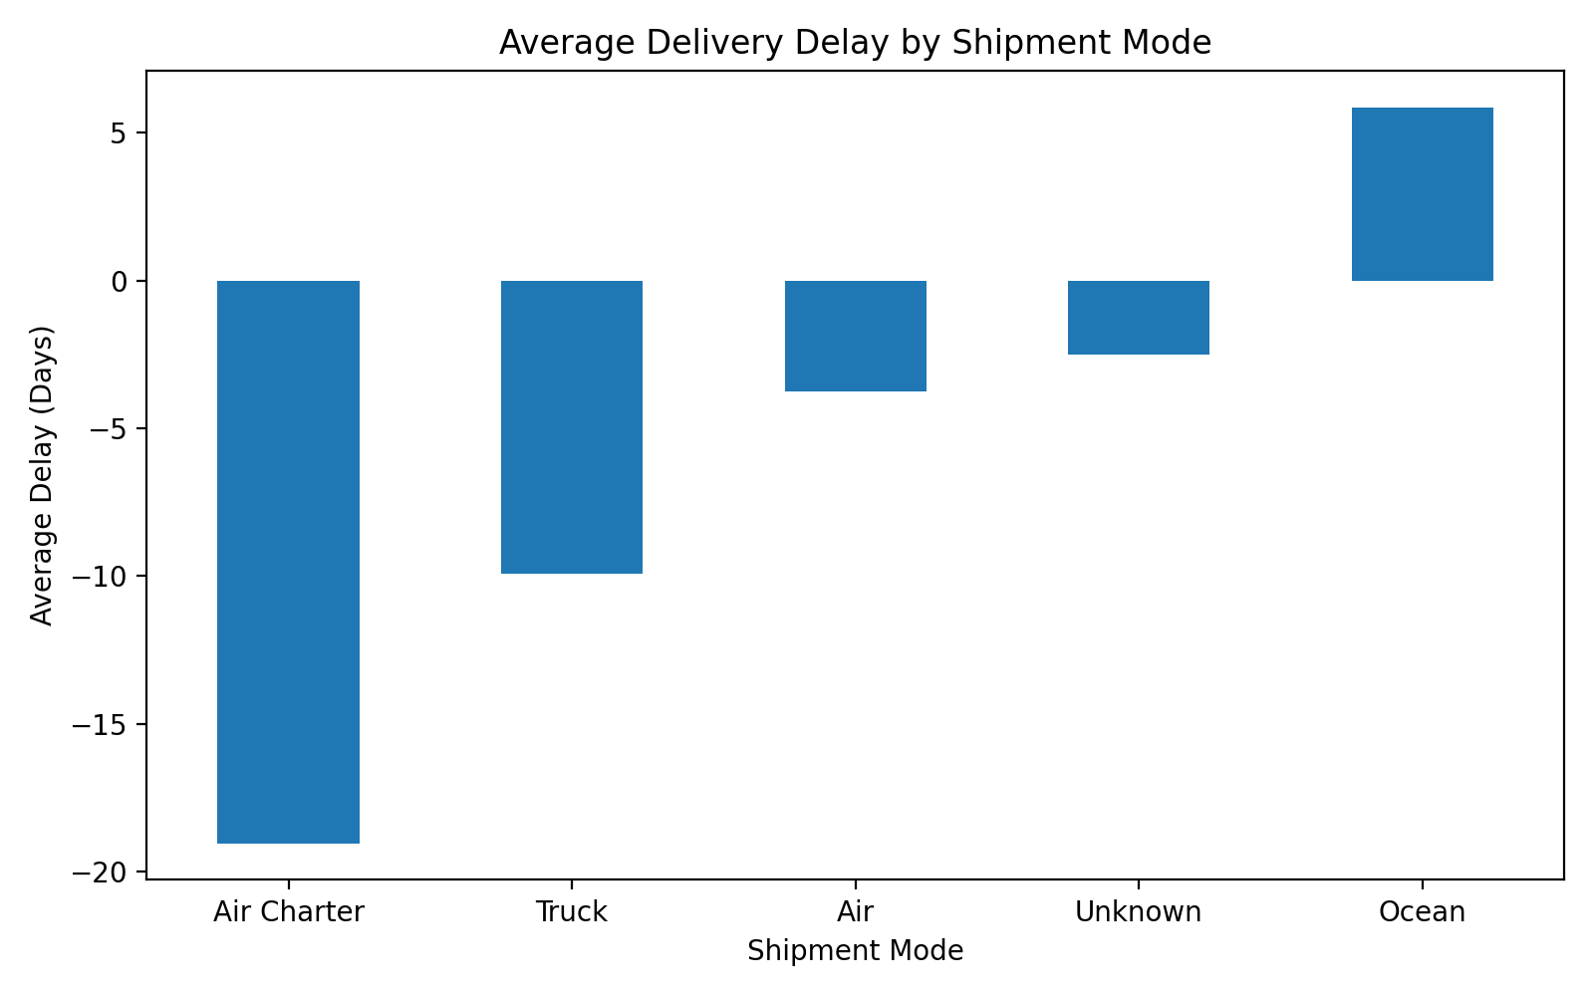
Figure 3. Average delivery delay by shipment mode

4. Shipment Mode Analysis
Air is the dominant shipment mode by volume, followed by Truck. Air Charter, Ocean, and Unknown account for substantially smaller shipment volumes. The concentration matters because changes in a high-volume mode can affect more shipments even when another mode has a more unusual metric.
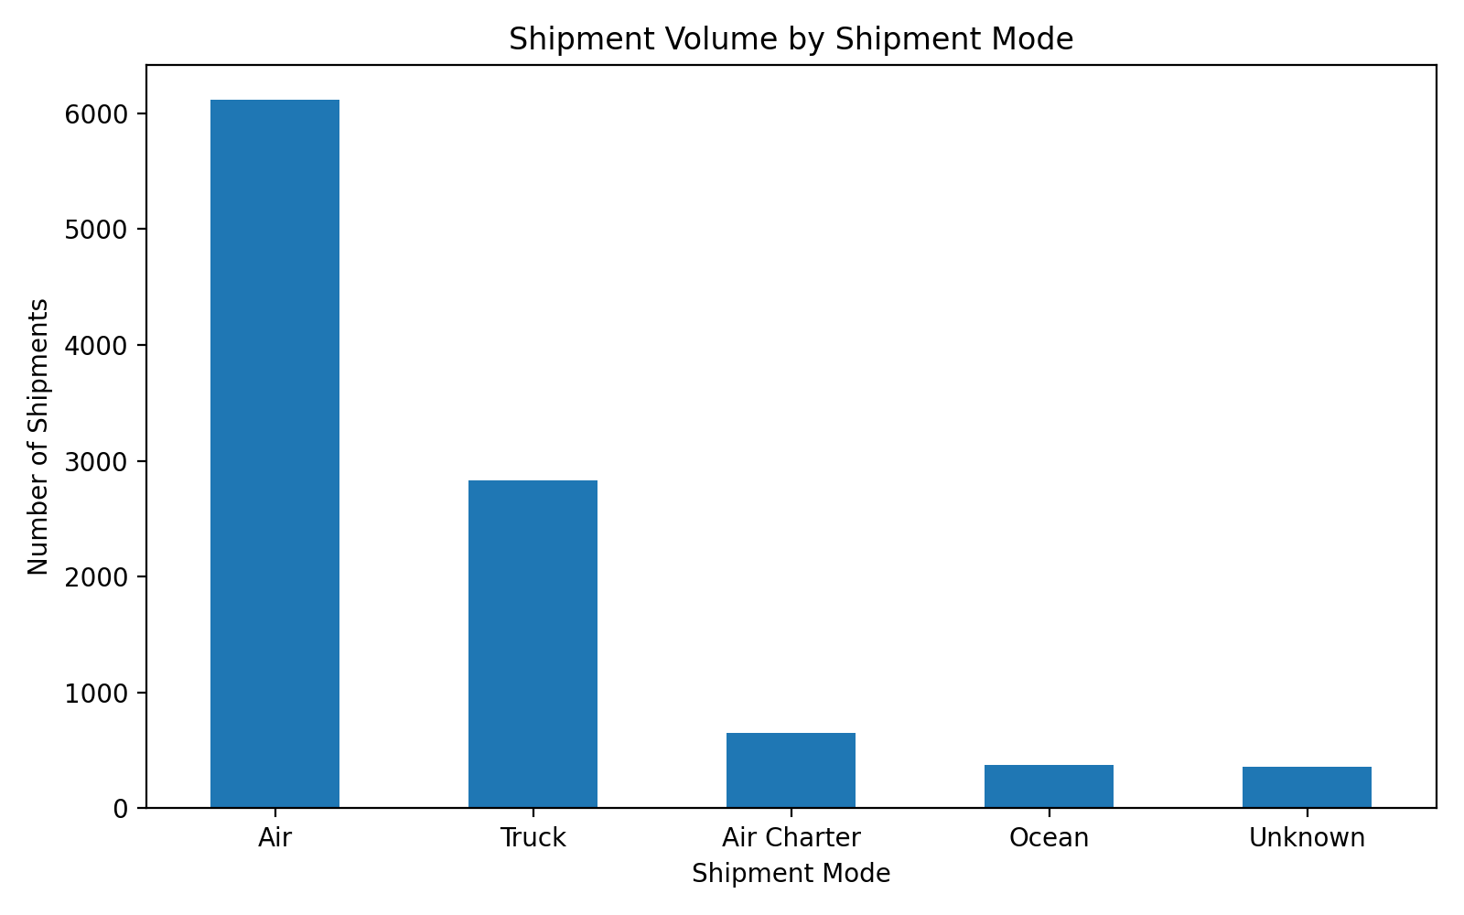
Figure 4. Shipment volume by shipment mode

4.1 On-time Rate by Mode
The mode-level on-time rates are approximately 82% for Ocean, 84% for Truck, 88% for Air Charter, 90% for Air, and 99% for Unknown. The Unknown category should be treated carefully because it represents missing or unclassified shipment-mode information; its high rate should not be interpreted as evidence that an unidentified mode is operationally superior.
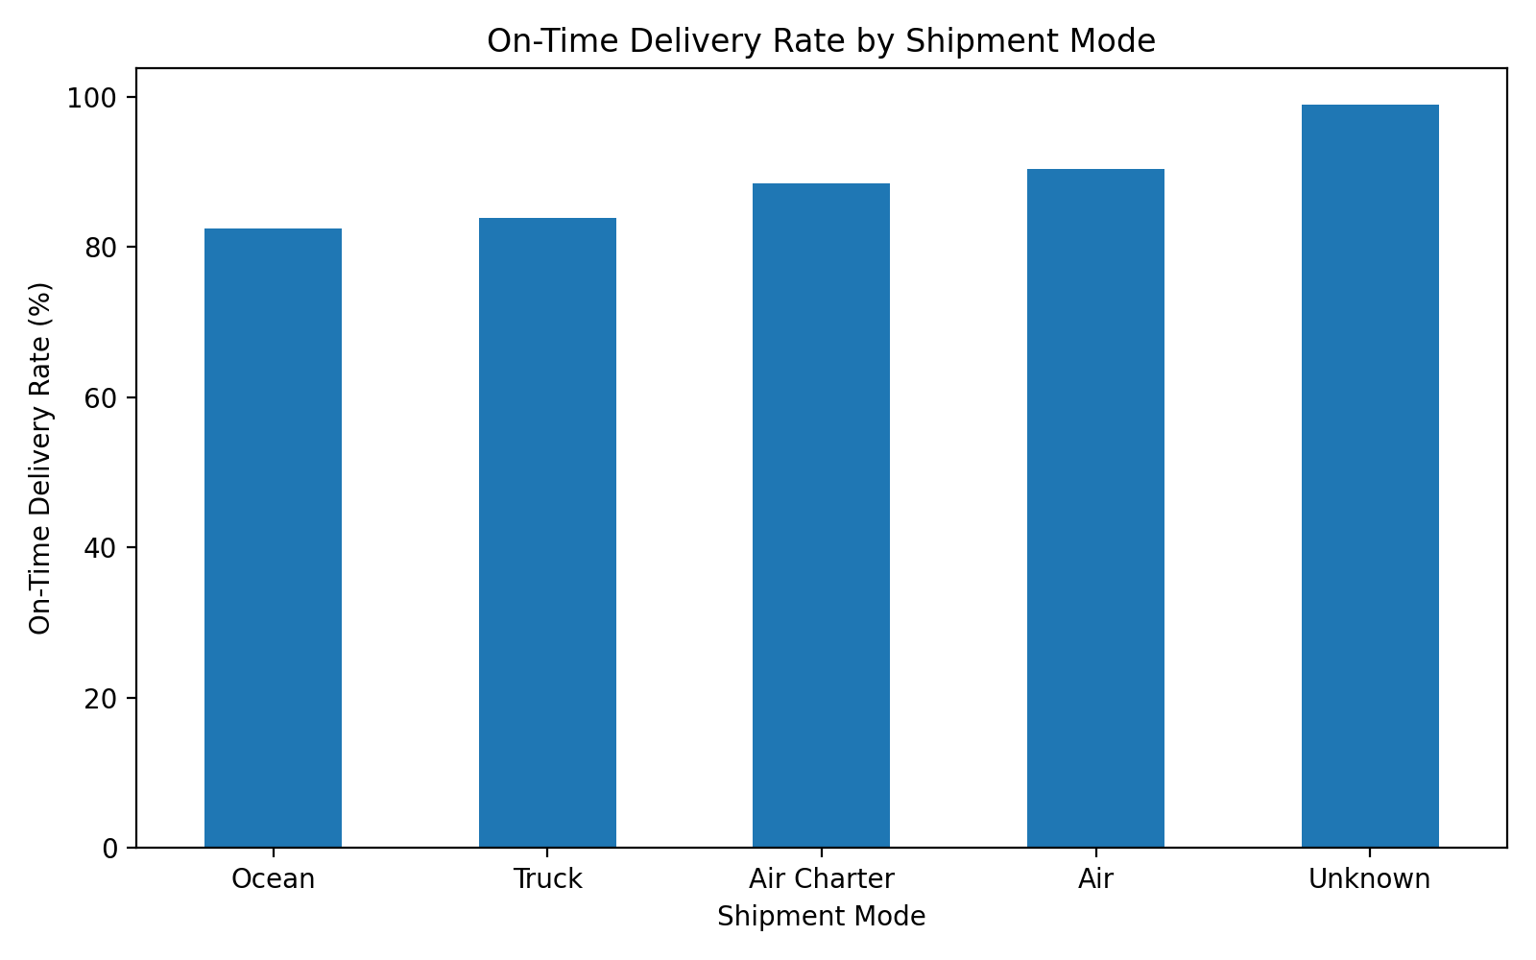
Figure 5. On-time delivery rate by shipment mode

4.2 Freight Cost by Mode
Average freight cost varies sharply by mode. Approximate averages are $6.6K for Unknown, $10.2K for Truck, $10.4K for Air, $12.8K for Ocean, and $21.0K for Air Charter. Because shipment volumes differ by mode, average cost alone should not be used to decide transportation strategy; cost per kilogram and shipment mix should also be considered.
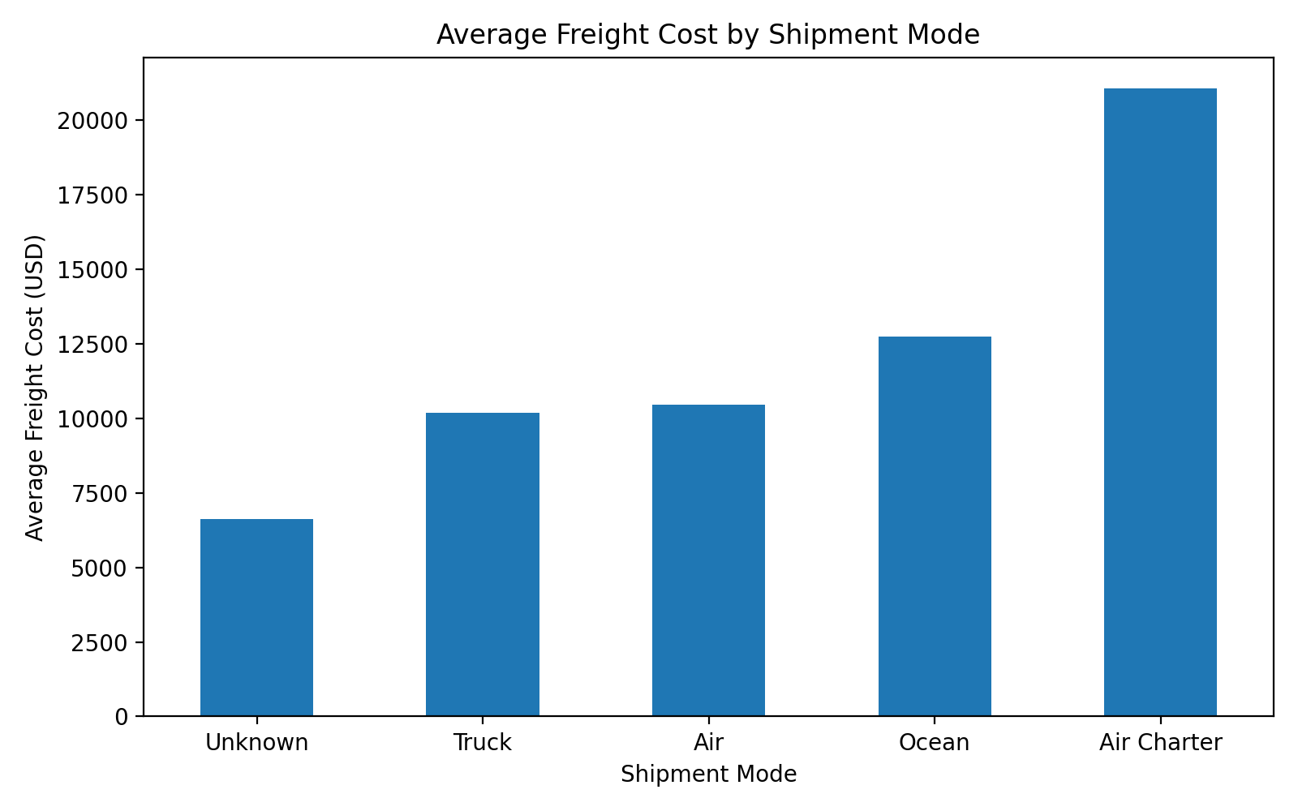
Figure 6. Average freight cost by shipment mode

5. Freight Cost Analysis

5.1 Freight Cost per Kilogram
The freight-cost-per-kg distribution is highly right-skewed. Most observations are clustered at relatively low values, while a small number extend to extremely high values. This pattern means the mean can be distorted by extreme observations. Median and percentile-based metrics should therefore be reported alongside the average.
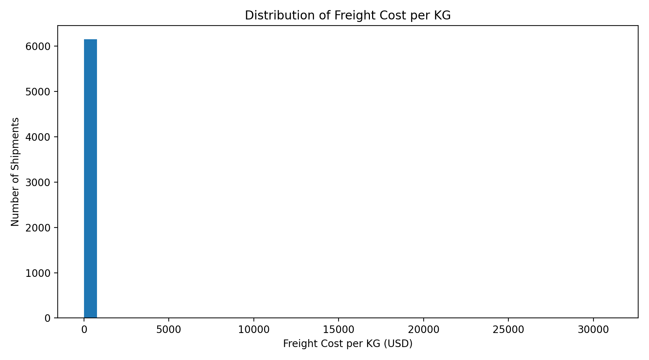
Figure 7. Freight cost per kilogram distribution

5.2 Weight vs. Freight Cost
The weight-versus-freight-cost scatter plot shows a dense cluster of shipments at lower weights and costs, plus several extreme observations. The plot does not support a simple visual conclusion that freight cost rises proportionally with weight across every shipment. Additional segmentation by shipment mode, country, and product group is required.
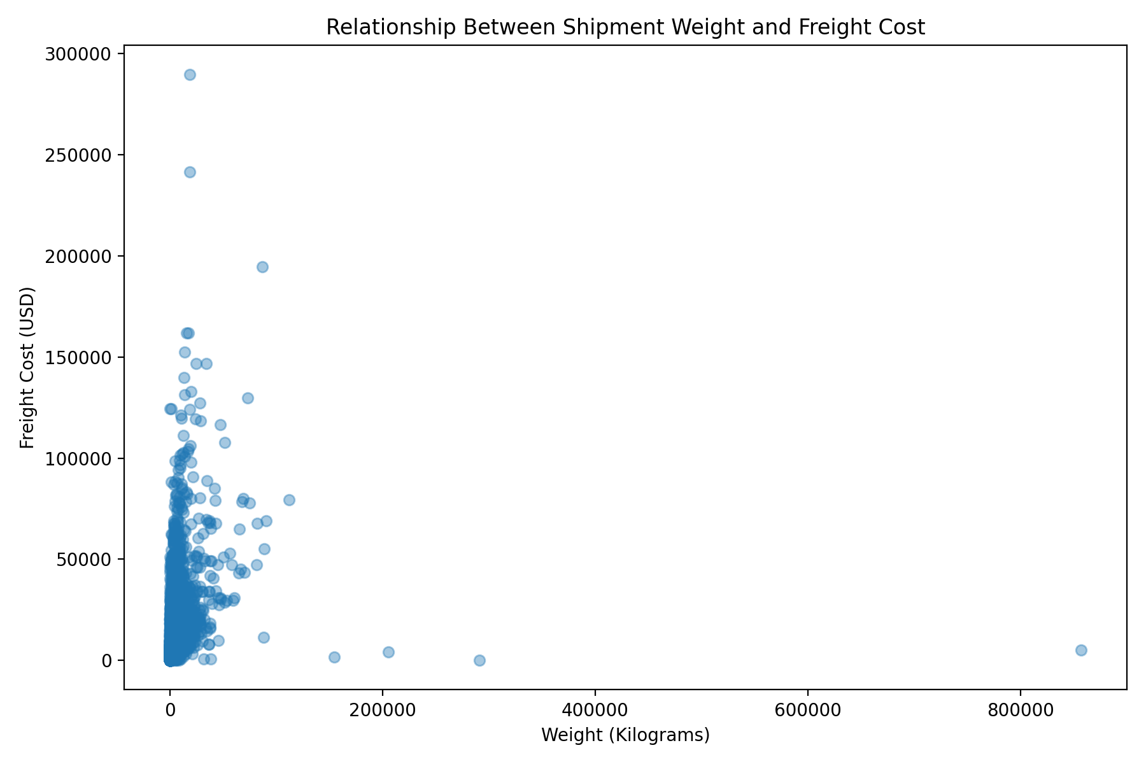
Figure 8. Relationship between shipment weight and freight cost

5.3 Freight Cost Outliers
The analysis workflow explicitly flags potential freight-cost outliers and exports them for further review. These records should be checked against shipment documents, weight, mode, country, and freight invoices before being removed or corrected. An outlier is a signal to investigate, not automatically a data error.

6. Country & Volume Analysis
The top-country shipment-volume chart shows South Africa as the highest-volume destination in the displayed top-10 list, followed by Nigeria and Côte d'Ivoire. Uganda, Vietnam, Zambia, Haiti, Mozambique, Zimbabwe, and Tanzania also appear among the highest-volume countries. Country-level KPIs should therefore be reviewed alongside shipment volume.
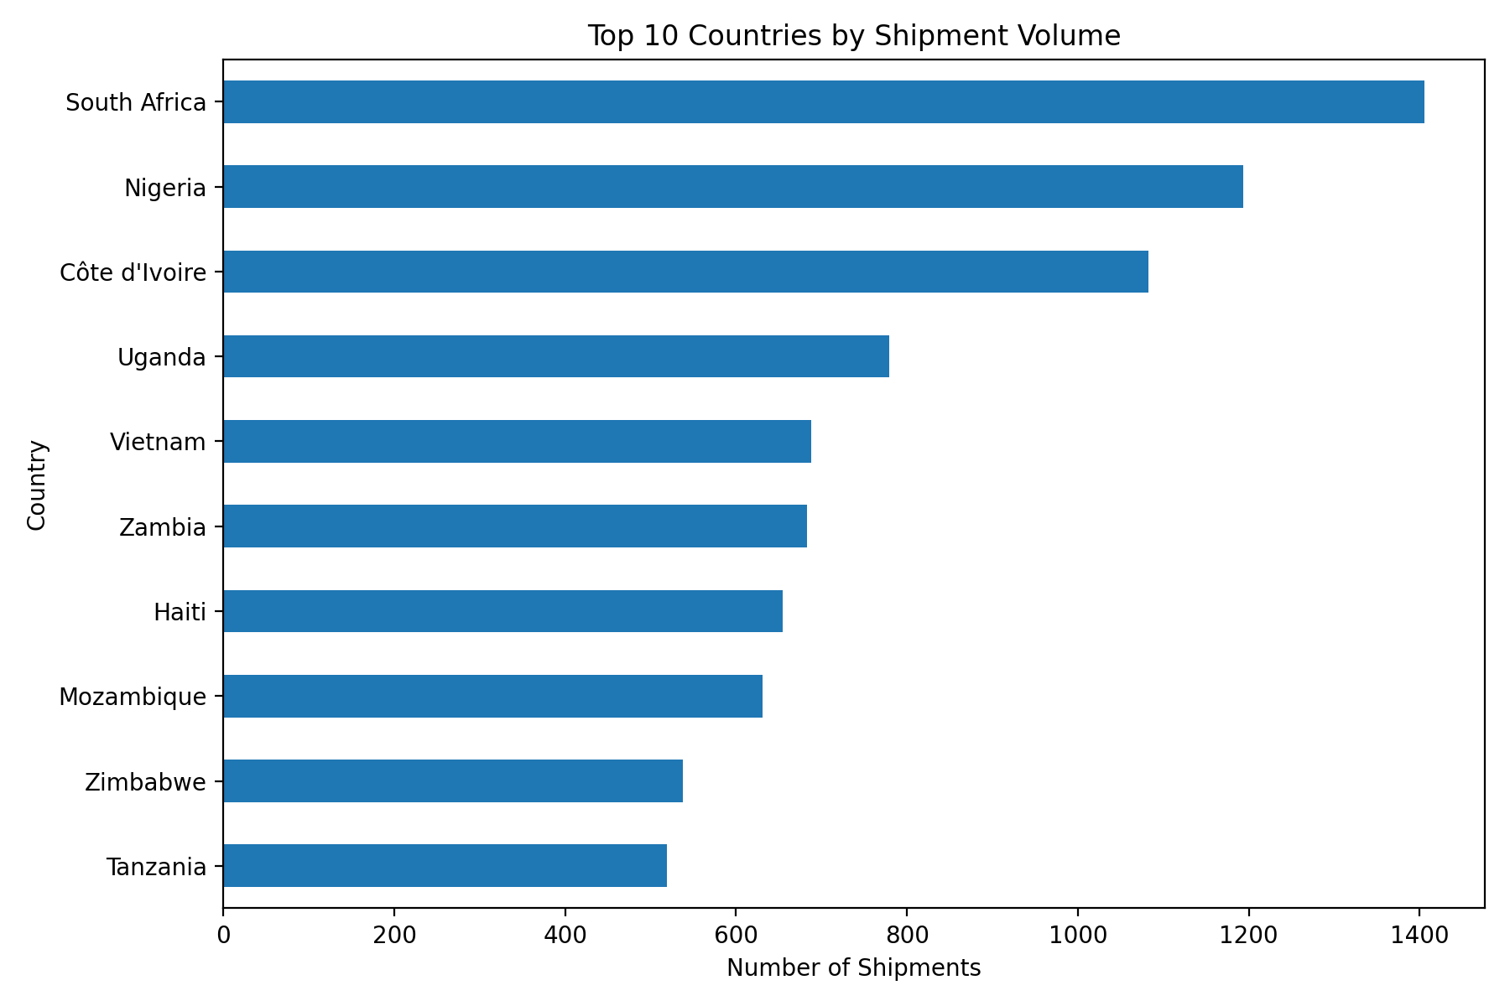
Figure 9. Top 10 countries by shipment volume

7. Year-wise Shipment Trend
Shipment volume increases sharply from 2006 through 2009, dips in 2010 and 2011, rises again during 2012–2013, reaches the highest displayed level in 2014 at approximately 1,520 shipments, and then falls to roughly 1,020 shipments in 2015. The pattern is therefore not a simple continuous upward trend; it contains multiple periods of growth and contraction.
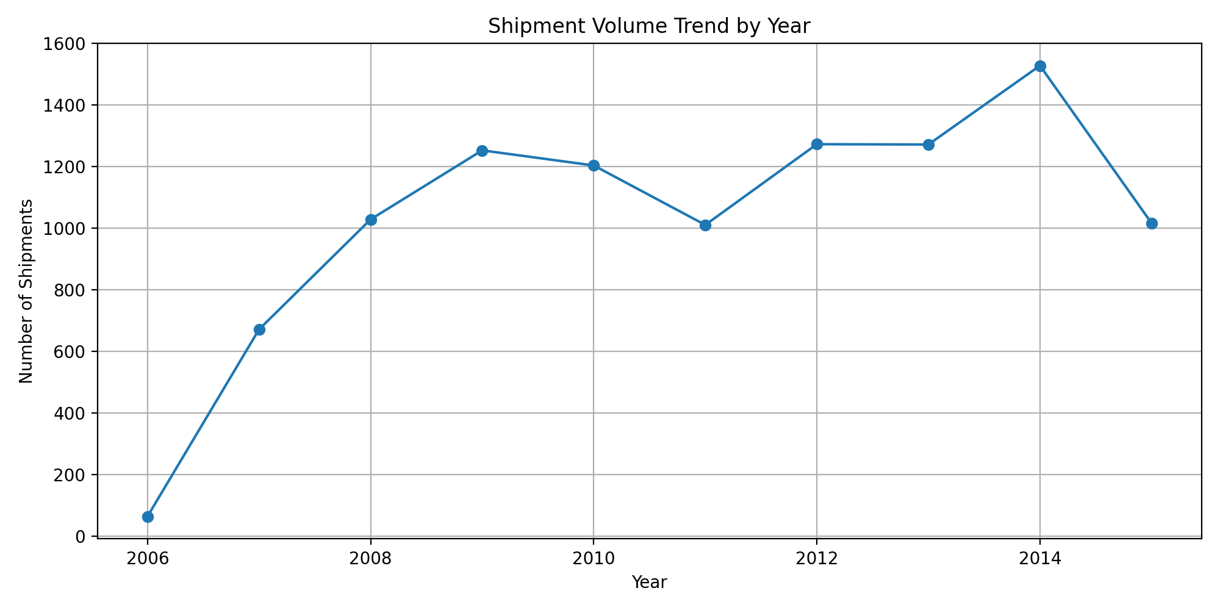
Figure 10. Year-wise shipment volume trend

8. Correlation Analysis
The correlation matrix was generated to examine relationships among quantity, line item value, pack price, unit price, weight, freight cost, delivery delay, freight cost per kilogram, and cost per unit.
Relationship | Correlation | Interpretation
Line Item Quantity ↔ Line Item Value | 0.839 | Strong positive relationship.
Line Item Value ↔ Freight Cost | 0.430 | Moderate positive relationship.
Line Item Quantity ↔ Freight Cost | 0.378 | Moderate positive relationship.
Weight ↔ Freight Cost | 0.232 | Positive but relatively weak relationship.
Delivery Delay ↔ Freight Cost | -0.037 | Very weak relationship in this dataset.
Delivery Delay ↔ Freight Cost/kg | -0.023 | Very weak relationship in this dataset.
A correlation value describes association, not causation. The strong relationship between quantity and line item value is consistent with the commercial structure of shipment records, while the relatively weak delay correlations indicate that delivery timing is not explained by a single freight-cost variable in this dataset.

9. Business Recommendations
- Investigate delayed shipments by country, shipment mode, vendor, and product group instead of relying only on the overall 88.51% on-time rate.
- Review Ocean shipments because the displayed average delay is positive, indicating later delivery relative to the scheduled date on average.
- Audit high freight-cost and freight-cost-per-kg outliers against invoices and shipment weights before taking corrective action.
- Separate 'Unknown' shipment-mode records from operational comparisons until the missing mode information is resolved.
- Track both average and median freight cost because freight distributions are strongly affected by extreme observations.
- For transportation decisions, evaluate cost, delivery performance, shipment volume, and cost per kilogram together rather than optimizing a single metric.

10. Methodology & Analytical Workflow
The cleaned SCMS Delivery History dataset was loaded into Python for exploratory analysis. The workflow examined dataset structure and missing values, calculated logistics KPIs, grouped records by shipment mode and country, calculated correlations among numeric logistics variables, and generated visualizations using Python plotting tools. Additional CSV outputs were produced for country, shipment-mode, freight, product-group, vendor, correlation, and potential freight-outlier analyses.
The visualizations were selected to answer distinct analytical questions: categorical comparison for delivery status, volume and mode-level KPIs; distribution plots for delay and freight-cost-per-kg behavior; a scatter plot for weight versus freight cost; and a line chart for year-wise shipment volume. Together, these views provide a multi-dimensional assessment of logistics performance.

11. Limitations & Data Quality Notes
- Several fields contain missing values, including PO Sent to Vendor Date, Freight Cost per KG, Freight Cost, Weight, PQ First Sent to Client Date, and Line Item Insurance.
- Negative delivery-delay values mean the actual delivery date was earlier than the scheduled delivery date under the dataset's delay calculation; they should not be interpreted as late shipments.
- Extreme delay and freight-cost values require validation before being treated as operational failures or data errors.
- The Unknown shipment-mode category represents missing or unclassified mode information and should be interpreted separately.
- The full vendor, product-group, and outlier tables are exported by the analysis workflow; this report avoids inventing rankings or counts not directly exposed in the supplied analysis results.

12. Next Steps
- Build an interactive Power BI dashboard using the Week 3 analysis outputs.
- Create KPI cards for total shipments, on-time rate, average delay, average freight cost, and cost per unit.
- Add slicers for year, country, shipment mode, vendor, and product group.
- Create a mode-level cost-versus-performance view to identify operational trade-offs.
- Investigate exported freight outlier records and document the reason for each confirmed anomaly.
- Use the correlation matrix and segmented analysis to identify relationships worth deeper investigation.

13. Source & Analysis Basis
Prepared from the Week 3 logistics analysis workflow and the resulting visualizations supplied with the project. The analysis script loads the cleaned SCMS Delivery History dataset and generates shipment-mode, country, product-group, vendor, freight, outlier, and correlation outputs.

