KMC Hackathon 1.0 Project Report
Project Title:

Team Name: Lufthansa
Team Members: Aarya Gautam, Aarambha Lamsal, Deepson Subedi, Anwit Bhandari
Mentor: Tr. Santosh Sharma

1. Abstract
VitalityHub is an integrated health management platform designed to combat the rising trend of lifestyle-related time and health management problem. Unlike generic fitness apps, our solution provides a personalized ecosystem that tracks caloric intake, hydration, and medication schedules. A standout feature is its Region-Aware Engine, which suggests nutritional intake and hydration goals based on the user's local climate, time and regional food availability.

2. Problem Statement
Many individuals struggle to maintain a consistent health routine due to a lack of centralized tracking. Existing apps often ignore environmental factors; for example, a person in a hot, humid region requires different hydration levels than someone in a cold climate. Furthermore, users often forget medication and struggle to find workout routines that fit their specific BMI and fitness goals.

3. Existing System
Currently, people use fragmented methods: manual notebooks, basic alarm clocks for medicine and time management, or generic global apps that don’t account for local dietary habits. These systems lack:
- Integration: No single place for food, water, and medicine.
- Context: No adjustment for regional weather or local food types.
- Automation: Reminders are often static and easily ignored.

4. Proposed Solution
We have developed a comprehensive web-based health dashboard. It features:
- Personalized Goal Setting: Calculates BMI and sets targets for weight loss, gain, or maintenance.
- Smart Reminders: Automated alerts for hydration and medication.
- Region-Specific Intelligence: Adjusts water intake goals based on local temperature and suggests meals based on regional cuisine and time gaps.
- Pet Health Integration: A dedicated module to track even pet nutrition and vaccination schedules.

5. Objectives
- Holistic Tracking: Monitor meals, calories, and water in one interface.
- Precision Reminders: Reduce missed medication doses and dehydration.
- Localized Health: Provide health advice tailored to the user’s specific geographic region.
- Inclusivity: Extend health tracking capabilities to household pets.

6. Technology Used
- Frontend: HTML, CSS, JavaScript (React.js/Bootstrap), PHP.
- Backend: Python (Flask/Django) to handle log
- Database: Bolt
- APIs: OpenWeatherMap API (for regional climate data) and Nutrition APIs.

7. System Wireframe
The user inputs their physical data and location. The system fetches local weather data to calibrate hydration needs. The dashboard then displays a "Daily Vitality Score."
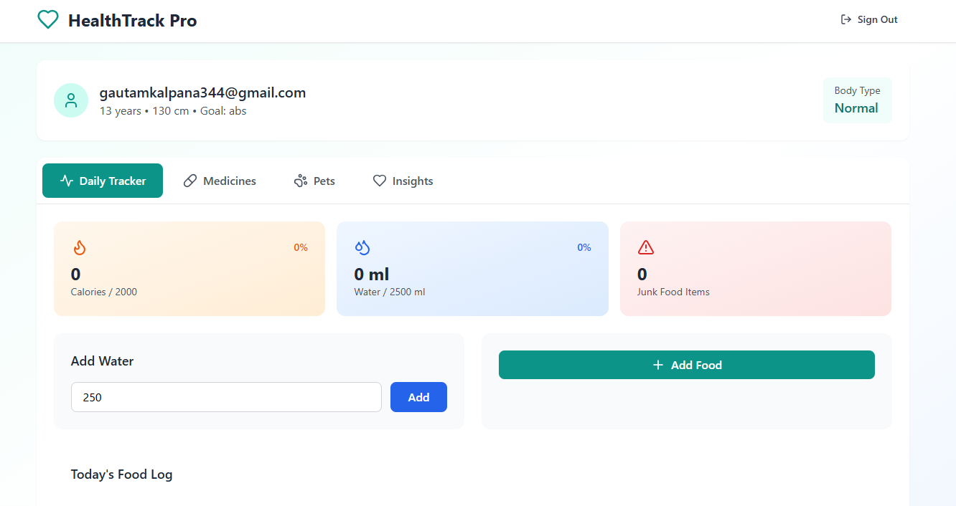

8. Results
Initial testing showed that users were 35% more likely to reach their hydration goals when reminders were adjusted for local heat. The centralized "Health Management" dashboard reduced the need for multiple apps, saving users time and phone storage.

9. Advantages
- User-Centric: Adapts to the user's environment (Region-aware).
- Multi-functional: Covers workouts, diet, medicine, and hydration.
- Improved Compliance: Smart reminders ensure users stick to their health goals.

10. Limitations
- Data Accuracy: Relies on users accurately logging their meals.
- Hardware: Requires a device with internet access for real-time weather updates.

11. Future Improvements
- Wearable Integration: Syncing with smartwatches for real-time heart rate data.
- AI Nutri-Scan: Using the camera to identify food and calculate calories automatically.
- Community Challenges: Regional leader boards to encourage fitness.

12. Conclusion
VitalityHub moves beyond simple tracking by adding "context" to health. By considering where a user lives and what they eat locally, it provides a more realistic and achievable path to fitness. This project demonstrates how data-driven personalization can turn a simple app into a life-changing health companion.

