ECONOMETRIC RESEARCH BRIEF: RURAL–URBAN INFLATION PASS-THROUGH IN INDIA (2014–2025)
Gokhale Institute of Politics and Economics (GIPE) | MoSPI CPI Base 2012=100 (N = 142) | OLS with Newey-West HAC
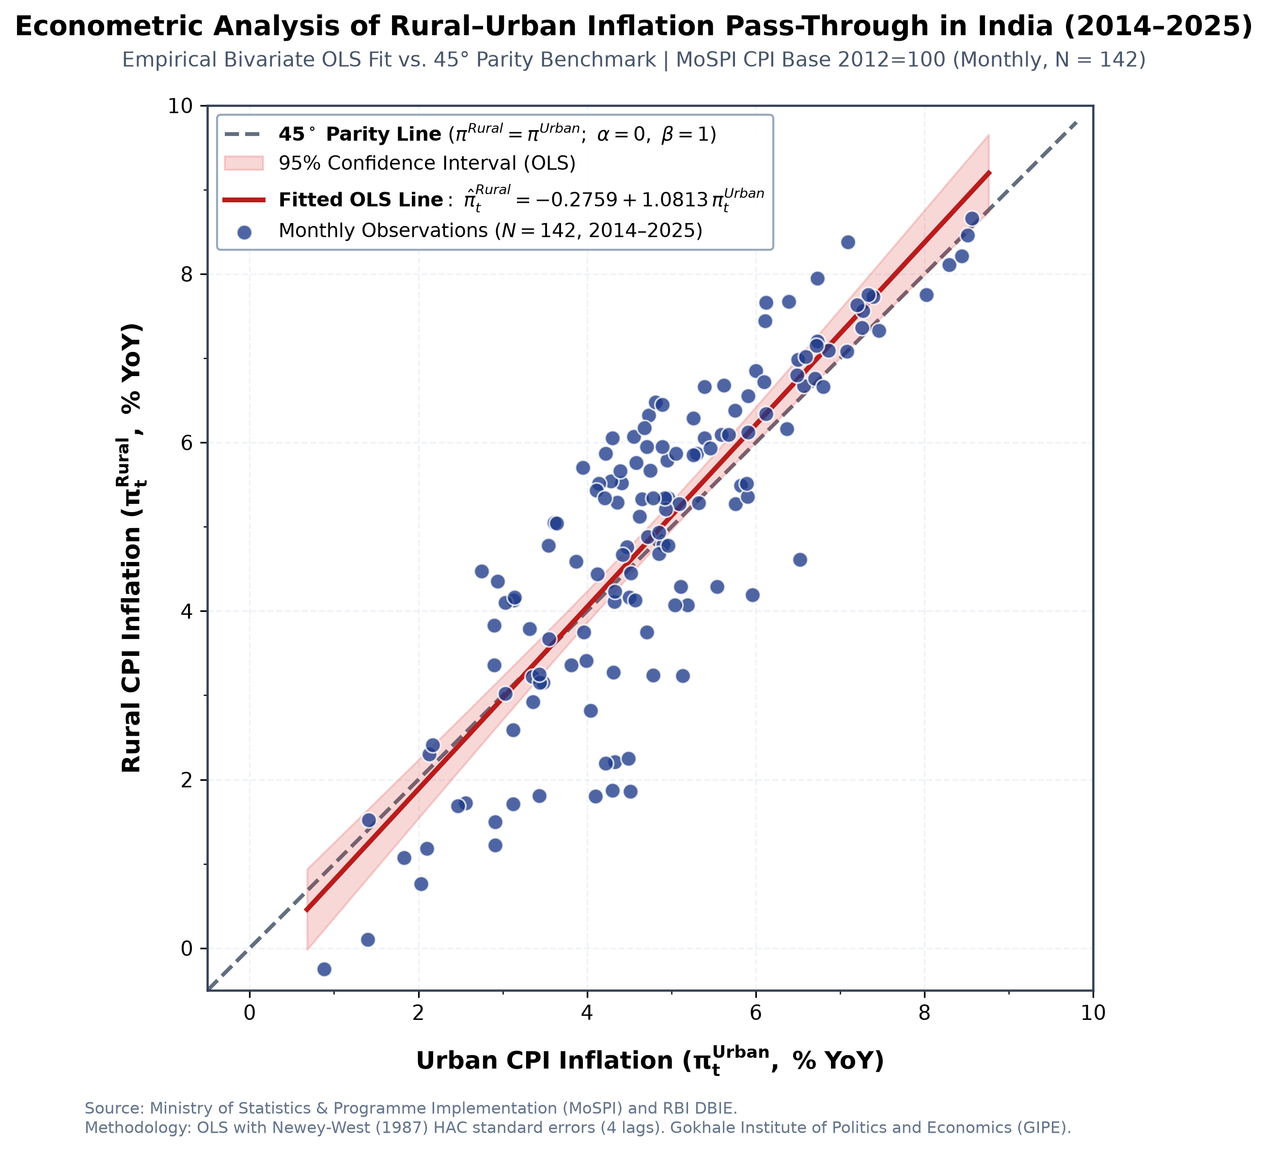
Figure 1: Bivariate OLS Fit (π̂_Rural = -0.2759 + 1.0813 π_Urban) vs. 45° Parity Line with 95% Confidence Band.
Parameter | OLS Coef | OLS SE | HAC SE (L=4) | HAC z | p-value
Urban Inflation (β) | 1.0813*** | 0.0549 | 0.0751 | 14.40 | < 0.0001
Intercept (α) | -0.2759 | 0.2776 | 0.4711 | -0.59 | 0.3219
R-squared: 0.7349 | Adj R²: 0.7330 | F: 388.1 | p: < 10^-41 | DW: 0.1852 | N = 142
45° Parity Wald F: 2.046 | df: (2, 140) | p-val: 0.1331 | Decision: Fail to Reject H0 at 5% level
Summary Takeaway: (1) Pass-through elasticity β̂ = 1.0813 (p < 0.0001, HAC z = 14.40) explains 73.5% of rural inflation variance. (2) Joint Wald test fails to reject 45° parity [F(2,140) = 2.046, p = 0.1331], confirming long-run spatial co-movement with slight rural amplification. (3) Driven by food's 54.18% rural weight vs. 36.29% urban weight (+17.89 pp), yielding higher rural volatility (σ = 1.94% vs. 1.54%).

