Hi Team,
I am looking forward to meeting you today! Below is your September performance report. I would love to walk through some of these numbers and talking points in our call. Feel free to come with any agenda items of your own!
Business Review September
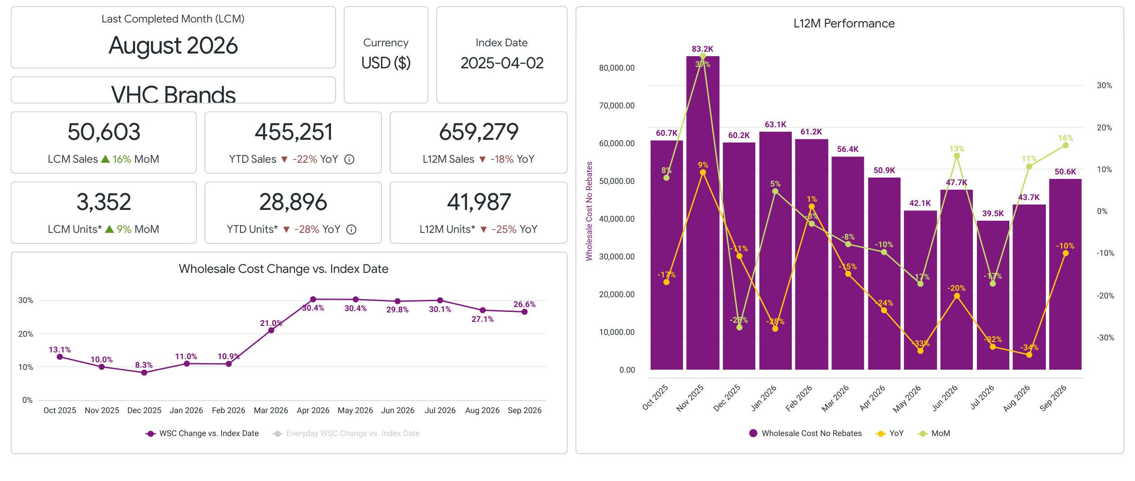
- $50.6K in WSC (+16% MoM, -10% YoY)
- MoM trend under indexed the overall Window category
- YoY trend under indexed the Window category
- Top Classes:
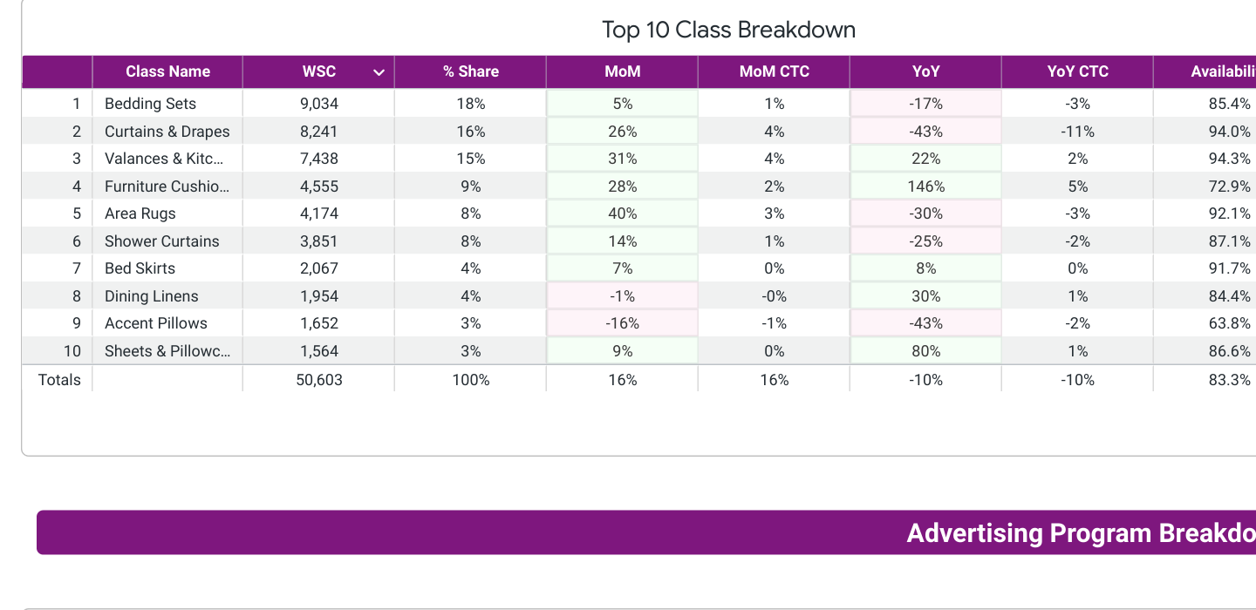
- Traffic:
- 145k SKU Visits (-1% MoM, +5% YoY)
- YoY trends under indexed the Window category
- MoM under indexed the Window category
- 1.04% CVR in September
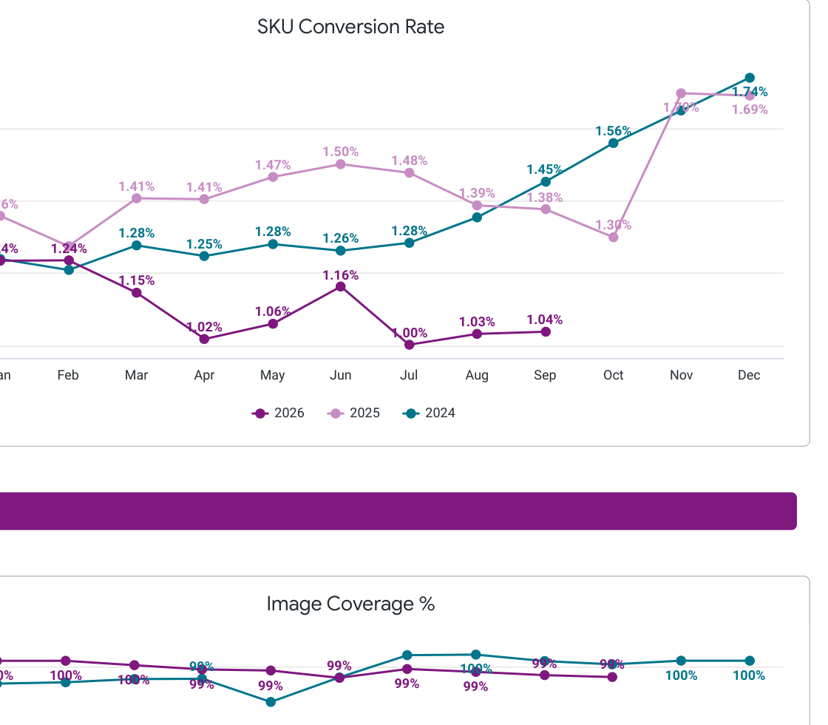
Key Point: Conversion is soft vs the Window category (1.04% vs category CVR) and remains a clear gap versus category growth.
- Availability
- September Global Availability: 83.3%
- Over indexing category
- Key Ask: Looks like this is all set. Glad to see continual health here.
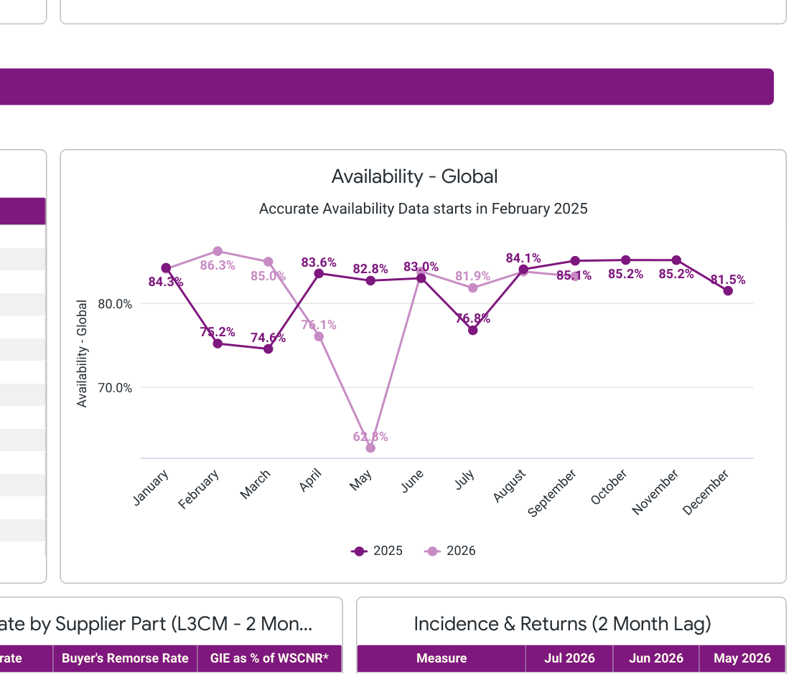
- Advertising
- Did not advertise in September
- Key Point: Last ad activity was in May. Is there a plan to restart advertising?
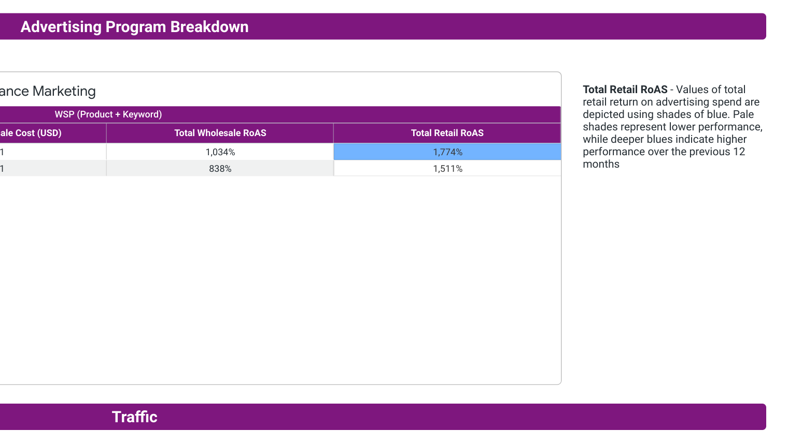
- Promotions
- Key Ask: I would recommend lining up participation in upcoming Major Shopping Holidays to help close the conversion / YoY gap vs the Window category.
- Conditional Offers
- Happy to keep building on Conditional Offers where incrementality looks healthy — bring any new offer ideas to the call.
Open Issues
- Multisource / media / exclusivity items: bring any open tickets you want to walk through and I’ll come prepared with status.
Please come with any talking points you would like to go through!
Ben

