Hi Payless Decor Team,
I’m looking forward to meeting with you and touching base on some future plans!
Brief Agenda:
- I included your August performance below as a reference for you. I'd love to walk through this performance recap to highlight additional areas we can partner together in 2026
Business Review August 2026
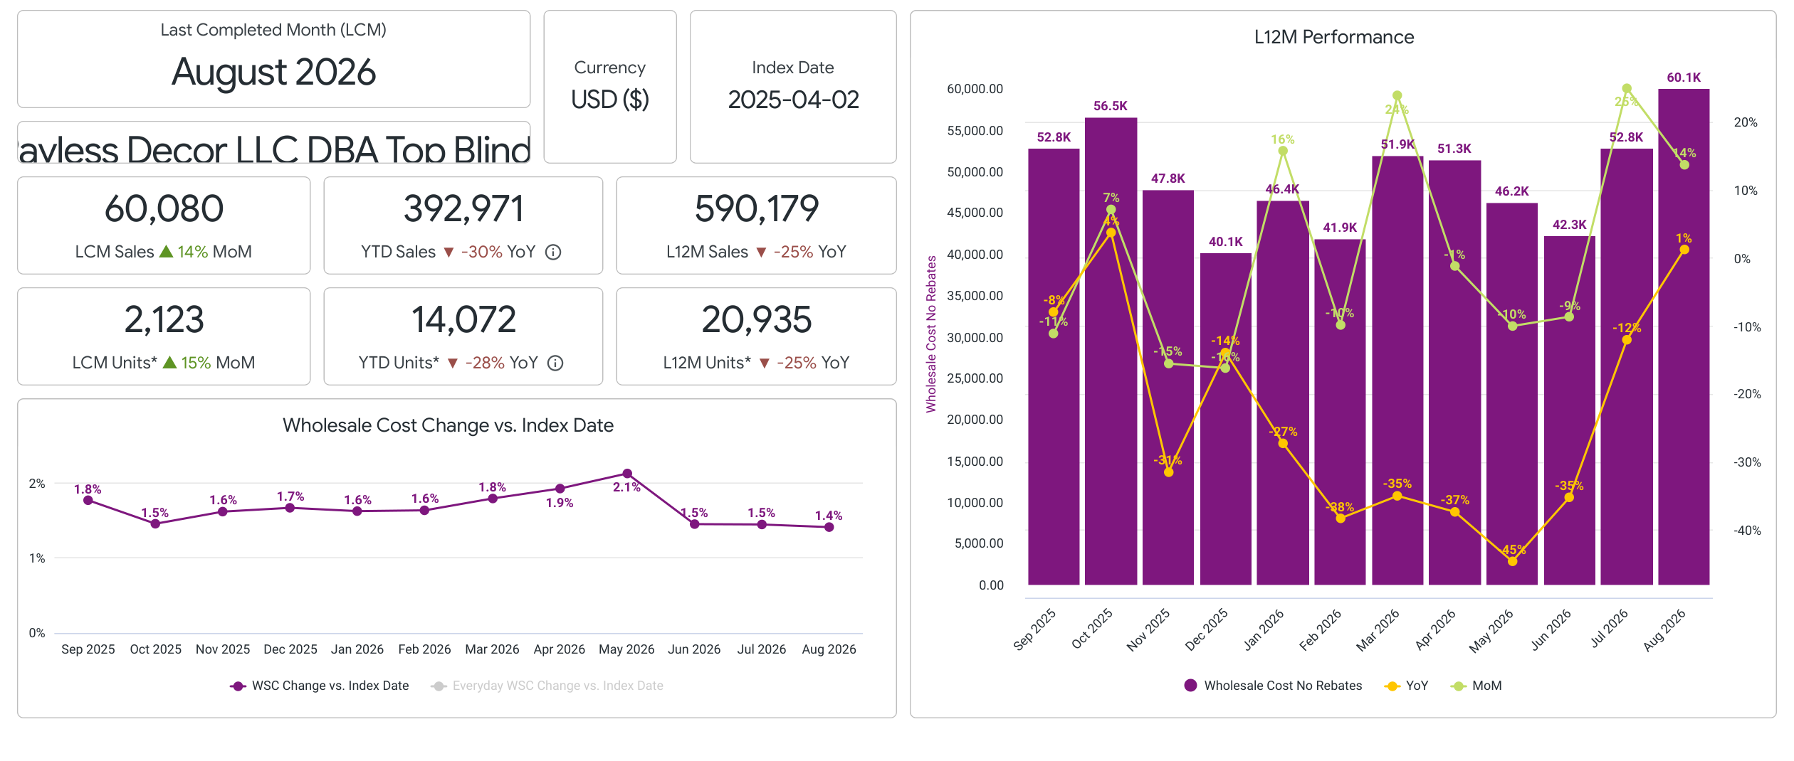
- $60.1K in WSC (+14% MoM, +1% YoY)
- MoM trend over indexed the Blinds & Shades Class
- YoY trend under indexed Blinds & Shades class
- Traffic:
- 30k SKU Visits (+3% MoM, +29% YoY)
- YoY trend under indexed Blinds & Shades Class
- MoM trend under indexed Blinds & Shades Class
- 2.09% CVR in August
- CVR is over indexing class
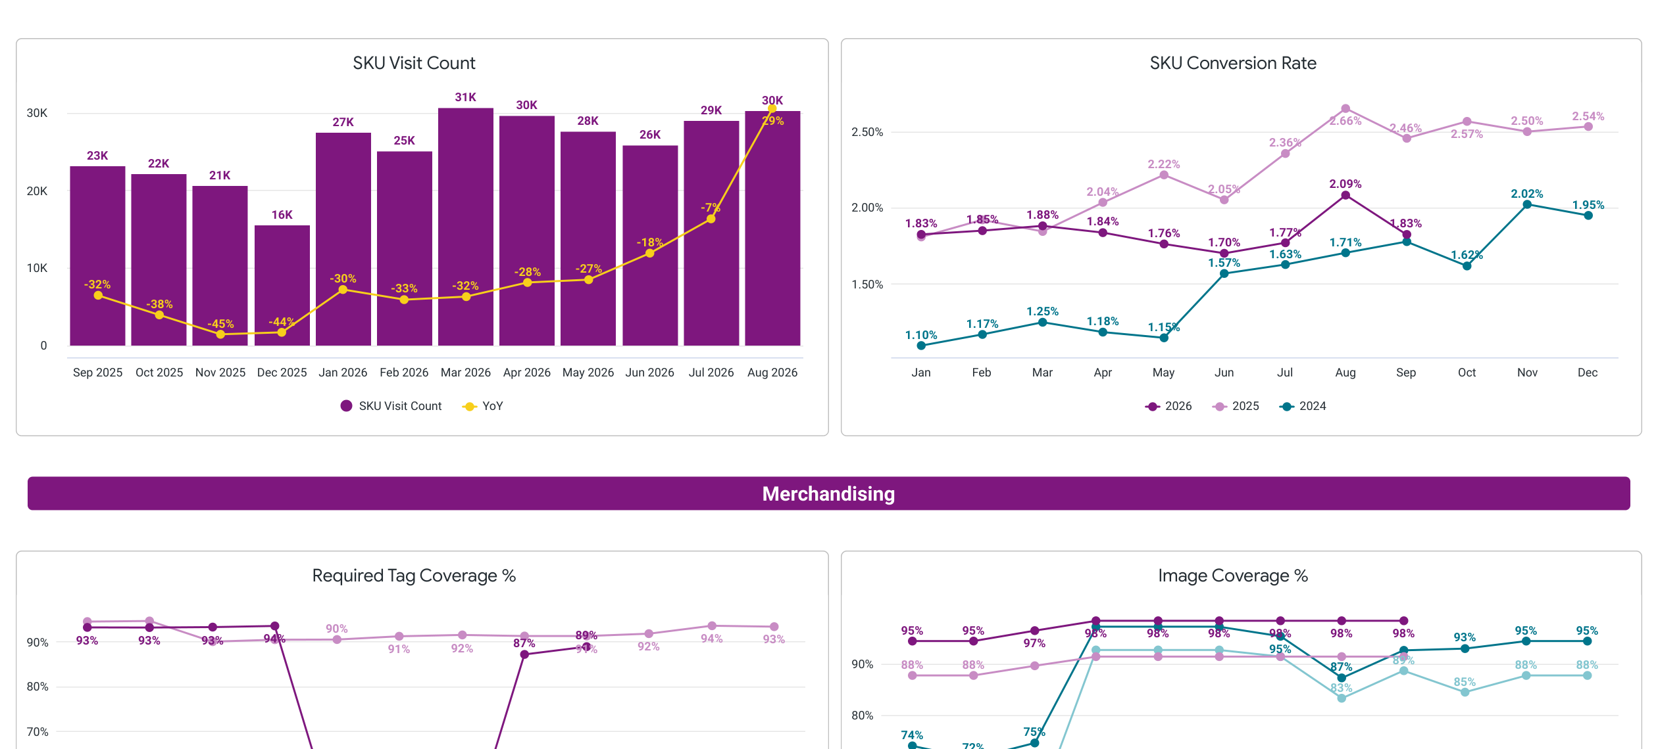
- Advertising
- 0.3% of WSC into Advertising (August spend $203; attributed WSC $731; Wholesale RoAS 360%)
- Do you have any thoughts on the pilot of your advertising program (ie: do you see it working, do you plan on increasing investment?)
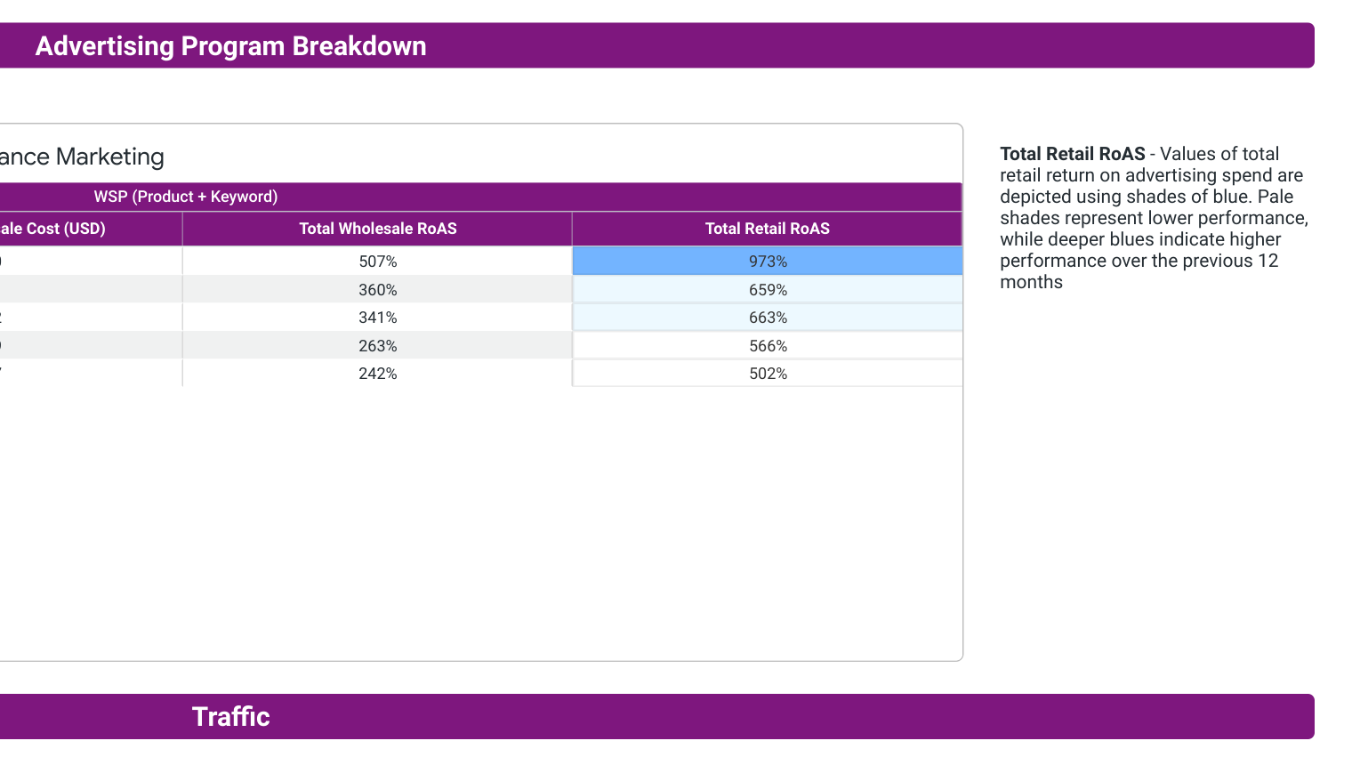
- Branded Competitiveness
- [Add % Uncompetitive + competitiveness chart if you want this section included]
Here is a pricing deep dive that we talked through previously: Cost Stack Report
https://docs.google.com/spreadsheets/d/1_lzlctlUwmhfXdWnn8EjxbzDB8Bmd03Epmbg_xUtDa8/edit?gid=1742226054#gid=1742226054
- Key Point: This is where I think the most opportunity areas are. I know that we have chatted about this, I just wanted to give you a picture of the progression.
- Wayfair Professional:
- 18% of Sales came from B2B (+42% MoM, +9% YoY)
- Availability
- August Availability: 91.1%
- Slightly soft MoM (91.4% in July), but still above June (89.6%).
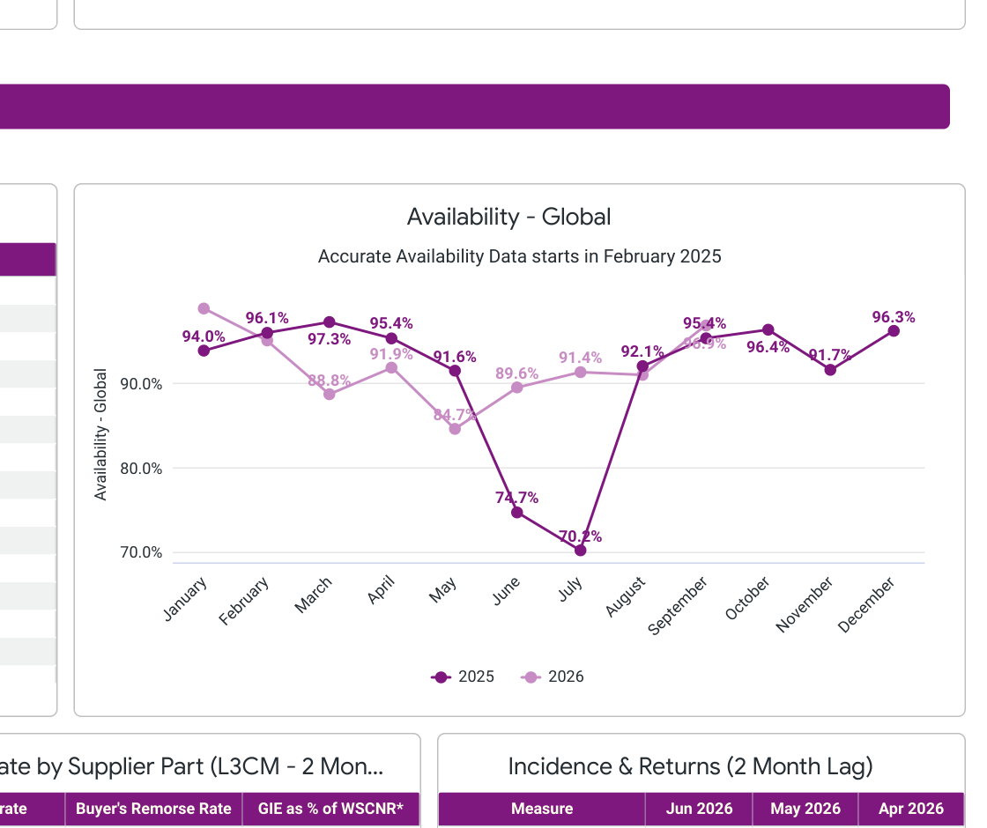
- Dropship performance is excellent. 100% supplier fill rate DS
Please come with any talking points you would like to go through, I imagine there will be some time for any of your agenda items!
Ben

