**Name:**

**-**

**BHANU PRASAD SAMAL**

Computer Science and Engineering

Email:

bhanuprasadsamal@gmail.com

Phone: +

91

8018931867

Linkedin:www.linkedin.com/in/bhanuprasadsamal1/

**Career Objective**

ADD COLLEGE

FORMAL PHOTO

HERE

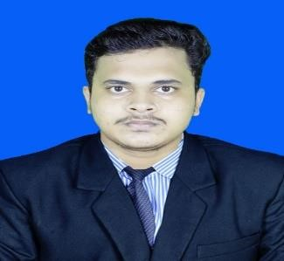

Seeking an opportunity in a dynamic organization that I will serve as: Computer Science and Engineering and contribute effectively to the prosperity of such establishment with satisfying individual development. With passion for learning, leading and delivering unique projects to meet objectives.

# Educational Qualifications

|  |  |  |  |  |
| --- | --- | --- | --- | --- |
| Degree and Year | Institute | Board |  | Marks/CGPA |
| B.Tech(CSE) | Gandhi Institute of  Engineering &  Technology,Gunupur. |  |  | 7.0 |
| +2 Science in | Hi-tech +2 Science college,kuakhia,Jajpur |  | CHSE | 69 |
| 10th in | Baruneswar High School , Arei,Jajpur |  | HSC | 50 |

# Training / Certification

* Joy of Computing Using Pythonfrom **Nptel.**
* C Programming training and certificationconducted by **Spoken Tutorial Project, IIT Bombay**.
* Communication skill – **TCS iON**
* Android Enterprise Associate learning path - **Google**

# Achievements and Extracurricular activities

* **Swags from Google Cloud.**
* **The Guinness World Record Event-GUVI Geek Network,IITM Research Park**
* **SAR Application for flood harzard mapping and monitoring - ISRO**

# Technical Skills

* OPPS (Object Oriented Programing)
* Data Structure
* Android in Java
* HTML / CSS/Java script/React Js/Tailwind/Streamlit/PWD/Django/MongoDB/php C/Python/DMDW/DBMS/git.

**Internship Programs**

* TEACHNOOK (01/Jun/2021 – 31/Jul/2021)
* Salesforce Administrator
* AICTC (IBM internship)

# Internship Project Details

|  |  |
| --- | --- |
| **Name of the Project** | **Digital Agency** |
| **Device used** | Windows OS |
| **Description** | Used for Digital marketing |

# Project Details

|  |  |
| --- | --- |
| Name of the Project | **Fitness Website** |
| **Language used** | React,bootstrap& Mongodb(for Backend) |
| **Device used** | Windows OS |
| **Description** | For help those people who find difficult to go outside home or those who want to exercised inside home, etc. |

# Personal Details

|  |  |
| --- | --- |
| Date of Birth | 25/10/2002 |
| Gender | Male |
| Father's Name | Khirod Kumar Samal |
| Address | Lenkasahi,Binjharpur,Jajpur,Odisha |
| Alternate phone number | 8280619127 |
| Language Known | English / Hindi/Odia/Bengali |
| Interests & Hobbies | Traveling,Photography |

Signature

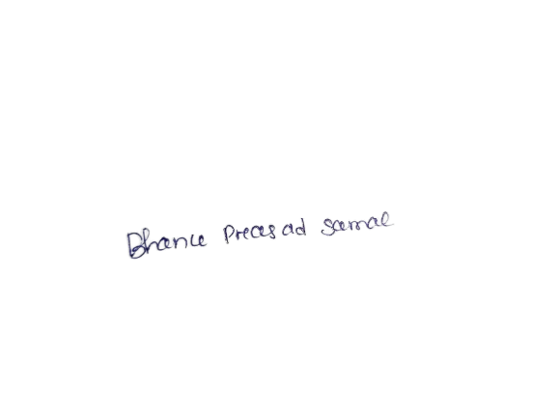

Place: Ammerpit,Hydrabad. Date: 1/07/2025