

Data Structures and Algorithms -23CSE203

Lab Manual

Submitted By

NAME | P. BHANU KIRAN
ROLL NO | AV.SC.U4CSE25142
YEAR/SEM/SECTION | 1ST YEAR/ SEM-3/CSE-B
CREDITS | 05

Submitted to
NAME | DR. RAJ KUMAR BATCHU
DESIGNATION | ASST.PROFFESSOR (Sl. Grade)
DEPARTMENT | SCHOOL OF COMPUTING

Index
week |  | Page-numbers
1 | - A rocket launch system displays a count down before launch. Instead of using a loop, implement the count down using recursion. Write a recursive python program to display countdown from n to 1 followed by launch.  - Banks calculate the growth of investment using compound interest. The formula requires calculating powers, which can be implemented recursively. Write a recursive program to calculate P^n where P = Principal growth factor, n = number of years  - A HR department stores employee details in a list. Develop a recursive program to search for a given employee ID. Write a recursive function to search for an employee ID in a list.  - In a logistic department, the no of possible ways to arrange n diff parcels are calculated using the factorial formula(n!). Write a recursive formula to find the factorial of a given number  - Print first n terms in a fibanocci number series | 3-10
2 | - Write the implementation for the linear search algorithm  - Write the implementation for the binary search algorithm  - Write the implementation for the binary search algorithm along with the sorting the input elements if they are not sorted. | 11-15
3 | - Write a python program to implement bubble sort where the input elements are taken from the user.  - Write a python program to implement insertion sort where the input elements are taken from the user.  - Write a python program to implement selection sort where the input elements are taken from the user. | 16-20
4 | - Write a python program to implement merge sort where the input elements are taken from the user  - Write a python program to implement quick sort where the input elements are taken from the user
6 | - Write a python program to implement the stack operations such as push, pop, peek, display using array, linked list

Lab – 1

1a)

Aim :
A rocket launch system displays a count down before launch. Instead of using a loop, implement the countdown using recursion. Write a recursive python program to display count down from n to 1 followed by launch.

Program:
# CSE25142 BHANU KIRAN

def main():
launch(10)

def launch(n):
if n == 0:
print("launch")
else:
print(n)
launch(n-1)

if __name__ == '__main__':
main()

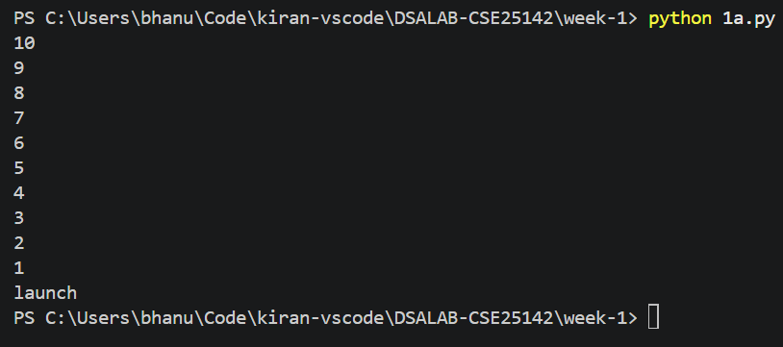
Output:

Error Table:
Error | Rectification
No errors

Description:
- calling a function itself is called recursion
- here until the n becomes o the function will call itself and if n is equal to zero then launch will be printed and function will end there.

1b)

Aim:
Banks Calculate the growth of investment using compound interest. The formula requires calculating powers , which can be implemented recursively. Write a recursive program to calculate P^n where
P = Principal growth amount, n = no of years

Program:
# CSE25142 BHANU KIRAN

def main():
result1 = growth(2, 10)
print(result1)
result2 = growth(2, -1)
print(result2)
result3 = growth(2, 0)
print(result3)
result4 = growth(-1, 9)
print(result4)

def growth(p, n):
if p < 0:
print("principal growth cannot be negative : ", end = "")
return
if n == 0:
return 1
if n < 0:
print("number of years cannot be negative : ", end="")
return
else:
return p*growth(p, n-1)

if __name__ == '__main__':
main()

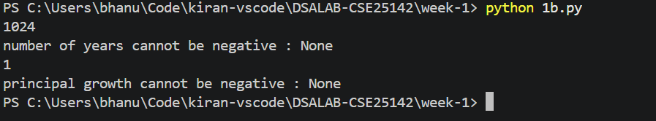
Output:

Error Table:
Error | Rectification
Ignored for the negative values | added n < 0 and p < 0 conditions, to handle the negative values

Description:
- to calculate the power the number need to get multiplied to itself multiple times, to achieve that using recursion we need to multiply it with itself in each recursion call.
- Here n is reduced and passed in each iteration in order identify the stopping condition. When n becomes 0 then 1 will be returned and the recursion calls will stop.
- If the growth and n is negative then the respective message will be called as they are considered edge cases.

1c)

Aim:
A HR department stores employee details in a list. Develop a recursive program to search for a given employee ID. Write a recursive function to search for an employee ID in a list.

Program:
# CSE25142 BHANU KIRAN
def main():
arr = [23, 24, 25, 26]
result1 = search(arr, 26, 0)
print(result1)
result2 = search(arr, 42, 0)
print(result2)

def search(arr, id, start):
if start == len(arr):
print("id not found :", end="")
return -1
if arr[start] == id:
return start
return search(arr, id, start+1)

if __name__ == '__main__':
main()

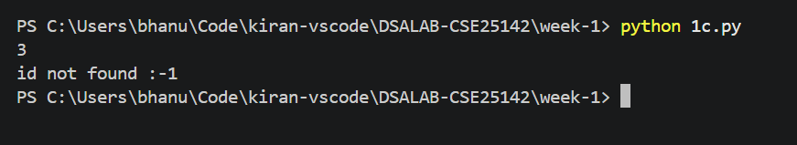
Output:

Error Table:
Error | Rectification
No errors

Description:
- To search for a specific value in an array, the elements need to be checked one by one. To achieve that using recursion, we need to compare the target id with the current element and call the search function again for the next position in each recursive step.
- Here, the start index is incremented and passed in each iteration in order to move through the list and identify the stopping conditions. When the element at arr[start] matches the id, the current index start will be returned and the recursion calls will stop.
- If the start index reaches the total length of the array, it indicates the list has been completely exhausted without finding the element. A respective "not found" message will be printed and -1 will be returned, as this acts as the edge case for a missing value.

Description:
- In each recursion call, the id, arr and the start will be passed.
- The start will start from 0. In each call it will check it will check if the id is at the start position. If not found then it will call itself and pass the increased start value.
- This will continue until the start position will be the len(arr). If the start index becomes len(arr) then that means the target is not in the arr and continuing the process further will result in index out bound error. To avoid that the recursion call should be stopped. Hence, this must act as the stopping condition.

1d)

Aim:
In a logistic department, the no of possible ways to arrange n diff parcels are calculated using the factorial formula(n!). Write a recursive formula to find the factorial of a given number

Program:
#CSE25142 BHANU KIRAN
def main():
result = fac(0)
print(result)

def fac(n):
if n==0:
return 1
return n*fac(n-1)

if __name__ == '__main__':
main()

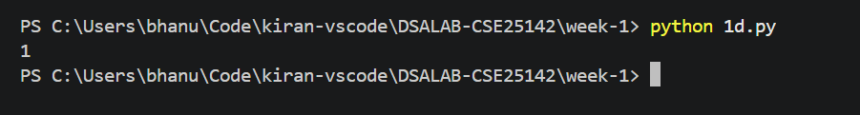
Output:

Error Table:
Error | Rectification
Didn’t implement for the negative values | Need to update

Description:
- To calculate the factorial, a number needs to be multiplied by all positive integers less than it. To achieve that using recursion, we need to multiply the current number n with the function called on n-1 in each recursion call.
- Here n is reduced by 1 and passed in each iteration in order to reach the stopping condition. When n becomes 0, then 1 will be returned and the recursion calls will stop.
- The main function specifically passes 0 to demonstrate the base condition. Because 0 is passed, it immediately hits the stopping condition and returns 1 without needing further recursive calls, handling the standard mathematical edge case for 0!.

1e)

Aim:
Print first n terms in a fibanocci number

Program:
# cse25142 BHANU KIRAN
def main():
print_fib(6)

def fib(n):
if n == 1:
return 0
if n == 2:
return 1
else:
return fib(n-1) + fib(n-2)

def print_fib(n):
for i in range(1, 9):
print(fib(i))

if __name__ == '__main__':
main()

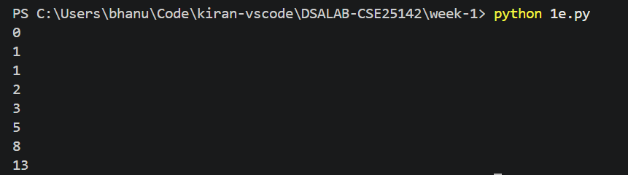
Output:

Error Table:
Error | Rectification
Failed to print the fibanocci number series in the same recursion definition | Added a new function with loops for printing the numbers

Description:
- To calculate a number in the Fibonacci sequence, it needs to be the sum of the two preceding numbers. To achieve this using recursion, we need to add the results of two separate function calls—one for n-1 and one for n-2—in each recursive step.
- Here n is reduced and passed into these dual calls in each iteration to eventually branch down and identify the stopping conditions. When n reaches 1, it returns 0, and when n reaches 2, it returns 1, which stops further recursive calls for those branches.
- These two specific conditions act as the required edge cases (or base cases), representing the first and second numbers of the Fibonacci sequence that are needed to build up the final sum.

Lab – 2

2a)

Aim:
Write a program for the linear search algorithm

Program:
# CSE 25142 BHANU KIRAN
def main():
# THE IMPLEMENTATION PART INCLUDING TAKING THE INPUTS
print("enter number of elements")
n = int(input(">"))
arr = []
print("Enter the elements:")
for _ in range(n):
arr.append(int(input(">")))
print("Enter the key value")
key = int(input(">"))
result = linear_search(arr, key)
if result ==-1:
print(f"{key} not found in the array")
else:
print(f"{key} found at the position {result}")

# LINEAR SEARCH ALGORITHM
def linear_search(arr, key):
for i in range(len(arr)):
if arr[i] == key:
return i
return -1
if __name__ == '__main__':
main()

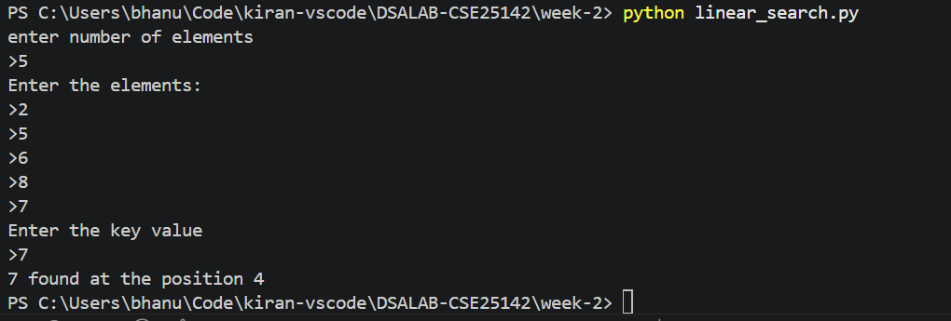
Output:

Error Table:
Error | Rectification
Forgot to return at the end which lead to the program returning none when the element is not found | Returned -1 at the very end which fixed the element not found case

Description:
- To search for a specific value in an array using a linear search, we need to inspect each element sequentially. To achieve that, we use a loop to iterate through the list and compare the target key with the current element in each step.
- Here, an index i is used to traverse the array from start to finish. When the element at arr[i] matches the key, the target is successfully found, and the function immediately returns that index position, stopping any further checks.
- If the loop finishes its entire execution without finding a match, the function returns -1. The main program accounts for this by checking the result and handling it appropriately, either displaying the found position or informing the user that the element does not exist in the array.

2b)

Aim:
Write a program for binary search algorithm considering the elements to be sorted

Program:
# CSE 25142 BHANU KIRAN

def main():
# method for the sorted array
print("enter no of elements ")
n = int(input('>'))
arr = []
for i in range(n):
arr.append(int(input(f"{i} element: ")))
key = int(input("enter the key value: "))
result = binary_search(arr, key)
if result != -1:
print(f"the {key} found at {result} index")
else:
print(f"{key} not found")

def binary_search(arr, key):
start = 0
end = len(arr) - 1
while start <= end:
mid = (start + end)//2
if arr[mid] == key:
return mid
elif arr[mid] > key:
end = mid - 1
else:
start = mid + 1
return -1

if __name__ == '__main__':
main()

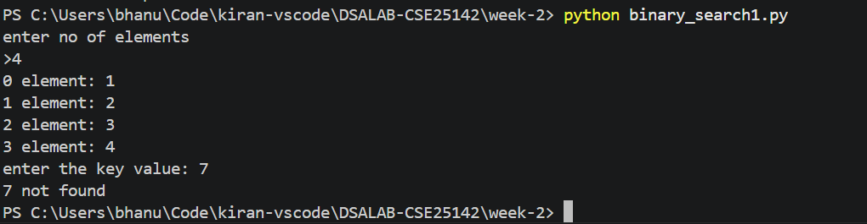
Output:

Error Table:
Error | Rectification
Wrote the mid formula outside the while loop which gave the infinite loop error | Added the mid formula inside the while loop

Description:
- To find a specific value efficiently within a sorted array, the search space needs to be continuously halved. To achieve that, we use a while loop to calculate the middle element of the current boundaries and compare it with the target key in each iteration.
- Here, the start and end pointers are dynamically adjusted to narrow down the search area. If the key is smaller than the middle element, the end pointer is reduced; if it is larger, the start pointer is increased. When the middle element exactly matches the key, the index position is returned and the loop stops.
- If the start pointer becomes greater than the end pointer, it indicates the search space has been completely exhausted and the element does not exist, so -1 is returned. The main program uses this result to display either the successful index position or a "not found" message.

2c)

Aim:
Write a program for implementation of binary search along with the sorting the elements

Program:
def main():
n = int(input("Enter no of elements: "))
arr = []
for _ in range(n):
arr.append(int(input()))
key = int(input("enter the key value: "))
result = binary_search(arr, key)
if result != -1:
print(f"{key} found at {result} index")
else:
print(f"{key} not found")
def binary_search(arr, key):
if arr == sorted(arr):
print("the array is already sorted")

else:
print("the array is not sorted\n sorting the array........")
arr.sort()
# the same binary search problem
start = 0
end = len(arr) - 1
while start <= end:
mid = (start + end)//2
if arr[mid] == key:
return mid
elif arr[mid] > key:
end = mid - 1
else:
start = mid + 1
return -1
if __name__ == '__main__':
main()

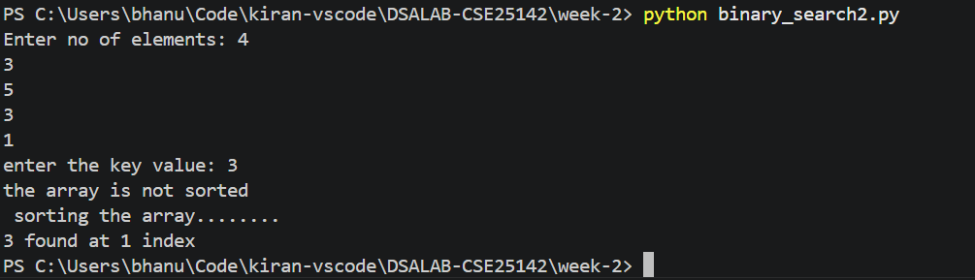
Output:

Error Table:
Error | Rectification
Used sorted method instead of which need to be referred to another variable as it returns a sorted array | Used the arr.sort() method which directly sorts the arr without using another variable

Description:
- To search for a specific value efficiently using binary search, the array must strictly be in ascending order. To achieve this, the function first checks if the array is already sorted; if it is not, it explicitly sorts the array before proceeding with the halving algorithm.
- Here, a while loop is used where start and end pointers are dynamically adjusted to narrow down the search area in each iteration. By calculating the middle element and comparing it with the key, the pointers are shifted until a match is found, at which point the index is returned and the loop stops.
- If the start pointer exceeds the end pointer, it indicates the search space has been completely exhausted and the element does not exist, returning -1. The main program handles this by either printing the index position (relative to the now-sorted array) or notifying the user that the element was not found.

Lab – 3

3a)

Aim:
Write a python program to implement bubble sort where the input elements are taken from the user.

Program:
# CSE25142 BHANU KIRAN

def main():
arr = []
n = int(input("Enter number of elements: "))
for i in range(n):
num = int(input(f"Enter the {i+1} element: "))
arr.append(num)
bubble_sort(arr)
print(arr)

def bubble_sort(arr):
n = len(arr)
for i in range(len(arr)):
for j in range(n-i-1):
if arr[j] > arr[j+1]:
arr[j], arr[j+1] = arr[j+1], arr[j]

if __name__ == '__main__':
main()

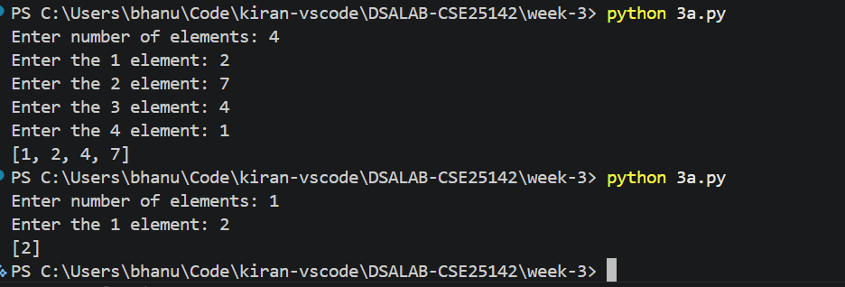
Output:

Error Table:
Error | Rectification
Gave the numbers in descending order | Changed the sign symbol while comparing the adjacent elements.

Description:
- To organize an array into a sorted order, its elements need to be systematically compared and rearranged. To achieve that using this sorting approach, we use nested loops to evaluate pairs of elements and swap their positions if they are found to be out of order.
- Here, an outer loop tracks the current pass, and an inner loop iterates through the remaining unsorted portion of the array. In each iteration, values are compared, and swapping them gradually shifts or "bubbles" the elements toward their correct positions step by step.
- As the outer loop progresses, the range of the inner loop is reduced (n-i-1) because a portion of the array is already correctly placed. Once the nested loops finish their complete execution, the array is successfully sorted in place, and the main function prints the final modified list.

3b)

Aim:
Write a python program to implement insertion sort where the input elements are taken from the user.

Program:
# CSE25142 BHANU KIRAN

def main():
arr = []
n = int(input("Enter number of elements: "))
for i in range(n):
num = int(input(f"Enter the {i+1} element: "))
arr.append(num)
insertion_sort(arr)
print(arr)

def insertion_sort(arr):
for i in range(1, len(arr)):
key = arr[i]
j = i -1
while j >=0 and arr[j] > key:
arr[j+1] = arr[j]
j = j-1
arr[j+1] = key

if __name__ == '__main__':
main()

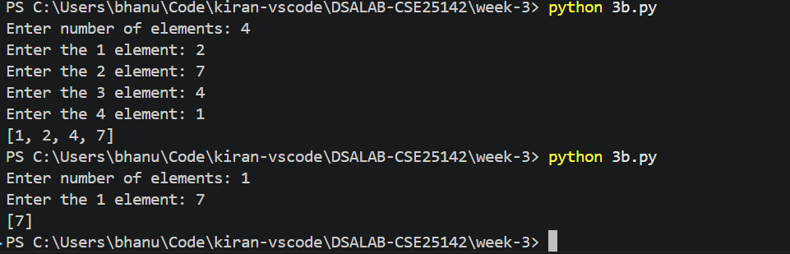
Output:

Error Table:
Error | Rectification
Compared arr[i] and arr[j] which led to the arr being same | Compared arr[j] and arr[j+1]
Took the sign arr[j] < arr[j+1] which sorted in the descending order | Changed to arr[j] > arr[j+1]

Description:
- To organize an array into a sorted order, each element needs to be inserted into its proper place among the already evaluated items. To achieve that using insertion sort, we need to take a current element (the key) and compare it backwards against the preceding elements in each iteration.
- Here, an outer loop moves through the array, while an inner while loop traverses the sorted portion backwards. As long as the preceding elements are greater than the key, they are shifted one position to the right. When a smaller element is found or the beginning of the list is reached, the shifting stops.
- The key is then placed into this newly identified correct position (j+1). As the outer loop progresses through the entire array, the sorted portion incrementally grows until the whole list is sorted in place, and the main function prints the final ordered array.

3c)

Aim:
Write a python program to implement selection sort where the input elements are taken from the user.

Program:
# CSE25142 BHANU KIRAN

def main():
arr = []
n = int(input("Enter number of elements: "))
for i in range(n):
num = int(input(f"Enter the {i+1} element: "))
arr.append(num)
selection_sort(arr)
print(arr)

def selection_sort(arr):
for i in range(len(arr)-1):
min_index = i
for j in range(i+1, len(arr)):
if arr[j] < arr[min_index]:
min_index = j
arr[i], arr[min_index] = arr[min_index], arr[i]

if __name__ == '__main__':
main()

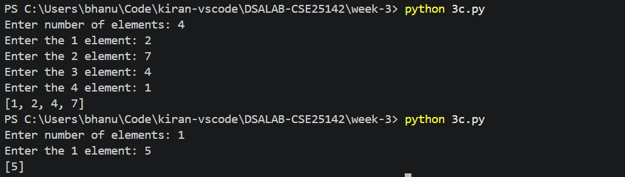
Output:

Error Table:
Error | Rectification
Forgot to initialize the min_index initaially to i | Initialized it in the outer loop but before the inner loop
Index out of bound error | Took the outer loop range(len(arr)) instead of range(len(arr)-1)

Description:
- To organize an array into a sorted order, the smallest elements need to be systematically identified and moved to the front. To achieve that using selection sort, we need to scan the unsorted portion of the array to find the minimum value in each iteration.
- Here, an outer loop tracks the target position for the next smallest element, while an inner loop traverses the remaining elements to locate the exact index (min_index) of this minimum value. Whenever a strictly smaller element is found during this inner scan, the index tracker is updated to point to it.
- After the inner loop completes its search, the found minimum element is swapped with the element at the current outer loop's starting position. This process securely locks one more sorted element into place per pass until the entire array is ordered, and the main function prints the final list.

Week – 4

4a)

Aim:
Write a python program to implement merge sort where the input elements are taken from the user

Code:
# CSE25142 BHANU KIRAN

def main():
print("rollno : cse25142\nname : P. Bhanu Kiran\n")
n = int(input("Enter size of array: "))
arr = []
for i in range(n):
arr.append(input(f"enter {i+1} element: "))
sorted_arr = merge_sort(arr)
print(sorted_arr)

def merge_sort(arr):
if len(arr) <= 1:
return arr
mid = len(arr) // 2
left = merge_sort(arr[:mid])
right = merge_sort(arr[mid:])
return merge(left, right)

def merge(left, right):
arr = []
i = 0
j = 0
while i < len(left) and j < len(right):
if left[i] <= right[j] :
arr.append(left[i])
i += 1
else:
arr.append(right[j])
j += 1
arr.extend(left[i:])
arr.extend(right[j:])
return arr

if __name__ == '__main__':
main()

Output:
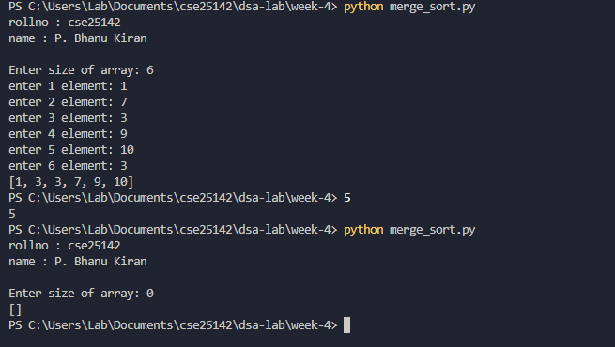

Error Table:
Error | Rectification
RecursionError: maximum recursion depth exceeded | base case in merge_sort() len(arr) <1 to len(arr) <= 1
PS C:\Users\Lab\Documents\cse25142\dsa-lab\week-4> python merge_sort.py  [2, 3, 7, 7, 8, 3, 7, 7, 8, 7, 7, 8] | kept the extend in the while loop instead of out of while loop

Description:
- The program implements the Merge Sort algorithm.
- The user enters the size of the array.
- The elements are taken from the user and stored in a list.
- The merge_sort() function recursively divides the array into two halves.
- The array is divided until each sub-array contains one or zero elements.
- The left and right portions are then sorted recursively.
- The sorted left and right arrays are compared element by element.
- The smaller element is placed into the original array.
- Remaining elements from either portion are then copied into the array.
- Finally, the completely sorted array is displayed.
- Merge Sort follows the divide-and-conquer approach.

4b)

Aim:
Write a python program to implement quick sort where the input elements are taken from the user.

Code:
# CSE 25142 BHANU KIRAN

def main():
print("rollno : cse25142\nname : P. Bhanu Kiran\n")
n = int(input("Enter size of array: "))
arr = []
for i in range(n):
arr.append(int(input(f"enter {i+1} element: ")))
quick_sort(arr, 0, n-1)
print(arr)

def quick_sort(a, low, high):
if low < high:
i = low
j = high
pivot = low

while i < j:
while i < len(a) and a[i] < a[pivot]:
i += 1
while a[j] > a[pivot]:
j -= 1
if i < j:
a[i], a[j] = a[j], a[i]
a[j], a[pivot] = a[pivot], a[j] # placing the pivot in the correct position
quick_sort(a, low, j-1) # left part
quick_sort(a, j+1, high) #right part

if __name__ == '__main__':
main()

Output:
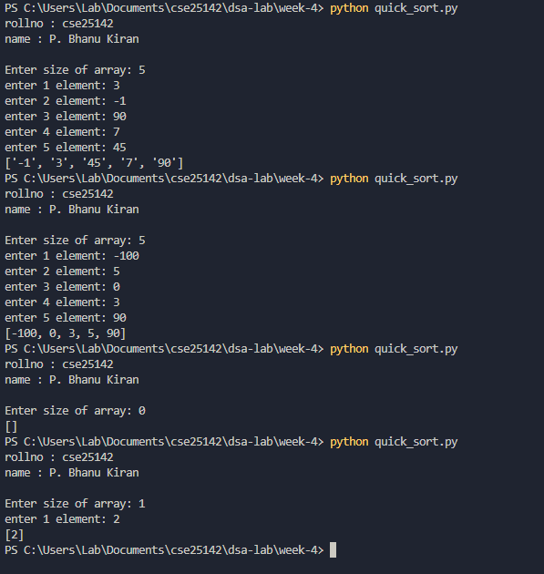

Error Table:
Error | Rectification
PS C:\Users\Lab\Documents\cse25142\dsa-lab\week-4> python quick_sort.py  rolln0 : cse25142  name : P. Bhanu Kiran  Enter size of array: 7  enter 1 element: 2  enter 2 element: 3  enter 3 element: 56  enter 4 element: 9  enter 5 element: -`  enter 6 element:  enter 7 element: 2 | Instead of inputting the integers, inputted the string added int before the input  arr.append(int(input(f”enter {i+1} element”)
PS C:\Users\Lab\Documents\cse25142\dsa-lab\week-4> python quick_sort.py  Traceback (most recent call last):  File "C:\Users\Lab\Documents\cse25142\dsa-lab\week-4\quick_sort.py", line 24, in <module>  main()  File "C:\Users\Lab\Documents\cse25142\dsa-lab\week-4\quick_sort.py", line 5, in main  quick_sort(arr)  TypeError: quick_sort() missing 2 required positional arguments: 'low' and 'high'  PS C:\Users\Lab\Documents\cse25142\dsa-lab\week-4> | added the two parameters to the function
Traceback (most recent call last):  File "C:\Users\Lab\Documents\cse25142\dsa-lab\week-4\quick_sort.py", line 29, in <module>  main()  File "C:\Users\Lab\Documents\cse25142\dsa-lab\week-4\quick_sort.py", line 9, in main  print(quick_sort(arr, 0, n-1))  ^^^^^^^^^^^^^^^^^^^^^^^  File "C:\Users\Lab\Documents\cse25142\dsa-lab\week-4\quick_sort.py", line 26, in quick_sort  quick_sort(a, j+1, high) #right part  ^^^^^^^^^^^^^^^^^^^^^^^^  File "C:\Users\Lab\Documents\cse25142\dsa-lab\week-4\quick_sort.py", line 24, in quick_sort  a[j], a[pivot] = a[pivot] = a[j] # placing the pivot in the correct position  ^^^^^^^^^^^^^^  ValueError: too many values to unpack (expected 2) | Placed a comma

Description:
- The program implements the Quick Sort algorithm.
- The user enters the size of the array.
- The elements are taken from the user and stored in a list.
- The quick_sort() function is used to sort the array recursively.
- The first element of the current portion is selected as the pivot.
- Two pointers, i and j, are used to compare elements with the pivot.
- i moves from the left side and searches for an element greater than or equal to the pivot.
- j moves from the right side and searches for an element smaller than or equal to the pivot.
- If i < j, the two elements are swapped.
- After the partitioning process, the pivot is placed in its correct position.
- The array is then divided into left and right portions.
- Quick Sort is recursively applied to both portions.
- Finally, the sorted array is printed.

Week – 5

5a)

Aim:
Write a Python program to implement a Singly Linked List (SLL) with the following operations:
1. Create LL
2. Insert at Beginning
3. Insert at End
4. Insert at Index
5. Delete by Value
6. Delete Prior Node
7. Delete Last Node
8. Count Number of Nodes
9. Display/Traverse
10. Exit

Code:
# CSE25142 Bhanu Kiran
def main():
print("CSE25142 Bhanu Kiran\n")
while True:
print(
"1.create\n2.insert at beginning\n3.insert at end\n4.insert at certain position\n5.delete first node\n6.delete last node\n7.delete specific node\n"
"8.count\n9.display\n10.exit"
)
option = input("Enter your choice: ")
if option == "1":
my_LinkedList = LinkedList()
print("linked list successfully created")
elif option == "2":
my_LinkedList.insert_begin(int(input("Enter the data: ")))
print("element is inserted")
elif option == "3":
my_LinkedList.insert_end(int(input("Enter the data: ")))
print("element inserted")
elif option == "4":
my_LinkedList.insert_position(
int(input("Enter the data: ")), int(input("Enter the position: "))
)
print("element inserted")
elif option == "5":
my_LinkedList.delete_begin()
print("first node deleted")
elif option == "6":
my_LinkedList.delete_end()
print("last node deleted")
elif option == "7":
my_LinkedList.delete_position(int(input("Enter position: ")))
print("node at position is deleted")
elif option == "8":
count = my_LinkedList.size()
print("the size of linked list is {}".format(count))
elif option == "9":
my_LinkedList.display()
elif option == "10":
print("exiting the program")
break
else:
print("option not defined")

class LinkedList:
def __init__(self):
self.head = None

def insert_begin(self, data):
node = Node(data)
if self.head is None:
self.head = node
return
node.next = self.head
self.head = node

def insert_end(self, data):
if self.head is None:
self.insert_begin(data)
return
node = Node(data)
temp = self.head
while temp.next:
temp = temp.next
temp.next = node

def size(self):
temp = self.head
count = 0
while temp:
temp = temp.next
count += 1
return count

def insert_position(self, data, pos):
if pos - 1 == 0:
self.insert_begin(data)
return
if pos < 1 or pos > self.count():
print("position not available")
return
temp = self.head
node = Node(data)
count = 0
while count < pos - 1:
temp = temp.next
node.next = temp.next.next
temp.next = node

def display(self):
temp = self.head
while temp:
print(temp.data, end=" <-> ")
temp = temp.next
print("None")

def delete_begin(self):
if self.head is None:
print("The Linked list is empty")
return
self.head = self.head.next

def delete_end(self):
if self.head is None:
print("The Linked list is empty")
return
temp = self.head
while temp.next.next:
temp = temp.next
temp.next = None

def delete_position(self, pos):
if self.head is None:
print("Empty linked list")
return
if pos < 0 or pos > self.size():
print("position do not exists")
return
temp = self.head
count = 0
while count < pos - 1:
temp = temp.next
count += 1
temp.next = temp.next.next

temp = self.head
count = 0
while count < pos - 1:
temp = temp.next
count += 1

class Node:
def __init__(self, data):
self.data = data
self.next = None

if __name__ == "__main__":
main()

Output:

Error Table:
Error | Rectification
The program may display an incorrect message for insertion at a specific index even when the index is invalid | Check whether the index is valid before displaying the successful insertion message.

Description:
- The program implements a Singly Linked List using Python classes.
- The Node class is used to create individual nodes.
- Each node contains two parts: data and next.
- data stores the value of the node.
- next stores the reference to the next node.
- The SingleLinkedList class manages the linked list.
- The head variable stores the reference to the first node.
- The program provides an option to create a linked list.
- It supports insertion at the beginning of the list.
- It supports insertion at the end of the list.
- It supports insertion at a specific index.
- It supports deletion of a specific value.
- It supports deletion of the first node.
- It supports deletion of the last node.
- It provides a function to count the number of nodes.
- It provides a function to display/traverse all the nodes.
- A menu-driven approach is used to allow the user to select different operations.
- The program continues running until the user selects the Exit option

5b)

Aim:
Write a Python program to implement a Double Linked List (DLL) with the following operations:
1. Create LL
2. Insert at Beginning
3. Insert at End
4. Insert at Index
5. Delete by Value
6. Delete Prior Node
7. Delete Last Node
8. Count Number of Nodes
9. Display/Traverse
10. Exit

Code:
#CSE25142 Bhanu Kiran

def main():
print("CSE25142 Bhanu Kiran\n")
while True:
print("\n---menu---\n1.Create DLL\n2.insert begin\n3.insert end" \
"\n4.insert index\n5.delete begin\n6.delete end\n7.delete value\n8.size of DLL\n9.exit")
o = input("Enter a choice: ")
match o:
case '1':
dll = DLL()
result = dll.create()
case '2':
dll.insert_begin(int(input("Enter the data: ")))
case '3':
dll.insert_end(int(input("Enter the data: ")))
case '4':
dll.insert_index(int(input("Enter the index: ")))
case '5':
dll.delete_begin()
case '6':
dll.delete_end()
case '7':
dll.delete_value(int(input("Enter the value: ")))
case '8':
dll.size()
case '9':
break
case _:
print("invalid choice")
print("Exiting the program........")

class Node:
def __init__(self, data):
self.data = data
self.next = None
self.prev = None
class DLL:
def __init__(self):
self.head = None
def create(self):
n = int(input("Enter the no of nodes: "))
for i in range(n):
data = int(input("Enter the data: "))
new = Node(data)
if self.head is None:
self.head = new
return
temp = self.head
while temp.next:
temp = temp.next
temp.next = new
new.prev = temp
return 1
def insert_begin(self, data):
new = Node(data)
if self.head is None:
self.head = new
return
self.head.prev = new
new.next = self.head
self.head = new
def insert_end(self, data):
new = Node(data)
if self.head is None:
self.insert_begin(data)
return
temp = self.head
while temp.next:
temp = temp.next
temp.next= new
new.prev = temp
def insert_index(self, data, index):
new = Node(data)
if index == 0:
self.insert_begin(data)
return
if index < 0:
print("not possible")
temp = self.head
for i in range(index-1):
if temp is None:
print("Not available")
return
temp = temp.next
if temp.next:
temp.next.prev = new
new.next = temp.next
temp.next = new
new.prev = temp
def size(self):
count = 0
if self.head is None:
print("List is Empty")
return count
temp = self.head
while temp:
count += 1
temp = temp.next
print(f"the dll contains {count} elemetns")
return count
def delete_begin(self):
if self.head is None:
print("Empty list")
return -1
if self.head.next is None:
self.head = None
return 1
self.head = self.head.next
self.head.prev = None
return 1
def delete_end(self):
if self.head is None:
self.insert_begin()
return
if self.head.next is None:
self.head = None
return 1
temp = self.head
while temp.next:
temp = temp.next
temp.prev.next = None
temp.prev = None
return 1
def delete_value(self, value):
if self.head is None:
print("The list is empty")
return -1
if self.head.data == value:
self.head = self.head.next
return 1
temp = self.head
while temp.next and temp.next.data != value:
temp = temp.next
if temp.next is None:
print("Value not available")
return -1
temp.prev.next = temp.next
if temp.next:
temp.next.prev = temp.prev
return 1

if __name__ == '__main__':
main()

Output:

Error Table:
Error | Rectification
The prev and next links may not be updated correctly during insertion or deletion. | Update both links whenever a node is inserted or deleted.

Description:
- The program implements a Doubly Linked List using Python classes.
- The Node class is used to create individual nodes.
- Each node contains three parts: data, prev, and next.
- data stores the value of the node.
- prev stores the reference to the previous node.
- next stores the reference to the next node.
- The DoubleLinkedList class is used to manage the linked list.
- The head variable stores the reference to the first node.
- The program provides an option to create a doubly linked list.
- It supports insertion at the beginning of the list.
- It supports insertion at the end of the list.
- It supports insertion at a specific index.
- It supports deletion of a specific value.
- It supports deletion of the first node.
- It supports deletion of the last node.
- It provides a function to count the number of nodes.
- It provides a function to display/traverse the list.
- During insertion and deletion, both prev and next links are updated.
- The list is displayed using <--> to show the connection between nodes.
- A menu-driven approach is used to perform different DLL operations.
- The program continues until the user selects the Exit option.

5c)

Aim:
Write a Python program to implement a Circular Linked List (CLL) with the following operations:
1. Create LL
2. Insert at Beginning
3. Insert at End
4. Insert at Index
5. Delete by Value
6. Delete Prior Node
7. Delete Last Node
8. Count Number of Nodes
9. Display/Traverse
10. Exit

Code:
# cse25412 Bhanu Kiran
print("Implementation of CLL")

class Node:
def __init__(self, data):
self.data = data
self.next = None

class CircularLinkedList:
def __init__(self):
self.head = None

# Creation
def create(self):
n = int(input("Enter no of elements: "))

for i in range(n):
data = int(input("Enter the values: "))
new = Node(data)

if self.head is None:
self.head = new
new.next = self.head
else:
temp = self.head

while temp.next != self.head:
temp = temp.next

temp.next = new
new.next = self.head

# Insert begin
def insert_begin(self, data):
new = Node(data)

if self.head is None:
self.head = new
new.next = self.head
else:
temp = self.head

while temp.next != self.head:
temp = temp.next

new.next = self.head
self.head = new
temp.next = self.head

# Insert end
def insert_end(self, data):
new = Node(data)

if self.head is None:
self.head = new
new.next = self.head
else:
temp = self.head

while temp.next != self.head:
temp = temp.next

temp.next = new
new.next = self.head

# Insert at specific index
def insert_index(self, index, data):
if index < 0:
print("Invalid index")
return

if index == 0:
self.insert_begin(data)
return

if self.head is None:
print("Invalid index")
return

temp = self.head

for i in range(index - 1):
if temp.next == self.head:
print("Invalid index")
return

temp = temp.next

new = Node(data)
new.next = temp.next
temp.next = new

# Delete specific value
def delete(self, data):
if self.head is None:
print("No data")
return

# If head contains the value
if self.head.data == data:

# Only one node
if self.head.next == self.head:
self.head = None
print("Value deleted")
return

temp = self.head

while temp.next != self.head:
temp = temp.next

temp.next = self.head.next
self.head = self.head.next

print("Value deleted")
return

temp = self.head

while temp.next != self.head and temp.next.data != data:
temp = temp.next

if temp.next == self.head:
print("Value not present")
else:
temp.next = temp.next.next
print("Value deleted")

# Delete begin
def delete_begin(self):
if self.head is None:
print("No data to delete")
return

# Only one node
if self.head.next == self.head:
print("Deleted value = ", self.head.data)
self.head = None
return

temp = self.head

while temp.next != self.head:
temp = temp.next

print("Deleted value = ", self.head.data)

temp.next = self.head.next
self.head = self.head.next

# Delete end
def delete_end(self):
if self.head is None:
print("No data to delete")
return

# Only one node
if self.head.next == self.head:
print("Deleted value = ", self.head.data)
self.head = None
return

temp = self.head

while temp.next.next != self.head:
temp = temp.next

print("Deleted value = ", temp.next.data)

temp.next = self.head

# Count
def count(self):
if self.head is None:
print("No data to count")
return

count = 0
temp = self.head

while True:
count += 1
temp = temp.next

if temp == self.head:
break

print(f"Number of nodes = {count}")

# Display / Traverse
def display(self):
if self.head is None:
print("No data")
return

temp = self.head

while True:
print(temp.data, end="-->")
temp = temp.next

if temp == self.head:
break

print("HEAD")

# Calling main function
CLL = CircularLinkedList()

print("cse25142 Bhanu Kiran\n")
while True:
print("\n1.Create CLL")
print("2.Insert at beginning")
print("3.Insert at ending")
print("4.Insert at index")
print("5.Delete by value")
print("6.Delete first node")
print("7.Delete last node")
print("8.Count no of nodes")
print("9.Display / Traverse")
print("10.Exit")

choice = int(input("Enter your choice: "))

if choice == 1:
CLL.create()
print("CLL is created")

elif choice == 2:
data = int(input("Enter data to insert: "))
CLL.insert_begin(data)
print("Data is inserted at beginning")

elif choice == 3:
data = int(input("Enter data to insert: "))
CLL.insert_end(data)
print("Data is inserted at ending")

elif choice == 4:
data = int(input("Enter data to insert: "))
index = int(input("Enter the index: "))
CLL.insert_index(index, data)

elif choice == 5:
data = int(input("Enter data to delete: "))
CLL.delete(data)

elif choice == 6:
CLL.delete_begin()

elif choice == 7:
CLL.delete_end()

elif choice == 8:
CLL.count()

elif choice == 9:
CLL.display()

elif choice == 10:
print("Exiting the program")
break

else:
print("Invalid choice")

Output:

Error Table:
Error | Rectification
No errors

Description:
- The program implements a Circular Linked List using Python classes.
- The Node class is used to create individual nodes.
- Each node contains two parts: data and next.
- data stores the value of the node.
- next stores the reference to the next node.
- In a Circular Linked List, the last node points back to the first node.
- The CircularLinkedList class is used to manage the linked list.
- The head variable stores the reference to the first node.
- The program provides an option to create a circular linked list.
- It supports insertion at the beginning of the list.
- It supports insertion at the end of the list.
- It supports insertion at a specific index.
- It supports deletion of a specific value.
- It supports deletion of the first node.
- It supports deletion of the last node.
- It provides a function to count the number of nodes.
- It provides a function to display/traverse the circular linked list.
- During traversal, the program stops when it reaches the head again.
- The list is displayed using --> and ends with HEAD, showing its circular nature.
- The program handles the special case where the list contains only one node.
- A menu-driven approach is used to perform different CLL operations.
- The program continues until the user selects the Exit option.

Week – 6

6a)

Aim:
Write a Python program to implement stack operations such as Push, Pop, Peek, and Display using an Array.
Code:
# cse25142 Bhanu Kiran
class Stack:
def __init__(self, size):
self.size = size
self.stack = [None]*size
self.top = -1
def push(self,item):
# check for over flow condition
if self.top == self.size-1:
print("Stack over flow")
return
self.top += 1
self.stack[self.top] = item
print(f"{item} inserted into stack")
return
def peek(self):
# check if the stack is empty
if self.top == -1:
print("Stack is empty")
return
# returning the top item in the array
return self.stack[self.top]
def pop(self):
# checking for the under flow condition
if self.top == -1:
print("stack under flow")
return
item = self.stack[self.top]
self.stack[self.top] = None
self.top -= 1
print(f"{item} removed successfully")
def display(self):
if self.top == -1:
print("Empty stack")
return
for i in range(self.top+1):
print(self.stack[i], end=" ")
print("\n")

def main():
print("cse25142 Bhanu Kiran\n")
stack = Stack(5)
stack.push(10)
stack.push(20)
stack.push(30)
stack.push(40)
stack.push(50)
stack.display()
stack.pop()
stack.pop()
stack.display()
stack.peek()
stack.pop()
stack.pop()
stack.pop()
stack.pop()

if __name__ == '__main__':
main()

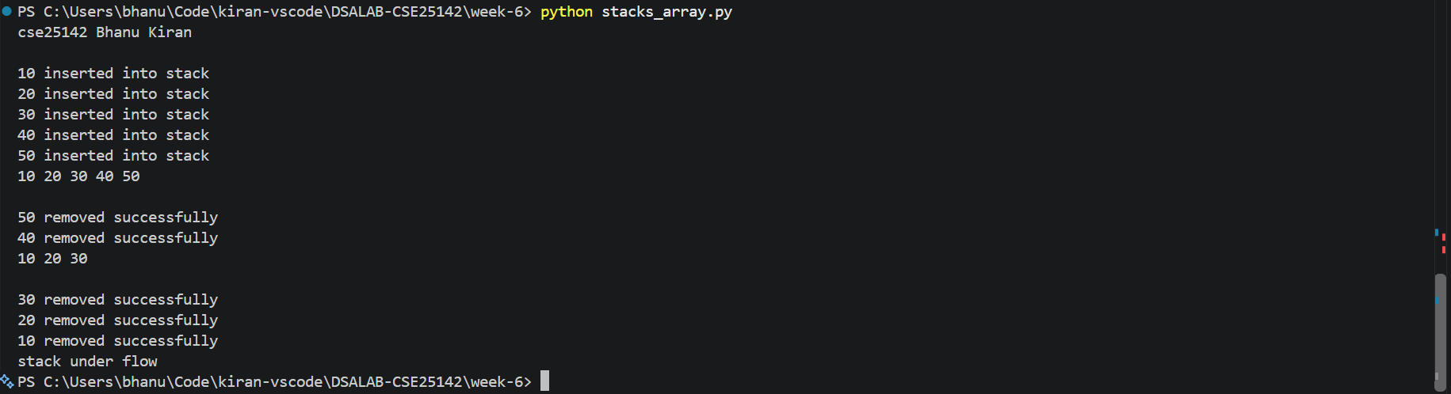
Output:

Error Table:
Error | Rectification
In peek, self.peek is taken in ‘if’ does not give correct answer for stack underflow. | Self.top is taken in ‘if’ to give correct output.

Description:
- The Stack class implements a stack using a Python list.
- size stores the maximum size of the stack.
- stack stores the stack elements.
- top keeps track of the top position. Initially, top = -1, meaning the stack is empty.
- Push adds an element to the top of the stack.
- Pop removes the top element from the stack.
- Peek displays the top element without removing it.
- Display prints all elements from top to bottom.
- Stack Overflow occurs when trying to push into a full stack.
- Stack Underflow occurs when trying to pop from an empty stack.
- The program uses a menu-driven approach with options for Push, Pop, Peek, Display, and Exit.

6b)

Aim:
Write a Python program to implement stack operations such as Push, Pop, Peek, and Display using an Linked List

Code:
# cse25142 Bhanu Kiran
class Node:
def __init__(self, data):
self.data = data
self.next = None

class Stack:
def __init__(self):
self.top = None
def push(self,item):
# since we use linked list, there is no over flow condition
node = Node(item)
if self.top is None:
self.top = node
return
node.next = self.top
self.top = node
print(f"{item} inserted")
def pop(self):
# checking for the under flow condition
if self.top is None:
print("stack under flow")
return
#need to give the self.top to the next node
item = self.top.data
self.top = self.top.next
print(f"{item} removed")
def peek(self):
# checking if the list is empty
if self.top is None:
print("stack is none")
return
# display the top node data
print(f"{self.top.data} is the top item")
def display(self):
# checking if hte stack is empty
if self.top is None:
print("stack is empty")
return
temp = self.top
while temp:
print(f"{temp.data}", end='->')
temp = temp.next
print("None")

def main():
print("cse25142 Bhanu Kiran\n")
stack = Stack()
stack.push(10)
stack.push(20)
stack.push(30)
stack.push(40)
stack.push(50)
stack.display()
stack.pop()
stack.pop()
stack.display()
stack.peek()
stack.pop()
stack.pop()
stack.pop()
stack.pop()
if __name__ =='__main__':
main()

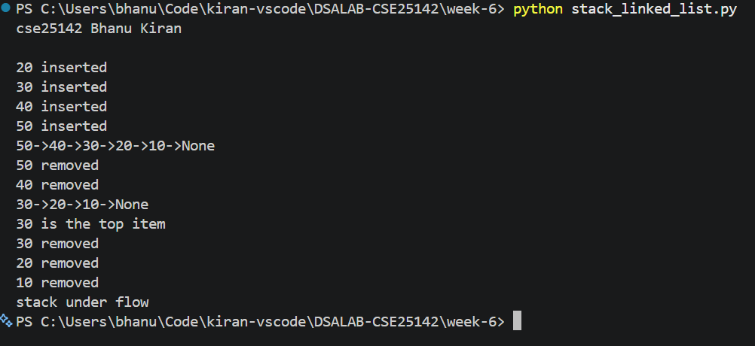
Output:

Error Table:
Error | Rectification
No errors

Description:
- The stack is implemented using a singly linked list.
- Each node contains data and a next pointer.
- top points to the top node of the stack.
- Push inserts a new node at the beginning of the linked list.
- Pop removes the node pointed to by top.
- Peek displays the data of the top node without removing it.
- Display traverses the linked list from top to the last node.
- If top is None, the stack is empty.
- Stack Overflow is not a fixed-size issue here because the stack grows dynamically, subject to available memory.

