C Practice problems set-4

- Write a C program that get absolute value of a number
- Write a program to calculate salary of an employee based on the following condition: If he served the organization for more than 15 years: Calculate 25% of his salary as HRA,Calculate 10% of his salary as DA , Rs1500.00 as bonus to his basic salary.
- Write a program to find whether a person is eligible for voting or not?
- Write a program to print the type of character that is being input
- Classify a person's age group and determine if they are eligible to vote. A person under 18 is a minor, between 18 and 65 is an adult, and above 65 is a senior. Only adults and seniors are eligible to vote.
- C program to check alphabet, digit or special character
- Simple Calculator using switch Statement
- C program to print number of days in a month using switch case
- C program to find cosx and sinx using built-in function and without built-in function
10.A program to print pascal’s triangle
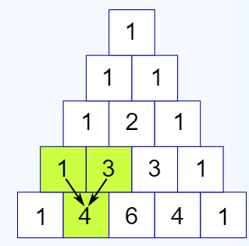

11.A program to print Floyd’s triangle
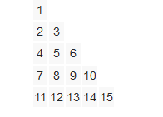
12.A program to print all the palindromes between a given range
If range is 100 to 150, output should be 101 111 121 131 141
13.A program to print number in words(i.e 124 as one two four)
14.A program to print following patterns
* * * * * * * * * | 1 2 3 4 5 6 7 8 9 | A B C D E F G H I
* * * * * * * | 1 2 3 4 5 6 7 | A B C D E F G
* * * * * | 1 2 3 4 5 | A B C D E
* * * | 1 2 3 | A B C
* | 1 | A
* * * | 1 2 3 | A B C
* * * * * | 1 2 3 4 5 | A B C D E
* * * * * * * | 1 2 3 4 5 6 7 | A B C D E F G
* * * * * * * * * | 1 2 3 4 5 6 7 8 9 | A B C D E F G H I
- Write a program to print all multiplication tables from 1 to 10 in a tabular format.
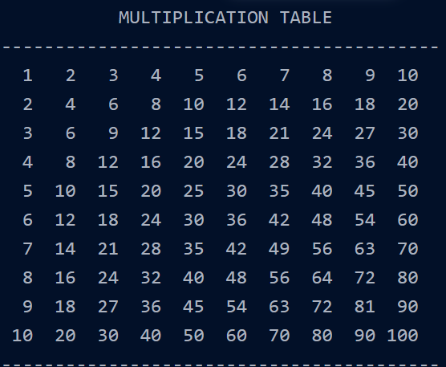
- C program to evaluate below series
- 1+2+3+4+..N
- 1^2+2^2+3^2+4^2+..N^2
- 1/1! + 2/2! + 3/3! + 4/4! + ... N/N!
- 1-1/2 + 1/3 - 1/4 + 1/5 - .. 1/N
- 1 + 3^2/3^3 + 5^2/5^3 + 7^2/7^3 + ... till N terms
- C program to demonstrate goto statement both backward and forward.

