**Week2: JUnit Basic Testing Exercises**

**Exercise 1: Setting Up Junit**

**CODE :**

**pom.xml**

<dependencies>

<dependency>

<groupId>junit</groupId>

<artifactId>junit</artifactId>

<version>4.13.2</version>

<scope>test</scope>

</dependency>

</dependencies>

**Exercise 2: Writing Basic JUnit Tests**

**CODE :**

**Calculator.java**

package org.example;  
public class Calculator {  
 public int add(int a, int b) { return a + b; }  
 public int subtract(int a, int b) { return a - b; }  
}

**CalculatorTest.java**

package org.example;  
import org.junit.Test;  
import static org.junit.Assert.*;  
public class CalculatorTest {  
 @Test  
 public void testAdd() {  
 Calculator calc = new Calculator();  
 *assertEquals*(5, calc.add(2,3));  
 }  
 @Test  
 public void testSubtract() {  
 Calculator calc = new Calculator();  
 *assertEquals*(1, calc.subtract(4,3));  
 }  
}

**OUTPUT:**

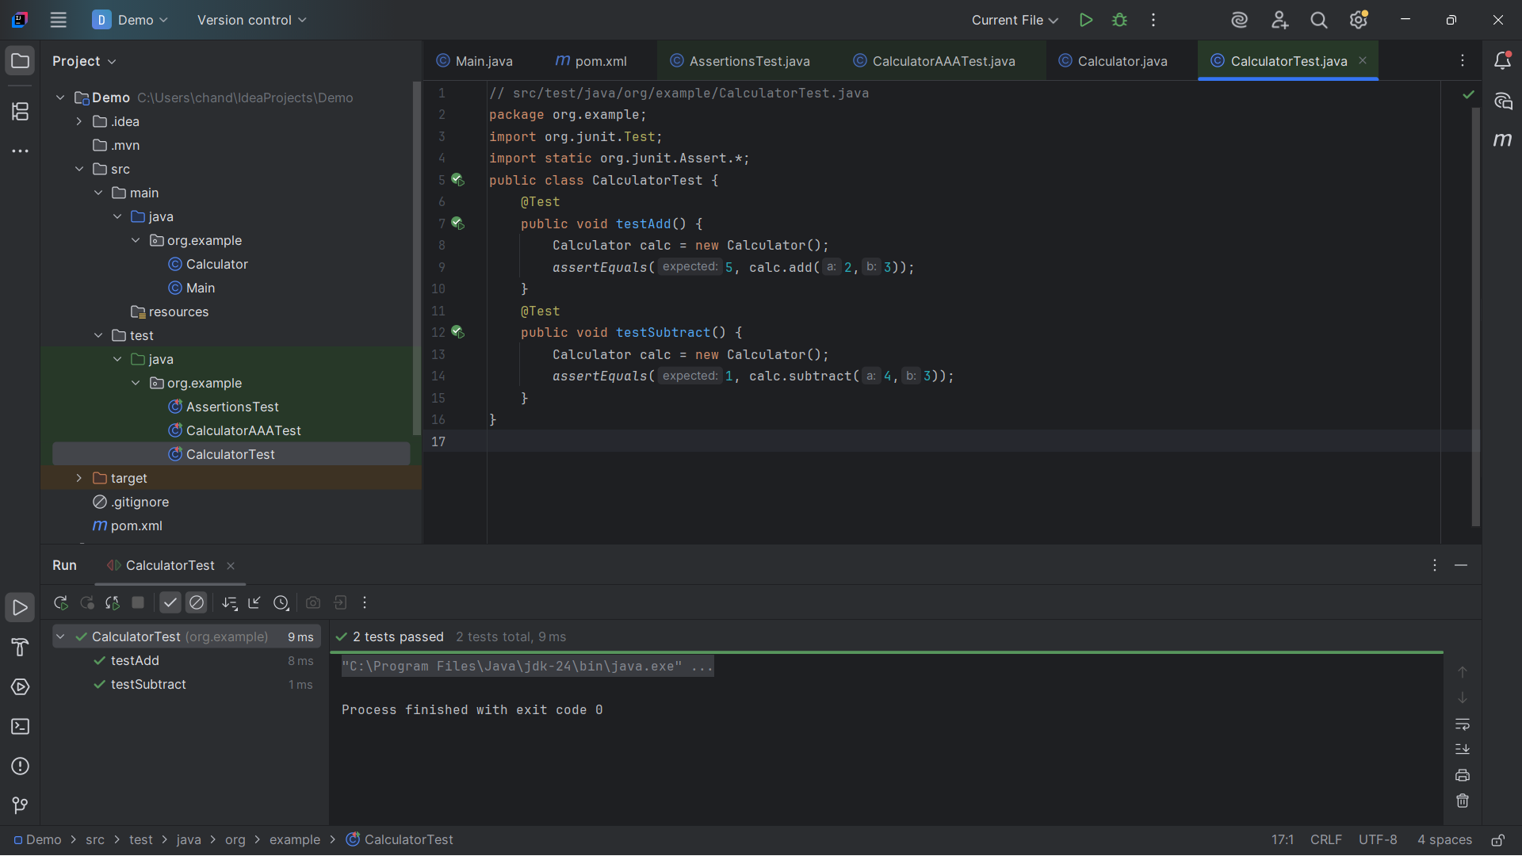

**Exercise 3: Assertions in Junit**

**CODE :**

**AssertionsTest.java**

package org.example;  
import org.junit.Test;  
import static org.junit.Assert.*;  
public class AssertionsTest {  
 @Test  
 public void testAssertions() {  
 *assertEquals*(5, 2 + 3);  
 *assertTrue*(5 > 3);  
 *assertFalse*(5 < 3);  
 *assertNull*(null);  
 *assertNotNull*(new Object());  
 }  
}

**OUTPUT:**

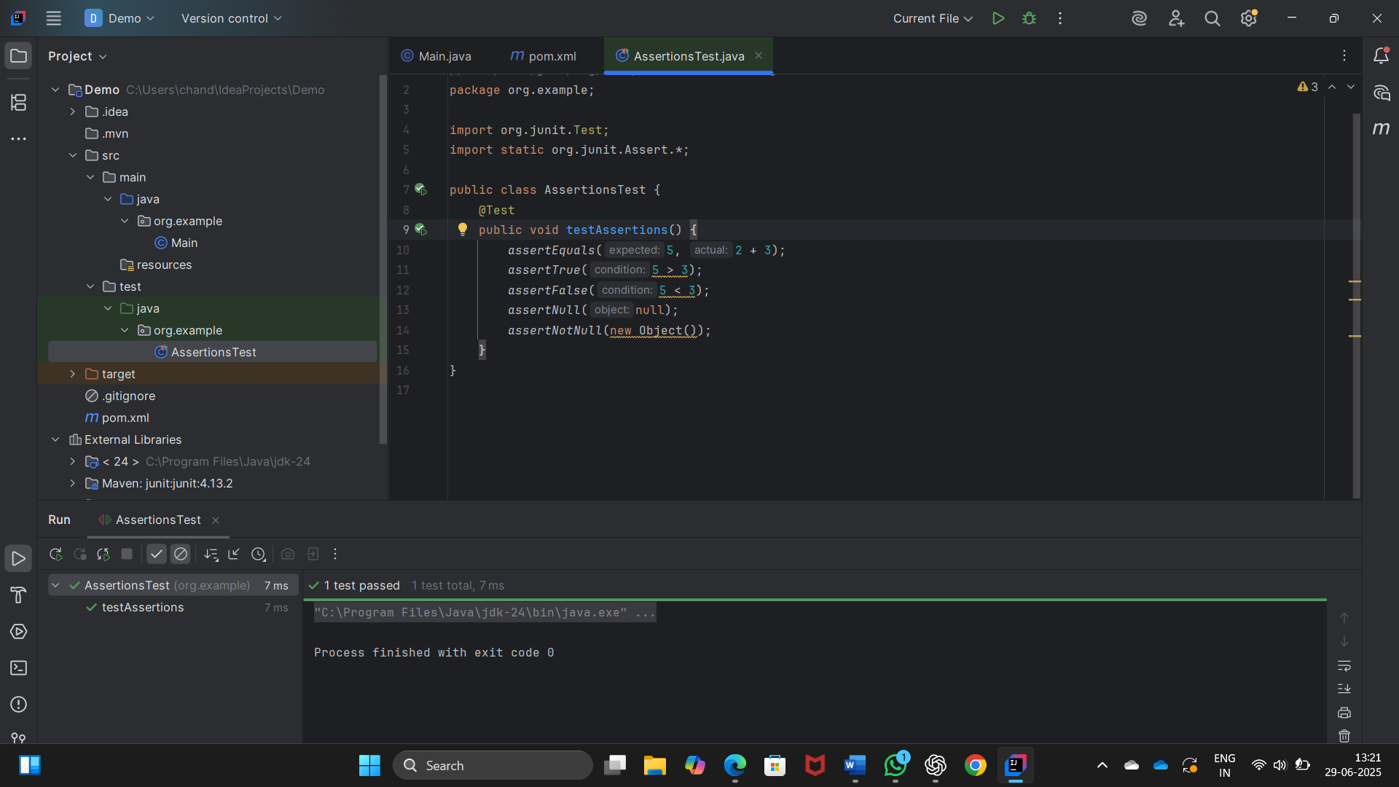

**Exercise 4: Arrange-Act-Assert (AAA) Pattern, Test Fixtures, Setup and Teardown Methods in JUnit**

**CODE :**  
package org.example;  
import org.junit.Before;  
import org.junit.After;  
import org.junit.Test;  
import static org.junit.Assert.*;  
public class CalculatorAAATest {  
 Calculator calc;  
 @Before  
 public void setUp() {  
 calc = new Calculator();  
 System.*out*.println("setup runs before each test");  
 }  
 @After  
 public void tearDown() {  
 System.*out*.println("teardown runs after each test");  
 }  
 @Test  
 public void testAdd() {  
 int a = 4, b = 5; // Arrange  
 int result = calc.add(a, b); // Act  
 *assertEquals*(9, result); // Assert  
 }  
 @Test  
 public void testSubtract() {  
 int a = 9, b = 4; // Arrange  
 int result = calc.subtract(a, b); // Act  
 *assertEquals*(5, result); // Assert  
 }  
}

**OUTPUT:**

