**Week 2 : SLF4J Logging Exercises**

**Exercise 1: Logging Error Messages and Warning Levels**

**CODE :**

**pom.xml**

<dependencies>

<dependency>

<groupId>org.slf4j</groupId>

<artifactId>slf4j-api</artifactId>

<version>1.7.30</version>

</dependency>

<dependency>

<groupId>ch.qos.logback</groupId>

<artifactId>logback-classic</artifactId>

<version>1.2.3</version>

</dependency>

</dependencies>

**LoggingExample.java**

package org.example;  
import org.slf4j.Logger;  
import org.slf4j.LoggerFactory;  
public class LoggingExample {  
 private static final Logger *logger* = LoggerFactory.*getLogger*(LoggingExample.class);  
 public static void main(String[] args) {  
 *logger*.error("This is an error message");  
 *logger*.warn("This is a warning message");  
 }  
}

**OUTPUT:**

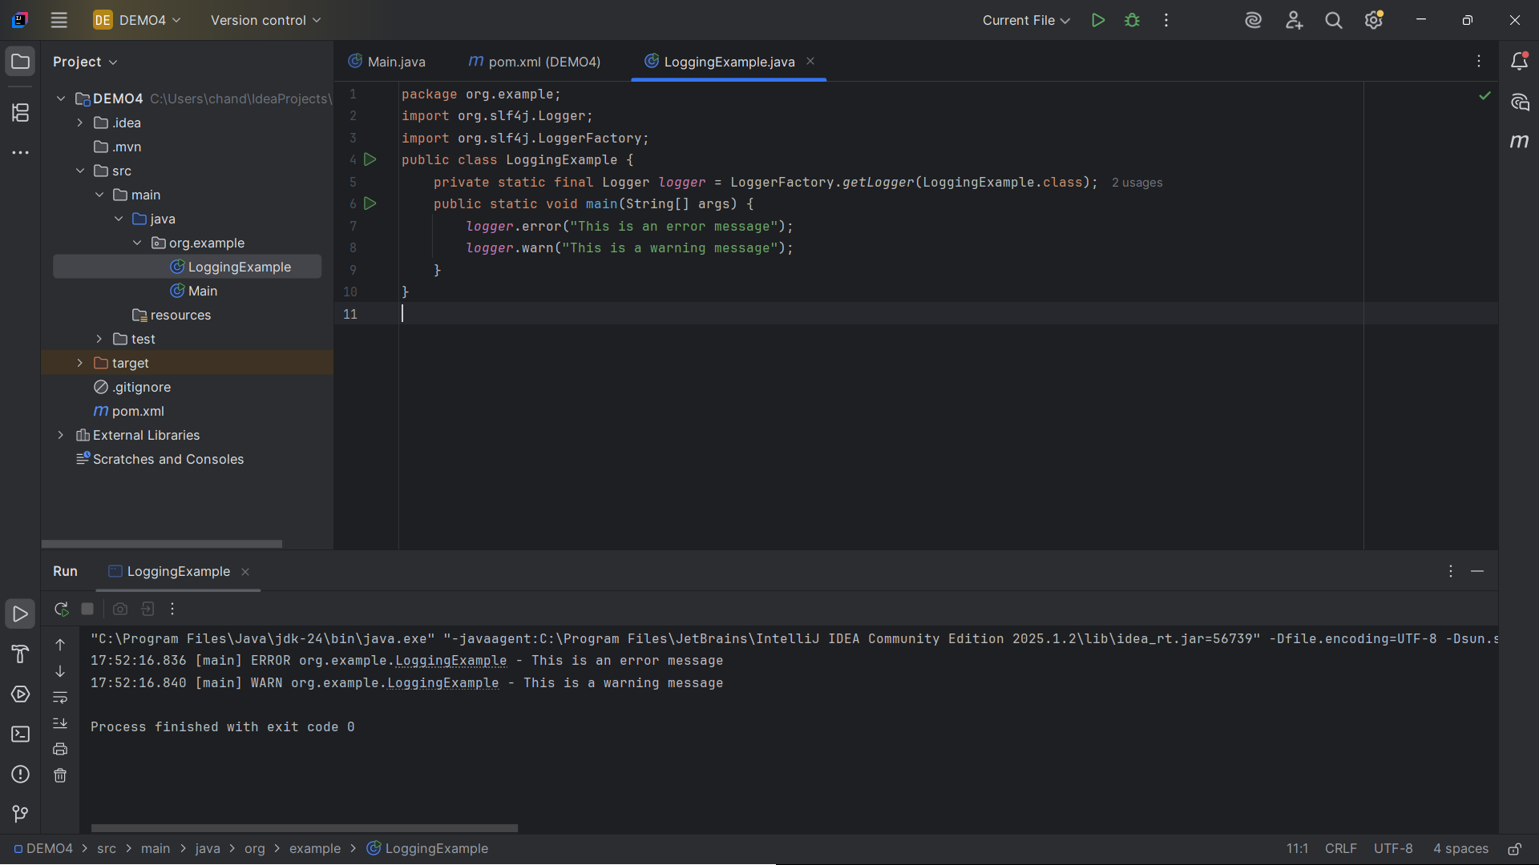

**Exercise 2: Parameterized Logging**

**CODE :**

**pom.xml :**

<dependency>

<groupId>org.slf4j</groupId>

<artifactId>slf4j-api</artifactId>

<version>1.7.30</version>

</dependency>

<dependency>

<groupId>ch.qos.logback</groupId>

<artifactId>logback-classic</artifactId>

<version>1.2.3</version>

</dependency>

**LoggingParameterizedExample.java**

package org.example;  
import org.slf4j.Logger;  
import org.slf4j.LoggerFactory;  
public class LoggingParameterizedExample {  
 private static final Logger *logger* = LoggerFactory.*getLogger*(LoggingParameterizedExample.class);  
 public static void main(String[] args) {  
 String username = "CHIKU";  
 int userId = 42;  
 // parameterized logging  
 *logger*.info("User {} with ID {} has logged in", username, userId);  
 double amount = 2500.75;  
 *logger*.warn("Transaction for user {} exceeded the limit: amount = {}", username, amount);  
 }  
}

**OUTPUT:**

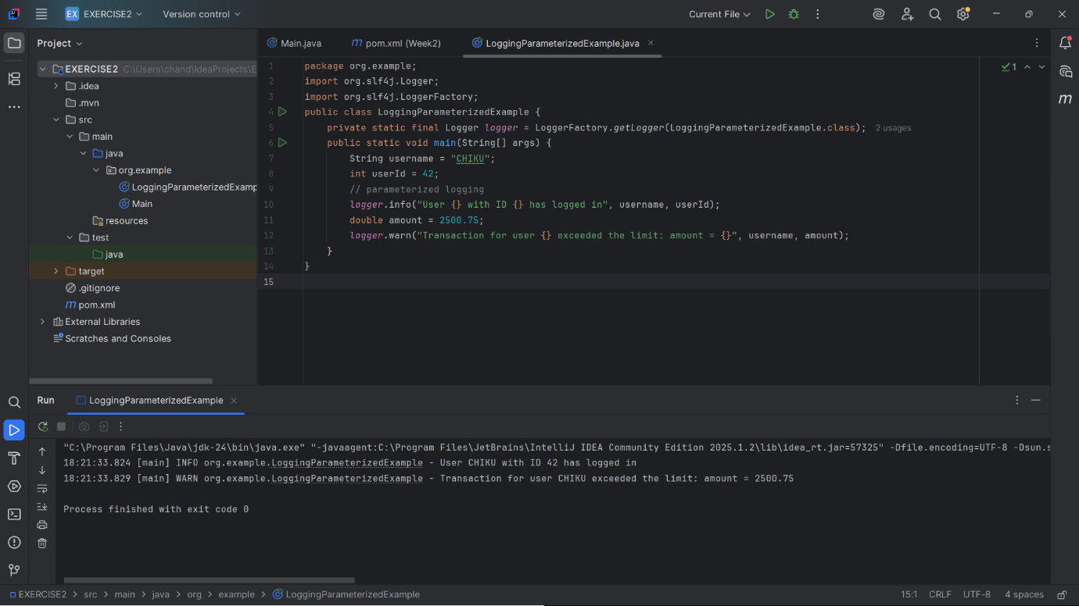

**Exercise 3: Using Different Appenders**

**CODE :**

**pom.xml :**

<dependencies>

<dependency>

<groupId>org.slf4j</groupId>

<artifactId>slf4j-api</artifactId>

<version>1.7.30</version>

</dependency>

<dependency>

<groupId>ch.qos.logback</groupId>

<artifactId>logback-classic</artifactId>

<version>1.2.3</version>

</dependency>

</dependencies>

**LoggingAppendersExample.java**

import org.slf4j.Logger;  
import org.slf4j.LoggerFactory;  
public class LoggingAppendersExample {  
 private static final Logger *logger* = LoggerFactory.*getLogger*(LoggingAppendersExample.class);  
 public static void main(String[] args) {  
 *logger*.info("Hello from SLF4J with multiple appenders!");  
 *logger*.warn("This is a warning message with multiple appenders");  
 *logger*.error("This is an error message with multiple appenders");  
 }  
}

**OUTPUT:**

