**WEEK 3 - Spring Core and Maven**

**Exercise 1: Configuring a Basic Spring Application**

**pom.xml**

<dependencies>

<!-- Spring Core -->

<dependency>

<groupId>org.springframework</groupId>

<artifactId>spring-context</artifactId>

<version>5.3.34</version>

</dependency>

</dependencies>

**applicationContext.xml**

<?xml version="1.0" encoding="UTF-8"?>

<beans xmlns="http://www.springframework.org/schema/beans"

xmlns:xsi="http://www.w3.org/2001/XMLSchema-instance"

xsi:schemaLocation="

http://www.springframework.org/schema/beans

http://www.springframework.org/schema/beans/spring-beans.xsd">

<bean id="bookRepository" class="com.library.repository.BookRepository" />

<bean id="bookService" class="com.library.service.BookService">

<property name="bookRepository" ref="bookRepository"/>

</bean>

</beans>

**BookRepository.java**

package com.library.repository;

public class BookRepository {

public void saveBook(String bookName) {

System.out.println("Book saved: " + bookName);

}

}

**BookService.java**

package com.library.service;

import com.library.repository.BookRepository;

public class BookService {

private BookRepository bookRepository;

public void setBookRepository(BookRepository bookRepository) {

this.bookRepository = bookRepository;

}

public void addBook(String name) {

bookRepository.saveBook(name);

}

}

**MainApp.java**

package com.library;

import com.library.service.BookService;

import org.springframework.context.ApplicationContext;

import org.springframework.context.support.ClassPathXmlApplicationContext;

public class MainApp {

public static void main(String[] args) {

ApplicationContext context = new ClassPathXmlApplicationContext("applicationContext.xml");

BookService bookService = (BookService) context.getBean("bookService");

bookService.addBook("Spring in Action");

}

}

**OUTPUT:**

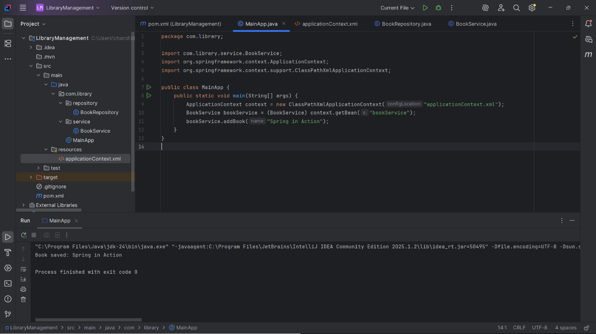

**Exercise 2: Implementing Dependency Injection**

**applicationContext.xml**

<?xml version="1.0" encoding="UTF-8"?>

<beans xmlns="http://www.springframework.org/schema/beans"

xmlns:xsi="http://www.w3.org/2001/XMLSchema-instance"

xsi:schemaLocation="

http://www.springframework.org/schema/beans

http://www.springframework.org/schema/beans/spring-beans.xsd">

<!-- BookRepository Bean -->

<bean id="bookRepository" class="com.library.repository.BookRepository"/>

<!-- BookService Bean with DI using setter -->

<bean id="bookService" class="com.library.service.BookService">

<property name="bookRepository" ref="bookRepository"/>

</bean>

</beans>

**BookService.java**

package com.library.service;

import com.library.repository.BookRepository;

public class BookService {

private BookRepository bookRepository;

public void setBookRepository(BookRepository bookRepository) {

this.bookRepository = bookRepository;

}

public void addBook(String name) {

System.out.println("Adding book: " + name);

bookRepository.saveBook(name);

}

}

**LibraryManagementApplication.java**

package com.library;

import com.library.service.BookService;

import org.springframework.context.ApplicationContext;

import org.springframework.context.support.ClassPathXmlApplicationContext;

public class LibraryManagementApplication {

public static void main(String[] args) {

ApplicationContext context = new ClassPathXmlApplicationContext("applicationContext.xml");

BookService bookService = (BookService) context.getBean("bookService");

bookService.addBook("Mastering Spring");

}

}

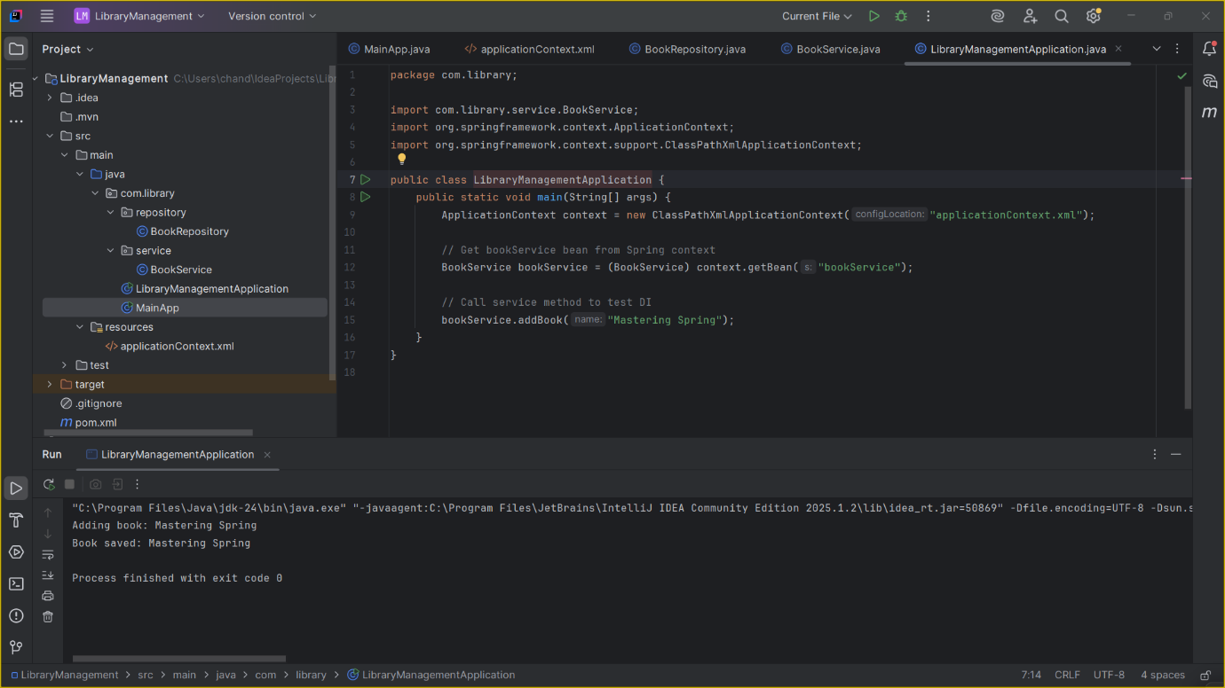

**Exercise 3: Implementing Logging with Spring AOP**

**pom.xml**

<!-- Spring AOP -->

<dependency>

<groupId>org.springframework</groupId>

<artifactId>spring-aspects</artifactId>

<version>5.3.34</version>

</dependency>

**LoggingAspect.java**

package com.library.aspect;

import org.aspectj.lang.ProceedingJoinPoint;

public class LoggingAspect {

public Object logExecutionTime(ProceedingJoinPoint joinPoint) throws Throwable {

long start = System.currentTimeMillis();

Object result = joinPoint.proceed(); // actual method call

long end = System.currentTimeMillis();

System.out.println("Method " + joinPoint.getSignature() + " executed in " + (end - start) + "ms");

return result;

}

}

**applicationContext.xml**

<?xml version="1.0" encoding="UTF-8"?>

<beans xmlns="http://www.springframework.org/schema/beans"

xmlns:xsi="http://www.w3.org/2001/XMLSchema-instance"

xmlns:aop="http://www.springframework.org/schema/aop"

xsi:schemaLocation="

http://www.springframework.org/schema/beans

http://www.springframework.org/schema/beans/spring-beans.xsd

http://www.springframework.org/schema/aop

http://www.springframework.org/schema/aop/spring-aop.xsd">

<!-- Enable AOP -->

<aop:aspectj-autoproxy/>

<!-- Aspect bean -->

<bean id="loggingAspect" class="com.library.aspect.LoggingAspect"/>

<!-- BookRepository bean -->

<bean id="bookRepository" class="com.library.repository.BookRepository"/>

<!-- BookService bean -->

<bean id="bookService" class="com.library.service.BookService">

<property name="bookRepository" ref="bookRepository"/>

</bean>

<!-- Define aspect manually (since not using @Aspect annotation) -->

<aop:config>

<aop:aspect ref="loggingAspect">

<aop:around method="logExecutionTime"

pointcut="execution(* com.library.service.*.*(..))"/>

</aop:aspect>

</aop:config>

</beans>

**LibraryManagementApplication.java**

package com.library;

import com.library.service.BookService;

import org.springframework.context.ApplicationContext;

import org.springframework.context.support.ClassPathXmlApplicationContext;

public class LibraryManagementApplication {

public static void main(String[] args) {

ApplicationContext context = new ClassPathXmlApplicationContext("applicationContext.xml");

BookService bookService = (BookService) context.getBean("bookService");

bookService.addBook("Spring AOP in Action");

}

}

**OUTPUT:**

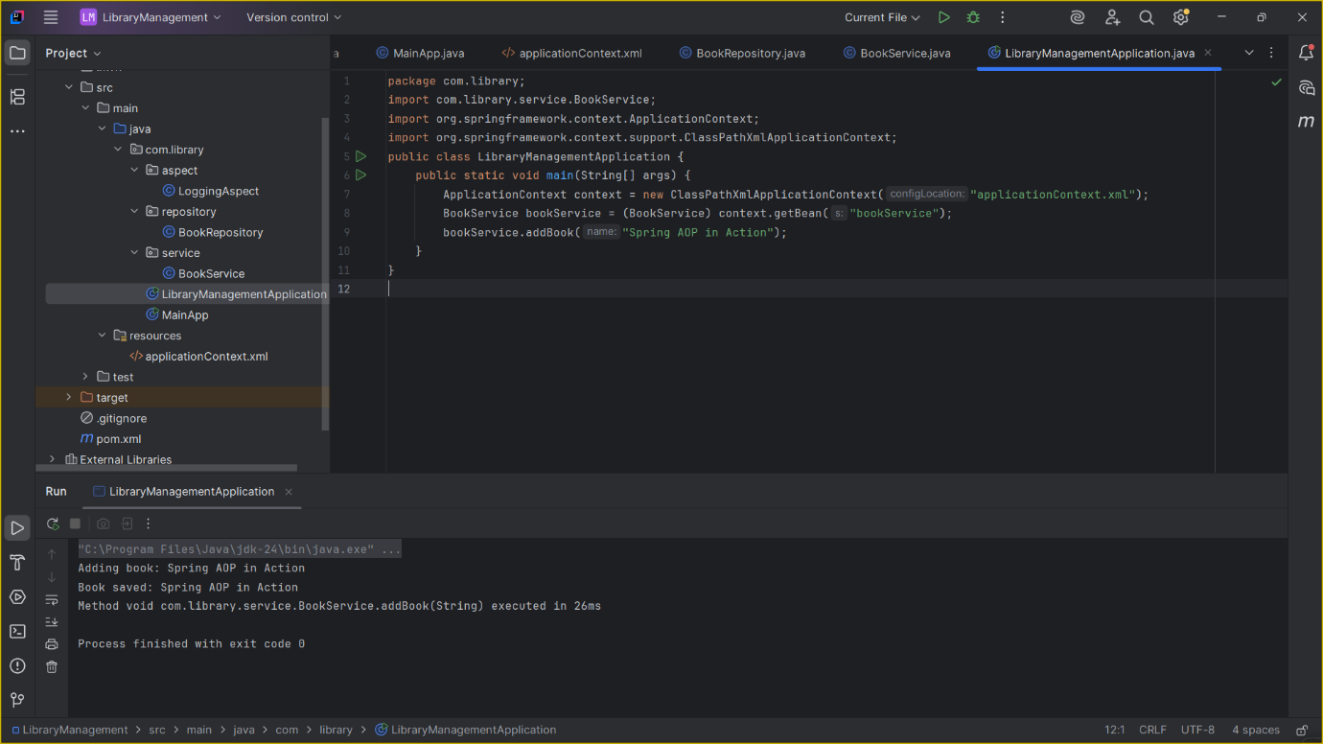

**Exercise 4: Creating and Configuring a Maven Project**

**pom.xml**

<dependencies>

<!-- Spring Context -->

<dependency>

<groupId>org.springframework</groupId>

<artifactId>spring-context</artifactId>

<version>5.3.34</version>

</dependency>

<!-- Spring AOP -->

<dependency>

<groupId>org.springframework</groupId>

<artifactId>spring-aspects</artifactId>

<version>5.3.34</version>

</dependency>

<!-- Spring WebMVC -->

<dependency>

<groupId>org.springframework</groupId>

<artifactId>spring-webmvc</artifactId>

<version>5.3.34</version>

</dependency>

</dependencies>

**Maven Plugins**

<build>

<plugins>

<plugin>

<groupId>org.apache.maven.plugins</groupId>

<artifactId>maven-compiler-plugin</artifactId>

<version>3.10.1</version>

<configuration>

<source>1.8</source>

<target>1.8</target>

</configuration>

</plugin>

</plugins>

</build>

Final  **pom.xml**

<project xmlns="http://maven.apache.org/POM/4.0.0"

xmlns:xsi="http://www.w3.org/2001/XMLSchema-instance"

xsi:schemaLocation="http://maven.apache.org/POM/4.0.0

http://maven.apache.org/xsd/maven-4.0.0.xsd">

<modelVersion>4.0.0</modelVersion>

<groupId>com.library</groupId>

<artifactId>LibraryManagement</artifactId>

<version>1.0-SNAPSHOT</version>

<properties>

<project.build.sourceEncoding>UTF-8</project.build.sourceEncoding>

</properties>

<dependencies>

<!-- Spring Context -->

<dependency>

<groupId>org.springframework</groupId>

<artifactId>spring-context</artifactId>

<version>5.3.34</version>

</dependency>

<!-- Spring AOP -->

<dependency>

<groupId>org.springframework</groupId>

<artifactId>spring-aspects</artifactId>

<version>5.3.34</version>

</dependency>

<!-- Spring WebMVC -->

<dependency>

<groupId>org.springframework</groupId>

<artifactId>spring-webmvc</artifactId>

<version>5.3.34</version>

</dependency>

</dependencies>

<build>

<plugins>

<plugin>

<groupId>org.apache.maven.plugins</groupId>

<artifactId>maven-compiler-plugin</artifactId>

<version>3.10.1</version>

<configuration>

<source>1.8</source>

<target>1.8</target>

</configuration>

</plugin>

</plugins>

</build>

</project>

**Exercise 5: Configuring the Spring IoC Container**

**applicationContext.xml**

<?xml version="1.0" encoding="UTF-8"?>

<beans xmlns="http://www.springframework.org/schema/beans"

xmlns:xsi="http://www.w3.org/2001/XMLSchema-instance"

xsi:schemaLocation="

http://www.springframework.org/schema/beans

http://www.springframework.org/schema/beans/spring-beans.xsd">

<!-- BookRepository Bean -->

<bean id="bookRepository" class="com.library.repository.BookRepository"/>

<!-- BookService Bean with DI -->

<bean id="bookService" class="com.library.service.BookService">

<property name="bookRepository" ref="bookRepository"/>

</bean>

</beans>

**BookService.java**

package com.library.service;

import com.library.repository.BookRepository;

public class BookService {

private BookRepository bookRepository;

// Setter for Dependency Injection

public void setBookRepository(BookRepository bookRepository) {

this.bookRepository = bookRepository;

}

public void addBook(String name) {

System.out.println("Adding book: " + name);

bookRepository.saveBook(name);

}

}

**BookRepository.java**

package com.library.repository;

public class BookRepository {

public void saveBook(String name) {

System.out.println("Book saved to database: " + name);

}

}

**LibraryManagementApplication.java**

package com.library;

import com.library.service.BookService;

import org.springframework.context.ApplicationContext;

import org.springframework.context.support.ClassPathXmlApplicationContext;

public class LibraryManagementApplication {

public static void main(String[] args) {

ApplicationContext context = new ClassPathXmlApplicationContext("applicationContext.xml");

BookService bookService = (BookService) context.getBean("bookService");

bookService.addBook("Spring Framework Essentials");

}

}

**OUTPUT:**

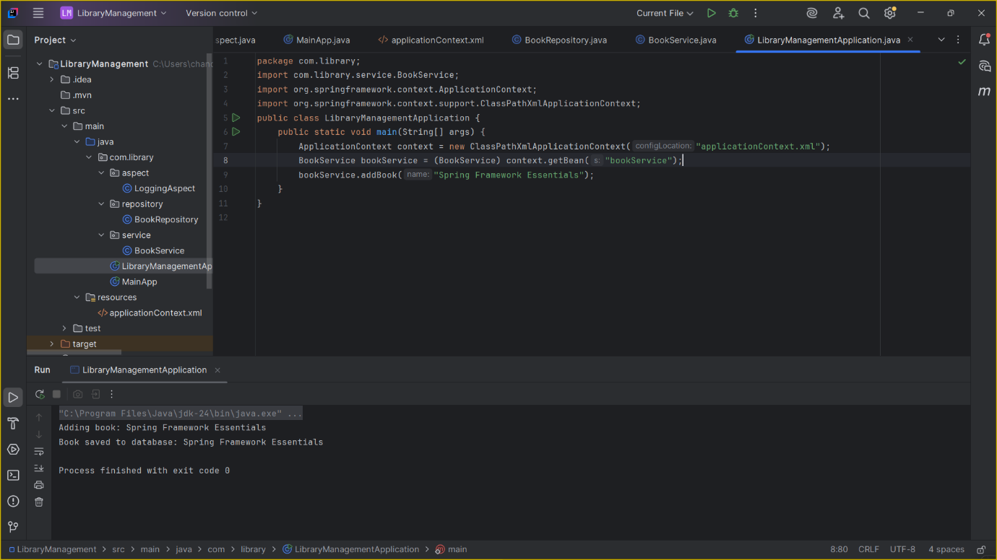

**Exercise 6: Configuring Beans with Annotations**

**applicationContext.xml**

<?xml version="1.0" encoding="UTF-8"?>

<beans xmlns="http://www.springframework.org/schema/beans"

xmlns:context="http://www.springframework.org/schema/context"

xmlns:xsi="http://www.w3.org/2001/XMLSchema-instance"

xsi:schemaLocation="

http://www.springframework.org/schema/beans

http://www.springframework.org/schema/beans/spring-beans.xsd

http://www.springframework.org/schema/context

http://www.springframework.org/schema/context/spring-context.xsd">

<!-- Enable annotation-based config -->

<context:component-scan base-package="com.library"/>

</beans>

**BookService.java**

package com.library.service;

import com.library.repository.BookRepository;

import org.springframework.beans.factory.annotation.Autowired;

import org.springframework.stereotype.Service;

@Service // Registers this class as a Spring Bean

public class BookService {

@Autowired // Inject BookRepository automatically

private BookRepository bookRepository;

public void addBook(String name) {

System.out.println("Adding book: " + name);

bookRepository.saveBook(name);

}

}

**BookRepository.java**

package com.library.repository;

import org.springframework.stereotype.Repository;

@Repository // Registers this class as a Spring Bean

public class BookRepository {

public void saveBook(String name) {

System.out.println("Book saved to database: " + name);

}

}

**LibraryManagementApplication.java**

package com.library;

import com.library.service.BookService;

import org.springframework.context.ApplicationContext;

import org.springframework.context.support.ClassPathXmlApplicationContext;

public class LibraryManagementApplication {

public static void main(String[] args) {

ApplicationContext context = new ClassPathXmlApplicationContext("applicationContext.xml");

BookService bookService = context.getBean(BookService.class);

bookService.addBook("Annotation-Based Spring");

}

}

**OUTPUT:**

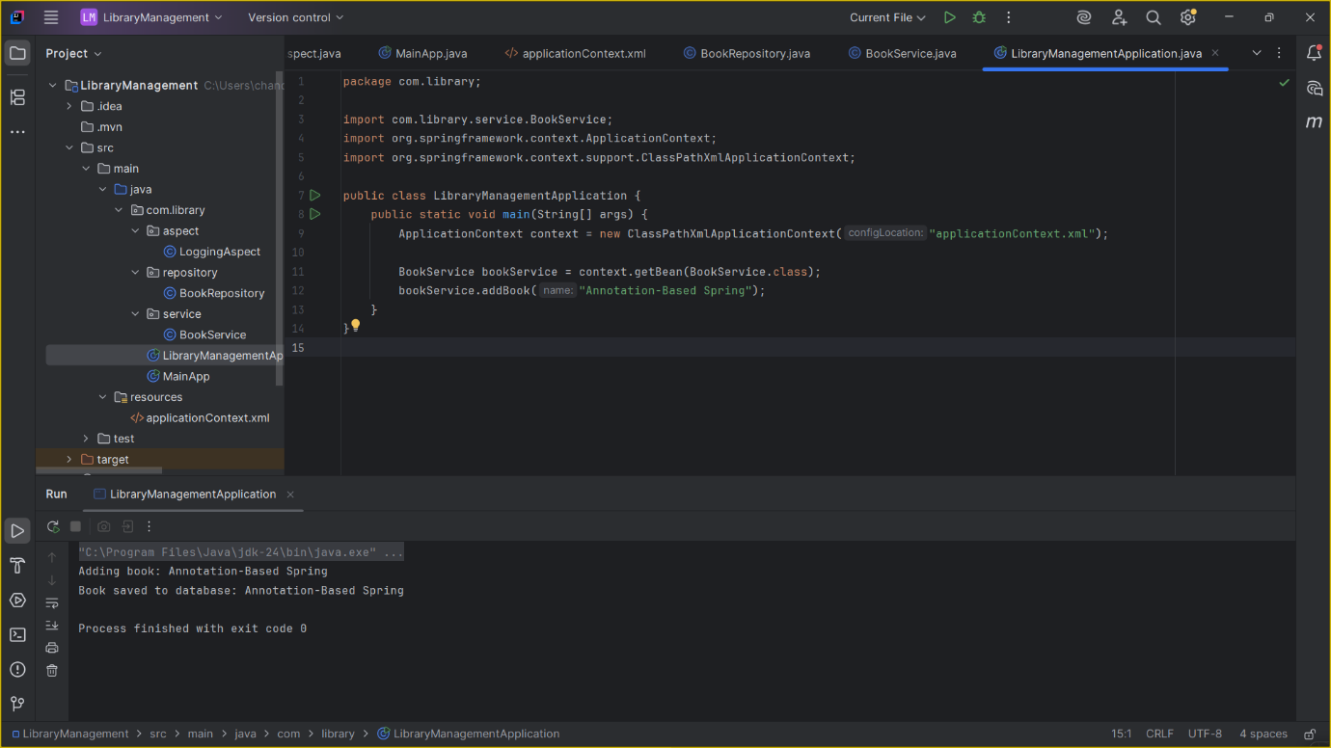

**Exercise 7: Implementing Constructor and Setter Injection**

**BookService.java**

package com.library.service;

import com.library.repository.BookRepository;

public class BookService {

private String libraryName; // for constructor injection

private BookRepository bookRepository; // for setter injection

// Constructor for injecting library name

public BookService(String libraryName) {

this.libraryName = libraryName;

}

// Setter for BookRepository

public void setBookRepository(BookRepository bookRepository) {

this.bookRepository = bookRepository;

}

public void addBook(String name) {

System.out.println("[" + libraryName + "] Adding book: " + name);

bookRepository.saveBook(name);

}

}

**applicationContext.xml**

<?xml version="1.0" encoding="UTF-8"?>

<beans xmlns="http://www.springframework.org/schema/beans"

xmlns:xsi="http://www.w3.org/2001/XMLSchema-instance"

xsi:schemaLocation="

http://www.springframework.org/schema/beans

http://www.springframework.org/schema/beans/spring-beans.xsd">

<!-- BookRepository Bean -->

<bean id="bookRepository" class="com.library.repository.BookRepository"/>

<!-- BookService Bean with constructor and setter injection -->

<bean id="bookService" class="com.library.service.BookService">

<!-- Constructor Injection -->

<constructor-arg value="Central City Library"/>

<!-- Setter Injection -->

<property name="bookRepository" ref="bookRepository"/>

</bean>

</beans>

**BookRepository.java**

package com.library.repository;

public class BookRepository {

public void saveBook(String name) {

System.out.println("Book saved to database: " + name);

}

}

**LibraryManagementApplication.java**

package com.library;

import com.library.service.BookService;

import org.springframework.context.ApplicationContext;

import org.springframework.context.support.ClassPathXmlApplicationContext;

public class LibraryManagementApplication {

public static void main(String[] args) {

ApplicationContext context = new ClassPathXmlApplicationContext("applicationContext.xml");

BookService bookService = context.getBean(BookService.class);

bookService.addBook("Effective Java");

}

}

**OUTPUT:**

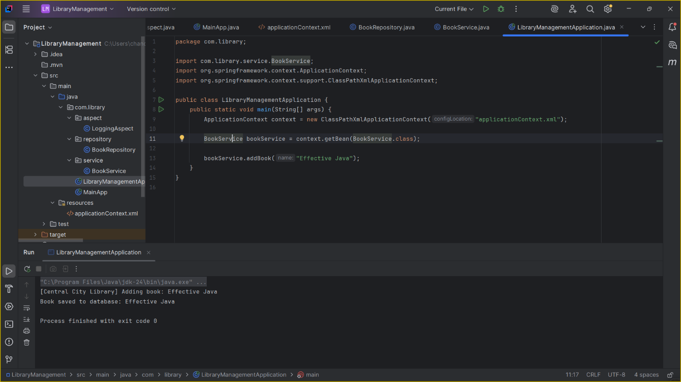

**Exercise 8: Implementing Basic AOP with Spring**

**LoggingAspect.java**

package com.library.aspect;

import org.aspectj.lang.JoinPoint;

import org.aspectj.lang.annotation.After;

import org.aspectj.lang.annotation.Aspect;

import org.aspectj.lang.annotation.Before;

@Aspect

public class LoggingAspect {

@Before("execution(* com.library.service.*.*(..))")

public void logBefore(JoinPoint joinPoint) {

System.out.println(" [BEFORE] Executing: " + joinPoint.getSignature().getName());

}

@After("execution(* com.library.service.*.*(..))")

public void logAfter(JoinPoint joinPoint) {

System.out.println("[AFTER] Completed: " + joinPoint.getSignature().getName());

}

}

**pom.xml**

<dependencies>

<!-- Spring Core Context -->

<dependency>

<groupId>org.springframework</groupId>

<artifactId>spring-context</artifactId>

<version>5.3.34</version>

</dependency>

<!-- Spring AOP -->

<dependency>

<groupId>org.springframework</groupId>

<artifactId>spring-aspects</artifactId>

<version>5.3.34</version>

</dependency>

</dependencies>

**applicationContext.xml**

<?xml version="1.0" encoding="UTF-8"?>

<beans xmlns="http://www.springframework.org/schema/beans"

xmlns:context="http://www.springframework.org/schema/context"

xmlns:aop="http://www.springframework.org/schema/aop"

xmlns:xsi="http://www.w3.org/2001/XMLSchema-instance"

xsi:schemaLocation="

http://www.springframework.org/schema/beans

http://www.springframework.org/schema/beans/spring-beans.xsd

http://www.springframework.org/schema/context

http://www.springframework.org/schema/context/spring-context.xsd

http://www.springframework.org/schema/aop

http://www.springframework.org/schema/aop/spring-aop.xsd">

<!-- Enable component scanning -->

<context:component-scan base-package="com.library"/>

<!-- Enable AspectJ auto proxy -->

<aop:aspectj-autoproxy/>

<!-- Register the Aspect -->

<bean id="loggingAspect" class="com.library.aspect.LoggingAspect"/>

</beans>

**BookService.java**

package com.library.service;

import com.library.repository.BookRepository;

import org.springframework.beans.factory.annotation.Autowired;

import org.springframework.stereotype.Service;

@Service

public class BookService {

@Autowired

private BookRepository bookRepository;

public void addBook(String name) {

System.out.println(" Adding book: " + name);

bookRepository.saveBook(name);

}

}

**BookRepository.java**

package com.library.repository;

import org.springframework.stereotype.Repository;

@Repository

public class BookRepository {

public void saveBook(String name) {

System.out.println("Book saved: " + name);

}

}

package com.library;

import com.library.service.BookService;

import org.springframework.context.ApplicationContext;

import org.springframework.context.support.ClassPathXmlApplicationContext;

public class LibraryManagementApplication {

public static void main(String[] args) {

ApplicationContext context = new ClassPathXmlApplicationContext("applicationContext.xml");

BookService bookService = context.getBean(BookService.class);

bookService.addBook("Spring AOP Basics");

}

}

**OUTPUT:**

