**Week 3 : Spring Data JPA and Hibernate**

**Hands on 1**

**Spring Data JPA - Quick Example**

**Code :**

**Country.java**

package com.cognizant.orm_learn.model;  
import jakarta.persistence.Column;  
import jakarta.persistence.Entity;  
import jakarta.persistence.Id;  
import jakarta.persistence.Table;  
@Entity  
@Table(name = "country")  
public class Country {  
 @Id  
 @Column(name = "co_code")  
 private String code;  
 @Column(name = "co_name")  
 private String name;  
 // Getters, Setters, toString()  
 public String getCode() {  
 return code;  
 }  
 public void setCode(String code) {  
 this.code = code;  
 }  
 public String getName() {  
 return name;  
 }  
 public void setName(String name) {  
 this.name = name;  
 }  
 @Override  
 public String toString() {  
 return "Country [code=" + code + ", name=" + name + "]";  
 }  
}

**CountryService.java**

package com.cognizant.orm_learn.service;  
import java.util.List;  
import org.springframework.beans.factory.annotation.Autowired;  
import org.springframework.stereotype.Service;  
import org.springframework.transaction.annotation.Transactional;  
import com.cognizant.orm_learn.model.Country;  
import com.cognizant.orm_learn.repository.CountryRepository;  
@Service  
public class CountryService {  
 @Autowired  
 private CountryRepository countryRepository;  
 @Transactional  
 public List<Country> getAllCountries() {  
 return countryRepository.findAll();  
 }  
}

**CountryRepository.java**

package com.cognizant.orm_learn.repository;  
import org.springframework.data.jpa.repository.JpaRepository;  
import org.springframework.stereotype.Repository;  
import com.cognizant.orm_learn.model.Country;  
@Repository  
public interface CountryRepository extends JpaRepository<Country, String> {  
}

**OrmLearnApplication.java**

package com.cognizant.orm_learn;  
import java.util.List;  
import org.slf4j.Logger;  
import org.slf4j.LoggerFactory;  
import org.springframework.boot.SpringApplication;  
import org.springframework.boot.autoconfigure.SpringBootApplication;  
import org.springframework.context.ApplicationContext;  
import com.cognizant.orm_learn.model.Country;  
import com.cognizant.orm_learn.service.CountryService;  
@SpringBootApplication  
public class OrmLearnApplication {  
 private static final Logger *LOGGER* = LoggerFactory.*getLogger*(OrmLearnApplication.class);  
 private static CountryService *countryService*;  
 public static void main(String[] args) {  
 ApplicationContext context = SpringApplication.*run*(OrmLearnApplication.class, args);  
 *countryService* = context.getBean(CountryService.class);  
 *LOGGER*.info("Inside main");  
 *testGetAllCountries*();  
 }  
 private static void testGetAllCountries() {  
 *LOGGER*.info("Start");  
 List<Country> countries = *countryService*.getAllCountries();  
 *LOGGER*.debug("countries={}", countries);  
 *LOGGER*.info("End");  
 }  
}

**Output :**

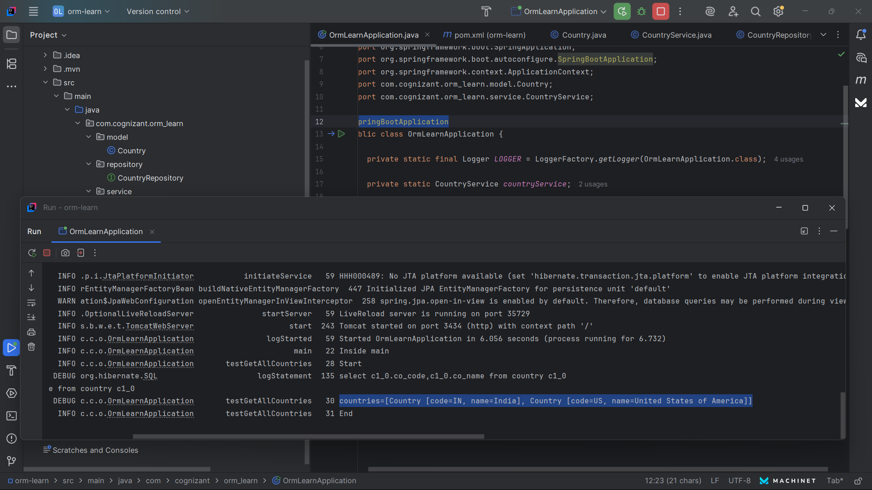

**Hands on 2**

**Hibernate XML Config implementation walk through   
Code :**

**hibernate.cfg.xml**

<hibernate-configuration>

<session-factory>

<property name="hibernate.connection.driver_class">com.mysql.cj.jdbc.Driver</property>

<property name="hibernate.connection.url">jdbc:mysql://localhost:3306/orm_learn</property>

<property name="hibernate.connection.username">root</property>

<property name="hibernate.connection.password">root</property>

<property name="hibernate.dialect">org.hibernate.dialect.MySQLDialect</property>

<mapping resource="country.hbm.xml"/>

</session-factory>

</hibernate-configuration>

**country.hbm.xml**

<class name="com.cognizant.model.Country" table="country">

<id name="code" column="co_code"/>

<property name="name" column="co_name"/>

</class>

**Output :**



**Hands on 3**

**Hibernate Annotation Config implementation walk through   
Code :**

**Country.java**

package com.cognizant.orm_learn.model;  
import jakarta.persistence.Column;  
import jakarta.persistence.Entity;  
import jakarta.persistence.Id;  
import jakarta.persistence.Table;  
@Entity  
@Table(name = "country")  
public class Country {  
 @Id  
 @Column(name = "co_code")  
 private String code;  
 @Column(name = "co_name")  
 private String name;  
 // Getters, Setters, toString()  
 public String getCode() {  
 return code;  
 }  
  
 public void setCode(String code) {  
 this.code = code;  
 }  
 public String getName() {  
 return name;  
 }  
 public void setName(String name) {  
 this.name = name;  
 }  
 @Override  
 public String toString() {  
 return "Country [code=" + code + ", name=" + name + "]";  
 }  
}

**CountryService.java**

package com.cognizant.orm_learn.service;  
import java.util.List;  
import org.springframework.beans.factory.annotation.Autowired;  
import org.springframework.stereotype.Service;  
import org.springframework.transaction.annotation.Transactional;  
import com.cognizant.orm_learn.model.Country;  
import com.cognizant.orm_learn.repository.CountryRepository;  
@Service  
public class CountryService {  
 @Autowired  
 private CountryRepository countryRepository;  
 @Transactional  
 public List<Country> getAllCountries() {  
 return countryRepository.findAll();  
 }  
}

**CountryRepository.java**

package com.cognizant.orm_learn.repository;  
import org.springframework.data.jpa.repository.JpaRepository;  
import org.springframework.stereotype.Repository;  
import com.cognizant.orm_learn.model.Country;  
@Repository  
public interface CountryRepository extends JpaRepository<Country, String> {  
}

**OrmLearnApplication.java**

package com.cognizant.orm_learn;  
import java.util.List;  
import org.slf4j.Logger;  
import org.slf4j.LoggerFactory;  
import org.springframework.boot.SpringApplication;  
import org.springframework.boot.autoconfigure.SpringBootApplication;  
import org.springframework.context.ApplicationContext;  
import com.cognizant.orm_learn.model.Country;  
import com.cognizant.orm_learn.service.CountryService;  
@SpringBootApplication  
public class OrmLearnApplication {  
 private static final Logger *LOGGER* = LoggerFactory.*getLogger*(OrmLearnApplication.class);  
 private static CountryService *countryService*;  
 public static void main(String[] args) {  
 ApplicationContext context = SpringApplication.*run*(OrmLearnApplication.class, args);  
 *countryService* = context.getBean(CountryService.class);  
 *LOGGER*.info("Inside main");  
 *testGetAllCountries*();  
 }  
 private static void testGetAllCountries() {  
 *LOGGER*.info("Start");  
 List<Country> countries = *countryService*.getAllCountries();  
 *LOGGER*.debug("countries={}", countries);  
 *LOGGER*.info("End");  
 }  
}

**Output :**



**Hands on 4**

**Difference between JPA, Hibernate and Spring Data JPA**

| **JPA** | **Hibernate** | **Spring Data JPA** |
| --- | --- | --- |
| Specification (Standard) | Implementation of JPA | Framework on top of JPA & Hibernate |
| Defines interfaces | Provides actual working classes | Provides repository abstraction (like CrudRepository) |
| Example: EntityManager | Example: SessionFactory | Example: CountryRepository extends JpaRepository |
| No implementation | Has implementation | Automates CRUD & pagination |

**Hands on 5**

**Implement services for managing Country   
Code :**

**Country.java**

package com.cognizant.orm_learn.model;  
import jakarta.persistence.Column;  
import jakarta.persistence.Entity;  
import jakarta.persistence.Id;  
import jakarta.persistence.Table;  
@Entity  
@Table(name = "country")  
public class Country {  
 @Id  
 @Column(name = "co_code")  
 private String code;  
 @Column(name = "co_name")  
 private String name;  
 // Getters, Setters, toString()  
 public String getCode() {  
 return code;  
 }  
 public void setCode(String code) {  
 this.code = code;  
 }  
 public String getName() {  
 return name;  
 }  
 public void setName(String name) {  
 this.name = name;  
 }  
 @Override  
 public String toString() {  
 return "Country [code=" + code + ", name=" + name + "]";  
 }  
}

**CountryService.java**

package com.cognizant.orm_learn.service;  
import java.util.List;  
import java.util.Optional;  
import org.springframework.beans.factory.annotation.Autowired;  
import org.springframework.stereotype.Service;  
import com.cognizant.orm_learn.model.Country;  
import com.cognizant.orm_learn.repository.CountryRepository;  
@Service  
public class CountryService {  
 @Autowired  
 private CountryRepository countryRepository;  
 public List<Country> getAllCountries() {  
 return countryRepository.findAll();  
 }  
 public Country findCountryByCode(String code) {  
 Optional<Country> result = countryRepository.findById(code);  
 return result.orElse(null);  
 }  
 public void addCountry(Country country) {  
 countryRepository.save(country);  
 }  
 public void updateCountry(String code, String name) {  
 Optional<Country> result = countryRepository.findById(code);  
 if (result.isPresent()) {  
 Country country = result.get();  
 country.setName(name);  
 countryRepository.save(country);  
 }  
 }  
 public void deleteCountry(String code) {  
 countryRepository.deleteById(code);  
 }  
}

**CountryRepository.java**

package com.cognizant.orm_learn.repository;  
import org.springframework.data.jpa.repository.JpaRepository;  
import com.cognizant.orm_learn.model.Country;  
public interface CountryRepository extends JpaRepository<Country, String> {  
 // JpaRepository already gives all CRUD methods  
}  
**OrmLearnApplication.java**

package com.cognizant.orm_learn;  
import java.util.List;  
import org.slf4j.Logger;  
import org.slf4j.LoggerFactory;  
import org.springframework.beans.factory.annotation.Autowired;  
import org.springframework.boot.CommandLineRunner;  
import org.springframework.boot.SpringApplication;  
import org.springframework.boot.autoconfigure.SpringBootApplication;  
import com.cognizant.orm_learn.model.Country;  
import com.cognizant.orm_learn.service.CountryService;  
@SpringBootApplication  
public class OrmLearnApplication implements CommandLineRunner {  
 private static final Logger *LOGGER* = LoggerFactory.*getLogger*(OrmLearnApplication.class);  
 @Autowired  
 private CountryService countryService;  
 public static void main(String[] args) {  
 SpringApplication.*run*(OrmLearnApplication.class, args);  
 *LOGGER*.info("Application Started...");  
 }  
 @Override  
 public void run(String... args) throws Exception {  
 *LOGGER*.info("Testing CRUD Operations...");  
 // Get All Countries  
 List<Country> countries = countryService.getAllCountries();  
 *LOGGER*.info("Countries: {}", countries);  
 // Add New Country  
 Country newCountry = new Country();  
 newCountry.setCode("NP");  
 newCountry.setName("Nepal");  
 countryService.addCountry(newCountry);  
 *LOGGER*.info("Added Country: {}", newCountry);  
 // Update Country  
 countryService.updateCountry("NP", "Federal Democratic Republic of Nepal");  
 *LOGGER*.info("Updated Country Name");  
 // Find Country  
 Country found = countryService.findCountryByCode("NP");  
 *LOGGER*.info("Found Country: {}", found);  
 // Delete Country  
 countryService.deleteCountry("NP");  
 *LOGGER*.info("Deleted Country with code NP");  
 }  
}

**Output :**

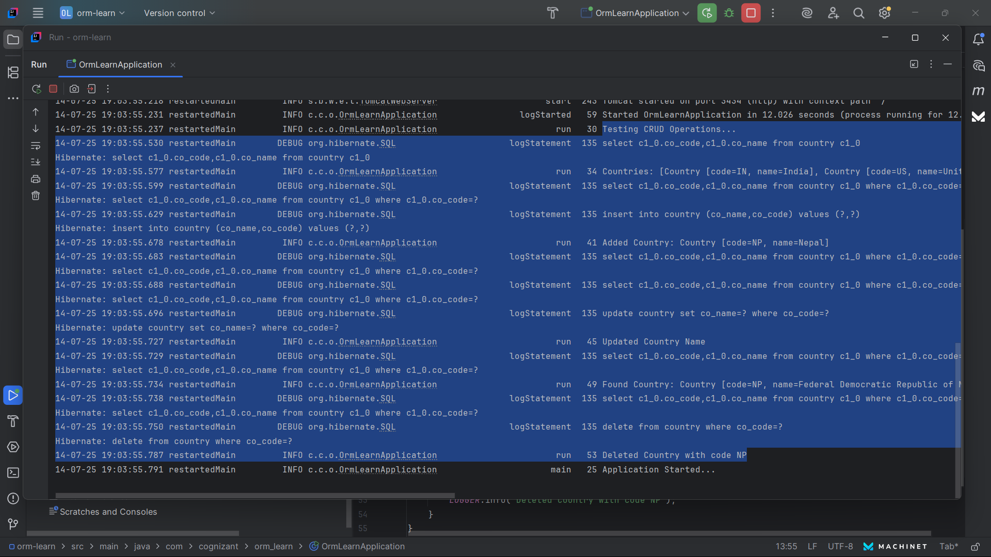

**Hands on 6**

**Find a country based on country code   
Code :**

**Country.java**

package com.cognizant.orm_learn.model;  
import jakarta.persistence.Column;  
import jakarta.persistence.Entity;  
import jakarta.persistence.Id;  
import jakarta.persistence.Table;  
@Entity  
@Table(name = "country")  
public class Country {  
 @Id  
 @Column(name = "co_code")  
 private String code;  
 @Column(name = "co_name")  
 private String name;  
 // Getters, Setters, toString()  
 public String getCode() {  
 return code;  
 }  
 public void setCode(String code) {  
 this.code = code;  
 }  
 public String getName() {  
 return name;  
 }

public void setName(String name) {  
 this.name = name;  
 }  
 @Override  
 public String toString() {  
 return "Country [code=" + code + ", name=" + name + "]";  
 }  
}

**CountryService.java**

package com.cognizant.orm_learn.service;  
import java.util.List;  
import java.util.Optional;  
import org.springframework.beans.factory.annotation.Autowired;  
import org.springframework.stereotype.Service;  
import com.cognizant.orm_learn.model.Country;  
import com.cognizant.orm_learn.repository.CountryRepository;  
@Service  
public class CountryService {  
 @Autowired  
 private CountryRepository countryRepository;  
 public List<Country> getAllCountries() {  
 return countryRepository.findAll();  
 }  
 public Country findCountryByCode(String code) {  
 Optional<Country> result = countryRepository.findById(code);  
 return result.orElse(null);  
 }  
 public void addCountry(Country country) {  
 countryRepository.save(country);  
 }  
 public void updateCountry(String code, String name) {  
 Optional<Country> result = countryRepository.findById(code);  
 if (result.isPresent()) {  
 Country country = result.get();  
 country.setName(name);  
 countryRepository.save(country);  
 }  
 }  
 public void deleteCountry(String code) {  
 countryRepository.deleteById(code);  
 }  
 public List<Country> findByNameContaining(String name) {  
 return countryRepository.findByNameContaining(name);  
 }  
 public List<Country> findByNameStartingWith(String prefix) {  
 return countryRepository.findByNameStartingWith(prefix);  
 }  
  
 public List<Country> findByNameEndingWith(String suffix) {  
 return countryRepository.findByNameEndingWith(suffix);  
 }  
 public List<Country> findByNameIgnoreCase(String name) {  
 return countryRepository.findByNameIgnoreCase(name);  
 }  
  
}

**CountryRepository.java**

package com.cognizant.orm_learn.repository;  
import java.util.List;  
import org.springframework.data.jpa.repository.JpaRepository;  
import com.cognizant.orm_learn.model.Country;  
public interface CountryRepository extends JpaRepository<Country, String> {  
 List<Country> findByNameContaining(String name);  
 List<Country> findByNameStartingWith(String prefix);  
 List<Country> findByNameEndingWith(String suffix);  
 List<Country> findByNameIgnoreCase(String name);  
}  
**OrmLearnApplication.java**

package com.cognizant.orm_learn;  
import java.util.List;  
import org.slf4j.Logger;  
import org.slf4j.LoggerFactory;  
import org.springframework.beans.factory.annotation.Autowired;  
import org.springframework.boot.CommandLineRunner;  
import org.springframework.boot.SpringApplication;  
import org.springframework.boot.autoconfigure.SpringBootApplication;  
import com.cognizant.orm_learn.model.Country;  
import com.cognizant.orm_learn.service.CountryService;  
@SpringBootApplication  
public class OrmLearnApplication implements CommandLineRunner {  
 private static final Logger *LOGGER* = LoggerFactory.*getLogger*(OrmLearnApplication.class);  
 @Autowired  
 private CountryService countryService;  
 public static void main(String[] args) {  
 SpringApplication.*run*(OrmLearnApplication.class, args);  
 *LOGGER*.info("Application Started...");  
 }  
 @Override  
 public void run(String... args) throws Exception {  
 *LOGGER*.info("Testing Derived Query Methods");  
 *LOGGER*.info("Countries containing 'a' : {}", countryService.findByNameContaining("a"));  
 *LOGGER*.info("Countries starting with 'U' : {}", countryService.findByNameStartingWith("U"));  
 *LOGGER*.info("Countries ending with 'a' : {}", countryService.findByNameEndingWith("a"));  
 *LOGGER*.info("Countries with name ignoring case 'india' : {}", countryService.findByNameIgnoreCase("india"));  
  
 }  
}

**Output :**

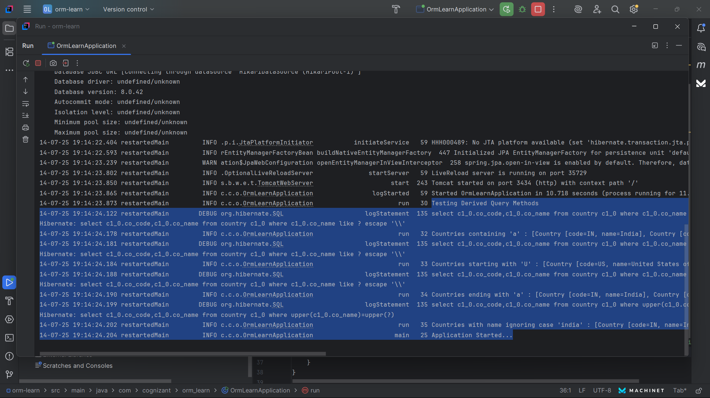

**Hands on 7**

**Add a new country   
Code :**

**OrmLearnApplication.java**

package com.cognizant.orm_learn;  
import java.util.List;  
import org.slf4j.Logger;  
import org.slf4j.LoggerFactory;  
import org.springframework.beans.factory.annotation.Autowired;  
import org.springframework.boot.CommandLineRunner;  
import org.springframework.boot.SpringApplication;  
import org.springframework.boot.autoconfigure.SpringBootApplication;  
import com.cognizant.orm_learn.model.Country;  
import com.cognizant.orm_learn.service.CountryService;  
@SpringBootApplication  
public class OrmLearnApplication implements CommandLineRunner {  
 private static final Logger *LOGGER* = LoggerFactory.*getLogger*(OrmLearnApplication.class);  
 @Autowired  
 private CountryService countryService;  
 public static void main(String[] args) {  
 SpringApplication.*run*(OrmLearnApplication.class, args);  
 *LOGGER*.info("Application Started...");  
 }  
 @Override  
 public void run(String... args) throws Exception {  
 *LOGGER*.info("Inside main");  
 Country newCountry = new Country();  
 newCountry.setCode("FR");  
 newCountry.setName("France");  
 countryService.addCountry(newCountry);  
 *LOGGER*.info("Country added: {}", newCountry);  
 }  
  
}

**Output :**

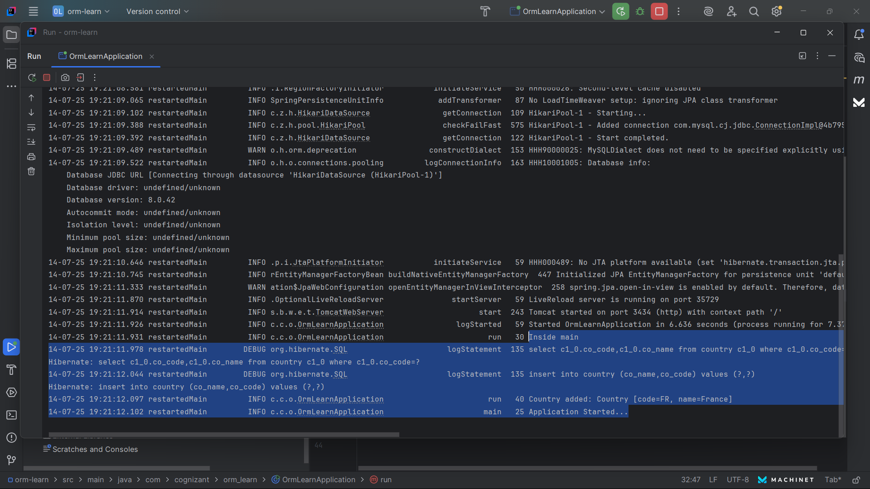

**Hands on 8**

**Update a country based on code   
Code :**

**OrmLearnApplication.java**

package com.cognizant.orm_learn;  
import java.util.List;  
import org.slf4j.Logger;  
import org.slf4j.LoggerFactory;  
import org.springframework.beans.factory.annotation.Autowired;  
import org.springframework.boot.CommandLineRunner;  
import org.springframework.boot.SpringApplication;  
import org.springframework.boot.autoconfigure.SpringBootApplication;  
  
import com.cognizant.orm_learn.model.Country;  
import com.cognizant.orm_learn.service.CountryService;  
@SpringBootApplication  
public class OrmLearnApplication implements CommandLineRunner {  
 private static final Logger *LOGGER* = LoggerFactory.*getLogger*(OrmLearnApplication.class);  
 @Autowired  
 private CountryService countryService;  
 public static void main(String[] args) {  
 SpringApplication.*run*(OrmLearnApplication.class, args);  
 *LOGGER*.info("Application Started...");  
 }  
 @Override  
 public void run(String... args) throws Exception {  
 try {  
 countryService.updateCountry("FR", "French Republic");  
 *LOGGER*.info("Country updated successfully");  
 } catch (RuntimeException e) {  
 *LOGGER*.error(e.getMessage());  
 }  
  
 }  
  
}

**Output :**

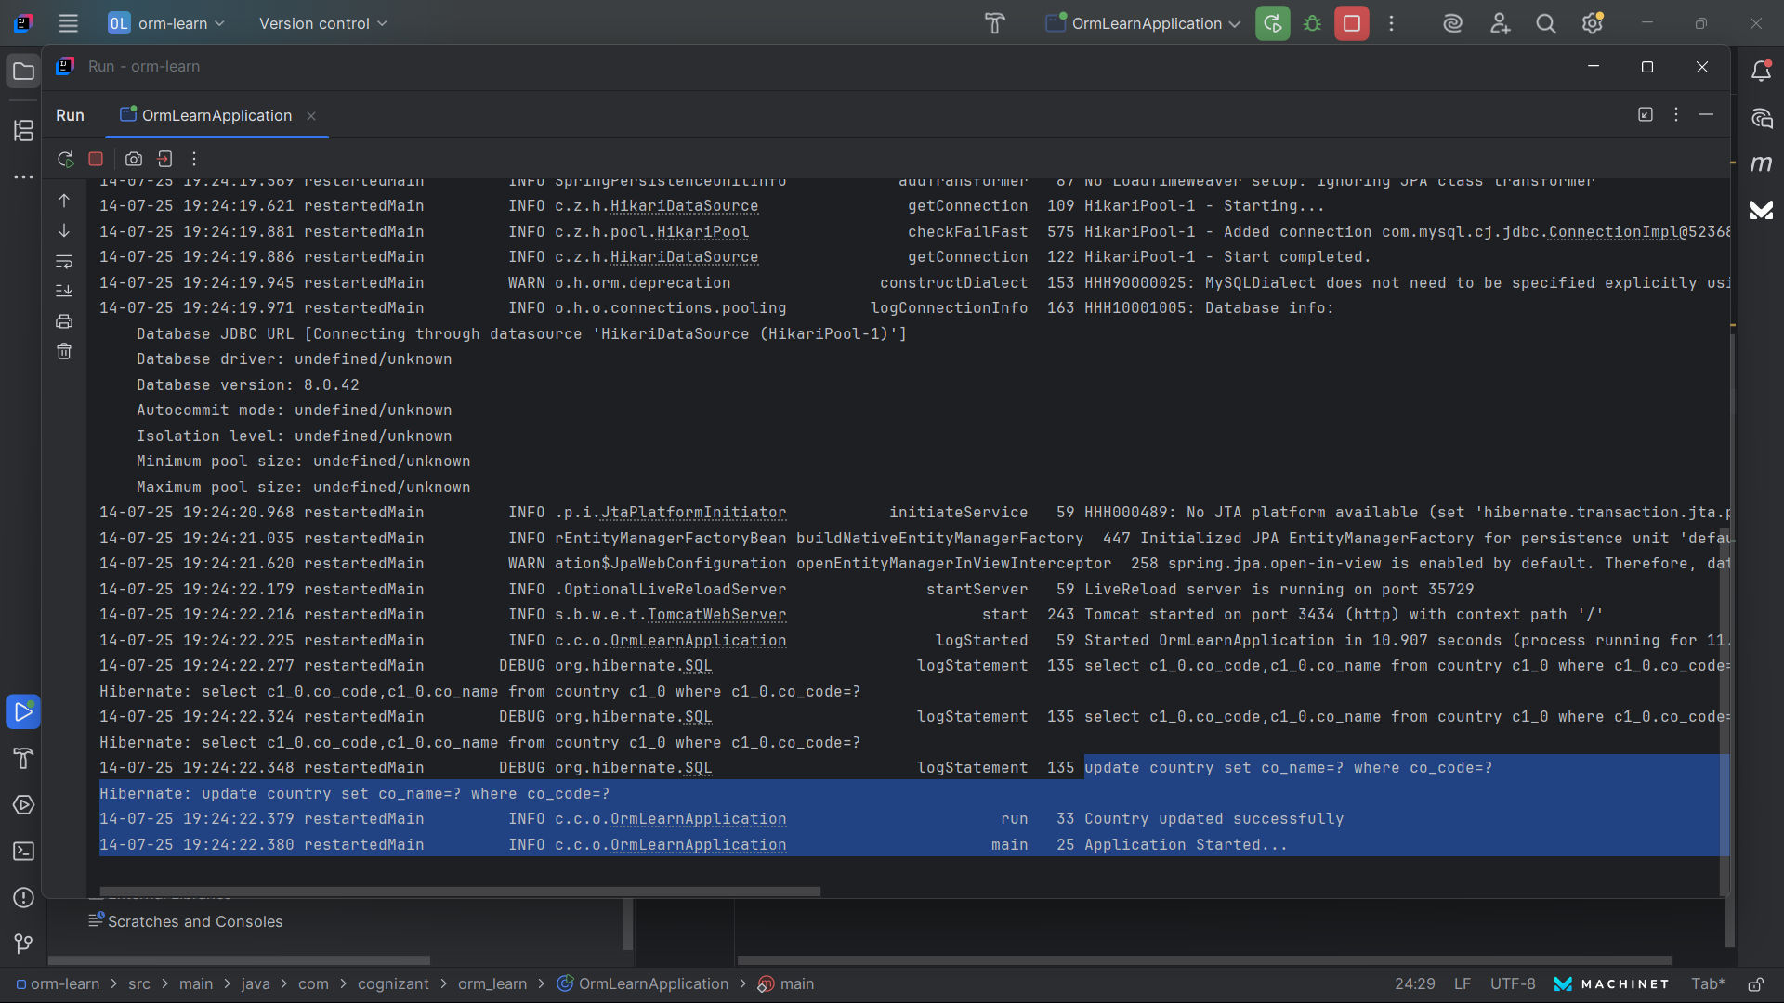

**Hands on 9**

**Delete a country based on code   
Code :**

**OrmLearnApplication.java**

package com.cognizant.orm_learn;  
import java.util.List;  
import org.slf4j.Logger;  
import org.slf4j.LoggerFactory;  
import org.springframework.beans.factory.annotation.Autowired;  
import org.springframework.boot.CommandLineRunner;  
import org.springframework.boot.SpringApplication;  
import org.springframework.boot.autoconfigure.SpringBootApplication;  
import com.cognizant.orm_learn.model.Country;  
import com.cognizant.orm_learn.service.CountryService;  
@SpringBootApplication  
public class OrmLearnApplication implements CommandLineRunner {  
 private static final Logger *LOGGER* = LoggerFactory.*getLogger*(OrmLearnApplication.class);  
 @Autowired  
 private CountryService countryService;  
 public static void main(String[] args) {  
 SpringApplication.*run*(OrmLearnApplication.class, args);  
 *LOGGER*.info("Application Started...");  
 }  
 @Override  
 public void run(String... args) throws Exception {  
 try {  
 countryService.deleteCountry("FR");  
 *LOGGER*.info("Country deleted successfully");  
 } catch (RuntimeException e) {  
 *LOGGER*.error(e.getMessage());  
 }  
 }  
}

**Output :**

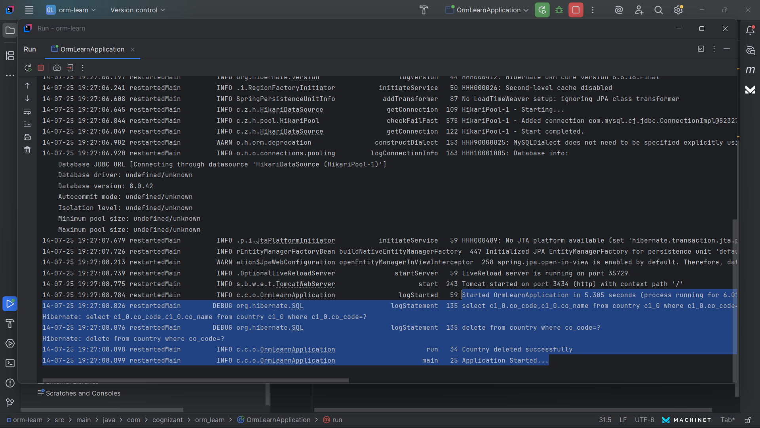

**Database :**

